Variational Quantum Eigensolver Benchmark
on the Hexagonal Boron-Nitride Quantum Dot B₈N₈H₁₀
Active-space reduction, Jordan–Wigner mapping, four ansätze, a 64-configuration optimizer grid, 8- and 12-qubit scaling studies, and execution on the IBM Quantum Heron processor ibm_fez

Item | Details
Project | VQE_QuantumDots (TistaBasak_Graphene)
Molecule | B₈N₈H₁₀, 26 atoms, 106 electrons, neutral closed-shell singlet, planar
Electronic structure | PySCF 2.14.0 — RHF and B3LYP in STO-3G and 6-31G(d,p); CASCI (2e,2o), (4e,4o), (6e,6o)
Quantum stack | Qiskit 2.3.1, Qiskit Nature 0.8.0, Qiskit Algorithms 0.4.0, Qiskit Aer 0.17.2, Qiskit IBM Runtime 0.45.1
Hardware | IBM Quantum ibm_fez (156-qubit Heron r2), 3 jobs, 100.35 QPU-seconds used of a 600 s budget
Data sources | data/*.json, results.xlsx (10 sheets), AUDIT_REPORT.md, CHANGELOG.md, src/, scripts/, tests/
Report date | 25 September 2026

Contents
Abstract 4
Key results at a glance 4
1. Chemical System Definition and Basis-Set Complexity 6
1.1 The B₈N₈H₁₀ quantum dot 6
1.2 Basis-set selection 6
1.3 Why the full molecule cannot be simulated 7
2. Theoretical Methodology and Hamiltonian Mapping 9
2.1 The electronic Hamiltonian in second quantization 9
2.2 Restricted Hartree–Fock pre-computation 9
2.3 Complete active space and core freezing 9
2.4 Active-space energetics 10
2.5 The (2e,2o) integrals and qubit Hamiltonian in full 11
2.6 Jordan–Wigner fermion-to-qubit mapping 12
2.7 Reference-determinant energy and the % correlation metric 13
3. Ansatz Architectures and Circuit Implementations 14
3.1 DexcG — doubles-only unitary coupled cluster 14
3.2 PCU2 — two-layer entangler circuit 15
3.3 UCCSD — unitary coupled cluster singles and doubles 16
3.4 Deep dive: how UCCSD is built in Qiskit, and what it requires 17
3.5 Brillouin’s theorem and vanishing single-excitation gradients 18
3.6 k-UpCCGSD — generalized UCC with k = 3 layers 19
3.7 Circuit resource metrics 21
4. Computational Benchmarking — the 64-Run Grid 23
4.1 Experimental design 23
4.2 The exact finite-difference gradient and why the parameter-shift rule failed 23
4.3 Learning-rate selection 24
4.4 Results on the (2e,2o) production space (4 qubits, 50 iterations) 24
Interpretation 26
4.5 Random-initialization robustness (5 seeds) 26
4.6 Scaling to (4e,4o): 8 qubits, 25 iterations 27
4.7 Scaling to (6e,6o): 12 qubits, SPSA only, 15 iterations 28
5. IBM Quantum Hardware Execution 29
5.1 Platform and access model 29
5.2 Complete job log 29
5.3 Pre-hardware noisy simulation (DexcG dry run on FakeFez) 30
5.4 The Phase 6 hardware script (scripts/run_live_hardware_job.py) 30
5.5 Hardware landscape analysis — did the device reproduce the curvature? 31
(a) DexcG sweep, Job 2 — the real test of curvature 31
(b) PCU2 sweep, Job 3 — a pure noise measurement 32
6. Verification, Reproducibility and Software Environment 33
6.1 Automated test suite 33
6.2 Software environment 33
6.3 Independent cross-checks performed for this report 33
6.4 How to reproduce 34
7. Conclusions and Recommendations 34
Limitations 35
Appendix A. Molecular Geometry (Å) 36
Appendix B. All 64 Configurations — (2e,2o), 6-31G(d,p) 36
Appendix C. All 64 Configurations — (4e,4o) 37
Appendix D. Learning-Rate Sweep 39
Appendix E. Data Provenance and Corrections to Earlier Drafts 39
Appendix F. Units and Glossary 40

(If the table of contents appears empty, right-click it in Word and choose “Update Field”.)

Abstract
This report documents a complete Variational Quantum Eigensolver (VQE) study of the ground-state electronic energy of a planar hexagonal boron-nitride quantum dot, B₈N₈H₁₀ (8 B, 8 N, 10 H; 106 electrons). The full molecule in the 6-31G(d,p) basis has 274 spherical atomic orbitals, which maps to 548 qubits under the Jordan–Wigner transformation and gives about $2.9×{10}^{114}$ Slater determinants in the $S_{z}=0$ sector. A quantum computation of that size is not possible today, so we reduce the problem with a complete-active-space (CAS) construction on top of a restricted Hartree–Fock (RHF) reference. The resulting active spaces are (2e,2o), (4e,4o) and (6e,6o), mapped to 4, 8 and 12 qubits with 27, 361 and 1,819 Pauli terms.
Four ansätze are compared: doubles-only unitary coupled cluster (DexcG), a hand-built two-layer entangler circuit (PCU2), UCCSD, and a three-layer generalized UCC circuit (k-UpCCGSD). Each is combined with four parameter initializations (zero, half, one, random) and four optimizers (gradient descent and ADAM with batched central finite-difference gradients, SPSA and QNSPSA). On the 4-qubit production space, 54 of 64 configurations (84.4%) finish within chemical accuracy (1.6 mHa). UCCSD with gradient descent reaches the exact CASCI energy to within $1.1×{10}^{-10}$ mHa from every initialization. DexcG stops at $2.13×{10}^{-4}$ mHa (99.48% of the correlation energy); we derive this limit analytically. At 8 qubits, UCCSD with gradient descent from zero still gets to 0.0048 mHa. At 12 qubits only SPSA was affordable, and every UCC run diverged from the Hartree–Fock basin.
Three jobs ran on the IBM Heron processor ibm_fez. (1) A θ = 0 UCCSD circuit that compiled down to state preparation only gave 0.64 mHa error, which is a readout-dominated noise floor. (2) A 5-point DexcG sweep (42 CZ gates) sat about 127–138 mHa above the exact energy. Once that offset is removed, it reproduces the curvature of the ideal energy curve to within about 17%. (3) A 5-point PCU2 sweep (18 CZ) sat about 28–31 mHa above the ideal value. We also show that the swept PCU2 parameter cannot change the ideal energy at all. That sweep therefore measures noise only, and its point-to-point scatter matches shot noise (χ² = 3.3 for 4 degrees of freedom).
A central physical finding runs through all of these results: in every active space studied, the correlation energy is below 1.6 mHa (0.041, 0.294 and 1.384 mHa). The Hartree–Fock determinant is therefore already “chemically accurate” for this system. The benchmark mostly measures how well optimizers and ansätze return to, or improve on, a very good starting point. It does not test strongly correlated electronic structure.

Key results at a glance
Table 1. Headline numbers. All values come from the repository data files.
Quantity | Value | Source
RHF total energy, 6-31G(d,p) | −639.72424230 Ha | data/bn_dot_631gdp.json
RHF total energy, STO-3G | −631.74167448 Ha | data/bn_dot_sto3g.json
Nuclear repulsion $V_{NN}$ | 944.07578906 Ha | all caches
CASCI (2e,2o) / (4e,4o) / (6e,6o) | −639.72428323 / −639.72453605 / −639.72562598 Ha | caches
Active correlation energy | 0.04093 / 0.29375 / 1.38368 mHa | caches
Qubits / Pauli terms | 4/27, 8/361, 12/1,819 | results.xlsx + independent re-derivation
Chemical accuracy, (2e,2o) grid | 54 / 64 configurations (84.4%) | benchmark_results_6-31gd_p.json
Best (2e,2o) configuration | UCCSD · random · GD: 1.14×10⁻¹⁰ mHa, 351 evals, 6.10 s | tie-ranked
Best (4e,4o) configuration | UCCSD · zero · GD: 0.00479 mHa (98.37% corr.), 1,326 evals | …_4e4o.json
Best (6e,6o) configuration | PCU2 · zero · SPSA: 1.384 mHa (= HF, 0% corr.) | …_6e6o.json
QPU job daor3p5r85ps73ffmvn0 | UCCSD @ θ=0, depth 1, 0 CZ — 0.6371 mHa | CHANGELOG, qpu_ledger.json
QPU job daqkle3t55cs738rsfrg | DexcG 5-pt sweep, depth 144, 42 CZ — best 127.37 mHa | AUDIT_REPORT, README
QPU job daqph1uekp0c73ar40l0 | PCU2 5-pt sweep, depth 56, 18 CZ — best 27.82 mHa | hardware_crosscheck.json

1. Chemical System Definition and Basis-Set Complexity

1.1 The B₈N₈H₁₀ quantum dot
Hexagonal boron nitride (h-BN) is isoelectronic with graphene. It has alternating B and N atoms on a honeycomb lattice. Unlike graphene it has a wide band gap, because the B–N bond is polar (boron is electron-poor and nitrogen electron-rich). Finite h-BN flakes, or “quantum dots”, keep this polar σ/π bonding. Their edges are passivated with hydrogen to remove dangling σ bonds. The system studied here is a four-ring fragment with 8 boron, 8 nitrogen and 10 hydrogen atoms. All 26 atoms lie in the z = 0 plane.
- Stoichiometry: B₈N₈H₁₀, 26 atoms. Charge Q = 0. Spin S = 0 (closed-shell singlet, PySCF mol.spin = 0).
- Electron count: $N_{e}=8·5+8·7+10·1=106$, i.e. 53 doubly occupied spatial orbitals in RHF.
- Bond lengths (computed from the stored coordinates): 19 B–N bonds, all 1.440 Å; 5 B–H bonds at 1.190 Å; 5 N–H bonds (1.010–1.190 Å). The mean B–N distance of 1.4400 Å is checked automatically by test VERIF-09.
- Nuclear repulsion energy: $V_{NN}=\sum_{A<B}{Z_{A}}Z_{B}/|R_{A}-R_{B}|=944.075789055 Ha$ (the same in every cache, as it must be, because it depends only on the geometry).
- Geometry source: the GEOMETRY_STR constant, duplicated in src/molecule.py and src/compute_pyscf.py (units Å, mol.unit = "Angstrom"). The full coordinate table is in Appendix A. The calculations do not use point-group symmetry.
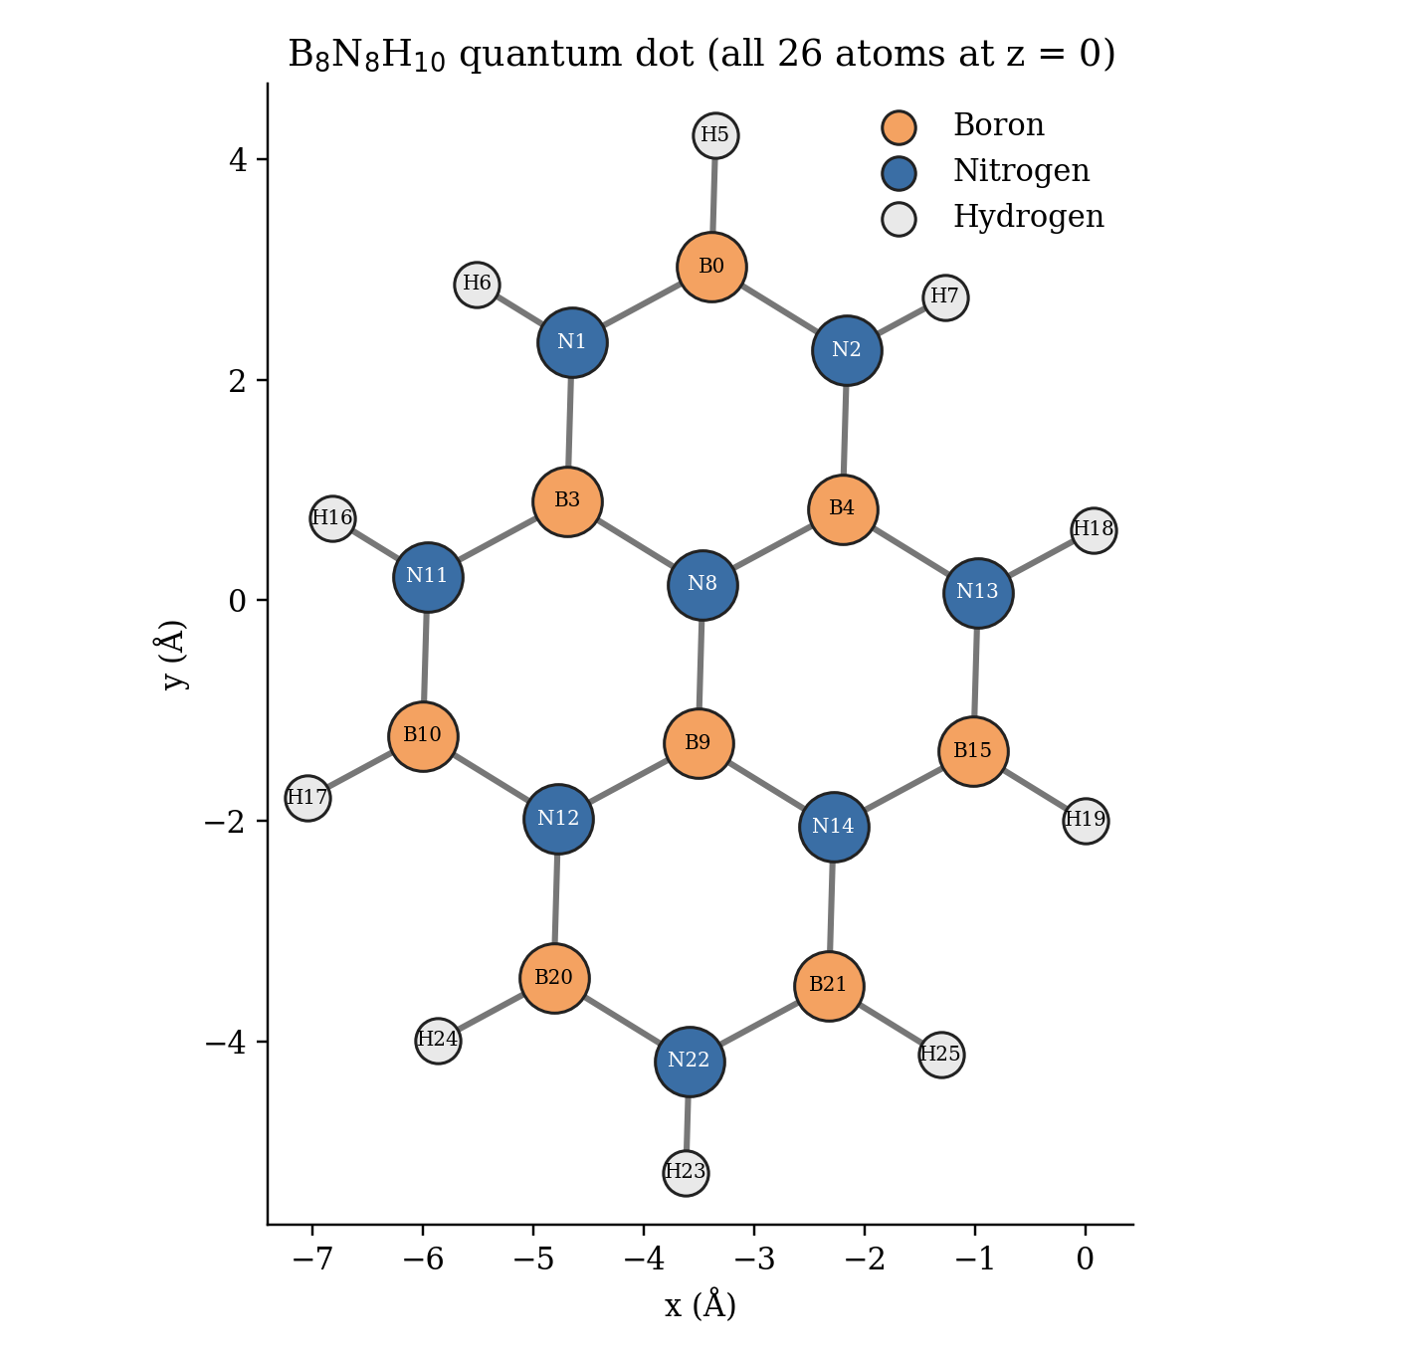
Figure 1. Structure of the B₈N₈H₁₀ quantum dot drawn from the repository coordinates. Atom labels match the 0-based indices in GEOMETRY_STR. Bonds are drawn for interatomic distances under 1.6 Å.

1.2 Basis-set selection
A basis set is the finite set of atom-centred Gaussian functions used to expand the molecular orbitals. Its size fixes the number of spatial orbitals $K$. Under Jordan–Wigner, the number of qubits needed for the full molecule is $2K$ (one qubit per spin-orbital). Two basis sets were used:
Table 2. Counting basis functions. PySCF was run with mol.cart = False (spherical d shells), so the 6-31G(d,p) calculation has 274 atomic orbitals, as confirmed by n_basis_functions = 274 in every 6-31G(d,p) cache. The often-quoted value of about 290 is the Cartesian count used by Gaussian-style programs.
Atom | STO-3G shells | STO-3G functions | 6-31G(d,p) shells | Cartesian (6d) | Spherical (5d)
B, N (×16) | 1s, 2s, 2p | 5 | 1s(6G); 2sp inner(3G) + outer(1G); d-polarization | 1+4+4+6 = 15 | 1+4+4+5 = 14
H (×10) | 1s | 1 | 1s inner(3G) + outer(1G); p-polarization | 2+3 = 5 | 2+3 = 5
Total |  | 16·5 + 10·1 = 90 |  | 16·15 + 10·5 = 290 | 16·14 + 10·5 = 274

- STO-3G (minimal basis) has one contracted function per occupied atomic shell, each a fit of three Gaussians to a Slater orbital. It is cheap. It was used as a smoke test of the pipeline (RHF = −631.74167448 Ha).
- 6-31G(d,p) (split-valence and polarized) is the production basis. The core 1s shell is a contraction of 6 Gaussians. Each valence shell is split into an inner part (3 Gaussians) and an outer part (1 Gaussian), so orbitals can expand or contract with their bonding environment. The (d,p) polarization functions (d on B/N, p on H) let the charge density distort away from atomic symmetry, which matters for the polar B–N bond. The variational RHF energy is 7.98 Ha lower than in STO-3G (−639.72424230 Ha).

1.3 Why the full molecule cannot be simulated
With $K$ spatial orbitals and $N_{α}=N_{β}=53$ electrons of each spin, the full configuration-interaction (FCI) space in the $S_{z}=0$ sector contains
$$N_{det}=\left(\begin{aligned}K \\ N_{α}\end{aligned}\right)\left(\begin{aligned}K \\ N_{β}\end{aligned}\right)={\left(\begin{aligned}274 \\ 53\end{aligned}\right)}^{2}≈2.9×{10}^{114}$$ | (1)

determinants. The qubit register has $2K=548$ qubits, so a state-vector simulation needs $2^{548}≈9.2×{10}^{164}$ complex amplitudes. At 16 bytes each, that is far more memory than could ever exist. Even the minimal STO-3G basis needs 180 qubits ($2^{180}≈1.5×{10}^{54}$ amplitudes; ${\left(\begin{aligned}90 \\ 53\end{aligned}\right)}^{2}≈6.4×{10}^{50}$ determinants). On the hardware side, ibm_fez has 156 physical qubits, fewer than even the STO-3G requirement. The largest active space here, (6e,6o) on only 12 qubits, already transpiles UCCSD to a depth of about 28,000 with about 9,800 CZ gates on the Heron target (Section 3.6). That is orders of magnitude beyond current coherence limits. The UCCSD parameter count for the full molecule (Section 3.4) is:
Table 3. Analytical qubit and parameter scaling (from src/scaling.py, reproduced in the “Active Space Scaling” sheet of results.xlsx). PCU2 = 2·(Q + (Q−1)) for Q qubits (Section 3.2).
System | $$K$$ | Qubits | Occupied $o$ | Virtual $v$ | Singles $2ov$ | Doubles | UCCSD total | PCU2 (2 reps)
Full molecule, STO-3G | 90 | 180 | 53 | 37 | 3,922 | 5,681,017 | 5,684,939 | 718
Full molecule, 6-31G(d,p) | 274 | 548 | 53 | 221 | 23,426 | 204,192,729 | 204,216,155 | 2,190
Active (2e,2o) | 2 | 4 | 1 | 1 | 2 | 1 | 3 | 14
Active (4e,4o) | 4 | 8 | 2 | 2 | 8 | 18 | 26 | 30
Active (6e,6o) | 6 | 12 | 3 | 3 | 18 | 99 | 117 | 46

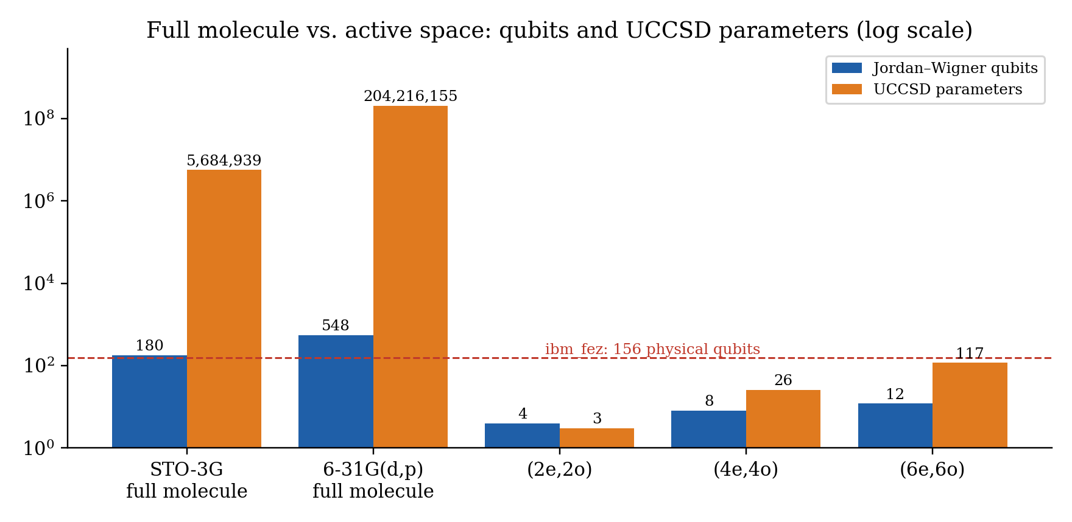
Figure 2. Qubit count and UCCSD parameter count on a log scale for the full molecule and the three active spaces. The dashed line marks the 156 physical qubits of ibm_fez.
Conclusion of Section 1
Active-space reduction is not an optional approximation here. It is the only way to make a quantum computation of this molecule possible. The rest of the report shows what that reduction keeps and what it gives up.

2. Theoretical Methodology and Hamiltonian Mapping
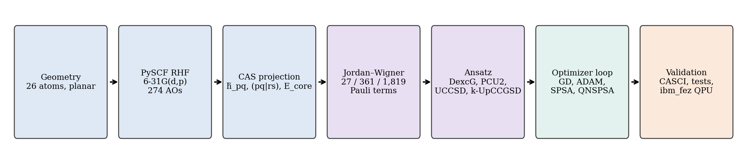
Figure 3. End-to-end workflow. The classical steps (blue) produce active-space integrals. The quantum-encoding steps (purple) turn them into a qubit Hamiltonian and parameterized circuits. The variational loop (green) is checked against exact CASCI, the automated tests, and the physical IBM QPU (orange).

2.1 The electronic Hamiltonian in second quantization
In the Born–Oppenheimer approximation and an orthonormal molecular-orbital (MO) basis $\left\{ϕ_{p}\right\}$, the non-relativistic electronic Hamiltonian is
$$\hat{H}=V_{NN}+\sum_{pq}{\sum_{σ}{h_{pq}}}a_{pσ}^{†}a_{qσ}+\frac{1}{2}\sum_{pqrs}{\sum_{στ}{(pq|rs)}}a_{pσ}^{†}a_{rτ}^{†}a_{sτ}a_{qσ}$$ | (2)

with one-electron integrals $h_{pq}=∫ϕ_{p}^{*}(r)\left(-\frac{1}{2}∇^{2}-\sum_{A}{Z_{A}}/|r-R_{A}|\right)ϕ_{q}(r)dr$ and two-electron repulsion integrals in chemists’ notation
$$(pq|rs)=∬\frac{ϕ_{p}^{*}(r_{1})ϕ_{q}(r_{1})ϕ_{r}^{*}(r_{2})ϕ_{s}(r_{2})}{\left|r_{1} − r_{2}\right|}dr_{1}dr_{2}$$ | (3)

The fermionic operators satisfy the canonical anticommutation relations $\{a_{p},a_{q}^{†}\}=δ_{pq}$ and $\{a_{p},a_{q}\}=0$. These relations encode the Pauli exclusion principle.

2.2 Restricted Hartree–Fock pre-computation
src/compute_pyscf.py builds the molecule in PySCF (gto.Mole, charge 0, spin 0, Å units, cart=False) and runs scf.RHF. RHF solves the Roothaan–Hall generalized eigenvalue problem self-consistently:
$$F(C)C=SCε, F_{μν}=h_{μν}+\sum_{λσ}{P_{λσ}}\left[(μν|λσ)-\frac{1}{2}(μλ|σν)\right]$$ | (4)

Here $S$ is the AO overlap matrix, $P=2C_{occ}C_{occ}^{†}$ is the density matrix, and the eigenvectors $C$ define the canonical MOs sorted by orbital energy $ε_{p}$. The 53 lowest MOs are doubly occupied. The eight lowest orbital energies (−15.55 to −15.52 Ha) are the nitrogen 1s cores. The next ones (≈ −7.61 Ha) are the boron 1s cores. RHF provides (i) the orbitals in which the active space is defined, (ii) the reference determinant $|Φ_{HF}⟩$ that every ansatz starts from, and (iii) the energy scale for measuring correlation. A second set of orbitals came from Kohn–Sham DFT (dft.RKS, xc = "b3lyp", total DFT energy −643.63393574 Ha) and was used for a comparative (2e,2o) space.

2.3 Complete active space and core freezing
The orbital space is split into three sets. There are $n_{core}$ inactive doubly occupied orbitals (C), $n_{act}$ active orbitals (A) around the HOMO–LUMO gap, and the remaining external virtual orbitals (V), which are discarded. In the code, ncore = (mol.nelectron − n_active_electrons) // 2. “Frozen core” here therefore means every occupied orbital below the active window, not only the 1s shells:
Table 4. Active-space partitioning used by compute_active_space().
Active space | Inactive orbitals | Frozen electrons | Active MO indices (0-based) | Orbital content | Qubits
(2e,2o) | 52 | 104 | 52–53 | HOMO, LUMO | 4
(4e,4o) | 51 | 102 | 51–54 | HOMO−1 … LUMO+1 | 8
(6e,6o) | 50 | 100 | 50–55 | HOMO−2 … LUMO+2 | 12

Projecting $\hat{H}$ onto the active space and treating the core at mean-field level gives an effective one-electron operator and a scalar core energy (PySCF CASSCF.get_h1eff):
$${\overset{\sim }{h}}_{pq}=h_{pq}+\sum_{i∈C}{\left[2(pq|ii)-(pi|iq)\right]}, p,q∈A$$ | (5)

$$E_{core}=V_{NN}+\sum_{i∈C}{\left(h_{ii} + {\overset{\sim }{h}}_{ii}\right)}=V_{NN}+2\sum_{i∈C}{h_{ii}}+\sum_{i,j∈C}{\left[2(ii|jj)-(ij|ji)\right]}$$ | (6)

$${\hat{H}}_{act}=E_{core}+\sum_{p,q∈A}{\sum_{σ}{{\overset{\sim }{h}}_{pq}}}a_{pσ}^{†}a_{qσ}+\frac{1}{2}\sum_{p,q,r,s∈A}{\sum_{στ}{(pq|rs)}}a_{pσ}^{†}a_{rτ}^{†}a_{sτ}a_{qσ}$$ | (7)

The active two-electron integrals come from ao2mo.kernel(mol, C_act) and are expanded to a 4-index tensor with ao2mo.restore(1, …). The exact answer inside the active space is CASCI (mcscf.CASCI(mf, n_o, n_e).kernel()), i.e. full CI in the active orbitals. Every VQE number in this report is measured against it.
Shift-integrity identity (bug fix documented in AUDIT_REPORT.md)
An earlier version added $V_{NN}$ on top of PySCF’s core energy, which already contains it. That counted the nuclear repulsion twice. load_or_build_bn_dot_hamiltonian() now asserts
$$\left|(E_{CASCI}-E_{0}^{act})-E_{core}\right|<{10}^{-6} Ha$$
where $E_{0}^{act}$ is the lowest eigenvalue of the mapped active-space operator without the constant. The measured deviation is 0 Ha for STO-3G, 6-31G(d,p) (2e,2o) and B3LYP, and $2.3×{10}^{-13}$ Ha for (4e,4o) and (6e,6o).

2.4 Active-space energetics
Table 5. Energies stored in the five PySCF caches. $E_{corr}=|E_{ref}-E_{CASCI}|$. For RHF orbitals $E_{ref}$ equals the total RHF energy to ${10}^{-11}$ Ha. For B3LYP orbitals it lies 87.12 mHa higher.
Configuration | $E_{core}$ (Ha) | $E_{ref}$ (Ha) | $E_{CASCI}$ (Ha) | $E_{corr}$ (mHa)
STO-3G (2e,2o) | -630.90779471 | -631.74167448 | -631.74178346 | 0.10897
6-31G(d,p) (2e,2o) | -638.74689305 | -639.72424230 | -639.72428323 | 0.04093
6-31G(d,p) (4e,4o) | -637.06241785 | -639.72424230 | -639.72453605 | 0.29375
6-31G(d,p) (6e,6o) | -634.50502581 | -639.72424230 | -639.72562598 | 1.38368
6-31G(d,p) B3LYP orbitals (2e,2o) | -638.67479031 | -639.63711823 | -639.63815054 | 1.03231

Table 6. Sizes of the three active-space problems. The Pauli counts were re-derived independently for this report (Section 6.3) and agree with results.xlsx.
Active space | Qubits | Hilbert-space dim. $2^{Q}$ | Determinants ($N$, $S_{z}=0$) | Pauli terms | Chem. acc. already met by HF?
(2e,2o) | 4 | 16 | $${\left(\begin{aligned}2 \\ 1\end{aligned}\right)}^{2}=4$$ | 27 | Yes (0.041 < 1.6 mHa)
(4e,4o) | 8 | 256 | $${\left(\begin{aligned}4 \\ 2\end{aligned}\right)}^{2}=36$$ | 361 | Yes (0.294 < 1.6 mHa)
(6e,6o) | 12 | 4,096 | $${\left(\begin{aligned}6 \\ 3\end{aligned}\right)}^{2}=400$$ | 1,819 | Yes (1.384 < 1.6 mHa)

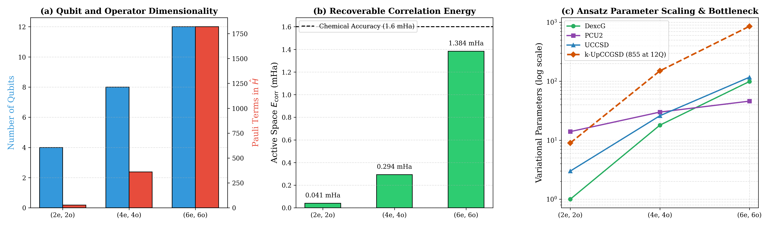
Figure 4. Active-space scaling from the repository (figures/active_space_scaling.png): (a) qubits and Pauli terms, (b) correlation energy recoverable by VQE compared with the 1.6 mHa chemical-accuracy line, (c) parameter counts of the four ansätze, showing the 855-parameter k-UpCCGSD bottleneck at 12 qubits.
Physical interpretation: a near-Hartree–Fock system
B–N bonding is strongly ionic, and the HOMO–LUMO excitation in the (2e,2o) space costs $E_{D}-E_{HF}=0.977$ Ha. Its coupling to the ground determinant is only $K=(01|01)=0.0063$ Ha. Second-order perturbation theory then estimates $E_{corr}≈K^{2}/(E_{D}-E_{HF})=0.0407$ mHa, almost exactly the CASCI value of 0.0409 mHa. The correlation energy grows with the active space (0.04 → 0.29 → 1.38 mHa) but stays below 1.6 mHa in every case. Consequences: (i) zero initialization (= the HF state) starts inside the chemical-accuracy window; (ii) “% correlation recovered” is a more informative figure of merit than the pass/fail chemical-accuracy flag; (iii) the benchmark mainly tests optimizer behaviour, not the ability to describe strong correlation.

2.5 The (2e,2o) integrals and qubit Hamiltonian in full
The production problem is small enough to write out completely. The active orbitals are MO 52 (HOMO, index 0 below) and MO 53 (LUMO, index 1). The stored integrals (Ha) are:
Table 7. Unique active-space integrals for 6-31G(d,p) (2e,2o) (from data/bn_dot_631gdp.json). The remaining elements follow from 8-fold permutational symmetry of real orbitals.
Integral | Value (Ha) | Integral | Value (Ha)
$${\overset{\sim }{h}}_{00}$$ | -0.6105981843 | $$\left(00 | 00\right)$$ | 0.2438471241
$${\overset{\sim }{h}}_{01}={\overset{\sim }{h}}_{10}$$ | 0.0165508041 | $$\left(00 | 01\right)$$ | -0.0165507187
$${\overset{\sim }{h}}_{11}$$ | -0.1160390831 | $\left(00 | 11\right)$ (Coulomb $J$) | 0.1398202535
$$E_{core}$$ | -638.7468930521 | $\left(01 | 01\right)$ (exchange $K$) | 0.0063065820
 |  | $$\left(01 | 11\right)$$ | 0.0152477338
 |  | $$\left(11 | 11\right)$$ | 0.2314951183

Table 8. All 27 terms of the mapped (2e,2o) 6-31G(d,p) qubit Hamiltonian, including the identity, which carries $E_{core}$ plus the constant parts of the fermionic operator. Strings are in Qiskit order (rightmost character = qubit 0). Qubits 0–1 are α spin-orbitals of MO 52/53 and qubits 2–3 are the β spin-orbitals.
Pauli string | Coefficient (Ha) | Pauli string | Coefficient (Ha)
IIII | -639.2180277964 | XXII | +0.0079496558
IIIZ | +0.1760038299 | YYIZ | +0.0041376797
IZII | +0.1760038299 | XXIZ | +0.0041376797
IIZI | -0.0681877193 | IZYY | +0.0041376797
ZIII | -0.0681877193 | IZXX | +0.0041376797
IZIZ | +0.0609617810 | ZIYY | -0.0038119334
ZIZI | +0.0578737796 | ZIXX | -0.0038119334
ZIIZ | +0.0349550634 | YYZI | -0.0038119334
IZZI | +0.0349550634 | XXZI | -0.0038119334
IIZZ | +0.0333784179 | YYYY | +0.0015766455
ZZII | +0.0333784179 | XXYY | +0.0015766455
IIYY | +0.0079496558 | YYXX | +0.0015766455
IIXX | +0.0079496558 | XXXX | +0.0015766455
YYII | +0.0079496558

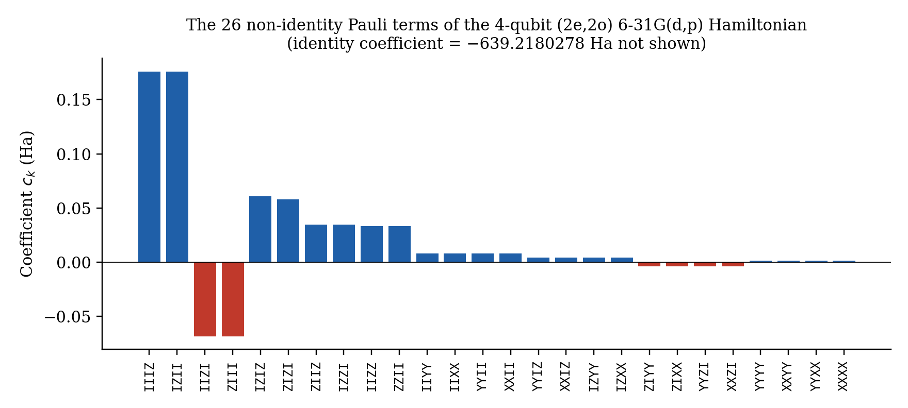
Figure 5. Magnitudes of the 26 non-identity Pauli coefficients. The diagonal Z and ZZ terms dominate. The XX/YY hopping and XXYY-type pair-exchange terms, which produce correlation, are 1–2 orders of magnitude smaller.

2.6 Jordan–Wigner fermion-to-qubit mapping
Each spin-orbital $j$ is assigned to one qubit, with $|1⟩$ meaning occupied. To preserve fermionic antisymmetry, each ladder operator carries a string of Z operators that records the parity of all lower-indexed modes:
$$a_{j}^{†}=\left(\prod_{k=0}^{j-1}{Z_{k}}\right)\frac{X_{j}-iY_{j}}{2}, a_{j}=\left(\prod_{k=0}^{j-1}{Z_{k}}\right)\frac{X_{j}+iY_{j}}{2}$$ | (8)

Products of these operators give Pauli strings. For example, number operators become $a_{j}^{†}a_{j}=(I-Z_{j})/2$, and hopping terms become $a_{p}^{†}a_{q}+a_{q}^{†}a_{p}=\frac{1}{2}(X_{p}X_{q}+Y_{p}Y_{q})\prod_{p<k<q}{Z_{k}}$. The Hamiltonian then becomes
$${\hat{H}}_{q}=\sum_{k=1}^{M}{c_{k}}{\hat{P}}_{k}, {\hat{P}}_{k}∈\{I,X,Y,Z\}^{⊗2n_{act}}, c_{k}∈R$$ | (9)

- Implementation (src/molecule.py): chemists’ integrals are converted to physicists’ ordering with np.einsum('pqrs->prqs', h2). Then ElectronicEnergy.from_raw_integrals(h1, h2_phys).second_q_op() builds the FermionicOp, and JordanWignerMapper().map(...) produces a SparsePauliOp. The constant shift is added as an identity term, and simplify() merges duplicate strings.
- Spin-orbital ordering (Qiskit Nature block convention): qubits $0…n-1$ are the α orbitals and $n…2n-1$ the β orbitals. The Hartree–Fock state for (2e,2o) occupies qubits 0 and 2, i.e. the bit string |0101⟩ (Qiskit little-endian).
- Why Jordan–Wigner: it is the simplest and most transparent mapping and keeps occupation numbers directly visible, which makes HF preparation a pair of X gates. Its cost is Z-strings of length up to $O(N)$. That cost is irrelevant at 4 qubits but contributes to CNOT ladders at 8–12 qubits. Parity or Bravyi–Kitaev mappings (and two-qubit reduction using $N$ and $S_{z}$ symmetry) would shorten the strings and remove qubits. They were not used.
- Exactness check: the code diagonalizes the dense $2^{Q}×2^{Q}$ matrix (np.linalg.eigh) and asserts agreement with CASCI through the shift identity (Section 2.3).

2.7 Reference-determinant energy and the % correlation metric
The reference determinant energy is the expectation value of the active Hamiltonian in the Hartree–Fock determinant built from the chosen orbitals. With $k=n_{e}/2$ doubly occupied active orbitals, compute_pyscf.py evaluates
$$E_{ref}=⟨Φ_{HF}|{\hat{H}}_{act}|Φ_{HF}⟩=E_{core}+2\sum_{i=1}^{k}{{\overset{\sim }{h}}_{ii}}+\sum_{i,j=1}^{k}{\left[2(ii|jj)-(ij|ji)\right]}$$ | (10)

and every benchmark module reports
$$\%Corr=\frac{E_{ref}-E_{VQE}}{E_{ref}-E_{CASCI}}×100\%$$ | (11)

Why this is the correct baseline. VQE works inside the active space and can only recover the correlation that lives there. Three properties make $E_{ref}$ the right zero point:
1. Consistency at θ = 0. For every ansatz, θ = 0 prepares exactly $|Φ_{HF}⟩$ (checked by VERIF-05 and test_uccsd_basis.py). The metric then gives exactly 0% at the starting point and exactly 100% at CASCI.
2. Orbital independence. With RHF orbitals, $E_{ref}=E_{RHF}$ to ${10}^{-11}$ Ha, so both baselines agree. With B3LYP orbitals, the determinant is not the Hartree–Fock minimum and $E_{ref}=-639.63711823$ Ha lies 87 mHa above $E_{RHF}$. Using the RHF energy, or the total DFT energy (−643.634 Ha), as the baseline gives meaningless percentages. The earlier cache reported a spurious 3995.79 mHa “correlation energy” for exactly this reason. It was corrected to 1.03231 mHa.
3. Interpretability of failures. A negative percentage means the optimizer ended above the HF energy. It lost energy rather than gaining it. This happens often for non-zero initializations (Section 4).

3. Ansatz Architectures and Circuit Implementations
All four ansätze are built in src/ansatze.py::get_ansatz_dict() with num_spatial_orbitals = n_act and num_particles = (n_e/2, n_e/2). The three UCC-family circuits use Qiskit Nature’s UCC class with JordanWignerMapper and a HartreeFock initial state. PCU2 is built by hand. For drawing, circuits are decomposed twice (decompose().decompose()) so that PauliEvolution and HartreeFock blocks expand into elementary gates. The figures below are the repository PNGs rendered at 300 dpi in the IQP style.
Table 9. Ansatz definitions and variational-parameter counts, taken from the benchmark result files.
Ansatz | Qiskit construction | (2e,2o) | (4e,4o) | (6e,6o) | Symmetries preserved
DexcG | UCC(excitations='d') | 1 | 18 | 99 | $N$, $S_{z}$ (exactly)
PCU2 | custom: RZ layer + CX·CRX·CX entanglers, reps = 2 | 14 | 30 | 46 | None in general (see 3.2)
UCCSD | UCC(excitations='sd') | 3 | 26 | 117 | $N$, $S_{z}$ (exactly)
k-UpCCGSD | UCC(excitations='sd', generalized=True, reps=3) | 9 | 150 | 855 | $N$, $S_{z}$ (exactly)

3.1 DexcG — doubles-only unitary coupled cluster
$$|Ψ_{DexcG}(θ)⟩=exp\left({\hat{T}}_{2}(θ)-{\hat{T}}_{2}^{†}(θ)\right)|Φ_{HF}⟩, {\hat{T}}_{2}=\sum_{i<j,a<b}{θ_{ij}^{ab}}a_{a}^{†}a_{b}^{†}a_{j}a_{i}$$ | (12)

In (2e,2o) there is exactly one spin-conserving double excitation, $\left(0_{α},0_{β})→(1_{α},1_{β}\right)$, i.e. qubits (0,2) → (1,3). Because the generator acts only inside the two-dimensional space $\left\{|Φ_{HF}⟩,|Φ_{D}⟩\right\}$, the state is an exact rotation:
$$|Ψ(θ)⟩=cosθ|Φ_{HF}⟩+sinθ|Φ_{D}⟩$$ | (13)

$$E(θ)=E_{HF}\cos^{2}θ+E_{D}\sin^{2}θ+Ksin2θ, K=⟨Φ_{D}|\hat{H}|Φ_{HF}⟩=(01|01)$$ | (14)

With $E_{HF}=-639.7242423$ Ha, $E_{D}=-638.7474761$ Ha and $K=0.0063066$ Ha, the minimum is at $tan2θ^{*}=-2K/(E_{D}-E_{HF})$, i.e. $θ^{*}=-0.00646$ rad. The optimized GD parameter in the benchmark is −0.006418 rad. The lowest DexcG energy lies 2.133×10⁻⁴ mHa above CASCI, exactly the plateau reached by all 12 DexcG runs that use GD, SPSA or QNSPSA. The missing 0.5% of correlation belongs to the singly excited open-shell configurations, which DexcG cannot reach by construction. The ideal curvature $d^{2}E/dθ^{2}|_{0}=2(E_{D}-E_{HF})≈1.95$ Ha/rad² is what the hardware sweep in Section 5.5 tests.
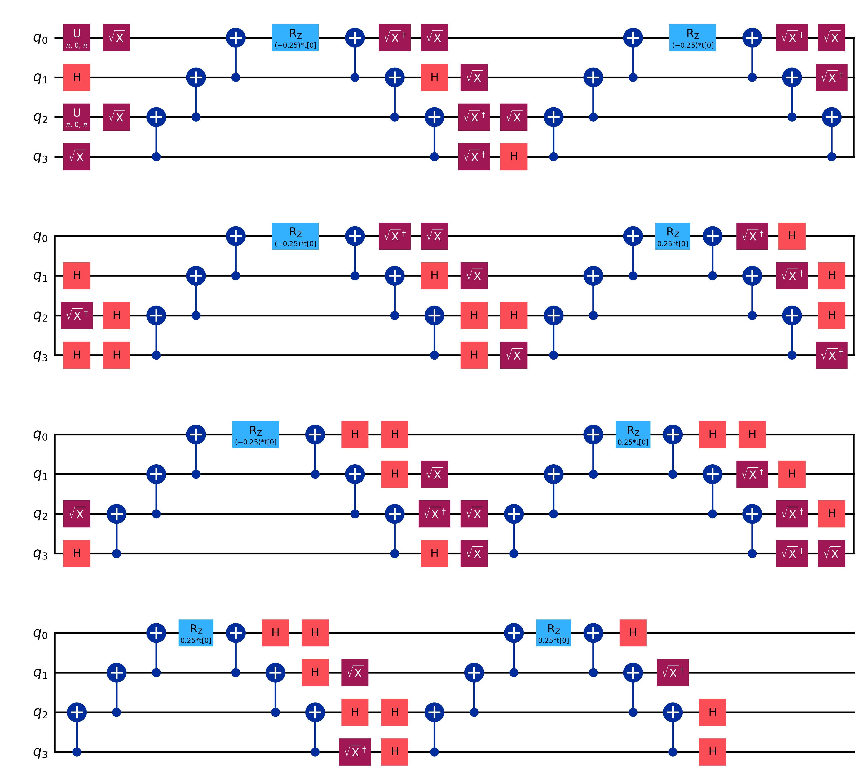
Figure 6. DexcG, (2e,2o), decomposed. The double-excitation generator maps to 8 mutually commuting Pauli strings (XXXY-type), each implemented as basis change → CNOT ladder → RZ(±θ/4) → inverse ladder. 1 parameter. Heron-transpiled depth 144, 42 CZ.

3.2 PCU2 — two-layer entangler circuit
build_particle_conserving_u2() prepares |HF⟩ and then repeats a layer reps = 2 times: an RZ on each of the Q qubits, an entangler $U(θ)={CX}_{q,q+1}{CRX}_{q→q+1}(θ){CX}_{q,q+1}$ on even pairs (0,1),(2,3),…, then the same on odd pairs (1,2),…. The parameter count is $reps·[Q+(Q-1)]$: 14, 30 and 46 for 4, 8 and 12 qubits. It has the shallowest transpiled circuit of the four (depth 56, 18 CZ on Heron), which is why the hardware harness selected it.
Two properties of PCU2 that the earlier drafts missed (verified numerically for this report)
- It is not particle-number conserving in general. On |10⟩ the block CX·CRX(θ)·CX produces $cos(θ/2)|10⟩-isin(θ/2)|11⟩$, which changes $N$. Simulating the exact repository circuit reproduces the benchmark’s iteration-0 energies to ${10}^{-12}$ Ha. It gives ⟨N⟩ = 2.40, 2.79 and 2.50 for the half, one and random initializations. For random parameters, 42% of the weight sits in the N = 3 sector. The symmetry test VERIF-06 passes only because it optimizes from θ = 0, where PCU2 never moves (next point). The name “particle-conserving” describes the intent (Barkoutsos et al.’s U2 block), not this implementation.
- θ = 0 is an exact stationary point. Every PCU2 gate satisfies $U(-θ)=U(θ)^{*}$ (RZ and CRX are complex-conjugate under θ → −θ; CX is real). The HF state and the Hamiltonian are real, so $E(-θ)=E(θ)$ and $∇E(0)=0$ exactly. The finite-difference gradient and the symmetric SPSA/QNSPSA difference $E(θ+cΔ)-E(θ-cΔ)$ both vanish identically. That is why all four PCU2·zero runs in every active space finish exactly at $E_{ref}$ (0% correlation). It also explains why the swept hardware parameter $θ_{0}$ (an RZ on an occupied qubit, i.e. a pure phase) leaves the ideal energy flat.

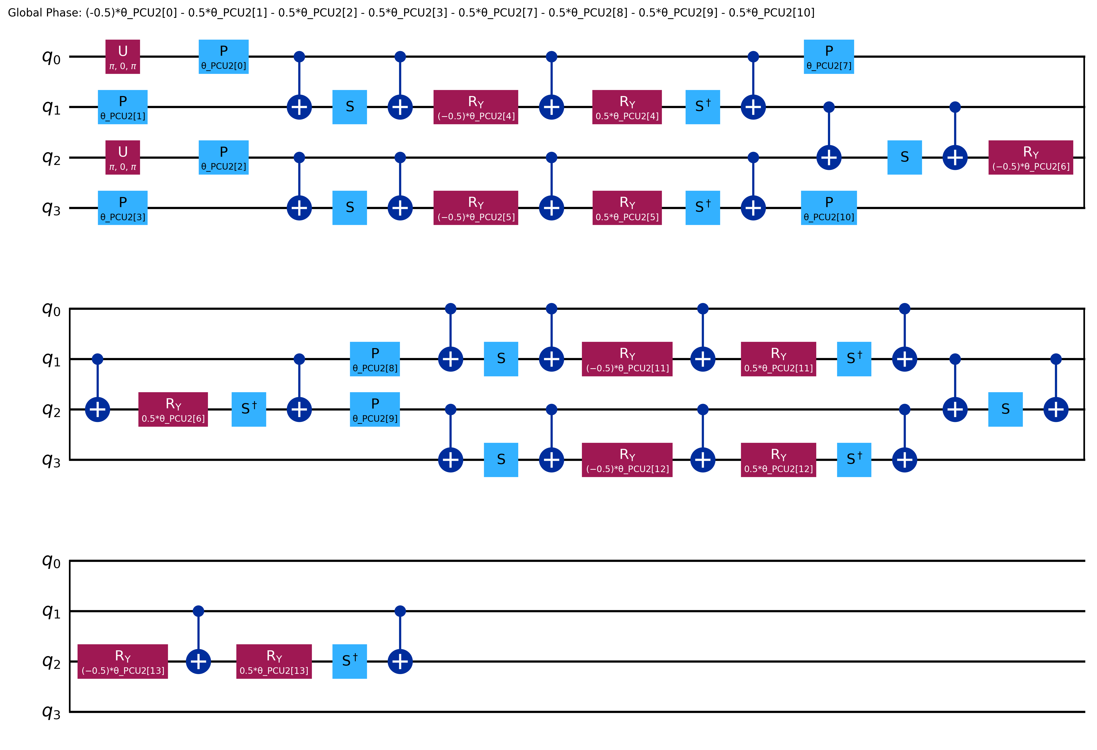
Figure 7. PCU2, (2e,2o), 14 parameters, decomposed: RZ appears as phase gates P(θ), and each CRX is expanded into S, CX, RY(±θ/2), S†. Global phase printed at top. Heron-transpiled depth 56, 18 CZ.

3.3 UCCSD — unitary coupled cluster singles and doubles
$$|Ψ_{UCCSD}(θ)⟩=e^{\hat{σ}(θ)}|Φ_{HF}⟩, \hat{σ}={\hat{T}}_{1}-{\hat{T}}_{1}^{†}+{\hat{T}}_{2}-{\hat{T}}_{2}^{†}, {\hat{T}}_{1}=\sum_{i∈occ,a∈vir}{θ_{i}^{a}}a_{a}^{†}a_{i}$$ | (15)

Because $\hat{σ}$ is anti-Hermitian, $e^{\hat{σ}}$ is unitary. That is the key difference from classical coupled cluster, whose $e^{\hat{T}}$ is not unitary and cannot be run as a gate sequence. For (2e,2o), UCCSD has three amplitudes: two spin-conserving singles ($0_{α}→1_{α}$ on qubits 0→1, $0_{β}→1_{β}$ on qubits 2→3) and the one double. Together these span the whole $N=2, S_{z}=0$ space, which is why UCCSD reaches CASCI exactly (Section 4.4).
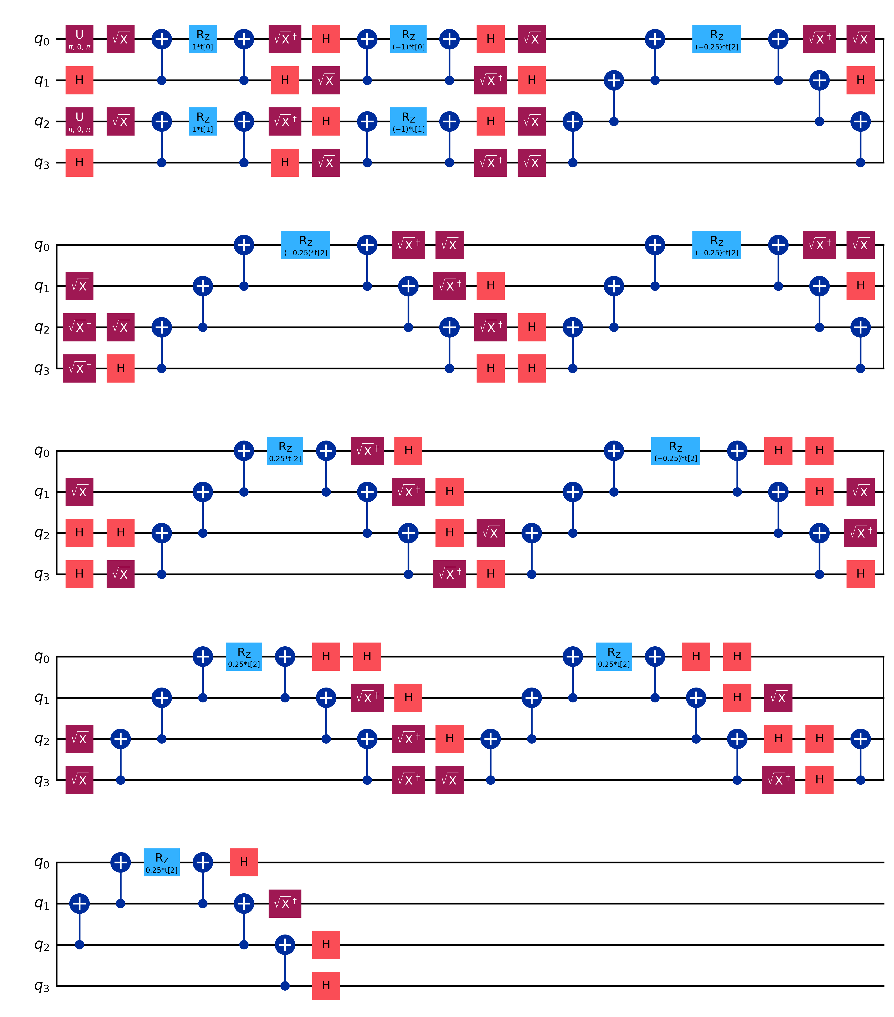
Figure 8. UCCSD, (2e,2o), decomposed. The first two blocks are the singles: each generator maps to 2 Pauli strings (XY and YX type) with RZ(±t[0]) and RZ(±t[1]). The rest is the double excitation: 8 strings with RZ(±0.25·t[2]). 3 parameters. Heron-transpiled depth 157, 49 CZ (audit), or 94 and 49 on the 5-qubit generic backend (workbook).

3.4 Deep dive: how UCCSD is built in Qiskit, and what it requires
1. Inputs required: number of spatial orbitals $n$, a particle tuple $\left(N_{α} , N_{β}\right)$, a QubitMapper (JW), and an initial state (HartreeFock(n, (Nα,Nβ), mapper), which applies X on the occupied qubits). The Hamiltonian must be mapped with the same mapper and orbital ordering, otherwise the circuit and the observable refer to different qubits.
2. Excitation generation: excitations='sd' lists every spin-conserving single $i_{σ}→a_{σ}$ and double $\left(i_{σ}j_{τ})→(a_{σ}b_{τ}\right)$ from occupied to virtual orbitals. With generalized=True (k-UpCCGSD), the occupied/virtual restriction is dropped.
3. Operator construction: each excitation $τ_{k}$ becomes the anti-Hermitian operator $τ_{k}-τ_{k}^{†}$ and is JW-mapped. A single maps to 2 Pauli strings, a double to 8, all mutually commuting.
4. Circuit (Trotterized product): UCC is an EvolvedOperatorAnsatz, so the unitary is the single-step product $U(θ)=\prod_{k}{e^{θ_{k}(τ_{k}-τ_{k}^{†})}}$, with one parameter per excitation (reps = 1). Each factor is a PauliEvolutionGate. Since the strings inside one factor commute, it is implemented exactly as a sequence of Pauli rotations. Each rotation is a basis change (H or √X/√X† to rotate X or Y into Z), a CNOT parity ladder, an RZ carrying the angle, and the reverse ladder.
5. Symmetry: every factor conserves $N$ and $S_{z}$, so the state never leaves the physical sector (VERIF-06).
6. Basis invariance: the circuit depends only on $\left(n_{e} , n_{o}\right)$. tests/test_uccsd_basis.py asserts that STO-3G and 6-31G(d,p) (2e,2o) UCCSD circuits have identical qubit counts (4), parameter counts (3), gate counts and depth, while their Hamiltonian coefficients differ. Changing the basis only changes ${\overset{\sim }{h}}_{pq}$ and $\left(pq | rs\right)$.
Parameter counting. With $o=n_{e}/2$ occupied and $v=n-o$ virtual spatial orbitals per spin (src/scaling.py):
$$N_{S}=2ov, N_{D}=\underset{αα, ββ}{\underset{⏟}{2\left(\begin{aligned}o \\ 2\end{aligned}\right)\left(\begin{aligned}v \\ 2\end{aligned}\right)}}+\underset{αβ}{\underset{⏟}{{\left(ov\right)}^{2}}}, N_{UCCSD}=N_{S}+N_{D}$$ | (16)

Table 10. UCCSD scaling for STO-3G compared with 6-31G(d,p). test_uccsd_parameter_counts_match_analytic checks the analytic totals against Qiskit’s circuits for all three active spaces.
Configuration | Basis | $$o$$ | $$v$$ | Qubits | Singles | Doubles | Total | Circuit identical across bases?
Full molecule | STO-3G | 53 | 37 | 180 | 3,922 | 5,681,017 | 5,684,939 | —
Full molecule | 6-31G(d,p) | 53 | 221 | 548 | 23,426 | 204,192,729 | 204,216,155 | —
(2e,2o) | STO-3G / 6-31G(d,p) | 1 | 1 | 4 | 2 | 1 | 3 | Yes (tested)
(4e,4o) | 6-31G(d,p) | 2 | 2 | 8 | 8 | 18 | 26 | Yes (analytic = circuit, tested)
(6e,6o) | 6-31G(d,p) | 3 | 3 | 12 | 18 | 99 | 117 | Yes (analytic = circuit, tested)

3.5 Brillouin’s theorem and vanishing single-excitation gradients
For the one-parameter family $|Ψ(θ)⟩=e^{θA}|Φ⟩$ with $A$ anti-Hermitian, the derivative at θ = 0 is a commutator expectation value:
$${\frac{∂E}{∂θ_{k}}|}_{θ=0}=⟨Φ_{HF}|[\hat{H},{\hat{τ}}_{k}-{\hat{τ}}_{k}^{†}]|Φ_{HF}⟩=2Re⟨Φ_{HF}|\hat{H}|Φ_{k}⟩$$ | (17)

For a single excitation, $⟨Φ_{i}^{a}|\hat{H}|Φ_{HF}⟩=f_{ia}$, the occupied–virtual element of the Fock matrix. Converged canonical HF orbitals diagonalize the Fock operator, so $f_{ia}=0$ (Brillouin’s theorem) and every singles gradient vanishes at θ = 0. For a double excitation, the matrix element is an exchange-type integral such as $\left(ia | jb\right)$, which is not zero. In the active space, $f_{01}={\overset{\sim }{h}}_{01}+(00|01)$:
Table 11. Brillouin’s theorem made quantitative. Gradients are the central-difference UCCSD values recorded in AUDIT_REPORT.md. $f_{01}$ and $2K$ are computed here from the cached integrals and reproduce them (singles ≈ 2f, doubles ≈ 2K).
Basis | $${\overset{\sim }{h}}_{01}$$ | $$\left(00 | 01\right)$$ | $f_{01}$ (Ha) | Singles gradient at 0 (recorded) | $$(01|01)=K$$ | Doubles gradient at 0 (recorded) ≈ 2K
STO-3G | 0.0226147424 | −0.0226145273 | 2.2×10⁻⁷ | −4.55×10⁻⁷ Ha/rad | 0.0103629 | 2.07×10⁻² Ha/rad
6-31G(d,p) | 0.0165508041 | −0.0165507187 | 8.5×10⁻⁸ | −1.82×10⁻⁷ Ha/rad | 0.0063066 | 1.26×10⁻² Ha/rad
6-31G(d,p) B3LYP orbitals | −0.0369596 | +0.0229339 | −1.4×10⁻² | not zero (KS orbitals) | 0.0096694 | —

The singles gradients are about 5 orders of magnitude smaller than the doubles gradient in both bases. Their residual size (${10}^{-7}$) comes from SCF convergence tolerance. For B3LYP orbitals the theorem does not hold, because Kohn–Sham orbitals diagonalize the KS operator, not the Fock operator. The practical consequences: (i) starting from HF, only the doubles amplitude moves at first, and singles enter only at higher order through their coupling to the doubles; (ii) DexcG does almost as well as UCCSD (99.48% vs 100%) with a third of the parameters; (iii) in the benchmark, the two UCCSD singles stay equal throughout (e.g. −0.000405, −0.000405 for zero·GD) because of α/β spin symmetry.

3.6 k-UpCCGSD — generalized UCC with k = 3 layers
$$U(θ)=\prod_{l=1}^{k}{exp}\left({\hat{T}}_{gen}^{\left(l\right)} − {\hat{T}}_{gen}^{(l)†}\right), {\hat{T}}_{gen}=\sum_{pq}{θ_{pq}}a_{p}^{†}a_{q}+\sum_{pqrs}{θ_{pqrs}}a_{p}^{†}a_{q}^{†}a_{r}a_{s}, k=3$$ | (18)

“Generalized” means indices run over all active orbitals (occupied→occupied and virtual→virtual moves are allowed). Repeating the layer k times with independent parameters increases expressibility. Parameters per layer are 3, 50 and 285 (totals 9, 150, 855). Note that the repository builds this with UCC(excitations='sd', generalized=True, reps=3). This is a generalized UCCSD with k layers, not the pair-restricted “Up” variant of Lee et al.; the code docstring says so explicitly. Its circuits are the deepest: 145 CZ at 4 qubits, 7,691 at 8, and 62,597 at 12 on the Heron target.
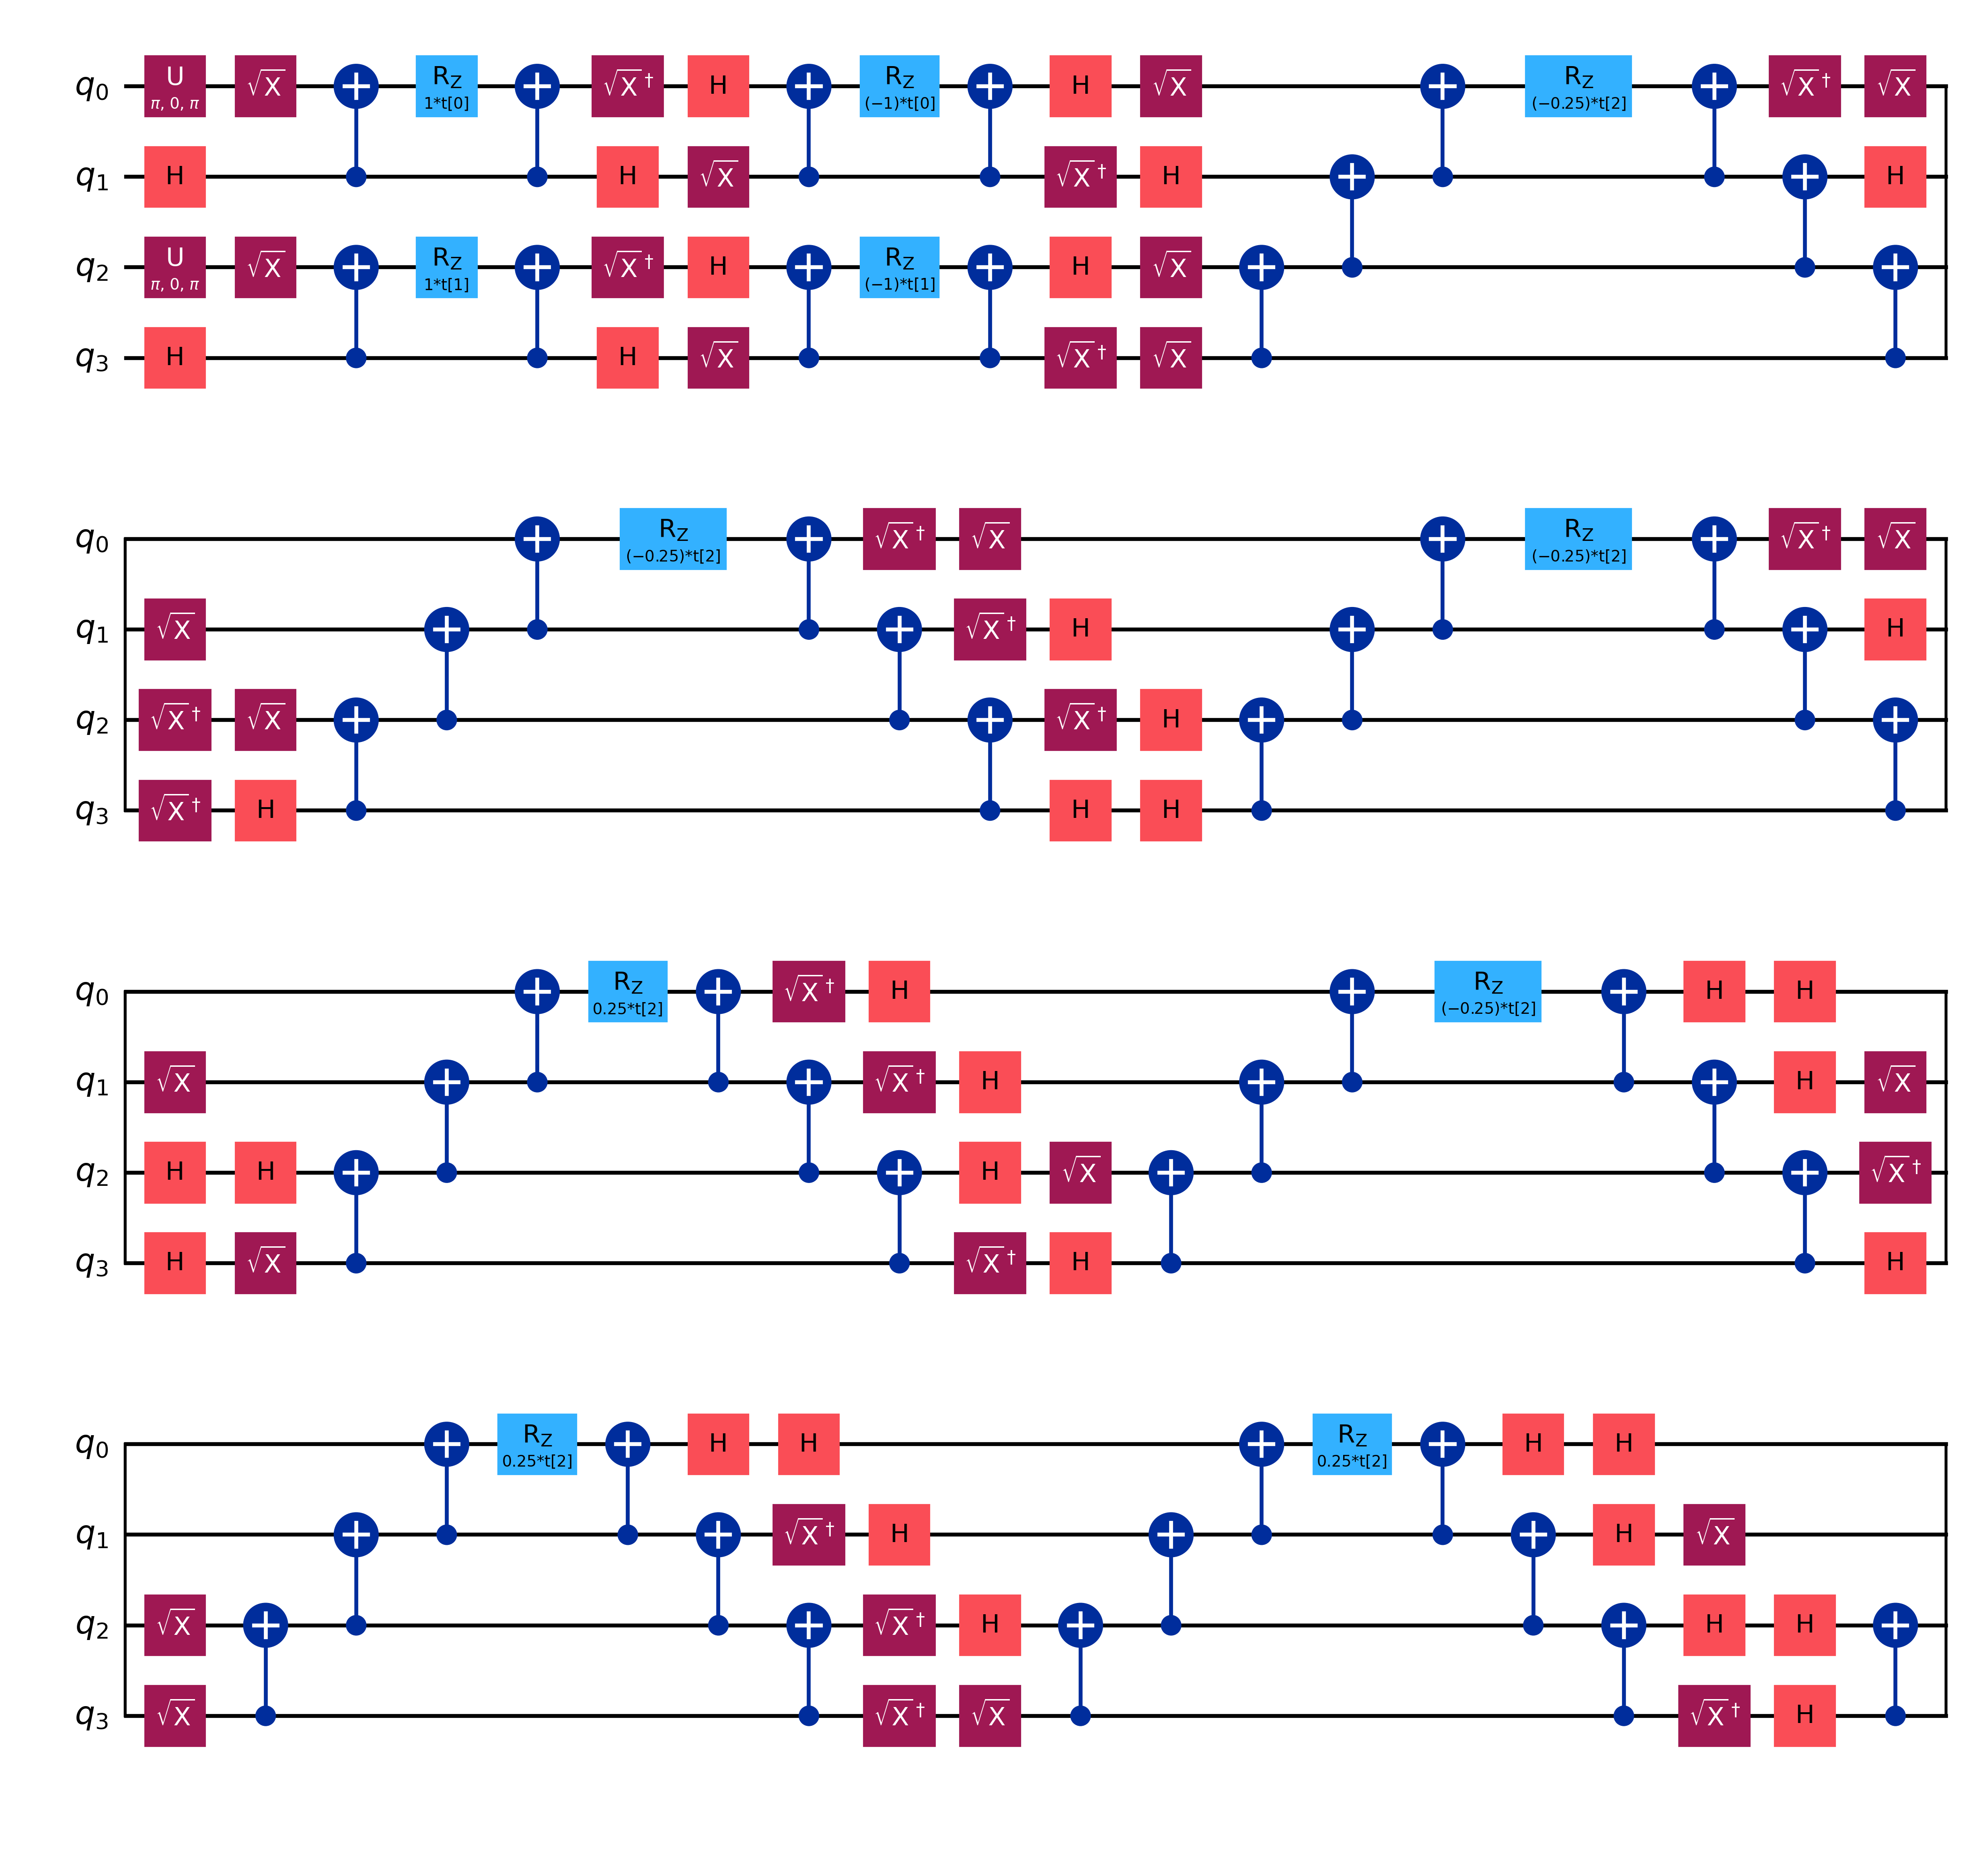
Figure 9. k-UpCCGSD, (2e,2o), decomposed — part 1 of 3 (the original image is 4200×12498 px and has been split for the page). 9 parameters in 3 layers of (2 singles + 1 double).
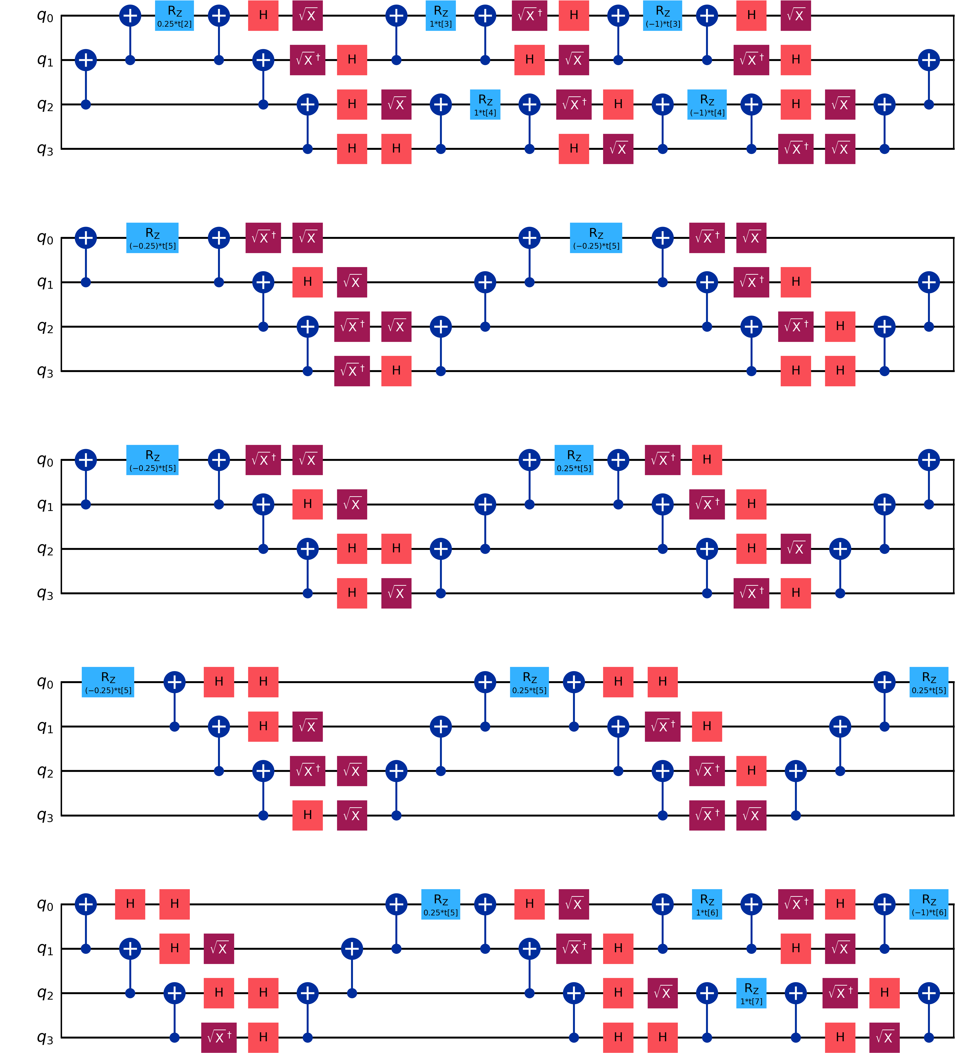
Figure 10. k-UpCCGSD, (2e,2o), decomposed — part 2 of 3 (the original image is 4200×12498 px and has been split for the page). 9 parameters in 3 layers of (2 singles + 1 double).
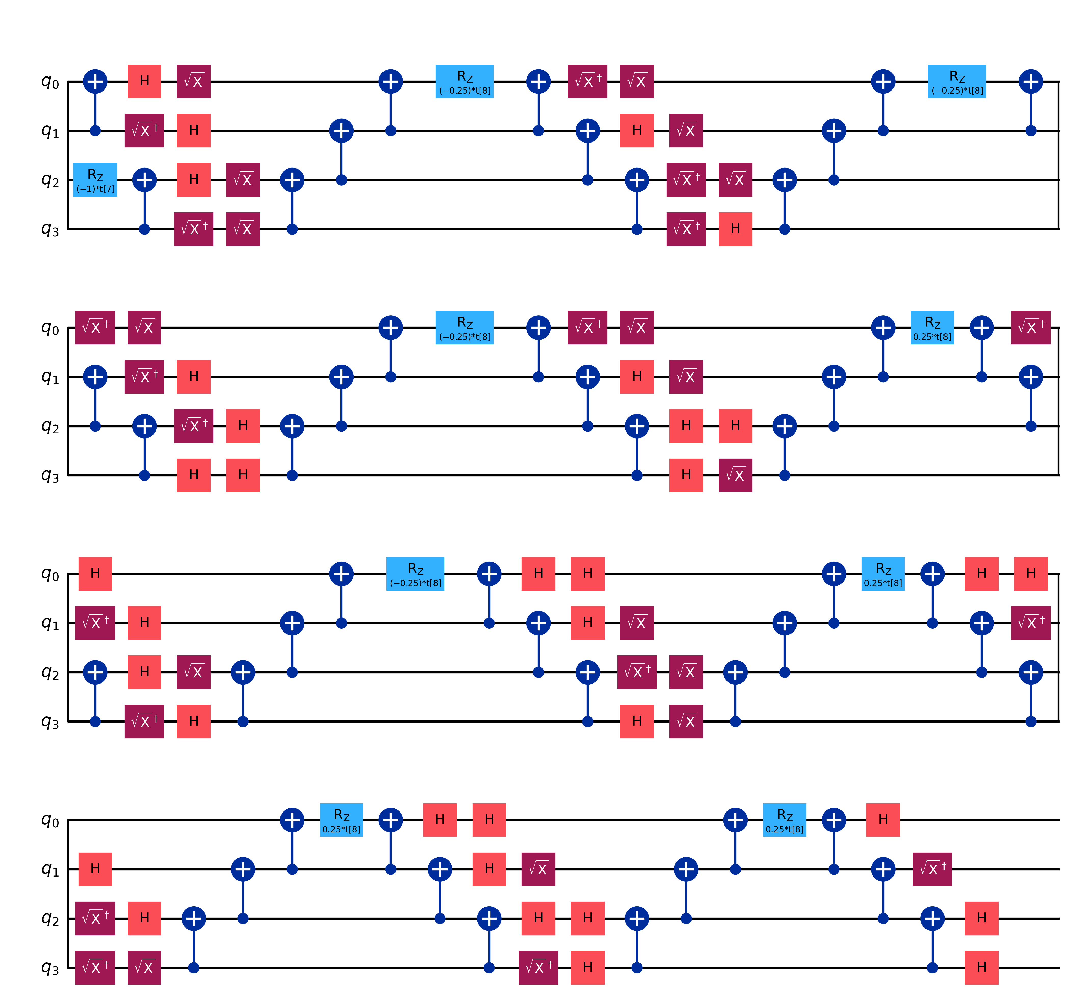
Figure 11. k-UpCCGSD, (2e,2o), decomposed — part 3 of 3 (the original image is 4200×12498 px and has been split for the page). 9 parameters in 3 layers of (2 singles + 1 double).

3.7 Circuit resource metrics
Table 12. (2e,2o) circuit metrics at optimization_level = 3. Raw and generic-backend columns: results.xlsx “Summary” sheet (GenericBackendV2(5), CX basis; raw 2Q counts include CRX). Heron columns: AUDIT_REPORT.md and the hardware jobs (CZ basis).
Ansatz | Params | Raw depth | Raw 2Q | Generic-5Q depth | Generic-5Q 2Q | Heron (FakeFez / ibm_fez) depth | Heron CZ
DexcG | 1 | 73 | 48 | 85 | 42 | 144 | 42
PCU2 | 14 | 35 | 24 | 66 | 18 | 56 | 18
UCCSD | 3 | 83 | 56 | 94 | 49 | 157 | 49
k-UpCCGSD | 9 | 247 | 168 | 274 | 145 | 455 | 145

Table 13. Heron (FakeFez) transpilation of the UCC-family circuits across active spaces (AUDIT_REPORT.md).
Active space | DexcG depth / CZ | UCCSD depth / CZ | k-UpCCGSD depth / CZ
(2e,2o) | 144 / 42 | 157 / 49 | 455 / 145
(4e,4o) | 3,997 / 1,362 | 4,091 / 1,417 | 22,299 / 7,691
(6e,6o) | 28,018 / 9,589 | 28,338 / 9,789 | 183,061 / 62,597

Why different documents quote different depths. The repository has at least three sets of numbers (e.g. DexcG depth 111, 85 or 144). They come from different targets (a 5-qubit generic backend with CX, or the 156-qubit Heron with CZ). Level-3 transpilation is also stochastic (layout and routing trials) and no seed_transpiler was fixed. The two-qubit counts are stable (42/18/49/145); the depths are not. We recommend fixing seed_transpiler in future runs. The hardware numbers (144/42 and 56/18) are the ones that actually ran on ibm_fez.
Parameter binding before transpiling. For UCCSD bound at θ = 0, every Pauli rotation becomes the identity and the transpiler removes it. The workbook’s “Parameter Binding” test records DexcG going from depth 144 / 42 CZ (symbolic) to depth 1 / 0 CZ (bound at 0). This explains the first hardware job (Section 5.2).

4. Computational Benchmarking — the 64-Run Grid

4.1 Experimental design
Table 14. Factorial design: 4 × 4 × 4 = 64 configurations per active space.
Factor | Levels | Details
Ansatz (4) | DexcG, PCU2, UCCSD, k-UpCCGSD | Section 3; circuits pre-decomposed once per run to avoid repeated synthesis
Initialization (4) | zero, half, one, random | θ₀ = 0 (HF); 0.5·1; 1.0·1; U(0,1) from np.random.RandomState(42)
Optimizer (4) | GD, ADAM, SPSA, QNSPSA | hyper-parameters below
Iterations | 50 (2e,2o) · 25 (4e,4o) · 15 (6e,6o) | maxiter per run
Estimator | Aer EstimatorV2 (fallback StatevectorEstimator) | noiseless, exact expectation values
Sampler (QNSPSA) | StatevectorSampler | fidelity for the quantum metric
Seed | 42 (benchmark), 123 (LR sweep), 42/123/456/789/1000 (robustness) | algorithm_globals.random_seed + np.random.seed

Table 15. Optimizers (src/optimizers.py). $d$ = number of parameters, $T$ = iterations. The evaluation formulas reproduce the recorded counts exactly (e.g. UCCSD GD: 1 + 50·7 = 351; PCU2: 1 + 50·29 = 1,451; SPSA at T = 50/25/15: 153/78/48).
Optimizer | Update rule | Hyper-parameters | Energy evaluations
GD | $$θ_{t+1}=θ_{t}-η∇E$$ | η = 0.05, momentum 0 | $$1+T(2d+1)$$
ADAM | $$θ_{t+1}=θ_{t}-η{\hat{m}}_{t}/(\sqrt{{\hat{v}}_{t}}+ϵ)$$ | η = 0.05, β₁ = 0.9, β₂ = 0.999, ε = 10⁻⁸ | $$1+T(2d+1)$$
SPSA | $\hat{g}=\frac{E(θ+cΔ)-E(θ-cΔ)}{2c}Δ$, Δ ∈ {±1}ᵈ | a = 0.1, c = 0.1 (fixed) | ≈ 3T + 3 (independent of d)
QNSPSA | SPSA preconditioned by Fubini–Study metric estimate | a = 0.1, c = 0.1 | ≈ 3T + 29 (+ fidelity circuits)

4.2 The exact finite-difference gradient and why the parameter-shift rule failed
The standard two-term parameter-shift rule, $∂_{θ}E=[E(θ+π/2)-E(θ-π/2)]/2$, is exact only for gates $e^{-iθP/2}$ whose generator has eigenvalues ±½ (frequency 1). A UCC factor $e^{θ(τ-τ^{†})}$ rotates by the full angle θ (Section 3.1), so $E(θ)=a+bcos2θ+csin2θ$ has frequency 2 and period π. A ±π/2 shift moves by exactly one period, so $E(θ+π/2)-E(θ-π/2)≡0$ everywhere. The original code therefore returned zero gradients and GD never moved (CHANGELOG §2). The fix (compute_gradient_batched) is a vectorized central finite difference:
$$g_{i}=\frac{E(θ+ϵe_{i})-E(θ-ϵe_{i})}{2ϵ}+O(ϵ^{2}), ϵ={10}^{-5}$$ | (19)

All $2d$ shifted parameter vectors go into one primitive unified bloc (PUB) (circuit, H, [θ+εe₁, θ−εe₁, …]), so each gradient is a single Estimator call. Truncation error is $O(ϵ^{2})≈{10}^{-10}$. Round-off error is about $δ_{mach}|E|/ϵ≈2×{10}^{-16}·640/{10}^{-5}≈{10}^{-8}$ Ha/rad. That round-off sets the ~10⁻¹⁰ mHa floor seen in the UCCSD convergence curves. VERIF-07 confirms the batched and single-point gradients agree to 0.0. (For reference, a correct shift rule does exist for frequency 2: $∂_{θ}E=E(θ+π/4)-E(θ-π/4)$.)
The cost bottleneck
Every GD/ADAM iteration costs $2d+1$ circuit evaluations, so the cost grows linearly with the parameter count and multiplies with circuit depth:
- (2e,2o): 3–29 evaluations per step; k-UpCCGSD GD 951 evaluations in 38 s.
- (4e,4o): k-UpCCGSD has 150 parameters, i.e. 301 evaluations per step and 7,526 per run, with measured wall times of 361–582 s (about 0.05 s per evaluation).
- (6e,6o): k-UpCCGSD has 855 parameters, i.e. $2·855+1=1,711$ evaluations per step and 85,551 for 50 steps. The circuit is 183,061 deep with 62,597 CZ. Even UCCSD at 12 qubits took about 1.0 s per evaluation (48.9 s for 48 SPSA evaluations). k-UpCCGSD with gradient methods would need more than 24 CPU-hours per run, plus the cost of binding 855 parameters into a 60k-gate circuit on every evaluation.
Hence scripts/run_active_space_benchmarks.py hard-skips k-UpCCGSD at (6e,6o) (“to prevent parameter-binding deadlock”) and restricts (6e,6o) to SPSA, whose cost is about 3 evaluations per iteration regardless of d (--exhaustive-6e6o would add GD/ADAM). The (6e,6o) study therefore has 3 ansätze × 4 initializations × SPSA = 12 runs of 15 iterations, run strictly serially with tqdm progress output.

4.3 Learning-rate selection
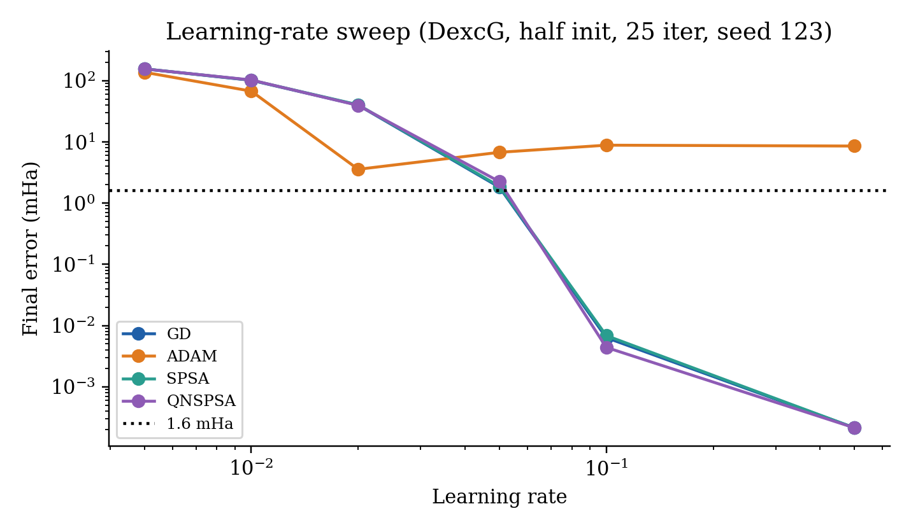
Figure 12. Learning-rate sweep (data/lr_sweep_results.json): DexcG from the half initialization, 25 iterations, seed 123, six rates per optimizer (24 runs).
The sweep shows GD, SPSA and QNSPSA all improve steadily up to η = 0.5 (0.00021 mHa, the DexcG limit). ADAM is best at η = 0.02 (3.55 mHa) and gets worse at larger η. The production grid nevertheless used η = 0.05 for GD and ADAM and 0.1 for SPSA/QNSPSA. For GD, 0.05 was not the sweep optimum (1.81 mHa after 25 iterations in the sweep). The results below are therefore conservative for GD. The full sweep table is in Appendix F.

4.4 Results on the (2e,2o) production space (4 qubits, 50 iterations)
Table 16. Tie-ranked leaderboard: primary key error (mHa), secondary key total evaluations, tertiary key wall time. Identical to the results.xlsx “Summary” sheet. Ranks 1–4 differ only by floating-point noise at the 10⁻¹⁰ mHa level, and ranks 6–10 all sit on the DexcG limit.
Rank | Ansatz | Init | Opt. | d | Final energy (Ha) | Error (mHa) | % Corr | Evals | Time (s)
1 | UCCSD | random | GD | 3 | -639.72428323 | 1.14e-10 | 100.00% | 351 | 6.10
2 | UCCSD | zero | GD | 3 | -639.72428323 | 1.14e-10 | 100.00% | 351 | 6.65
3 | UCCSD | one | GD | 3 | -639.72428323 | 2.27e-10 | 100.00% | 351 | 6.96
4 | UCCSD | half | GD | 3 | -639.72428323 | 3.41e-10 | 100.00% | 351 | 6.33
5 | k-UpCCGSD | zero | GD | 9 | -639.72428321 | 2.04e-05 | 99.95% | 951 | 38.08
6 | DexcG | zero | QNSPSA | 1 | -639.72428301 | 2.13e-04 | 99.48% | 179 | 4.97
7 | DexcG | half | GD | 1 | -639.72428301 | 2.13e-04 | 99.48% | 151 | 1.34
8 | DexcG | zero | GD | 1 | -639.72428301 | 2.13e-04 | 99.48% | 151 | 1.27
9 | DexcG | zero | SPSA | 1 | -639.72428301 | 2.13e-04 | 99.48% | 153 | 1.26
10 | DexcG | random | GD | 1 | -639.72428301 | 2.13e-04 | 99.48% | 151 | 1.32

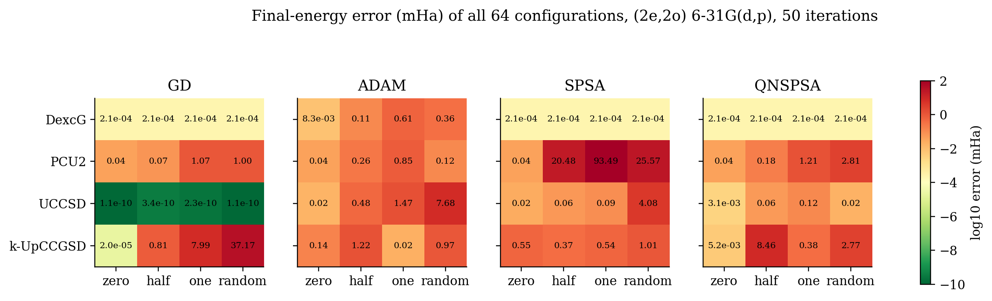
Figure 13. Final-energy error of every configuration in the (2e,2o) grid (colour = log₁₀ mHa; green is better). The full numeric table is in Appendix B.
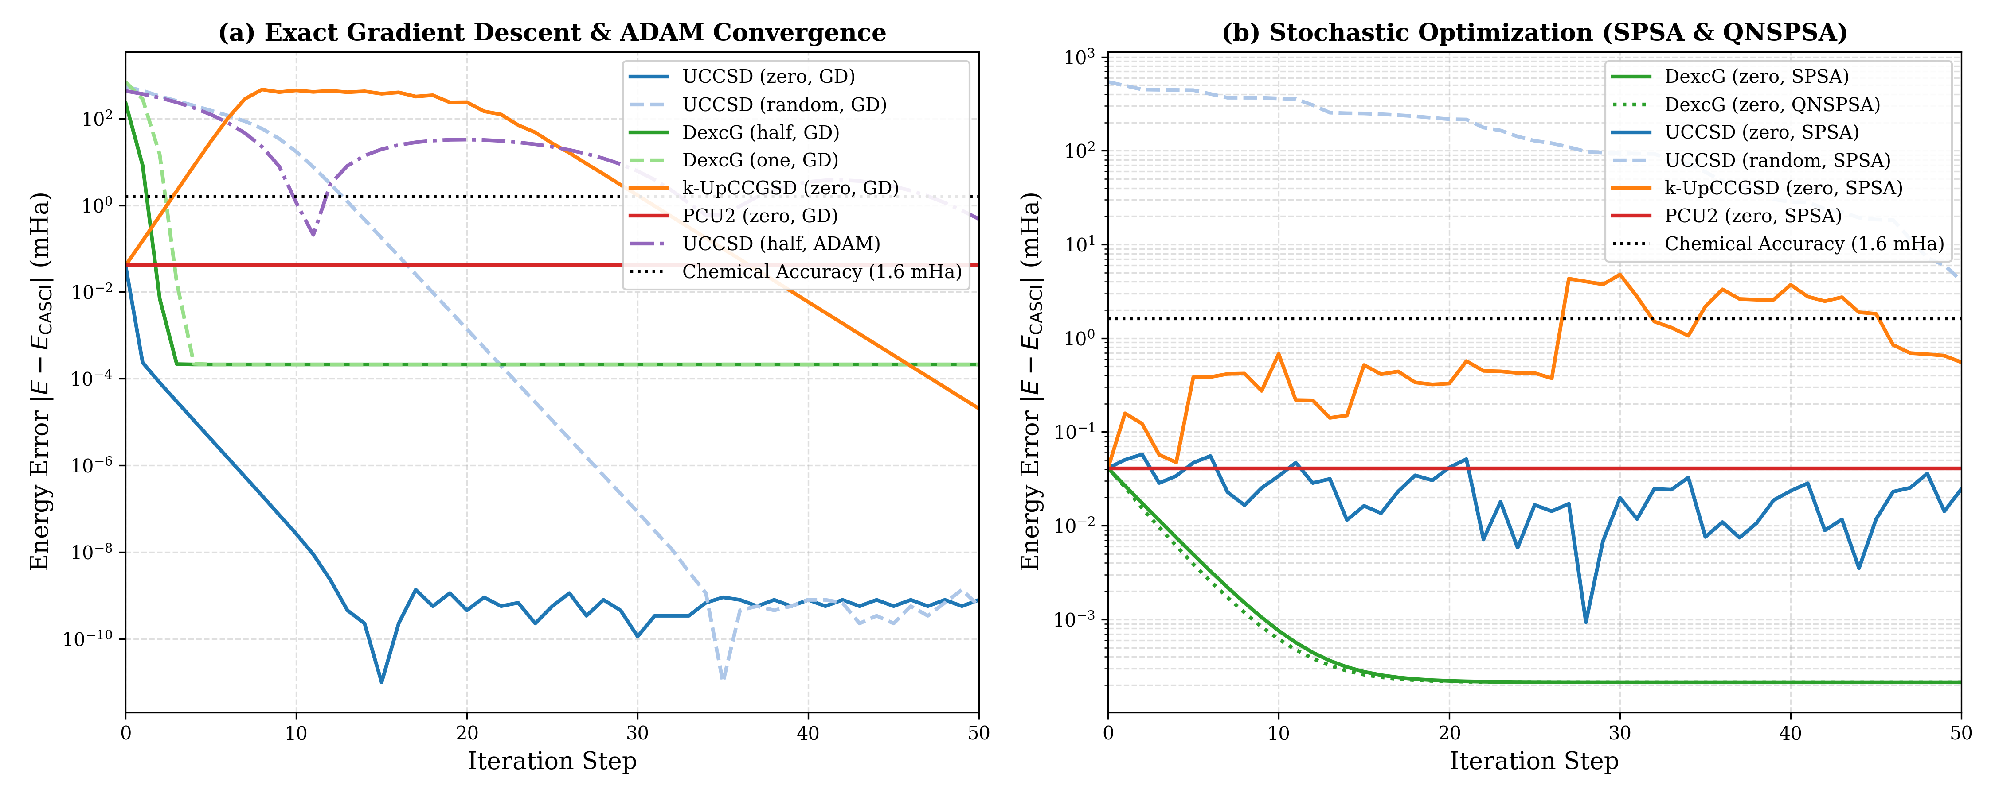
Figure 14. Energy-error convergence (log scale) for representative configurations (repository figure). (a) GD/ADAM: UCCSD·zero falls to the 10⁻¹⁰ mHa round-off floor within about 15 iterations, DexcG settles on its 2.1×10⁻⁴ mHa plateau, PCU2·zero stays flat at the HF value, and k-UpCCGSD·zero first overshoots and then converges. (b) SPSA/QNSPSA: DexcG converges smoothly; UCCSD·zero·SPSA moves around at the 10⁻² mHa level because of its fixed 0.1 perturbation.
Table 17. Optimizer summary for (2e,2o).
Optimizer | Mean error (mHa) | Min error (mHa) | Mean evals | Mean time (s) | < 1.6 mHa | < 1.0 mHa
GD | 3.009 | 1.14e-10 | 726 | 12.62 | 14/16 | 12/16
ADAM | 0.898 | 0.0083 | 726 | 12.38 | 15/16 | 13/16
SPSA | 9.145 | 2.13e-04 | 153 | 2.96 | 12/16 | 11/16
QNSPSA | 1.004 | 2.13e-04 | 179 | 11.59 | 13/16 | 12/16

Table 18. Summary by ansatz and by initialization for (2e,2o). Overall: 54/64 within 1.6 mHa, 48/64 within 1.0 mHa.
Group | Params | Mean error (mHa) | Min error (mHa) | Chem. acc.
DexcG | 1 | 0.068 | 2.13e-04 | 16/16
PCU2 | 14 | 9.204 | 0.0409 | 12/16
UCCSD | 3 | 0.882 | 1.14e-10 | 14/16
k-UpCCGSD | 9 | 3.900 | 2.04e-05 | 12/16
init = zero | — | 0.057 | 1.14e-10 | 16/16
init = half | — | 2.035 | 3.41e-10 | 14/16
init = one | — | 6.740 | 2.27e-10 | 14/16
init = random | — | 5.222 | 1.14e-10 | 10/16

Interpretation
- UCCSD + GD is exact from every initialization. Three parameters span the full 4-dimensional $N=2,S_{z}=0$ space (a singlet from HF, D and the open-shell combination), so the global minimum equals CASCI. GD finds a minimum from all four starts. The optimized parameters differ (e.g. one → (1.494, 1.494, 1.566)) because the landscape is periodic and has several equivalent minima.
- DexcG sits on its analytic limit. 16/16 runs are within chemical accuracy. The plateau at 2.133×10⁻⁴ mHa (99.48%) is the value derived in Section 3.1. It is the cheapest accurate choice: 151 evaluations in about 1.3 s.
- ADAM stalls near the minimum. Its normalized step $η\hat{m}/\sqrt{\hat{v}}$ keeps a magnitude of about η = 0.05 even when the gradient is tiny, while the DexcG minimum is only 0.0065 rad from zero. DexcG·zero·ADAM therefore oscillates and ends at 8.3×10⁻³ mHa (79.7%).
- PCU2·zero never moves (exact stationary point, Section 3.2). All four optimizers return exactly $E_{ref}$ (error 0.0409 mHa = $E_{corr}$, 0.00%). From other starts, PCU2 leaks out of the N = 2 sector and several runs end far above HF (e.g. one·SPSA: 93.5 mHa).
- Initialization dominates. Zero initialization gives 16/16 within chemical accuracy with a mean error of 0.057 mHa. Random gives only 10/16 (mean 5.2 mHa), because 0.5–1.0 rad displacements put the state in regions with much higher energy and many local minima.
- Negative % correlation (e.g. k-UpCCGSD·random·GD, −90,710%) means the run ended tens of mHa above HF. Percentages are large because the denominator is only 0.041 mHa.
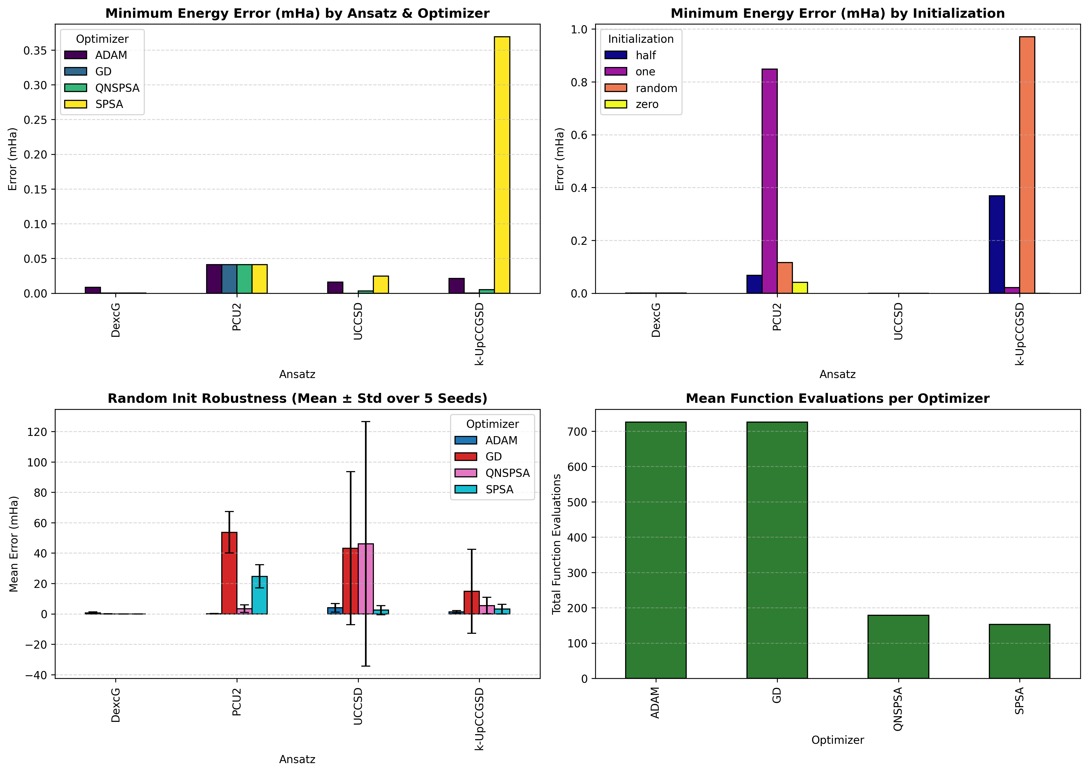
Figure 15. Repository overview figure: minimum error by ansatz and optimizer, by initialization, 5-seed robustness (mean ± std) and mean evaluation counts per optimizer.

4.5 Random-initialization robustness (5 seeds)
Table 19. Robustness over seeds 42, 123, 456, 789, 1000 (random init, 50 iterations; data/robustness_results.json, 80 runs). Note: the robustness table in README.md is out of date and does not match this file.
Ansatz | Optimizer | Mean (mHa) | Std (mHa) | Min (mHa) | Max (mHa)
DexcG | GD | 0.0119 | 0.0097 | 0.0025 | 0.0258
DexcG | ADAM | 0.6940 | 0.6593 | 0.0016 | 1.74
DexcG | SPSA | 2.13e-04 | 1.30e-07 | 2.13e-04 | 2.14e-04
DexcG | QNSPSA | 2.13e-04 | 1.11e-07 | 2.13e-04 | 2.14e-04
PCU2 | GD | 53.71 | 13.66 | 40.52 | 78.60
PCU2 | ADAM | 0.1682 | 0.0617 | 0.1163 | 0.2667
PCU2 | SPSA | 24.69 | 7.58 | 12.62 | 36.11
PCU2 | QNSPSA | 3.41 | 2.48 | 0.0711 | 7.80
UCCSD | GD | 43.22 | 50.31 | 0.8386 | 115.54
UCCSD | ADAM | 4.02 | 2.85 | 0.9122 | 7.68
UCCSD | SPSA | 2.44 | 2.96 | 0.0293 | 7.52
UCCSD | QNSPSA | 46.11 | 80.51 | 0.0025 | 206.54
k-UpCCGSD | GD | 14.85 | 27.70 | 0.0626 | 70.21
k-UpCCGSD | ADAM | 1.27 | 0.8454 | 0.5060 | 2.92
k-UpCCGSD | SPSA | 3.16 | 3.19 | 0.3855 | 7.94
k-UpCCGSD | QNSPSA | 5.50 | 5.35 | 0.2633 | 13.57

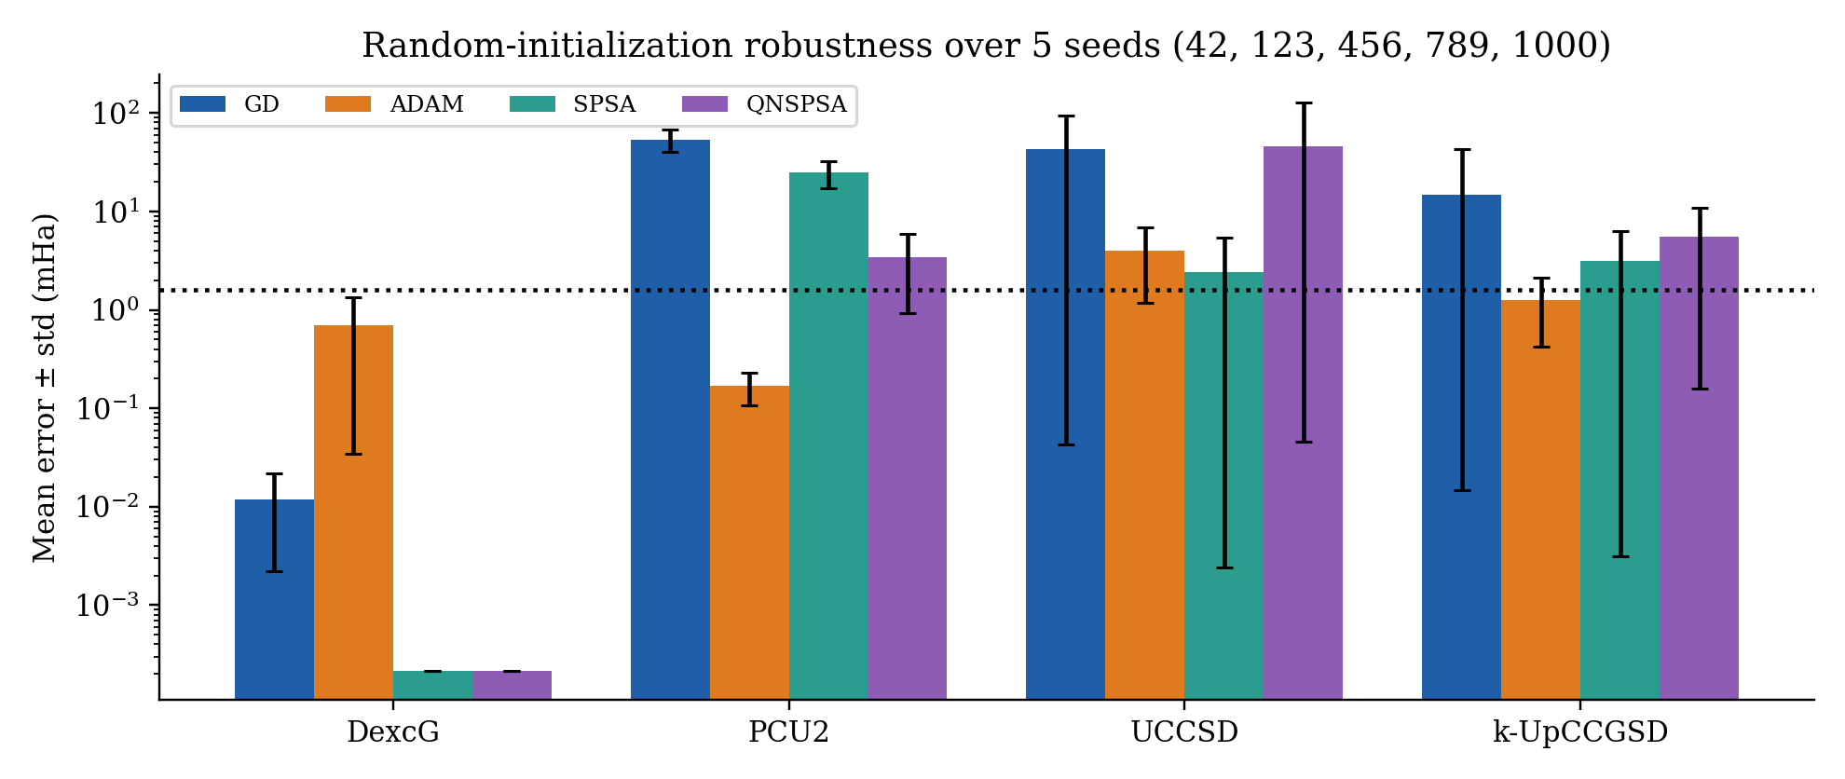
Figure 16. Mean ± standard deviation of the final error over 5 random seeds (log scale). Only DexcG with SPSA/QNSPSA/GD is robust to the random start. UCCSD·GD, which was exact with seed 42, has a mean of 43 mHa here: 50 GD steps at η = 0.05 do not always get back from a random start.

4.6 Scaling to (4e,4o): 8 qubits, 25 iterations
Table 20. (4e,4o) leaderboard, top 12 of 64. $E_{CASCI}=-639.72453605$ Ha, $E_{corr}=0.29375$ mHa. 14/64 runs are within chemical accuracy, and 13 of those 14 use zero initialization; 4 of the 14 are PCU2·zero runs stuck exactly at HF. Full table in Appendix C.
Rank | Ansatz | Init | Opt. | d | Error (mHa) | % Corr | Evals | Time (s)
1 | UCCSD | zero | GD | 26 | 0.0048 | 98.37% | 1326 | 22.8
2 | DexcG | zero | GD | 18 | 0.0064 | 97.83% | 926 | 24.6
3 | k-UpCCGSD | zero | GD | 150 | 0.0352 | 88.00% | 7526 | 392.6
4 | DexcG | zero | QNSPSA | 18 | 0.1944 | 33.84% | 104 | 36.2
5 | UCCSD | zero | QNSPSA | 26 | 0.2539 | 13.58% | 104 | 24.1
6 | k-UpCCGSD | zero | QNSPSA | 150 | 0.2695 | 8.24% | 104 | 204.8
7 | PCU2 | zero | SPSA | 30 | 0.2938 | -0.00% | 78 | 6.6
8 | PCU2 | zero | QNSPSA | 30 | 0.2938 | -0.00% | 104 | 10.7
9 | PCU2 | zero | GD | 30 | 0.2938 | -0.00% | 1526 | 23.9
10 | PCU2 | zero | ADAM | 30 | 0.2938 | -0.00% | 1526 | 32.0
11 | DexcG | zero | ADAM | 18 | 0.8578 | -192.03% | 926 | 23.5
12 | UCCSD | zero | ADAM | 26 | 1.20 | -307.56% | 1326 | 22.9

Only gradient descent from the HF point actually recovers correlation: UCCSD 98.37% (0.0048 mHa, 1,326 evaluations, 22.8 s), DexcG 97.83%, k-UpCCGSD 88.0% (7,526 evaluations, 393 s). Every non-zero initialization fails for every ansatz, often by hundreds of mHa. Most DexcG runs from half/one/random land 700–795 mHa above CASCI. With 18–150 parameters, a displacement of 0.5–1 rad per parameter puts the state in a different electronic configuration, and 25 iterations are not enough to return.

4.7 Scaling to (6e,6o): 12 qubits, SPSA only, 15 iterations
Table 21. All 12 (6e,6o) runs (benchmark_results_6-31gd_p_6e6o.json). $E_{CASCI}=-639.72562598$ Ha, $E_{corr}=1.38368$ mHa. k-UpCCGSD was not run.
Ansatz | Init | d | Final energy (Ha) | Error (mHa) | % Corr | Evals | Time (s)
PCU2 | zero | 46 | -639.72424230 | 1.38 | -0.0% | 48 | 4.6
PCU2 | random | 46 | -639.51036946 | 215.26 | -15456.8% | 48 | 5.4
PCU2 | half | 46 | -639.50025022 | 225.38 | -16188.2% | 48 | 5.3
UCCSD | zero | 117 | -639.23639111 | 489.23 | -35257.5% | 48 | 48.9
DexcG | zero | 99 | -639.22629650 | 499.33 | -35987.1% | 48 | 49.6
PCU2 | one | 46 | -638.98010095 | 745.53 | -53779.9% | 48 | 5.3
UCCSD | one | 117 | -638.76400114 | 961.62 | -69397.7% | 48 | 48.8
UCCSD | half | 117 | -638.69949584 | 1026.13 | -74059.6% | 48 | 46.8
UCCSD | random | 117 | -638.55788391 | 1167.74 | -84294.0% | 48 | 47.5
DexcG | half | 99 | -638.27585356 | 1449.77 | -104676.7% | 48 | 47.2
DexcG | one | 99 | -638.12967011 | 1595.96 | -115241.5% | 48 | 50.6
DexcG | random | 99 | -638.12761333 | 1598.01 | -115390.1% | 48 | 45.6

The only run within 1.6 mHa is PCU2·zero, and it is exactly the HF energy (1.3837 mHa = $E_{corr}$, 0% correlation), i.e. the stationary point of Section 3.2. All UCC runs diverge, including UCCSD·zero (489 mHa). The reason is SPSA’s fixed perturbation: each step moves every one of the $d$ parameters by ±c = ±0.1 at once, a displacement of norm $0.1\sqrt{d}≈1.1$ rad for d = 117. That is far outside the narrow basin around HF, whose minimum is only about 10⁻² rad away. The optimizer does not recover in 15 iterations. With the settings used, 12-qubit VQE on this system gives no useful correlation energy. Making it work would need a calibrated or decaying SPSA schedule (c ≪ 0.1), more iterations, or an adjoint gradient.
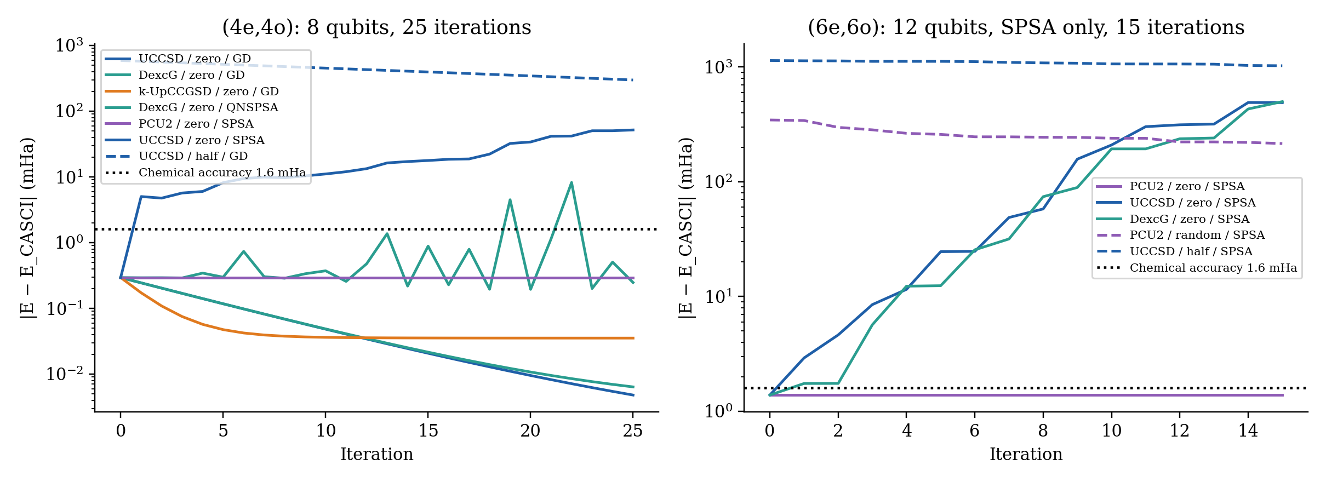
Figure 17. Convergence at 8 and 12 qubits (error vs. iteration, log scale; solid = zero init, dashed = other). (a) Only the zero-initialized GD runs fall well below the 1.6 mHa line. (b) At 12 qubits, SPSA immediately jumps hundreds of mHa away from HF, while PCU2·zero stays at the HF value.

5. IBM Quantum Hardware Execution

5.1 Platform and access model
- Backend: ibm_fez, a 156-qubit IBM Heron r2 processor. Native ISA: CZ (two-qubit), RZ, SX, X (one-qubit), with measurement. The FakeFez snapshot in qiskit_ibm_runtime.fake_provider was used for dry runs and noisy Aer simulation.
- Access: IBM Quantum Open Plan through QiskitRuntimeService (channel ibm_quantum_platform; the token is read from .env via IBM_QUANTUM_TOKEN/QISKIT_IBM_TOKEN, see src/config.py). The Open Plan allows job mode only (no sessions) and a limited QPU-time budget. The repository tracks a 600 s budget in data/qpu_ledger.json.
- Primitive: Qiskit Runtime EstimatorV2(mode=backend). It takes PUBs of (ISA circuit, ISA observable, parameter array) and returns expectation values evs and standard errors stds for every parameter set.

5.2 Complete job log
Table 22. Every IBM Quantum job in the repository. Budget: 100.35 s used, 499.65 s remaining. data/hardware_run.json now holds Job 3; the per-point energies of Job 2 survive in AUDIT_REPORT.md and README.md.
Field | Job 1 | Job 2 | Job 3
Job ID | daor3p5r85ps73ffmvn0 | daqkle3t55cs738rsfrg | daqph1uekp0c73ar40l0
Ledger timestamp (UTC) | 2026-09-24 15:58:59 | 2026-09-24 16:08:37 | 2026-09-24 21:40:23
Launcher | src/hardware.py (single point) | earlier run_live_hardware_job.py --submit | scripts/run_live_hardware_job.py (Phase 6)
Ansatz / points | UCCSD, θ = 0, 1 point | DexcG, θ ∈ {−0.10,…,+0.10}, 5 points | PCU2, θ₀ ∈ {−0.10,…,+0.10}, others 0, 5 points
Transpiled depth / CZ | 1 / 0 (collapsed) | 144 / 42 (181 gates: 71 RZ, 68 SX, 42 CZ) | 56 / 18
Shots | 4,096 | 4,096 per point (20,480) | 4,096 per point (20,480)
Resilience level | not set (runtime default) | not recorded | 0
QPU time billed | 30.35 s | 20.0 s | 50.0 s
Wall time | 30.35 s (wait+exec) | 77.18 s | 65.92 s
Best energy (Ha) | −639.72364609 | −639.59691169 (θ = +0.05) | −639.69642295 (θ₀ = +0.05)
Error | 0.6371 mHa vs CASCI | 127.37 mHa vs CASCI | 27.82 mHa vs ideal (27.86 vs CASCI)
Record | CHANGELOG §4, ledger | AUDIT_REPORT Phase 6, README, ledger | hardware_crosscheck.json, hardware_run.json, xlsx

Correction to the earlier draft prompt
The earlier draft attributed “0.637 mHa, depth 144, 42 CZ, 20 s” to job daqkle3t55cs738rsfrg. That combines two different jobs. The 0.637 mHa result is Job 1 (daor3p5r85ps73ffmvn0). UCCSD was bound at θ = 0 before transpilation, so every entangling gate cancelled and only the X gates preparing |0101⟩ plus measurement remained (depth 1, 0 CZ, 30.35 s). It is a readout/SPAM noise floor (0.60 mHa above $E_{ref}$), not a VQE circuit. Job 2 (daqkle3t55cs738rsfrg) is the 42-CZ, depth-144 DexcG sweep, 20.0 s, with a best-point error of 127.37 mHa.

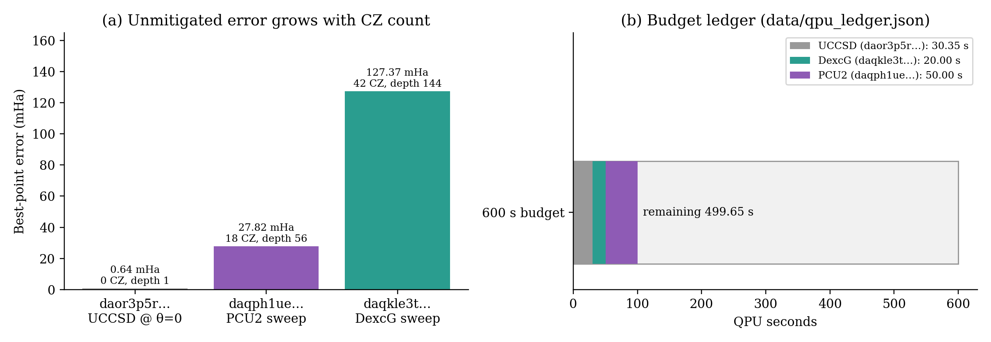
Figure 18. (a) Best-point unmitigated error of each job against its CZ count: 0.64 → 27.8 → 127.4 mHa. (b) QPU-seconds consumed from the 600 s budget.

5.3 Pre-hardware noisy simulation (DexcG dry run on FakeFez)
Table 23. The dry-run noise model (AUDIT_REPORT Phase 6) predicted 31–54 mHa errors. The real device gave 127–138 mHa, about 3× worse. The calibration snapshot underestimates noise on the qubits actually used.
θ (rad) | −0.10 | −0.05 | 0.00 | +0.05 | +0.10
FakeFez Aer energy (Ha) | −639.6699 | −639.6934 | −639.6898 | −639.6803 | −639.6759
Error vs CASCI (mHa) | 54.34 | 30.92 | 34.52 | 44.03 | 48.42
ibm_fez (Job 2) energy (Ha) | −639.58606039 | −639.59354271 | −639.59675784 | −639.59691169 | −639.58595898
ibm_fez error vs CASCI (mHa) | 138.22 | 130.74 | 127.53 | 127.37 | 138.32

5.4 The Phase 6 hardware script (scripts/run_live_hardware_job.py)
1. Load the Hamiltonian: 6-31G(d,p) (2e,2o), 4 qubits, 27 Pauli terms. Print $E_{ref}$, CASCI and $E_{corr}$.
2. Select the backend: --backend override, or service.least_busy(operational=True, simulator=False, min_num_qubits=4). With --dry-run, FakeFez is used instead.
3. Pick the cheapest circuit: PCU2 and DexcG are both transpiled with generate_preset_pass_manager(backend=backend, optimization_level=3) into the Heron ISA (CZ/RZ/SX/X, native coupling map, noise-aware layout). The candidate with the smaller (depth, 2Q-count) wins, unless --ansatz forces one. Result: PCU2 (56/18) was chosen over DexcG (144/42).
4. Build the landscape and ideal reference: for PCU2, θ₀ ∈ {−0.10, −0.05, 0, +0.05, +0.10} with the other 13 parameters at 0. Ideal energies come from StatevectorEstimator on the untranspiled circuit. The observable is mapped to the physical layout with H.apply_layout(isa_circuit.layout).
5. Strict pre-submission approval gate: prints backend, ansatz, parameters, points, depth, 2Q count, shots, total shots, mode and estimated QPU time. Hard abort if the 2Q count > `MAX_2Q_GATE_LIMIT = 60` (sys.exit(1)), so deep circuits can never spend budget. The current script then asks for interactive confirmation with input("Proceed with hardware submission? (y/n)"). (The --yes flag mentioned in the earlier draft and the --submit flag in AUDIT_REPORT belong to earlier versions and are not in the current file.)
6. Execute: EstimatorV2(mode=backend) with options.resilience_level = 0 and options.default_shots = 4096. One PUB (isa_circuit, isa_observable, points) broadcasts all 5 parameter sets in a single job.
7. Collect: evs, stds, job.metrics()['usage']['quantum_seconds'] and wall time. Write data/hardware_crosscheck.json.
Why these choices. Two-qubit gates dominate error on superconducting hardware (CZ error ~10⁻³, plus the idling decoherence they cause), so the CZ cap is the most direct guard on result quality. ISA transpilation is required: Qiskit Runtime V2 primitives reject circuits that are not already in the backend’s native gates and connectivity. resilience_level = 0 switches off TREX readout mitigation and ZNE. That gives the raw device behaviour and the lowest QPU time, at the price of a biased energy. Job mode matches the Open Plan (no sessions). Putting all 5 points in one PUB shares queueing and compilation overhead.

5.5 Hardware landscape analysis — did the device reproduce the curvature?
The earlier draft’s figure (figures/hardware_landscape_comparison.png) overlaid the PCU2 points on the ideal PCU2 curve and described it as “preserving parabolic curvature”. The ideal PCU2 curve along θ₀ is flat, so that claim cannot hold. We therefore analyse both sweeps separately against their correct ideal curves.

(a) DexcG sweep, Job 2 — the real test of curvature
Table 24. DexcG sweep. Ideal energies computed for this report from the exact rotation formula (Section 3.1), which reproduces the benchmark DexcG minimum to 10⁻¹¹ Ha. ΔE is measured from the θ = 0 point.
θ (rad) | Ideal E(θ) (Ha) | QPU E(θ) (Ha) | Offset (mHa) | Ideal ΔE (mHa) | QPU ΔE (mHa)
-0.10 | -639.71576007 | -639.58606039 | 129.70 | +8.48 | +10.70
-0.05 | -639.72243202 | -639.59354271 | 128.89 | +1.81 | +3.22
+0.00 | -639.72424230 | -639.59675784 | 127.48 | +0.00 | +0.00
+0.05 | -639.72117281 | -639.59691169 | 124.26 | +3.07 | -0.15
+0.10 | -639.71325423 | -639.58595898 | 127.30 | +10.99 | +10.80

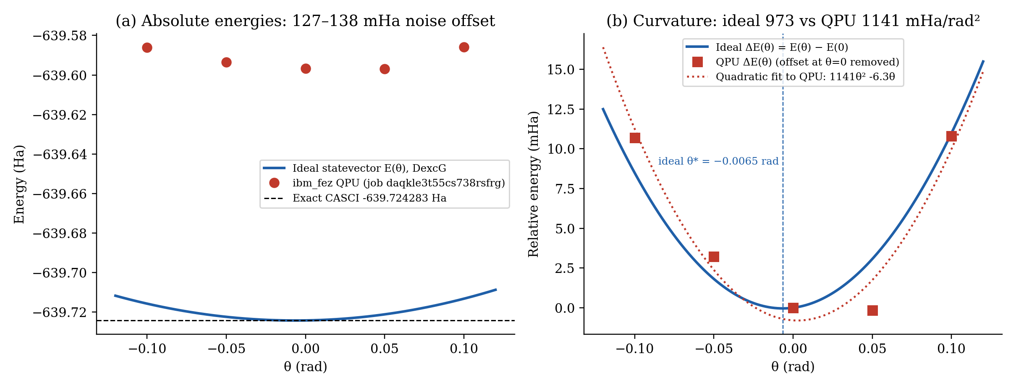
Figure 19. Ideal DexcG energy curve against the ibm_fez measurements (Job 2). (a) Absolute scale: a 124–130 mHa noise offset. (b) Offset removed: the QPU points follow the ideal parabola. A quadratic fit gives curvature 1141 mHa/rad² against 973 mHa/rad² ideal.
- Curvature: reproduced. Both edge points rise by about 10.7–10.8 mHa (ideal +8.5 / +11.0 mHa). The fitted quadratic coefficient is 1141 mHa/rad² against 973 mHa/rad² ideal (+17%). This is the $(E_{D}-E_{HF})\sin^{2}θ$ term, i.e. the device reproduces the HF↔D rotation that DexcG implements, through 42 CZ gates.
- Minimum location: not resolved. The ideal minimum is at θ* = −0.0065 rad and is only 0.041 mHa deep, set by the small linear term $2Kθ$ (±0.63 mHa at θ = ±0.05). The QPU fit puts its vertex at +0.0028 rad, and the lowest measured point is +0.05 rad, on the other side. Over ±0.05 the ideal asymmetry is 1.3 mHa, which is below the ~1.6 mHa per-point shot noise expected at 4,096 shots (Job 3 measured σ ≈ 1.6 mHa; Job 2 standard errors were not stored).
- Offset: large and nearly constant. 124–130 mHa (about 3 mHa per CZ) that varies by about 5 mHa across points. Depolarizing noise pulls the state towards the maximally mixed state, whose energy is the identity coefficient −639.218 Ha, about 506 mHa above CASCI. An upward shift is therefore expected. A 25% depolarized fraction would explain the observed offset.

(b) PCU2 sweep, Job 3 — a pure noise measurement
Table 25. Job 3 (data/hardware_crosscheck.json). The ideal energy is the same at every point: θ₀ is an RZ on qubit 0, which is |1⟩ in HF, so it only adds a global phase.
Point | Ideal (Ha) | QPU (Ha) | Error vs ideal (mHa) | σ (mHa)
theta_0 = -0.100 (displaced) | -639.72424230 | -639.69341138 | 30.8309 | 1.638
theta_0 = -0.050 (displaced) | -639.72424230 | -639.69519729 | 29.0450 | 1.622
theta_0 = +0.000 (HF Ref, zeros) | -639.72424230 | -639.69395500 | 30.2873 | 1.608
theta_0 = +0.050 (displaced) | -639.72424230 | -639.69642295 | 27.8193 | 1.599
theta_0 = +0.100 (displaced) | -639.72424230 | -639.69274835 | 31.4939 | 1.635

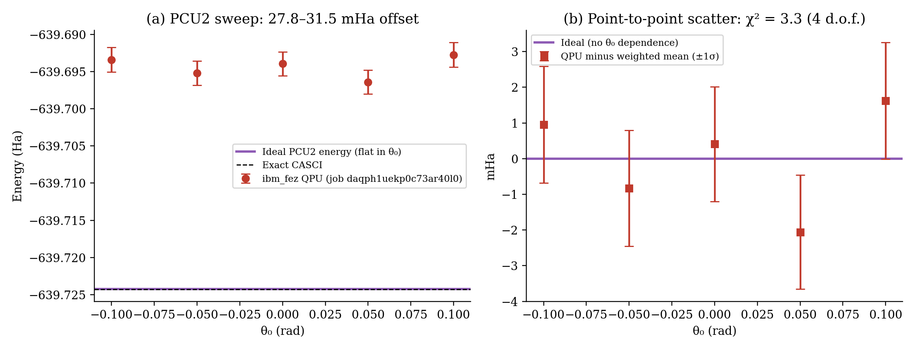
Figure 20. PCU2 sweep on ibm_fez (Job 3). (a) Flat ideal line against the QPU points with ±1σ bars. (b) Residuals about the inverse-variance-weighted mean (-639.694366 Ha): χ² = 3.3 for 4 degrees of freedom (p ≈ 0.5). The point-to-point variation is fully explained by shot noise.
- There is no curvature to reproduce. The measured variation (27.8–31.5 mHa) is statistical, so the “minimum at +0.05 rad” in the earlier draft is a shot-noise fluctuation and not a physical minimum.
- The run is still useful: it measures the noise offset of an 18-CZ circuit, 29.9 mHa on average. That is 4.4× smaller than the 42-CZ DexcG offset (132.4 mHa mean vs CASCI). Error grows with entangling-gate count, but not linearly (≈ 1.7 mHa/CZ for PCU2 vs ≈ 3.2 mHa/CZ for DexcG). Layout, one-qubit gates, idle time and readout also contribute.
- The error bars (σ ≈ 1.6 mHa per point) are set by 4,096 shots over 27 Pauli terms grouped into commuting measurement bases. Halving σ would require 4× the shots.
Answer to the landscape question
Yes, for the sweep where it could be tested: the DexcG sweep on ibm_fez reproduces the theoretical curvature of the energy landscape to within about 17%, despite a 124–130 mHa unmitigated offset. It does not resolve the location of the true minimum (−0.0065 rad), which requires sub-mHa precision. The PCU2 sweep cannot test curvature because its ideal landscape is flat. It measures the device noise floor for an 18-CZ circuit (~30 mHa).

6. Verification, Reproducibility and Software Environment

6.1 Automated test suite
Table 26. pytest suite: 20 tests passed (AUDIT_REPORT.md, 24.8 s).
Test module | Tests | What is checked
test_ansatze.py | 4 | parameter counts; θ = 0 reproduces $E_{ref}$ (RHF and B3LYP)
test_b3lyp_active_space.py | 1 | B3LYP active-space VQE; DFT total energy kept separate
test_conservation.py | 4 | ⟨N⟩ = 2, ⟨S_z⟩ = 0 after 20 GD steps from zero init (all ansätze)
test_geometry.py | 2 | 26 atoms, planarity, B–N bond length
test_gradients.py | 2 | batched FD = independent FD; monotone GD descent (DexcG)
test_hamiltonian.py | 2 | exact diagonalization = CASCI for STO-3G and 6-31G(d,p)
test_pyscf_reference.py | 2 | RHF and CASCI reference values
test_reproducibility.py | 1 | identical seeds give identical energies (< 10⁻¹⁰ Ha)
test_uccsd_basis.py | 2 | UCCSD basis invariance; analytic parameter counts; θ = 0 = $E_{ref}$

Table 27. The 17-check verification suite (results.xlsx “Verification” sheet). *For PCU2 the check passes only because the optimization starts at the stationary point θ = 0 (Section 3.2).
Check | Description | Value | Status
VERIF-01A/B | STO-3G RHF / CASCI | −631.74167448 / −631.74178346 Ha | PASS
VERIF-02A/B | 6-31G(d,p) RHF / CASCI | −639.72424230 / −639.72428323 Ha | PASS
VERIF-03 | ⟨HF|H|HF⟩ statevector | −639.72424230 Ha | PASS
VERIF-04 | Diagonalization in N = 2, S_z = 0 sector | −639.72428323 Ha | PASS
VERIF-05 (×4) | Parameter counts 1/14/3/9 and θ = 0 energy | −639.72424230 Ha | PASS
VERIF-06 (×4) | N and S_z of optimized state | N = 2.0000, S_z = 0.0000 | PASS*
VERIF-07 | Batched vs independent FD gradient (UCCSD) | max diff 0.0 | PASS
VERIF-08 | Seed reproducibility (SPSA) | ΔE = 0.0 Ha | PASS
VERIF-09 | Mean B–N bond length | 1.4400 Å (tol. 0.05) | PASS

6.2 Software environment
Table 28. Pinned environment (requirements.txt, results.xlsx “Config”).
Package | Version | Role
Python | 3.13.12 (per workbook) | Windows host
qiskit | 2.3.1 | circuits, transpiler, V2 primitives
qiskit-nature | 0.8.0 | ElectronicEnergy, JordanWignerMapper, UCC, HartreeFock
qiskit-algorithms | 0.4.0 | SPSA, QNSPSA, gradients
qiskit-aer | 0.17.2 | EstimatorV2 (benchmark), noisy FakeFez simulation
qiskit-ibm-runtime | 0.45.1 | QiskitRuntimeService, EstimatorV2, FakeFez
PySCF | 2.14.0 (WSL Ubuntu) | RHF, B3LYP, CASCI, integrals (no native Windows wheels)
numpy / scipy / pandas | 2.4.3 / 1.17.1 / 3.0.1 | numerics and tables
matplotlib / openpyxl / pytest | 3.10.8 / 3.1.5 / 9.1.1 | figures, results.xlsx, tests

6.3 Independent cross-checks performed for this report
To make sure the numbers in this document are right, the following were recomputed independently from the cached integrals (a separate Jordan–Wigner implementation in NumPy). No repository file was modified.
- Pauli-term counts 27 / 361 / 1,819 for (2e,2o) / (4e,4o) / (6e,6o) match results.xlsx. The earlier draft’s 15 / 185 / 1,089 were wrong.
- Exact ground energies of the mapped Hamiltonians match the stored CASCI values to 10⁻⁸ Ha for STO-3G, 6-31G(d,p), B3LYP and (4e,4o).
- The DexcG optimum (θ* = −0.00646 rad, 2.1334×10⁻⁴ mHa above CASCI) matches the benchmark (−0.006418 rad, 2.1333×10⁻⁴ mHa).
- Brillouin: $f_{01}$ and $2K$ reproduce the recorded singles and doubles gradients in both bases.
- A simulation of the PCU2 circuit reproduces the benchmark’s iteration-0 energies to 10⁻¹² Ha. This confirms the stationary point at θ = 0 and the particle-number leakage for θ ≠ 0.

6.4 How to reproduce
wsl python3 src/compute_pyscf.py # regenerate the 5 integral caches (PySCF)
python run_benchmark.py # (2e,2o) 64-run grid, LR sweep, robustness, figures, Excel
python scripts/run_active_space_benchmarks.py # (4e,4o) grid and (6e,6o) SPSA study, rebuild results.xlsx
python scripts/run_live_hardware_job.py --dry-run # transpile + approval gate on FakeFez
python scripts/run_live_hardware_job.py --backend ibm_fez # live job (asks y/n)
pytest -v tests/

7. Conclusions and Recommendations
Table 29. Recommended pipelines, by use case.
Use case | Ansatz | Optimizer | Init | Result
Exact answer, noiseless simulator (4 q) | UCCSD | GD (FD gradients, η = 0.05) | zero | 1.1×10⁻¹⁰ mHa, 100%, 351 evals, 6.6 s
Cheapest chemically accurate (4 q) | DexcG | GD | zero | 2.1×10⁻⁴ mHa, 99.48%, 151 evals, 1.3 s
Extended space (8 q) | UCCSD | GD | zero | 0.0048 mHa, 98.37%, 1,326 evals, 22.8 s
Physical QPU, lowest noise floor | PCU2 circuit | — (fixed points) | zero | ~30 mHa offset with 18 CZ
Physical QPU, physically meaningful landscape | DexcG | SPSA-type (shot-noise robust) | zero | curvature reproduced within 17%, 127 mHa offset

1. The optimal pipeline for this molecule is UCCSD + zero (Hartree–Fock) initialization + gradient descent with exact finite-difference gradients. It reaches the exact CASCI energy at 4 qubits and recovers 98% of the correlation at 8 qubits. Tie-break rank 1 went to the random initialization only because of a 0.5 s wall-time difference; zero initialization is the robust choice (Section 4.5).
2. Doubles dominate because of Brillouin’s theorem. DexcG recovers 99.5% of the (2e,2o) correlation with one parameter and has a closed-form optimum. It is the best choice when circuit cost matters, and its landscape is the one the hardware reproduced.
3. The system is weakly correlated in every active space studied ($E_{corr}≤1.38$ mHa < 1.6 mHa). Chemical-accuracy counts therefore reward staying near HF. % correlation recovered is the more meaningful metric.
4. PCU2 as implemented should be fixed before further use: it breaks particle-number conservation and is stuck at θ = 0. A true number-conserving block (e.g. Givens rotations $G(θ)$ on the {|01⟩,|10⟩} subspace, or the full U2 of Barkoutsos et al.) and a small symmetry-breaking initial offset would address both problems.
5. Finite differences do not transfer to hardware. With σ ≈ 1.6 mHa per energy estimate and ε = 10⁻⁵, the FD gradient noise would be about σ/(√2 ε) ≈ 110 Ha/rad. On a QPU, use the frequency-2 shift rule ($E(θ+π/4)-E(θ-π/4)$) or SPSA.
6. Next steps for hardware: readout mitigation (TREX, resilience_level = 1) to remove the ~0.6 mHa floor; ZNE or PEC (resilience_level = 2) to reduce the 30–130 mHa offsets; a fixed seed_transpiler; recording stds for every job; and spending the remaining 499.65 s on a denser DexcG sweep (e.g. 9 points in ±0.1 rad).
7. Next steps for chemistry: CASSCF orbital optimization and larger or better-chosen active spaces (e.g. π-only spaces) where $E_{corr}$ exceeds chemical accuracy, so VQE has something substantial to recover. Qubit tapering (parity mapping with $N$ and $S_{z}$ symmetries) saves 2 qubits per space.

Limitations
- Single fixed geometry; no geometry optimization and no dissociation curve.
- Wall times were measured on one Windows workstation and are only comparable within this study.
- Only one repetition per hardware configuration; Job 2 per-point standard errors were not saved.
- The hardware PCU2 sweep direction (θ₀) cannot change the ideal energy; a different parameter direction should have been chosen.
- The (6e,6o) study used only SPSA with an uncalibrated schedule, and k-UpCCGSD was skipped there.

Appendix A. Molecular Geometry (Å)
Table 30. Cartesian coordinates from GEOMETRY_STR.
# | Element | x | y | z
0 | B | -3.38352416 | 3.02033458 | 0.0
1 | N | -4.65065508 | 2.33624451 | 0.0
2 | N | -2.15751932 | 2.26501205 | 0.0
3 | B | -4.69178116 | 0.89683190 | 0.0
4 | B | -2.19864540 | 0.82559945 | 0.0
5 | H | -3.34953803 | 4.20984917 | 0.0
6 | H | -5.51056126 | 2.86601934 | 0.0
7 | H | -1.26876777 | 2.74482523 | 0.0
8 | N | -3.46577632 | 0.14150937 | 0.0
9 | B | -3.50690239 | -1.29790323 | 0.0
10 | B | -6.00003816 | -1.22667078 | 0.0
11 | N | -5.95891208 | 0.21274183 | 0.0
12 | N | -4.77403331 | -1.98199331 | 0.0
13 | N | -0.97264055 | 0.07027692 | 0.0
14 | N | -2.28089755 | -2.05322576 | 0.0
15 | B | -1.01376663 | -1.36913568 | 0.0
16 | H | -6.81881825 | 0.74251666 | 0.0
17 | H | -7.04718107 | -1.79199522 | 0.0
18 | H | 0.07450236 | 0.63560136 | 0.0
19 | H | -0.00060985 | -1.99332583 | 0.0
20 | B | -4.81515939 | -3.42140591 | 0.0
21 | B | -2.32202362 | -3.49263836 | 0.0
22 | N | -3.58915454 | -4.17672844 | 0.0
23 | H | -3.61799991 | -5.18631645 | 0.0
24 | H | -5.86230230 | -3.98673035 | 0.0
25 | H | -1.30886684 | -4.11682851 | 0.0

Appendix B. All 64 Configurations — (2e,2o), 6-31G(d,p)
Table 31. Complete (2e,2o) grid in Config_ID order (50 iterations; $E_{CASCI}=-639.72428323$ Ha).
ID | Ansatz | Init | Opt. | Final E (Ha) | Best E (Ha) | Err (mHa) | % Corr | Evals | t (s)
1 | DexcG | zero | GD | -639.72428301 | -639.72428301 | 2.13e-04 | 99.48 | 151 | 1.27
2 | DexcG | zero | ADAM | -639.72427492 | -639.72428298 | 0.0083 | 79.71 | 151 | 1.27
3 | DexcG | zero | SPSA | -639.72428301 | -639.72428301 | 2.13e-04 | 99.48 | 153 | 1.26
4 | DexcG | zero | QNSPSA | -639.72428301 | -639.72428301 | 2.13e-04 | 99.48 | 179 | 4.97
5 | DexcG | half | GD | -639.72428301 | -639.72428301 | 2.13e-04 | 99.48 | 151 | 1.34
6 | DexcG | half | ADAM | -639.72417077 | -639.72428282 | 0.1125 | -174.75 | 151 | 1.43
7 | DexcG | half | SPSA | -639.72428301 | -639.72428301 | 2.13e-04 | 99.48 | 153 | 1.60
8 | DexcG | half | QNSPSA | -639.72428301 | -639.72428301 | 2.14e-04 | 99.48 | 179 | 5.08
9 | DexcG | one | GD | -639.72428301 | -639.72428301 | 2.13e-04 | 99.48 | 151 | 1.32
10 | DexcG | one | ADAM | -639.72367340 | -639.72428163 | 0.6098 | -1389.91 | 151 | 1.33
11 | DexcG | one | SPSA | -639.72428301 | -639.72428301 | 2.15e-04 | 99.48 | 153 | 1.63
12 | DexcG | one | QNSPSA | -639.72428301 | -639.72428301 | 2.15e-04 | 99.48 | 179 | 5.69
13 | DexcG | random | GD | -639.72428301 | -639.72428301 | 2.13e-04 | 99.48 | 151 | 1.32
14 | DexcG | random | ADAM | -639.72392294 | -639.72427770 | 0.3603 | -780.25 | 151 | 1.01
15 | DexcG | random | SPSA | -639.72428301 | -639.72428301 | 2.13e-04 | 99.48 | 153 | 1.50
16 | DexcG | random | QNSPSA | -639.72428301 | -639.72428301 | 2.13e-04 | 99.48 | 179 | 4.94
17 | PCU2 | zero | GD | -639.72424230 | -639.72424230 | 0.0409 | -0.00 | 1451 | 2.64
18 | PCU2 | zero | ADAM | -639.72424230 | -639.72424230 | 0.0409 | -0.00 | 1451 | 2.60
19 | PCU2 | zero | SPSA | -639.72424230 | -639.72424230 | 0.0409 | -0.00 | 153 | 0.55
20 | PCU2 | zero | QNSPSA | -639.72424230 | -639.72424230 | 0.0409 | -0.00 | 179 | 3.16
21 | PCU2 | half | GD | -639.72421593 | -639.72421593 | 0.0673 | -64.41 | 1451 | 3.00
22 | PCU2 | half | ADAM | -639.72402578 | -639.72423510 | 0.2574 | -528.99 | 1451 | 2.58
23 | PCU2 | half | SPSA | -639.70380017 | -639.70380017 | 20.48 | -49943.33 | 153 | 0.49
24 | PCU2 | half | QNSPSA | -639.72409944 | -639.72409944 | 0.1838 | -349.03 | 179 | 3.59
25 | PCU2 | one | GD | -639.72321326 | -639.72321326 | 1.07 | -2514.11 | 1451 | 3.77
26 | PCU2 | one | ADAM | -639.72343489 | -639.72420967 | 0.8483 | -1972.61 | 1451 | 3.87
27 | PCU2 | one | SPSA | -639.63079327 | -639.63079327 | 93.49 | -228310.65 | 153 | 0.86
28 | PCU2 | one | QNSPSA | -639.72306888 | -639.72306888 | 1.21 | -2866.83 | 179 | 3.61
29 | PCU2 | random | GD | -639.72328182 | -639.72328182 | 1.00 | -2346.59 | 1451 | 3.46
30 | PCU2 | random | ADAM | -639.72416692 | -639.72421029 | 0.1163 | -184.16 | 1451 | 3.89
31 | PCU2 | random | SPSA | -639.69871601 | -639.69871601 | 25.57 | -62364.73 | 153 | 1.05
32 | PCU2 | random | QNSPSA | -639.72147509 | -639.72147509 | 2.81 | -6760.71 | 179 | 3.35
33 | UCCSD | zero | GD | -639.72428323 | -639.72428323 | 1.14e-10 | 100.00 | 351 | 6.65
34 | UCCSD | zero | ADAM | -639.72426709 | -639.72428236 | 0.0161 | 60.57 | 351 | 7.33
35 | UCCSD | zero | SPSA | -639.72425858 | -639.72428229 | 0.0246 | 39.79 | 153 | 2.78
36 | UCCSD | zero | QNSPSA | -639.72428016 | -639.72428016 | 0.0031 | 92.51 | 179 | 13.20
37 | UCCSD | half | GD | -639.72428323 | -639.72428323 | 3.41e-10 | 100.00 | 351 | 6.33
38 | UCCSD | half | ADAM | -639.72380260 | -639.72407583 | 0.4806 | -1074.24 | 351 | 6.57
39 | UCCSD | half | SPSA | -639.72421833 | -639.72422927 | 0.0649 | -58.56 | 153 | 2.68
40 | UCCSD | half | QNSPSA | -639.72422710 | -639.72422710 | 0.0561 | -37.13 | 179 | 10.70
41 | UCCSD | one | GD | -639.72428323 | -639.72428323 | 2.27e-10 | 100.00 | 351 | 6.96
42 | UCCSD | one | ADAM | -639.72281478 | -639.72418943 | 1.47 | -3487.64 | 351 | 6.00
43 | UCCSD | one | SPSA | -639.72419147 | -639.72420155 | 0.0918 | -124.18 | 153 | 4.24
44 | UCCSD | one | QNSPSA | -639.72416289 | -639.72416289 | 0.1203 | -194.01 | 179 | 11.27
45 | UCCSD | random | GD | -639.72428323 | -639.72428323 | 1.14e-10 | 100.00 | 351 | 6.10
46 | UCCSD | random | ADAM | -639.71659859 | -639.71734983 | 7.68 | -18674.77 | 351 | 5.60
47 | UCCSD | random | SPSA | -639.72020096 | -639.72020096 | 4.08 | -9873.61 | 153 | 3.39
48 | UCCSD | random | QNSPSA | -639.72426434 | -639.72426434 | 0.0189 | 53.86 | 179 | 12.24
49 | k-UpCCGSD | zero | GD | -639.72428321 | -639.72428321 | 2.04e-05 | 99.95 | 951 | 38.08
50 | k-UpCCGSD | zero | ADAM | -639.72414008 | -639.72428303 | 0.1431 | -249.73 | 951 | 36.49
51 | k-UpCCGSD | zero | SPSA | -639.72373043 | -639.72424230 | 0.5528 | -1250.57 | 153 | 5.61
52 | k-UpCCGSD | zero | QNSPSA | -639.72427803 | -639.72427803 | 0.0052 | 87.31 | 179 | 24.12
53 | k-UpCCGSD | half | GD | -639.72347661 | -639.72347661 | 0.8066 | -1870.68 | 951 | 39.55
54 | k-UpCCGSD | half | ADAM | -639.72306094 | -639.72427619 | 1.22 | -2886.25 | 951 | 39.87
55 | k-UpCCGSD | half | SPSA | -639.72391423 | -639.72413725 | 0.3690 | -801.52 | 153 | 6.85
56 | k-UpCCGSD | half | QNSPSA | -639.71582378 | -639.71582378 | 8.46 | -20567.75 | 179 | 27.46
57 | k-UpCCGSD | one | GD | -639.71629467 | -639.71629467 | 7.99 | -19417.29 | 951 | 40.74
58 | k-UpCCGSD | one | ADAM | -639.72426206 | -639.72428221 | 0.0212 | 48.27 | 951 | 40.91
59 | k-UpCCGSD | one | SPSA | -639.72374334 | -639.72421620 | 0.5399 | -1219.02 | 153 | 6.53
60 | k-UpCCGSD | one | QNSPSA | -639.72390164 | -639.72390164 | 0.3816 | -832.27 | 179 | 26.65
61 | k-UpCCGSD | random | GD | -639.68711391 | -639.68801086 | 37.17 | -90710.47 | 951 | 39.40
62 | k-UpCCGSD | random | ADAM | -639.72331286 | -639.72392227 | 0.9704 | -2270.76 | 951 | 37.32
63 | k-UpCCGSD | random | SPSA | -639.72327486 | -639.72327486 | 1.01 | -2363.61 | 153 | 6.26
64 | k-UpCCGSD | random | QNSPSA | -639.72151701 | -639.72151701 | 2.77 | -6658.30 | 179 | 25.39

Appendix C. All 64 Configurations — (4e,4o)
Table 32. Complete (4e,4o) grid (25 iterations; $E_{CASCI}=-639.72453605$ Ha).
ID | Ansatz | Init | Opt. | d | Final E (Ha) | Err (mHa) | % Corr | Evals | t (s)
1 | DexcG | zero | GD | 18 | -639.72452968 | 0.0064 | 97.8 | 926 | 24.6
2 | DexcG | zero | ADAM | 18 | -639.72367820 | 0.8578 | -192.0 | 926 | 23.5
3 | DexcG | zero | SPSA | 18 | -639.72333274 | 1.20 | -309.6 | 78 | 9.8
4 | DexcG | zero | QNSPSA | 18 | -639.72434169 | 0.1944 | 33.8 | 104 | 36.2
5 | DexcG | half | GD | 18 | -638.95305152 | 771.48 | -262530.8 | 926 | 28.6
6 | DexcG | half | ADAM | 18 | -639.40580301 | 318.73 | -108403.9 | 926 | 28.0
7 | DexcG | half | SPSA | 18 | -638.93896123 | 785.57 | -267327.4 | 78 | 10.8
8 | DexcG | half | QNSPSA | 18 | -638.97184156 | 752.69 | -256134.2 | 104 | 40.7
9 | DexcG | one | GD | 18 | -638.95816400 | 766.37 | -260790.4 | 926 | 25.8
10 | DexcG | one | ADAM | 18 | -638.96052488 | 764.01 | -259986.7 | 926 | 25.9
11 | DexcG | one | SPSA | 18 | -638.96357611 | 760.96 | -258948.0 | 78 | 10.2
12 | DexcG | one | QNSPSA | 18 | -638.93649087 | 788.05 | -268168.4 | 104 | 41.4
13 | DexcG | random | GD | 18 | -638.93132023 | 793.22 | -269928.6 | 926 | 26.5
14 | DexcG | random | ADAM | 18 | -639.01462773 | 709.91 | -241568.8 | 926 | 27.3
15 | DexcG | random | SPSA | 18 | -638.92974584 | 794.79 | -270464.6 | 78 | 9.5
16 | DexcG | random | QNSPSA | 18 | -638.94451165 | 780.02 | -265437.9 | 104 | 38.2
17 | PCU2 | zero | GD | 30 | -639.72424230 | 0.2938 | -0.0 | 1526 | 23.9
18 | PCU2 | zero | ADAM | 30 | -639.72424230 | 0.2938 | -0.0 | 1526 | 32.0
19 | PCU2 | zero | SPSA | 30 | -639.72424230 | 0.2938 | -0.0 | 78 | 6.6
20 | PCU2 | zero | QNSPSA | 30 | -639.72424230 | 0.2938 | -0.0 | 104 | 10.7
21 | PCU2 | half | GD | 30 | -639.59484387 | 129.69 | -44050.1 | 1526 | 23.8
22 | PCU2 | half | ADAM | 30 | -639.71712425 | 7.41 | -2423.1 | 1526 | 24.9
23 | PCU2 | half | SPSA | 30 | -639.64715436 | 77.38 | -26242.5 | 78 | 6.6
24 | PCU2 | half | QNSPSA | 30 | -639.68282573 | 41.71 | -14099.1 | 104 | 10.2
25 | PCU2 | one | GD | 30 | -639.27938078 | 445.16 | -151440.9 | 1526 | 21.5
26 | PCU2 | one | ADAM | 30 | -639.72325003 | 1.29 | -337.8 | 1526 | 16.4
27 | PCU2 | one | SPSA | 30 | -639.36768613 | 356.85 | -121379.8 | 78 | 5.4
28 | PCU2 | one | QNSPSA | 30 | -639.44035412 | 284.18 | -96642.0 | 104 | 7.5
29 | PCU2 | random | GD | 30 | -639.61267246 | 111.86 | -37980.9 | 1526 | 16.2
30 | PCU2 | random | ADAM | 30 | -639.71918348 | 5.35 | -1722.1 | 1526 | 15.9
31 | PCU2 | random | SPSA | 30 | -639.65988856 | 64.65 | -21907.5 | 78 | 4.2
32 | PCU2 | random | QNSPSA | 30 | -639.67275597 | 51.78 | -17527.1 | 104 | 7.4
33 | UCCSD | zero | GD | 26 | -639.72453126 | 0.0048 | 98.4 | 1326 | 22.8
34 | UCCSD | zero | ADAM | 26 | -639.72333884 | 1.20 | -307.6 | 1326 | 22.9
35 | UCCSD | zero | SPSA | 26 | -639.67279466 | 51.74 | -17513.9 | 78 | 6.5
36 | UCCSD | zero | QNSPSA | 26 | -639.72428219 | 0.2539 | 13.6 | 104 | 24.1
37 | UCCSD | half | GD | 26 | -639.42669482 | 297.84 | -101291.9 | 1326 | 23.3
38 | UCCSD | half | ADAM | 26 | -639.72007946 | 4.46 | -1417.1 | 1326 | 24.3
39 | UCCSD | half | SPSA | 26 | -639.37322403 | 351.31 | -119494.6 | 78 | 6.6
40 | UCCSD | half | QNSPSA | 26 | -639.33748006 | 387.06 | -131662.6 | 104 | 24.4
41 | UCCSD | one | GD | 26 | -639.51831940 | 206.22 | -70100.8 | 1326 | 22.8
42 | UCCSD | one | ADAM | 26 | -639.70172887 | 22.81 | -7664.1 | 1326 | 23.4
43 | UCCSD | one | SPSA | 26 | -639.53542234 | 189.11 | -64278.6 | 78 | 7.0
44 | UCCSD | one | QNSPSA | 26 | -639.38550892 | 339.03 | -115312.5 | 104 | 24.9
45 | UCCSD | random | GD | 26 | -639.45169197 | 272.84 | -92782.3 | 1326 | 23.0
46 | UCCSD | random | ADAM | 26 | -639.69972741 | 24.81 | -8345.4 | 1326 | 22.9
47 | UCCSD | random | SPSA | 26 | -639.56112483 | 163.41 | -55528.9 | 78 | 8.1
48 | UCCSD | random | QNSPSA | 26 | -639.26071990 | 463.82 | -157793.5 | 104 | 24.9
49 | k-UpCCGSD | zero | GD | 150 | -639.72450081 | 0.0352 | 88.0 | 7526 | 392.6
50 | k-UpCCGSD | zero | ADAM | 150 | -639.71863784 | 5.90 | -1907.9 | 7526 | 581.9
51 | k-UpCCGSD | zero | SPSA | 150 | -639.17541085 | 549.13 | -186834.6 | 78 | 33.3
52 | k-UpCCGSD | zero | QNSPSA | 150 | -639.72426650 | 0.2695 | 8.2 | 104 | 204.8
53 | k-UpCCGSD | half | GD | 150 | -639.32594615 | 398.59 | -135589.0 | 7526 | 441.4
54 | k-UpCCGSD | half | ADAM | 150 | -639.71571900 | 8.82 | -2901.5 | 7526 | 382.8
55 | k-UpCCGSD | half | SPSA | 150 | -639.19955116 | 524.98 | -178616.7 | 78 | 27.5
56 | k-UpCCGSD | half | QNSPSA | 150 | -639.09555235 | 628.98 | -214020.3 | 104 | 136.8
57 | k-UpCCGSD | one | GD | 150 | -639.56944205 | 155.09 | -52697.5 | 7526 | 467.8
58 | k-UpCCGSD | one | ADAM | 150 | -639.71606420 | 8.47 | -2784.0 | 7526 | 404.0
59 | k-UpCCGSD | one | SPSA | 150 | -639.10859758 | 615.94 | -209579.4 | 78 | 19.9
60 | k-UpCCGSD | one | QNSPSA | 150 | -639.19189785 | 532.64 | -181222.1 | 104 | 131.4
61 | k-UpCCGSD | random | GD | 150 | -639.31735960 | 407.18 | -138512.1 | 7526 | 361.5
62 | k-UpCCGSD | random | ADAM | 150 | -639.70936715 | 15.17 | -5063.8 | 7526 | 409.4
63 | k-UpCCGSD | random | SPSA | 150 | -639.22945899 | 495.08 | -168435.4 | 78 | 21.6
64 | k-UpCCGSD | random | QNSPSA | 150 | -639.08338618 | 641.15 | -218161.9 | 104 | 134.5

Appendix D. Learning-Rate Sweep
Table 33. data/lr_sweep_results.json (DexcG, half init, 25 iterations, seed 123).
Optimizer | η | Final E (Ha) | Error (mHa) | Evals | Time (s)
GD | 0.005 | -639.56932898 | 154.95 | 76 | 0.94
GD | 0.01 | -639.62345194 | 100.83 | 76 | 0.98
GD | 0.02 | -639.68461162 | 39.67 | 76 | 0.90
GD | 0.05 | -639.72247293 | 1.81 | 76 | 0.76
GD | 0.1 | -639.72427690 | 0.0063 | 76 | 0.83
GD | 0.5 | -639.72428301 | 2.13e-04 | 76 | 0.53
ADAM | 0.005 | -639.58771655 | 136.57 | 76 | 0.81
ADAM | 0.01 | -639.65715306 | 67.13 | 76 | 0.85
ADAM | 0.02 | -639.72072989 | 3.55 | 76 | 0.49
ADAM | 0.05 | -639.71755332 | 6.73 | 76 | 0.49
ADAM | 0.1 | -639.71548350 | 8.80 | 76 | 0.43
ADAM | 0.5 | -639.71576284 | 8.52 | 76 | 0.44
SPSA | 0.005 | -639.56890216 | 155.38 | 78 | 0.52
SPSA | 0.01 | -639.62285419 | 101.43 | 78 | 0.53
SPSA | 0.02 | -639.68409697 | 40.19 | 78 | 0.49
SPSA | 0.05 | -639.72240712 | 1.88 | 78 | 0.48
SPSA | 0.1 | -639.72427639 | 0.0068 | 78 | 0.66
SPSA | 0.5 | -639.72428301 | 2.13e-04 | 78 | 0.58
QNSPSA | 0.005 | -639.56942829 | 154.85 | 104 | 2.81
QNSPSA | 0.01 | -639.62214601 | 102.14 | 104 | 2.62
QNSPSA | 0.02 | -639.68498911 | 39.29 | 104 | 2.43
QNSPSA | 0.05 | -639.72204931 | 2.23 | 104 | 2.59
QNSPSA | 0.1 | -639.72427884 | 0.0044 | 104 | 2.48
QNSPSA | 0.5 | -639.72428301 | 2.13e-04 | 104 | 2.43

Appendix E. Data Provenance and Corrections to Earlier Drafts
Earlier drafts (including the prompt and report text generated with another assistant) contained values that do not match the repository data. This report uses the data files. Corrected items:
Table 34. Corrections relative to earlier drafts.
Item | Earlier draft | Correct value (this report) | Evidence
Pauli terms (2e,2o)/(4e,4o)/(6e,6o) | 15 / 185 / 1,089 | 27 / 361 / 1,819 | results.xlsx; independent JW
CASCI STO-3G (2e,2o) | −627.91572914 Ha | −631.74178346 Ha | bn_dot_sto3g.json
CASCI (4e,4o) / (6e,6o) | −639.72898144 / −639.73489102 | −639.72453605 / −639.72562598 | caches
CASCI B3LYP (2e,2o) | −639.71890214 | −639.63815054 (E_corr 1.03231 mHa) | bn_dot_631gdp_b3lyp.json
STO-3G E_corr | 0.0381 mHa | 0.10897 mHa | bn_dot_sto3g.json
DexcG params at (4e,4o) | 14 | 18 | benchmark 4e4o
Full-molecule doubles (6-31G(d,p)) | 137,192,209 [(ov)² only] | 204,192,729 (αα+ββ+αβ) | src/scaling.py
Full-molecule PCU2 params | 716 / 2,192 | 718 / 2,190 | 2(Q+Q−1)
FCI size (6-31G(d,p)) | C(548,106) ≈ 4.3×10¹¹⁵ | C(274,53)² ≈ 2.9×10¹¹⁴ (S_z=0); C(548,106) ≈ 3.4×10¹¹⁵ | computed
Frozen electrons, (2e,2o) | 102 | 104 (52 inactive orbitals) | compute_pyscf.py
0.637 mHa hardware result | job daqkle…, depth 144, 42 CZ | job daor3p5r…, depth 1, 0 CZ | CHANGELOG, ledger
Approval flag | --yes | interactive input() + --dry-run | run_live_hardware_job.py
PCU2 “reproduces parabolic curvature” | claimed | ideal PCU2 curve is flat; scatter = shot noise | Section 5.5
PCU2 “particle-conserving” | claimed | not conserving for θ ≠ 0 | Section 3.2
Molecular symmetry “C2v”, HOMO/LUMO −0.2745/+0.0152 Ha | stated | not in data files; omitted | —
PySCF version | 2.7.0 | 2.14.0 | results.xlsx Config
Robustness table | README values | robustness_results.json values | data file
hardware_landscape_comparison.png | used as evidence | superseded by Figures in Section 5.5 | Section 5.5

Appendix F. Units and Glossary
- Ha (hartree) = 27.2114 eV = 627.51 kcal/mol; mHa = 10⁻³ Ha. Chemical accuracy = 1 kcal/mol = 1.594 mHa (the code uses 1.6 mHa).
- CASCI — complete-active-space configuration interaction (exact diagonalization inside the active space).
- PUB — primitive unified bloc, the (circuit, observable, parameters) input of Qiskit V2 primitives.
- ISA circuit — a circuit expressed in the target backend’s native instruction set and connectivity.
- CZ — controlled-Z, the native two-qubit gate of IBM Heron processors.
- SPAM — state-preparation and measurement error.

