Anti-White Discrimination Claims: Primary Analysis

Elisabeth R Silver

2022

## Loading required package: pacman

# Merge EEOC and Census data

Read in the EEOC data and merge with Census data (note: white_unemployment_pop.csv comes from the Python notebook Get Census Data with Unemployment.ipynb. It contains population information about race and unemployment, both in total and for white people. This isn’t generated in R since I needed to get estimates from both the data profiles and the subject tables.)

Look at the number of counties for each state:

Save the merged dataset:

# Read in merged EEOC Census data file and run analyses

Read in the dataset and get table 1:

total complaints (w retal): 5,300,971  
excluded bc retaliation: 1,257,286  
failed geocode (without retal) 24898  
0.62%  
average population of counties without any complaints: 1971.72  
range of population for counties without any complaints: 73 7525  
no complaints in county: 50  
number of counties without conservatism score: 1  
Final num. of non-retaliation complaints: 3991203  
Final num. of counties: 3091  
num complaints no retal: 3991203  
num anti-white discrimination complaints: 106375  
percent anti-white discrimination complaints no retal: 0.02665237

| **Variable** | **M (SD)** | **Range** | **1** | **2** | **3** |
| --- | --- | --- | --- | --- | --- |
| 1. Anti-white claim prevalence | 2.8 (4.5) | 0.0, 100.0 |  |  |  |
| 2. Percent POC | 22.6 (19.9) | 0.7, 96.9 | .27** |  |  |
| 3. White unemployment | 7.4 (3.2) | 0.0, 31.6 | .00 | .01 |  |
| 4. Conservatism | 0.3 (0.3) | -1.1, 0.9 | .01 | -.23** | -.01 |
| Note. N = 3,091 counties. POC indicates people of color, M indicates mean, SD indicates standard deviation. ** indicates p < .01. | | | | | |

Run the regression analyses:

##   
## Call:  
## lm(formula = sqrt_prop_white ~ acs_nonwhite_prop + mrp_ideology_mean +   
## acs_unemploy_white, data = grpd_demog_county)  
##   
## Residuals:  
## Min 1Q Median 3Q Max   
## -0.30286 -0.08518 0.00292 0.05260 0.87961   
##   
## Coefficients:  
## Estimate Std. Error t value Pr(>|t|)   
## (Intercept) 0.067887 0.005394 12.585 < 2e-16 ***  
## acs_nonwhite_prop 0.215024 0.009072 23.702 < 2e-16 ***  
## mrp_ideology_mean 0.001969 0.007123 0.276 0.78222   
## acs_unemploy_white 0.145692 0.055378 2.631 0.00856 **   
## ---  
## Signif. codes: 0 '***' 0.001 '**' 0.01 '*' 0.05 '.' 0.1 ' ' 1  
##   
## Residual standard error: 0.09753 on 3087 degrees of freedom  
## Multiple R-squared: 0.1625, Adjusted R-squared: 0.1617   
## F-statistic: 199.7 on 3 and 3087 DF, p-value: < 2.2e-16

##   
## Call:  
## lm(formula = sqrt_prop_white ~ acs_nonwhite_prop * mrp_ideology_mean +   
## acs_unemploy_white, data = grpd_demog_county)  
##   
## Residuals:  
## Min 1Q Median 3Q Max   
## -0.29799 -0.08168 0.00238 0.05153 0.87800   
##   
## Coefficients:  
## Estimate Std. Error t value Pr(>|t|)   
## (Intercept) 0.077300 0.005744 13.458 < 2e-16 ***  
## acs_nonwhite_prop 0.185199 0.011081 16.713 < 2e-16 ***  
## mrp_ideology_mean -0.040529 0.011564 -3.505 0.000463 ***  
## acs_unemploy_white 0.162349 0.055309 2.935 0.003357 **   
## acs_nonwhite_prop:mrp_ideology_mean 0.151835 0.032612 4.656 3.36e-06 ***  
## ---  
## Signif. codes: 0 '***' 0.001 '**' 0.01 '*' 0.05 '.' 0.1 ' ' 1  
##   
## Residual standard error: 0.09721 on 3086 degrees of freedom  
## Multiple R-squared: 0.1684, Adjusted R-squared: 0.1673   
## F-statistic: 156.2 on 4 and 3086 DF, p-value: < 2.2e-16

##   
## Call:  
## lm(formula = sqrt_prop_white ~ acs_nonwhite_prop * mrp_ideology_mean *   
## acs_unemploy_white, data = grpd_demog_county)  
##   
## Residuals:  
## Min 1Q Median 3Q Max   
## -0.30533 -0.08156 0.00206 0.05129 0.87646   
##   
## Coefficients:  
## Estimate Std. Error  
## (Intercept) 0.08178 0.01174  
## acs_nonwhite_prop 0.21193 0.02781  
## mrp_ideology_mean -0.04244 0.03246  
## acs_unemploy_white 0.08901 0.14935  
## acs_nonwhite_prop:mrp_ideology_mean -0.01919 0.08774  
## acs_nonwhite_prop:acs_unemploy_white -0.31097 0.33558  
## mrp_ideology_mean:acs_unemploy_white 0.02864 0.40674  
## acs_nonwhite_prop:mrp_ideology_mean:acs_unemploy_white 2.41485 1.11178  
## t value Pr(>|t|)   
## (Intercept) 6.968 3.91e-12 ***  
## acs_nonwhite_prop 7.619 3.38e-14 ***  
## mrp_ideology_mean -1.308 0.1911   
## acs_unemploy_white 0.596 0.5512   
## acs_nonwhite_prop:mrp_ideology_mean -0.219 0.8269   
## acs_nonwhite_prop:acs_unemploy_white -0.927 0.3542   
## mrp_ideology_mean:acs_unemploy_white 0.070 0.9439   
## acs_nonwhite_prop:mrp_ideology_mean:acs_unemploy_white 2.172 0.0299 *   
## ---  
## Signif. codes: 0 '***' 0.001 '**' 0.01 '*' 0.05 '.' 0.1 ' ' 1  
##   
## Residual standard error: 0.09707 on 3083 degrees of freedom  
## Multiple R-squared: 0.1714, Adjusted R-squared: 0.1695   
## F-statistic: 91.12 on 7 and 3083 DF, p-value: < 2.2e-16

## contrast   
## mrp_ideology_mean0.00596497236835691 - mrp_ideology_mean0.512500829676936  
## estimate SE df t.ratio p.value  
## -0.0769 0.0165 3086 -4.656 <.0001

## acs_unemploy_white = 0.0421:  
## contrast   
## mrp_ideology_mean0.00596497236835691 - mrp_ideology_mean0.512500829676936  
## estimate SE df t.ratio p.value  
## -0.0418 0.0241 3083 -1.732 0.0834  
##   
## acs_unemploy_white = 0.1055:  
## contrast   
## mrp_ideology_mean0.00596497236835691 - mrp_ideology_mean0.512500829676936  
## estimate SE df t.ratio p.value  
## -0.1193 0.0246 3083 -4.850 <.0001

Format and save regression outputs:

| **Predictor** | **Model 1** | | **Model 2** | | **Model 3** | |
| --- | --- | --- | --- | --- | --- | --- |
|  | *b* | *SE b* | *b* | *SE b* | *b* | *SE b* |
| Intercept | 0.07*** | 0.01 | 0.08*** | 0.01 | 0.08*** | 0.01 |
| Racial diversity | 0.22*** | 0.01 | 0.19*** | 0.01 | 0.21*** | 0.03 |
| Conservatism | 0.00 | 0.01 | -0.04*** | 0.01 | -0.04 | 0.03 |
| White unemployment | 0.15** | 0.06 | 0.16** | 0.06 | 0.09 | 0.15 |
| Racial diversity x Conservatism | - | - | 0.15*** | 0.03 | -0.02 | 0.09 |
| Racial diversity x White unemployment | - | - | - | - | -0.31 | 0.34 |
| Conservatism x White unemployment | - | - | - | - | 0.03 | 0.41 |
| Racial diversity x Conservatism x White unemployment | - | - | - | - | 2.41* | 1.11 |
| R2 | - | 0.162 | - | 0.167 | - | 0.170 |
| Change in R2 | - | - | - | 21.68*** | - | 3.80** |
| Note. N = 3,091 counties. The criterion has been square-root transformed to improve the normality of residuals. b represents the unstandardized regression weight, SE indicates standard error. * indicates p < .05. ** indicates p < .01. *** indicates p < .001 | | | | | | |

Examine the interaction:

H2: two-way between conservatism and racial diversity:

## JOHNSON-NEYMAN INTERVAL   
##   
## When mrp_ideology_mean is OUTSIDE the interval [-2.26, -0.79], the slope of  
## acs_nonwhite_prop is p < .05.  
##   
## Note: The range of observed values of mrp_ideology_mean is [-1.10, 0.92]

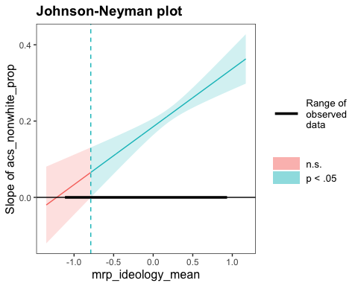

## SIMPLE SLOPES ANALYSIS   
##   
## Slope of acs_nonwhite_prop when mrp_ideology_mean = 0.005964972 (- 1 SD):   
##   
## Est. S.E. 2.5% 97.5% t val. p  
## ------ ------ ------ ------- -------- ------  
## 0.19 0.01 0.16 0.21 16.97 0.00  
##   
## Slope of acs_nonwhite_prop when mrp_ideology_mean = 0.512500830 (+ 1 SD):   
##   
## Est. S.E. 2.5% 97.5% t val. p  
## ------ ------ ------ ------- -------- ------  
## 0.26 0.01 0.24 0.29 19.18 0.00

H3 interaction between diversity, conservatism, and white unemployment:

## ████████ While acs_unemploy_white (2nd moderator) = 0.04209928 (- 1 SD) ████████   
##   
## JOHNSON-NEYMAN INTERVAL   
##   
## When mrp_ideology_mean is INSIDE the interval [-0.99, 20.22], the slope of  
## acs_nonwhite_prop is p < .05.  
##   
## Note: The range of observed values of mrp_ideology_mean is [-1.10, 0.92]  
##   
## SIMPLE SLOPES ANALYSIS   
##   
## Slope of acs_nonwhite_prop when mrp_ideology_mean = 0.005964972 (- 1 SD):   
##   
## Est. S.E. 2.5% 97.5% t val. p  
## ------ ------ ------ ------- -------- ------  
## 0.20 0.02 0.17 0.23 12.70 0.00  
##   
## Slope of acs_nonwhite_prop when mrp_ideology_mean = 0.512500830 (+ 1 SD):   
##   
## Est. S.E. 2.5% 97.5% t val. p  
## ------ ------ ------ ------- -------- ------  
## 0.24 0.02 0.21 0.28 13.85 0.00  
##   
## ████████ While acs_unemploy_white (2nd moderator) = 0.10547044 (+ 1 SD) ████████   
##   
## JOHNSON-NEYMAN INTERVAL   
##   
## When mrp_ideology_mean is OUTSIDE the interval [-1.41, -0.48], the slope of  
## acs_nonwhite_prop is p < .05.  
##   
## Note: The range of observed values of mrp_ideology_mean is [-1.10, 0.92]  
##   
## SIMPLE SLOPES ANALYSIS   
##   
## Slope of acs_nonwhite_prop when mrp_ideology_mean = 0.005964972 (- 1 SD):   
##   
## Est. S.E. 2.5% 97.5% t val. p  
## ------ ------ ------ ------- -------- ------  
## 0.18 0.01 0.15 0.21 12.28 0.00  
##   
## Slope of acs_nonwhite_prop when mrp_ideology_mean = 0.512500830 (+ 1 SD):   
##   
## Est. S.E. 2.5% 97.5% t val. p  
## ------ ------ ------ ------- -------- ------  
## 0.30 0.02 0.26 0.34 14.88 0.00

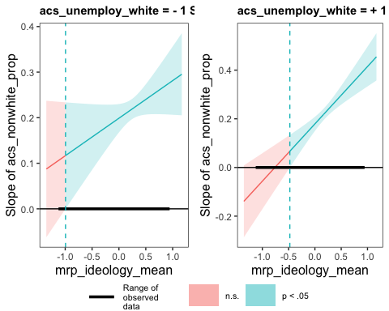

Plot H1

## Warning: Removed 2 row(s) containing missing values (geom_path).

## Warning: Removed 2 rows containing missing values (geom_point).

## Warning: Removed 2 row(s) containing missing values (geom_path).

## Warning: Removed 2 rows containing missing values (geom_point).

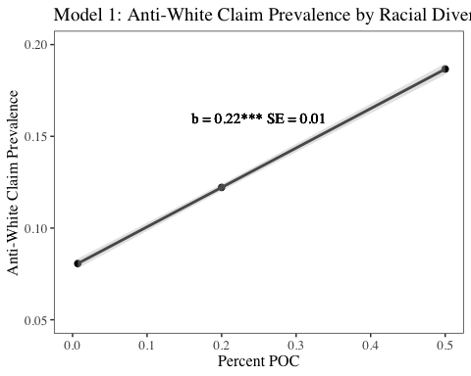

Plot H2: Claim prevalence by racial diversity and conservatism

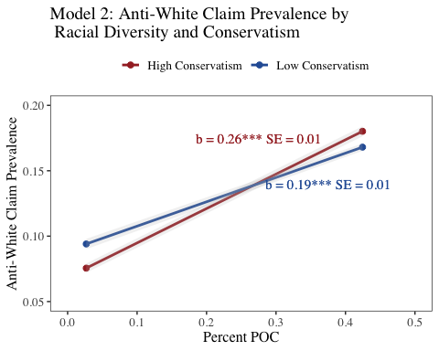

Plot the 2-way diversity x conservatism interaction separately for counties with low white unemployment and counties with high white unemployment.

Low white unemployment:

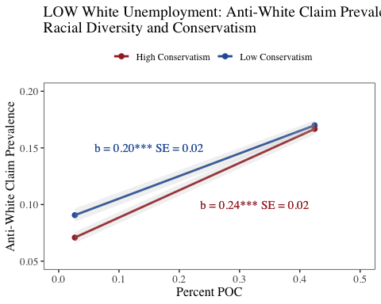

High white unemployment:

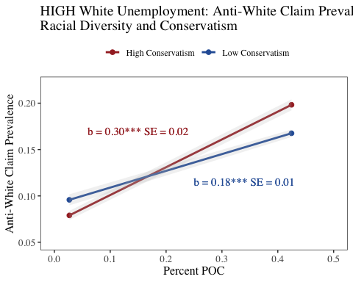

Plot the 3-way interaction with a pretty title:

