Seeing is believing 3-way ANOVAs

Elisabeth R. Silver et al.

07/08/2021

## 3-way interactions

Knitting this file to a Word document produces formatted outputs that can be easily copied and pasted into a manuscript write-up file.

### STEM Career Interest

(Intercept)

Participant gender

*F*(1, 328) = 2.55, *p* = 0.11, partial = 0.01  
Image condition

*F*(1, 328) = 0.20, *p* = 0.66, partial = 0.00  
Scientist gender

*F*(1, 328) = 0.71, *p* = 0.40, partial = 0.00  
Participant gender x Image condition

*F*(1, 328) = 2.43, *p* = 0.12, partial = 0.01  
Participant gender x Scientist gender

*F*(1, 328) = 4.16, *p* = 0.04, partial = 0.01  
Image condition x Scientist gender

*F*(1, 328) = 0.79, *p* = 0.38, partial = 0.00  
Participant gender x Image condition x Scientist gender

*F*(1, 328) = 9.28, *p* < 0.01, partial = 0.03  
Error

*F*(328, 328) = NA, , partial = NA

There was a significant 3-way interaction between image condition, scientist gender, and participant gender, *F*(1, 328) = 9.28, *p* < 0.01, partial = 0.03 .

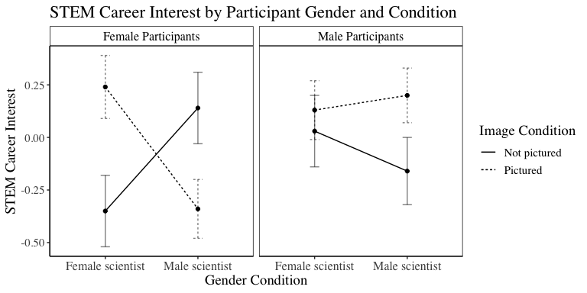

### General STEM Interest

(Intercept)

Participant gender

*F*(1, 328) = 2.13, *p* = 0.14, partial = 0.01  
Image condition

*F*(1, 328) = 0.01, *p* = 0.93, partial = 0.00  
Scientist gender

*F*(1, 328) = 0.05, *p* = 0.82, partial = 0.00  
Participant gender x Image condition

*F*(1, 328) = 3.20, *p* = 0.07, partial = 0.01  
Participant gender x Scientist gender

*F*(1, 328) = 0.94, *p* = 0.33, partial = 0.00  
Image condition x Scientist gender

*F*(1, 328) = 0.05, *p* = 0.83, partial = 0.00  
Participant gender x Image condition x Scientist gender

*F*(1, 328) = 3.75, *p* = 0.05, partial = 0.01  
Error

There was a marginal 3-way interaction between image condition, scientist gender, and participant gender, *F*(1, 328) = 3.75, *p* = 0.05, partial = 0.01 .

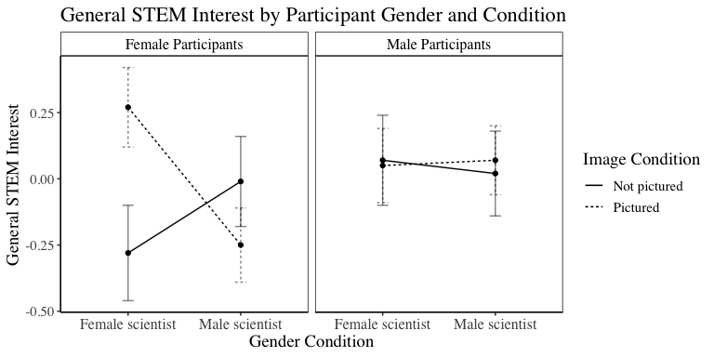

### STEM Belonging

(Intercept)

Participant gender

*F*(1, 328) = 4.16, *p* = 0.04, partial = 0.01  
Image condition

*F*(1, 328) = 0.89, *p* = 0.35, partial = 0.00  
Scientist gender

*F*(1, 328) = 0.13, *p* = 0.72, partial = 0.00  
Participant gender x Image condition

*F*(1, 328) = 1.65, *p* = 0.20, partial = 0.00  
Participant gender x Scientist gender

*F*(1, 328) = 0.46, *p* = 0.50, partial = 0.00  
Image condition x Scientist gender

*F*(1, 328) = 0.01, *p* = 0.93, partial = 0.00  
Participant gender x Image condition x Scientist gender

*F*(1, 328) = 0.55, *p* = 0.46, partial = 0.00  
Error

The 3-way interaction between image condition, scientist gender, and participant gender was not significant, *F*(1, 328) = 0.55, *p* = 0.46, partial = 0.00 .

### Identification with STEM

(Intercept)

Participant gender

*F*(1, 328) = 0.13, *p* = 0.71, partial = 0.00  
Image condition

*F*(1, 328) = 0.35, *p* = 0.55, partial = 0.00  
Scientist gender

*F*(1, 328) = 0.31, *p* = 0.58, partial = 0.00  
Participant gender x Image condition

*F*(1, 328) = 1.08, *p* = 0.30, partial = 0.00  
Participant gender x Scientist gender

*F*(1, 328) = 0.68, *p* = 0.41, partial = 0.00  
Image condition x Scientist gender

*F*(1, 328) = 0.65, *p* = 0.42, partial = 0.00  
Participant gender x Image condition x Scientist gender

*F*(1, 328) = 4.68, *p* = 0.03, partial = 0.01  
Error

There was a significant 3-way interaction between image condition, scientist gender, and participant gender, *F*(1, 328) = 4.68, *p* = 0.03, partial = 0.01 .

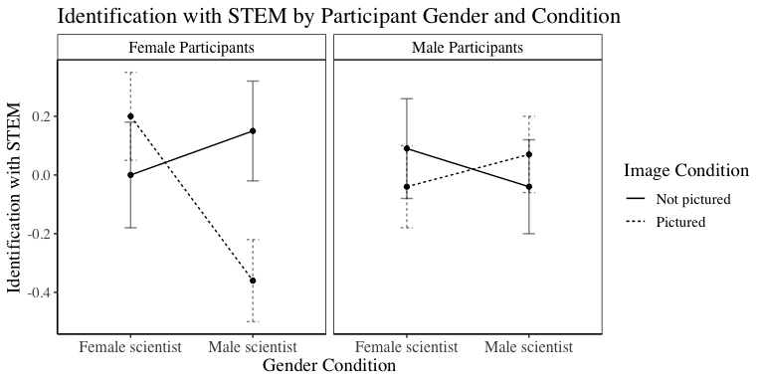

|  |  |  |
| --- | --- | --- |
| new.contrast | formatted.result | outcome |
| Women Male scientist Pictured - Men Male scientist Pictured | *t*(328) = -2.79, *p* = 0.01 (Mdiff = -0.54, 95% CI: -0.93, -0.16) | z.lead.all |
| Women Male scientist Pictured - Men Male scientist Pictured | *t*(328) = -1.59, *p* = 0.15 (Mdiff = -0.31, 95% CI: -0.70, 0.07) | z.interest.all |
| Women Male scientist Pictured - Men Male scientist Pictured | *t*(328) = -0.95, *p* = 0.61 (Mdiff = -0.19, 95% CI: -0.58, 0.20) | z.dd.belonging.all |
| Women Male scientist Pictured - Men Male scientist Pictured | *t*(328) = -2.22, *p* = 0.05 (Mdiff = -0.44, 95% CI: -0.82, -0.05) | z.dd.id.all |

|  |  |  |
| --- | --- | --- |
| new.contrast | formatted.result | outcome |
| Women Male scientist Pictured - Women Female scientist Pictured | *t*(328) = -2.81, *p* = 0.01 (Mdiff = -0.58, 95% CI: -0.98, -0.17) | z.lead.all |
| Women Male scientist Pictured - Women Female scientist Pictured | *t*(328) = -2.48, *p* = 0.04 (Mdiff = -0.52, 95% CI: -0.93, -0.11) | z.interest.all |
| Women Male scientist Pictured - Women Female scientist Pictured | *t*(328) = -0.75, *p* = 0.61 (Mdiff = -0.16, 95% CI: -0.57, 0.25) | z.dd.belonging.all |
| Women Male scientist Pictured - Women Female scientist Pictured | *t*(328) = -2.71, *p* = 0.03 (Mdiff = -0.56, 95% CI: -0.97, -0.15) | z.dd.id.all |

|  |  |  |
| --- | --- | --- |
| new.contrast | formatted.result | outcome |
| Women Female scientist Not pictured - Women Female scientist Pictured | *t*(328) = -2.57, *p* = 0.01 (Mdiff = -0.59, 95% CI: -1.04, -0.14) | z.lead.all |
| Women Female scientist Not pictured - Women Female scientist Pictured | *t*(328) = -2.38, *p* = 0.04 (Mdiff = -0.55, 95% CI: -1.01, -0.10) | z.interest.all |
| Women Female scientist Not pictured - Women Female scientist Pictured | *t*(328) = -0.88, *p* = 0.61 (Mdiff = -0.20, 95% CI: -0.66, 0.25) | z.dd.belonging.all |
| Women Female scientist Not pictured - Women Female scientist Pictured | *t*(328) = -0.87, *p* = 0.39 (Mdiff = -0.20, 95% CI: -0.66, 0.25) | z.dd.id.all |

|  |  |  |
| --- | --- | --- |
| new.contrast | formatted.result | outcome |
| Men Female scientist Pictured - Women Female scientist Pictured | *t*(328) = -0.53, *p* = 0.60 (Mdiff = -0.11, 95% CI: -0.51, 0.29) | z.lead.all |
| Men Female scientist Pictured - Women Female scientist Pictured | *t*(328) = -1.05, *p* = 0.30 (Mdiff = -0.22, 95% CI: -0.62, 0.19) | z.interest.all |
| Men Female scientist Pictured - Women Female scientist Pictured | *t*(328) = 0.43, *p* = 0.67 (Mdiff = 0.09, 95% CI: -0.32, 0.49) | z.dd.belonging.all |
| Men Female scientist Pictured - Women Female scientist Pictured | *t*(328) = -1.18, *p* = 0.32 (Mdiff = -0.24, 95% CI: -0.65, 0.16) | z.dd.id.all |