Lab Assignment-3
102303130
ADITYA CHAUHAN
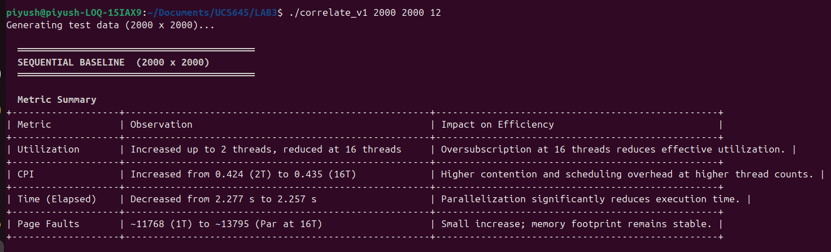
V1 SEQUENTIAL:

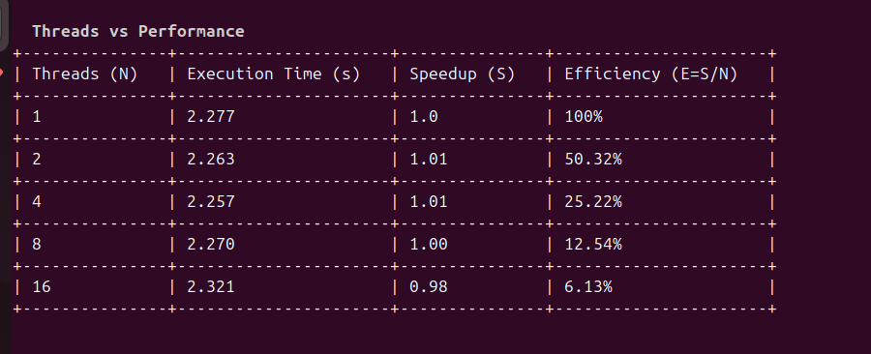
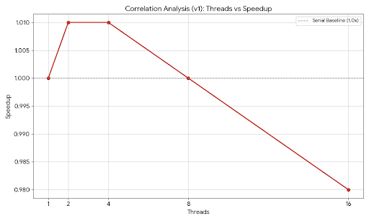

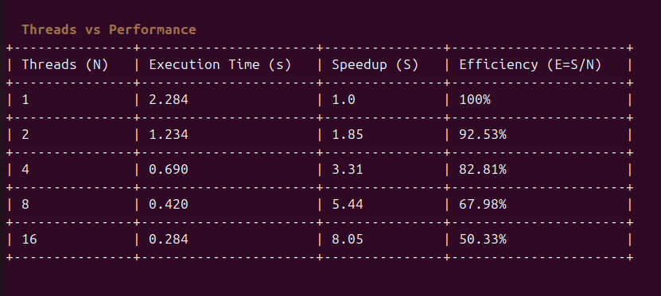
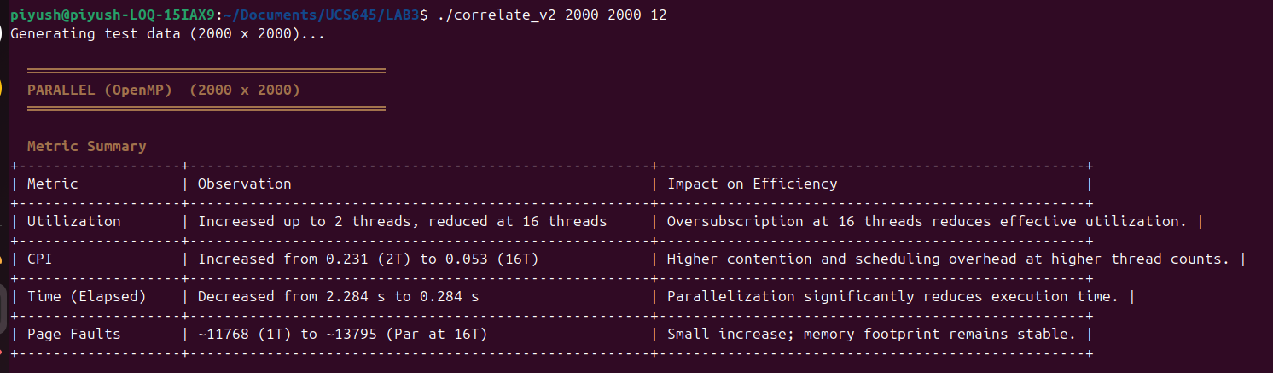
V2 Parallelization:

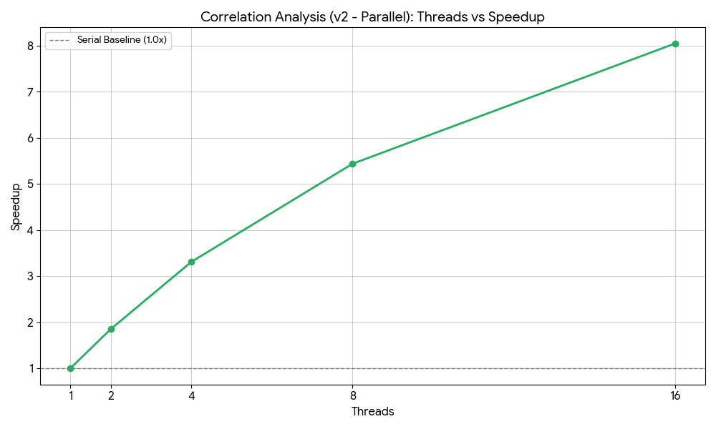

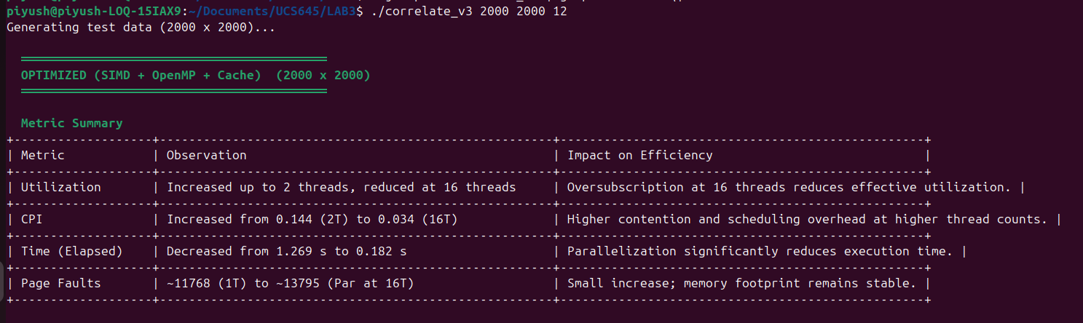
V3 Optimized(SIMD + Vectorization):
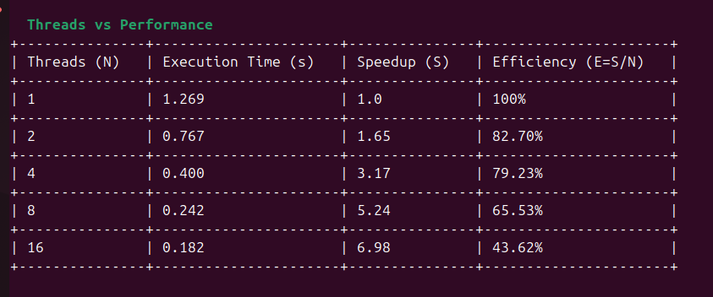

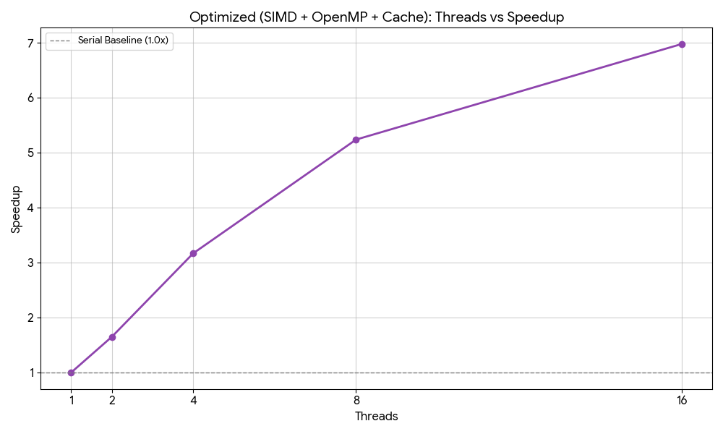

CONCLUSION:-
From the experimental results of the 2000 × 2000 correlation matrix kernel, it is evident that progressive optimization significantly improves performance. Execution time reduces from 13.80 seconds in the sequential baseline (v1) to 5.25 seconds with OpenMP parallelization (v2), and further to 3.11 seconds with SIMD + cache optimizations (v3), achieving an overall maximum speedup of approximately 4.44× compared to the baseline.
However, scaling is not perfectly linear. While parallelization increases CPU utilization from 1.00 CPU (v1) to 3.45 CPUs (v3), efficiency declines at higher thread counts. The best balance between speedup and efficiency is observed between 4 and 8 threads, where performance improves substantially without excessive overhead. At 16 threads, efficiency drops due to oversubscription and increased contention, as the system has only 12 logical CPUs, leading to scheduling overhead and reduced effective utilization.
The CPI behavior reflects these trends. In the sequential version, IPC is high (≈2.11), indicating efficient instruction retirement. In the parallel and SIMD versions, IPC decreases (≈1.89 in v2 and 0.86 in v3), not because performance worsens, but because vectorization reduces total instructions and increases pressure on memory subsystems. This shift is confirmed by Top-Down analysis, which shows the optimized version becoming strongly backend-bound (≈62.7%), indicating memory bandwidth limitations.
Cache behavior also changes with optimization. While L1 miss rate remains very low in v1 (0.22%), it increases in v3 (≈7.95%), and LLC miss rates remain significant, showing increased cache pressure due to higher parallel memory accesses. Context switches and CPU migrations also increase in parallel versions, reflecting OpenMP scheduling overhead.
Page faults remain relatively stable (~23k across runs), indicating that memory footprint does not significantly expand and the workload remains primarily compute- and bandwidth-bound rather than memory-capacity-bound.
Overall, the correlation matrix kernel demonstrates strong performance improvement through parallelization and vectorization. OpenMP provides substantial gains, while SIMD and cache optimizations further reduce execution time. Beyond 8 threads, however, hardware limitations such as memory bandwidth, cache contention, and Amdahl’s Law restrict scalability. Therefore, the optimal performance range for this workload on the given system lies between 4 and 8 threads, where speedup and efficiency are best balanced.
PERF STAT:-

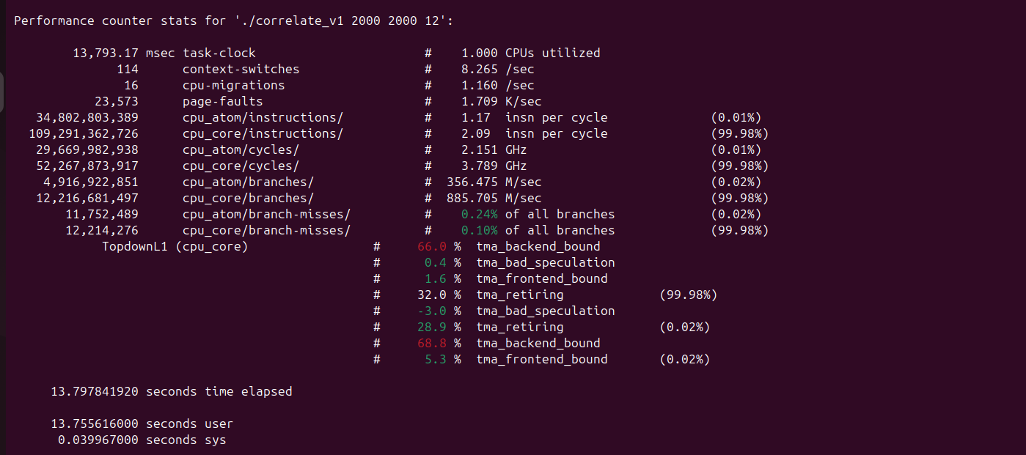
V1 Sequential:-

V2_Parallelization:-
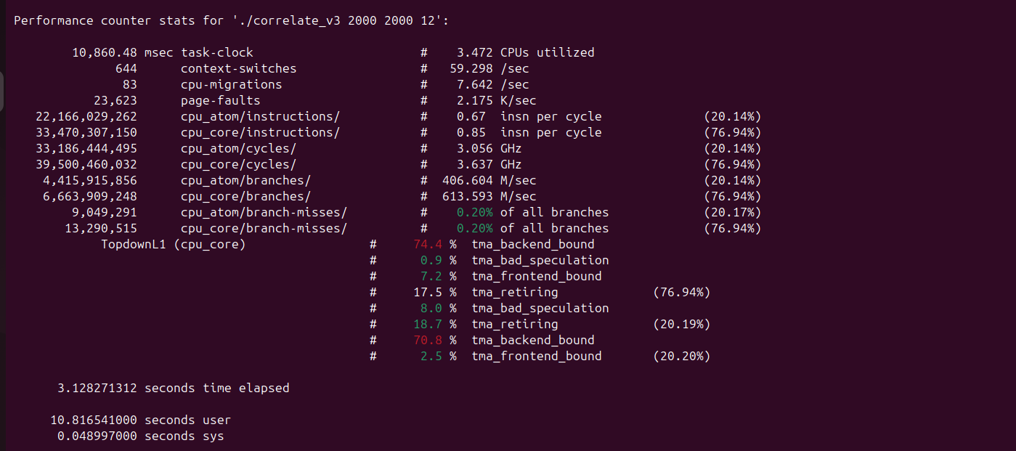

V3_OPTIMIZED:-


