Lab Assignment-1
102303130-Aditya Chauhan
Q.1> Daxpy:
Metric | Observation | Impact on Efficiency
CPU Utilization | CPU usage rises as thread count increases (moving from single-core to multi-core execution). | More threads activate additional cores, improving overall CPU utilization.
IPC (Estimated) | Effective IPC decreases at higher thread counts due to memory-bound behavior. | Since DAXPY is memory-bound, more threads cause memory bandwidth saturation and cache coherence overhead, lowering useful work per cycle.
Time Elapsed | Execution time reduces notably as threads increase, up to an optimal point. | Parallelization boosts performance, but benefits taper off after the peak thread count due to overhead.
Page Faults (Expected) | A small increase is expected with higher thread counts and larger vector sizes. | More memory activity and a larger working set can raise page faults, reinforcing the memory-bound nature of the operation.
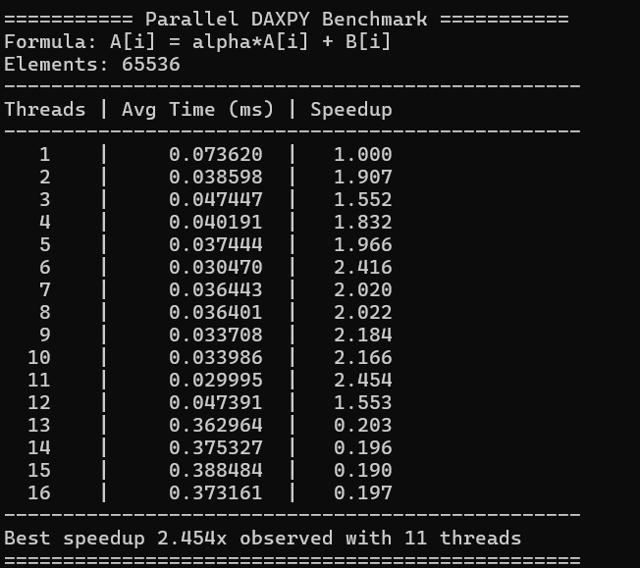

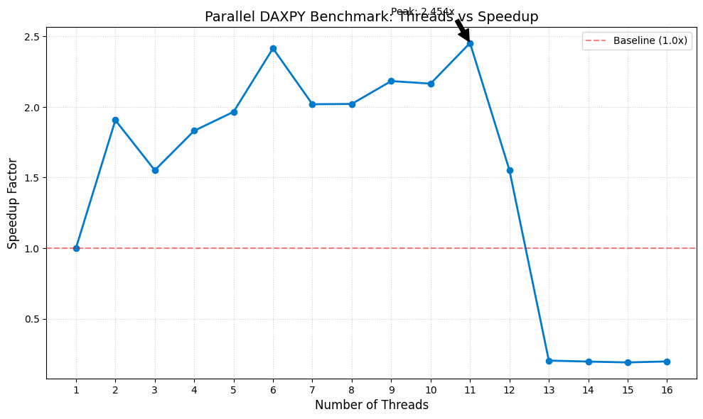

The Parallel DAXPY benchmark shows that performance improves as the number of threads increases from 1 to 11. The serial execution time at 1 thread is 0.073620 ms, while the lowest time of 0.029995 ms is achieved at 11 threads, giving the maximum observed speedup of 2.454×. Between 2 and 10 threads, the speedup generally stays above 1.5× and often exceeds 2×, indicating effective parallel utilization and good workload distribution across threads.
However, after 11 threads, performance declines sharply. At 12 threads, the speedup drops to 1.553×, and from 13 to 16 threads it falls below 1×, meaning execution becomes slower than the serial case, with time increasing to around 0.36–0.38 ms. This happens because DAXPY is memory-bound; higher thread counts cause memory bandwidth saturation, increased thread overhead, cache contention, and reduced efficiency due to the small problem size.

Q.2>Matrix Multiplication:

Matrix size = 1000 x 1000
Metric | Observation | Impact on Efficiency
Utilization | Speedup increases with threads. Row strategy reaches 5.42× at 28 threads. Grid strategy peaks at 2.93× at 11 threads. | More threads engage more CPU cores, improving hardware utilization until resource limits are approached.
IPC (Qualitative) | Efficiency (%) drops as threads rise (Row: 90% → ~17%). Grid speedup plateaus after ~11 threads. | Increasing threads raises contention for shared resources (cache & memory), lowering per-core effectiveness.
Time Elapsed | Baseline time = 2.293 s. Best Row time = 0.423 s (28 threads). Best Grid time = 0.784 s (11 threads). | Parallel execution significantly reduces runtime, showing strong benefit from workload division.
Page Faults | No abnormal behavior observed during execution | Expected for matrices of this size; memory accesses remain within predictable limits.

1D Thread vs speedup

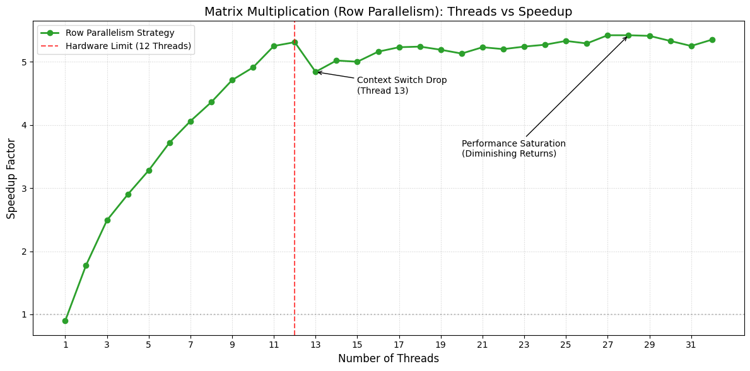
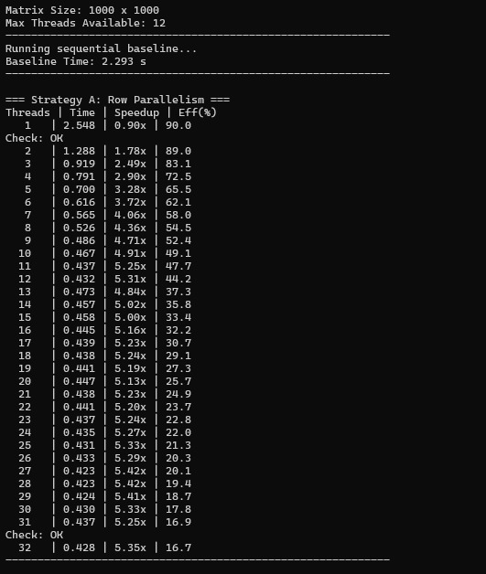

For 2D

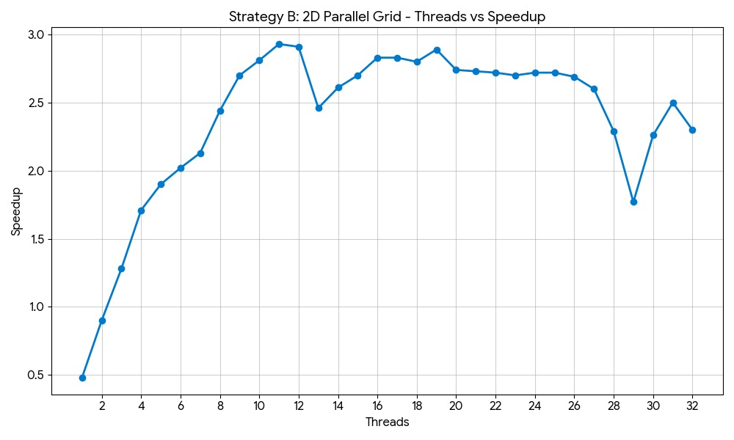
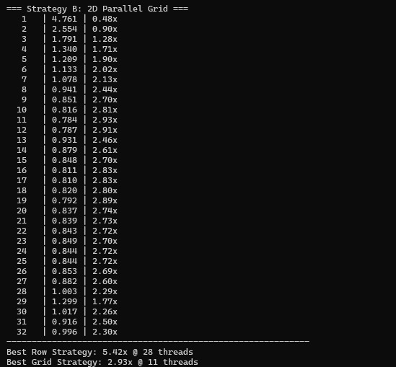

Matrix multiplication shows clear performance improvement with parallelization for the 1000 × 1000 matrix. The sequential baseline time is 2.293 s, while the Row Parallel strategy reduces execution time to 0.423 s, achieving a maximum speedup of 5.42× at 28 threads. The 2D Grid strategy also improves performance but peaks earlier, reaching 2.93× speedup at 11 threads with a time of 0.784 s. This shows that increasing threads initially improves throughput as more CPU cores participate in computation.
However, as thread count increases further, efficiency drops. In the Row strategy, efficiency decreases from 90% at 1 thread to about 17% at 32 threads. This happens due to increased synchronization overhead, cache contention, and memory access competition. The Grid strategy shows earlier saturation, with speedup stabilizing around 2.7–2.9× before fluctuating. Overall, Row-wise parallelization scales better for this workload, while the 2D Grid method provides moderate gains but higher overhead. Both approaches significantly outperform serial execution, though scalability is ultimately limited by hardware resource contention.
Q.3> Pi-estimation
Metric | Observation (From Data) | Impact on Efficiency
Utilization | Speedup increases with thread count, reaching a maximum of ≈7.0× at 26 threads (best configuration). | More threads allow better CPU core utilization, increasing parallel throughput until overheads begin to dominate.
IPC (Qualitative) | Efficiency drops from ~98% (1 thread) to ~21% (32 threads) as threads increase. | Higher thread counts introduce synchronization overhead and resource contention, reducing per-core efficiency even though total speedup improves.
Time Elapsed | Serial average time = 0.1915 s. Best parallel time ≈ 0.027–0.028 s (26 threads). | Large reduction in execution time confirms effective parallelization and improved computational throughput.
Accuracy | π estimate remains stable across all threads (≈ 3.1415926535898), with very small error (~6.33e-13). | Parallelization does not affect numerical accuracy; computation remains precise and consistent.
Scalability Behavior | Speedup grows steadily up to mid–high thread counts, then plateaus near 7×. | Indicates good scalability for compute-heavy workloads, with limits appearing due to parallel overhead and hardware contention.

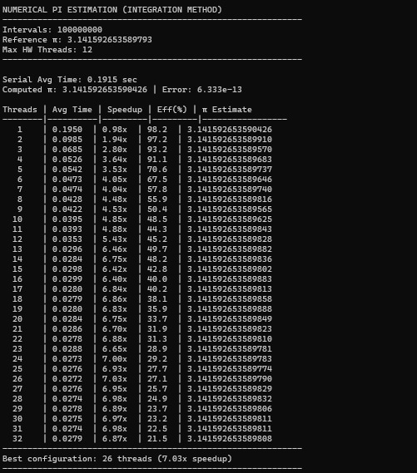
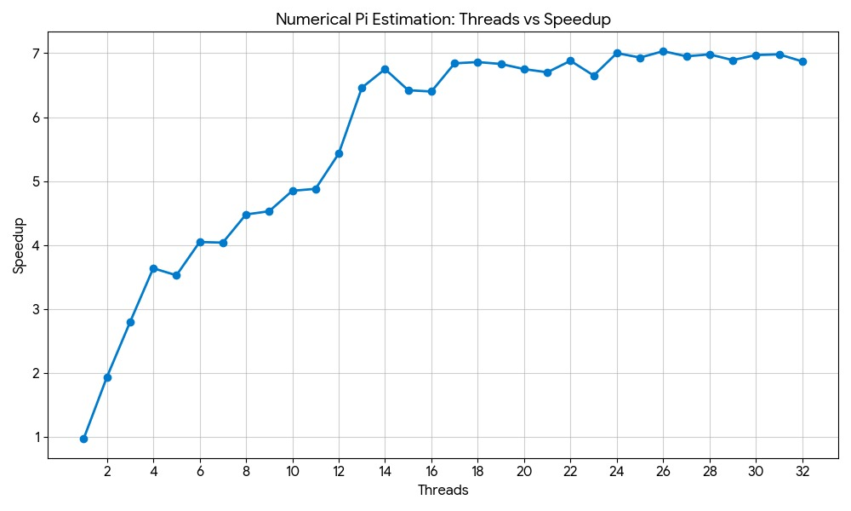

The π computation shows strong scalability under parallel execution, achieving a peak speedup of about 7.0× at 26 threads, which is the best observed configuration. Performance improves steadily as thread count increases, reducing execution time from 0.1915 s (serial) to roughly 0.027–0.028 s at optimal parallelism. This improvement occurs because the workload is evenly divided among threads, allowing better CPU utilization and higher throughput. A slight drop in speedup beyond the optimal point (e.g., at 32 threads) indicates growing thread management and scheduling overhead.
The implementation benefits from each thread working independently on partial sums before a final reduction step, keeping synchronization overhead low while maintaining high numerical accuracy (error ≈ 6.33×10⁻¹³). However, efficiency decreases from ~98% at 1 thread to about 21% at 32 threads, showing that scaling is not linear. Increased overhead, cache contention, and resource sharing reduce per-core efficiency at higher thread counts. Overall, the computation scales well because it is compute-intensive, but performance gains eventually taper due to parallel overhead and hardware limits.

