Show the data structures and the first 10 records of each table. Use a SELECT query to show the records.

|  |
| --- |
| SELECT * FROM Sessions, Skype_users LIMIT 10; |

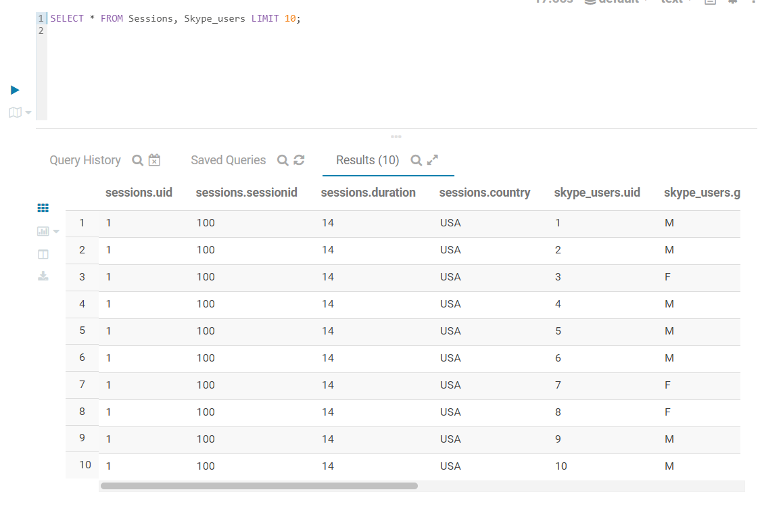

How many females older than 25 found Skype to be easy to use (i.e., EasyToUse >= 4)

|  |
| --- |
| SELECT COUNT(*) as qualifiedfemales FROM Skype_users  WHERE Gender = 'F' AND Age > 25 AND EasyToUse >= 4; |

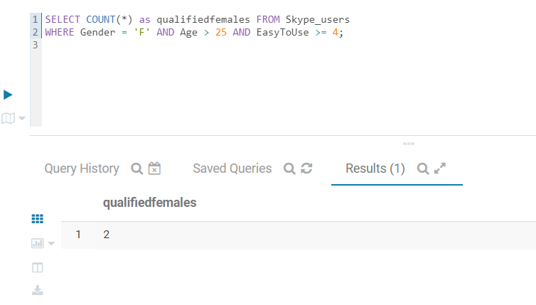

Show UID, Gender, Age, EasyToUse and FutureUse of the US users who spent more time in each session of Skype (i.e., UseDuration = 1 to 3 hours and UseDuration = 30 – 60 minutes).

|  |
| --- |
| SELECT DISTINCT Skype_users.UID, Skype_users.Gender, Skype_users.Age, Skype_users.EasyToUse, Skype_users.FutureUse  FROM Skype_users  JOIN Sessions ON (Skype_users.UID = Sessions.UID)  WHERE Sessions.Country == 'US'  AND (Skype_users.UseDuration =='1 to 3 hours' OR Skype_users.UseDuration =='30 - 60 minutes'); |

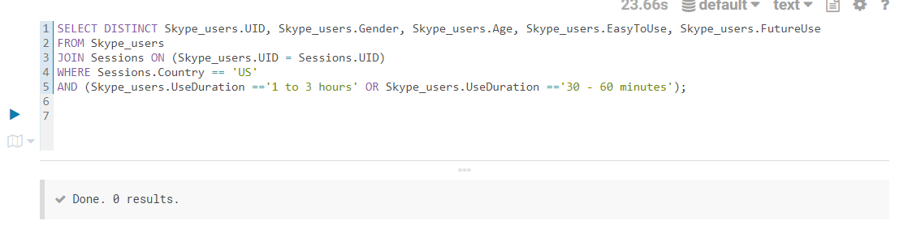

Show the average FutureUse by country and sort the results by country.

|  |
| --- |
| SELECT Country, AVG(FutureUse) as avg_future_use  FROM Skype_users  JOIN sessions on (skype_users.uid = sessions.uid)  GROUP BY Country  ORDER BY Country; |

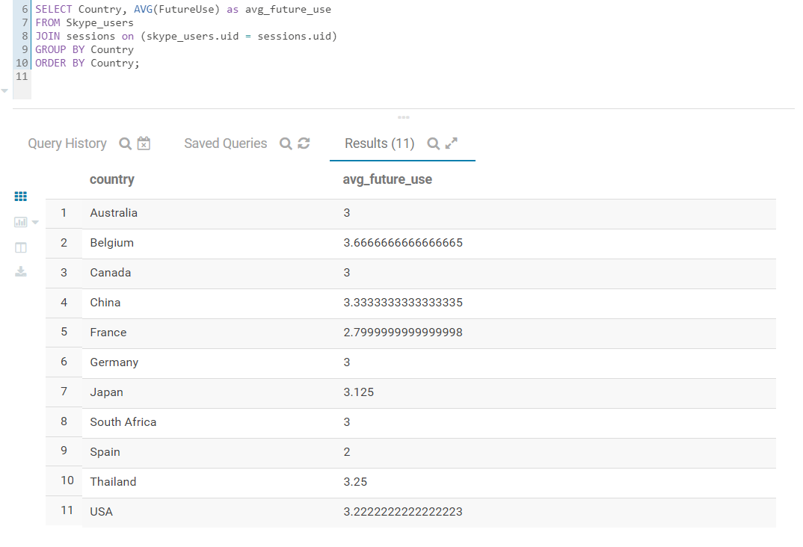

Implementing a query to show whether there is a gender difference in UseDuration.

|  |
| --- |
| SELECT Gender, UseDuration, COUNT(*) AS Total  FROM Skype_users  JOIN Sessions ON Skype_users.UID = Sessions.UID  GROUP BY Gender, UseDuration  ORDER BY Gender, UseDuration; |

