Summary of Eight Bit Calculator Design

Jason Mobarak
ECE 338
May 12th, 2005

Table of Contents

Introduction 3
Product Specifications 3
Input Bus 3
Output Bus 3
Output Range 4
Operator Implementation 4
Design 5
Description of Main Calculator States 5
IDLE 5
RECV_IN1 5
RECV_OP 6
RECV_IN2 6
RESULT_WAIT 6
OUTPUT 6

Illustration Index

Illustration 1 - main calculator state machine 5

Introduction
The deign described in this document is an eight bit calculator with 4 different operations. The hardware for the eight be calculator is not described in this document.
In this design, it is assumed that there is an external device that provides input to the calculator and pulses a signal to indicate that input is present.
Normally, implementation of this calculator with a higher level hardware description language like VHDL or Verilog. However, this design chooses to describe the underlying mechanics of each operation, implemented at the gate level.

Product Specifications

Input Bus
The input bus receives all data for the calculator, operands and operators are all input through this one bus. Input is directed to the bus and an input valid signal is pulsed, on a positive clock edge of this signal input from the bus is loaded into a register.
The order of input is important. The first input is the left operand of the operation, second is the operator and third is the right operand. Example, the VHDL translation of the operation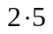would be:
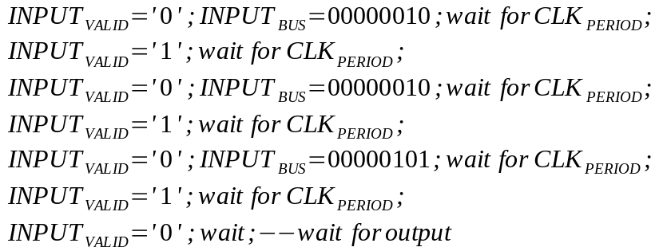

Output Bus
The output bus transmits the result of an operation, the output bus should only be read when the OUTPUT_VALID signal has a positive clock edge. When OUTPUT_VALID does not have a positive clock edge the calculator is still attempting to calculate the result of the operation requested.

Output Range
Output from the calculator is unsigned and can only be in the range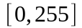. Should the result of any operation be greater that 255 or less than 0 the result should be 255 or 0, respectively.

Operator Implementation
Operators for this calculator can only be implemented with primitive gate operations. These operations include: AND, OR, NOR, NAND, XOR, and XNOR. Operations should be implemented by hand and not by a synthesis tool, full control over operator implementation is desired.

Design
The main calculator was designed as a state machine with 6 states. See Illustration 1 for a basic diagram of the main finite state machine.

Illustration 1 - main calculator state machine

Description of Main Calculator States

IDLE
This is the initial state, the calculator waits here for the first input, it will advance out of this state when INPUT_VALID is pulsed.

RECV_IN1
This state is named to imply that the first input has been received, loaded in the a register and the machine is now waiting for the second input, the operand, this state will be left when INPUT_VALID is pulsed again

RECV_OP
This state signals that the second input is received and the machine is now waiting for the final input, this state will be left when INPUT_VALID is pulsed.

RECV_IN2
Once this state is entered the the operation begins, the operator that was selected in the RECV_OP state will be used to signal that the subcomponent that corresponds to the operator should be started and the operands loaded in to that subcomponent, RESULT_WAIT is always entered after the operator subcomponent is initialized.

RESULT_WAIT
Each subcomponent for an operator has a “done” signal that tells the parent component when it's done performing it's operation, this state monitors the operator that was selected in RECV_OP and waits for that operator signal that it's done with it's operation. This state is re-entered if the operator is not finished, once it's finished the OUTPUT state is entered.

OUTPUT
This state is only one clock cycle long and during it the result of an operand it outputted by pulsing OUTPUT_VALID, the actual output should have been loaded into the OUTPUT_BUS in the previous state.

