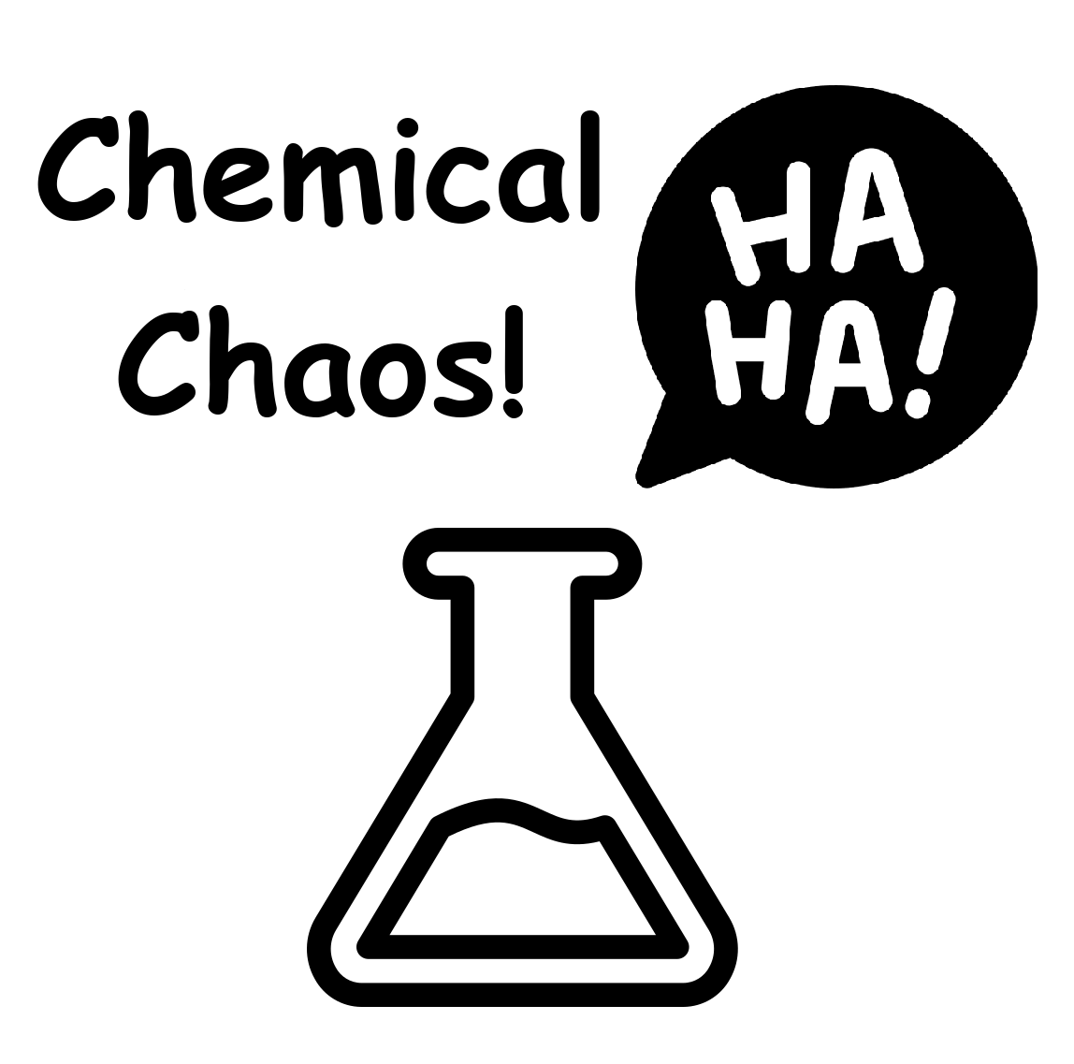

Chemical Chaos!
Instructions

A Card Game by Keegan & Sherri Noecker
Global Game Jam 2024

Chemical Chaos! is a casual party card game designed to be quick to learn and full of laughs for groups of 3-6 players. This game was created for the 2024 Global Game Jam (globalgamejam.org) by 12 year old Keegan Noecker and his mom Sherri Noecker as part of the Windsor Hackforge GGJ jam site.
Contents
Chemical Chaos! Instructions 1
Overview 2
Objective 2
Quick Start 2
Contents 3
Pintable Game Instructions 3
Setup 3
Player Turn 3
Cards In Hand 4
Ingredient Cards 4
Recipe Cards 4
Side Effects 5
Card Descriptions & Errata 5
Comforting Soup 5
Cordial Of Confusion 5
Could Shoulder Elixir 6
Daffy Draught 6
Full Of Beans Brew 6
Multiplying Mixture 6
Remedy Of Reflection 6
Royal Restorative 7
Sweet Talk Tonic 7
Instant Cards 7
Side Effect Enforcement 7
Scoring & Winning 8
Credits 8
Attributions 8

Overview
Number of Players: 3-6
Avg Play Time: 60 minutes
Ages: 8 and up
Licence: Creative Commons Attribution-NonCommercial-ShareAlike 4.0 International
Required Components:
- Chemical Chaos! printable playing cards (included)
- Score counting tokens or a pen & paper (not included)

Objective
To be the first player to collect the needed ingredients and create 5 recipes (4 for a shorter game).

Quick Start
- Shuffle the cards and place them face down in the center of the play area.
- Deal 8 starting cards to each player.
- Players play in turns clockwise; drawing a new card, exchanging up to 3 cards, then playing any number of recipes they have the ingredients for. Players draw an extra 2 cards for every recipe played, and they score 1 Chemistry Point for each recipe created.
- Most recipes affect other players, any card with a Side Effect is placed in front of the affected player until it is cured or removed by another card effect.
- All players must obey all Side Effects affecting any player.
- Any player who catches another player not obeying an applicable Side Effect may take a random card from the caught player.
- First player to score 5 Chemistry Points (craft 5 recipes) wins.
- Any player who runs out of cards completely, is eliminated. They may watch for other players not obeying Side Effects in order to take a card and get back in the game.

Contents
- 29 Recipe Cards
- 76 Ingredient Cards
- 4 Instant Cards

Pintable Game Instructions
There are PDF versions of the printable cards for this game. One is a double sided PDF designed for printing via a printer capable of double sided printing. There is also a single sided PDF that you can print and then feed back into your printer and print the PDF of card backs onto them.
We recommend professional colour printing onto 80lb glossy cardstock paper.
Cut out the printed cards.

Setup
To begin, shuffle the deck of cards. Deal 8 cards (face down) to each player. Place the remaining cards (face down) in the center of the table. This is the draw pile. Play begins clockwise with the player to the left of the dealer.

Player Turn
Each player can perform the following actions in this order on their turn:
- Draw 1 card from the draw pile
- (Optional) discard up to 3 cards into the discard pile then draw the same number of cards that you discarded from the draw pile.
- (Optional) craft a recipe (potion) if you have all of the ingredients listed on the recipe card and the recipe card itself. Discard the 3 ingredient cards and follow the instructions on the recipe card. Then draw 2 new cards from the draw pile. Players can play any number of recipe cards in their hand.
Players can play an Instant card at any time during their turn or another player’s turn.

Cards In Hand
Players have no maximum to the number of cards they can have in their hand unless they have been targeted by a Sweet Talk Tonic.
Cards are held in hand and kept secret from other players. Although some play groups may prefer to play open handed to make the game easier or more approachable for children.
Once players have no more cards in their hand, they are eliminated from the game. However they can watch for players who are not obeying Side Effects and steal a card to get back in the game.
If the draw pile runs out of cards, shuffle the discard pile and add it to the draw pile.

Ingredient Cards
Ingredient cards are special materials that can be combined with each other (according to recipes) to make a special chemical potion. Ingredients have different rarities (different amounts of that ingredient in the deck).

Recipe Cards
Recipe cards are where the fun is in Chemical Chaos! They allow players to trigger different effects on other players, or themselves. Most recipe cards have 2 effects on the target:
- Gameplay Effect (ex: take a random card from the target)
- Side Effect (ex: the target can now only say the word “sugar”)

To play a recipe card on their turn, the player must discard all the ingredients listed on the recipe card into the discard pile. They then name the affected player. The Gameplay Effect happens immediately (or in the case of the Cold Shoulder Elixir, they lose their upcoming turn). If the card has a Side Effect (indicated by a flag icon), then the recipe card is placed face up on the table in front of the affected player facing toward the center of the group. That Side Effect is now active. If there is no Side Effect, the receipe card is discarded.
After playing a recipe card, the player immediately draws 2 new cards from the draw pile to restock their hand. Players may use these cards this turn.
Players can play any number of recipe cards that they wish during their turn. It is not mandatory to play a recipe card as soon as you are able.
When a player has played a recipe card, they score a Chemistry Point: take a counter token or mark your point on a piece of paper.

Side Effects
Most recipe cards have funny Side Effects described at the bottom of the card and indicated with a flag icon. Side Effects continue to affect a targeted player until they are cured with a Comforting Soup recipe or an Experimental Cure instant card. When a Side Effect is cured, discard it to the discard pile and the player is no longer affected.
Players must enforce Side Effects on each other by watching for players who slip and forget to obey the effect. If a player catches another player forgetting to obey a Side Effect, then they may steal a random card from the hand of the forgetting player. This process can cause much chaos during game play and players should endeavour to be good natured about it.
Players who have important Out Of Game matters to do or discuss should be allowed to forego obeying the Side Effect within reason. For example, a player asking where the washroom is, should not be penalized for not only saying the word “sugar”, or a player helping a child should not be penalized for forgetting to keep their hands crossed. However during gameplay, Side Effects should be obeyed strictly.
Side Effects can stack with each other. This means a player could be under the effect of the Sweet Talk Tonic and the Daffy Draught and therefor all their sentences will sound similar to “Sugar, sugar, ha! Sugar ha sugar??” while gesturing and using other methods to communicate their intentions.
Some Side Effects which make use of hand movements, have accessibility alternatives for players who cannot perform the Side Effect as described. These are indicated with an * and described in these instructions.
The same side effect cannot be stacked onto the same player. The player creating the recipe can choose another target or discard the crafted recipe immediately without targeting another player if there are no other players who do not already have that side effect on them.

Card Descriptions & Errata

Comforting Soup
Gameplay effect: cures any 1 side effect on yourself or any other player. The associated recipe card is discarded.

Cordial Of Confusion
Gameplay effect: Target player must discard 1 recipe card of their choice if able.
Side effect: Target player must* play with their hands crossed.
* Accessibility option: Target player must play with their cards face down on the table (target player can’t hold their cards in their hand).

Could Shoulder Elixir
Gameplay effect: the targeted player loses their upcoming turn. Play skips that player and continues with the next player.
Side Effect: The targeted player must turn their chair or sit with their back to the table or gameplay area. They may turn their head to see the game play and may reach behind them to draw and play cards.
Errata: Players for whom this causes discomfort or in environments where the chair cannot be turned, players may stand if everyone else is seated, or sit if everyone else is standing, etc.

Daffy Draught
Gameplay effect: The player creating this recipe may steal a random card from the target player’s hand.
Side effect: The targeted player must now insert the word “ha!” into all their sentences.

Full Of Beans Brew
Gameplay effect: Every other player must say to the player who crafts this recipe “You’re full of beans!” and give that player all their Jelly Beans cards.
This card has no Side Effect and is discarded after playing.

Multiplying Mixture
Gameplay effect: This card is only played on yourself. If the player can perform* the “pat your head and rub your belly” gesture (at the same time) within 3 tries, they can then draw 2 bonus cards (in addition to the restock cards drawn after crafting a recipe). This has the effect of replacing the 3 ingredient cards and the Multiplying Mixture recipe card for a total of 4 new cards, and scoring a Chemistry Point. If the player cannot do the gesture, then they cannot draw the 2 bonus cards.
This card has no Side Effect and is discarded after playing.
* Accessibility option: Target player must whistle a recognizeable tune or drum it on the table.

Remedy Of Reflection
Gameplay affect: Move any Side Effect recipe card that is on yourself or any other player, and put it on another player (including yourself). The newly targeted player must now obey the Side Effect on the moved card.
This card has no Side Effect of its own and is discarded after playing.

Royal Restorative
Gameplay effect: All other players must give you 1 random card (picked from their hand at random).
Side effect: All other players must refer to you as “your highness” when talking to you or about you.
Errata: If a player calls out another player for failing to refer to the affected player as “your highness” then it is the player who does the catching who gets to steal a card.

Sweet Talk Tonic
Gameplay effect: The targeted player must immediately discard down to a maximum of 6 cards in their hand.
Side effect: The target player can only say “sugar”. This means all words in all sentences this player says becomes “sugar” with the exception of other words they must say to obey other Side Effects. Ie, they can still say “ha!” and “your highness”.

Instant Cards
There is currently one type of Instant card in the game: the Experimental Cure. This card can be played at any time and used to remove (discard) a side effect recipe card on any player including the player who plays this card. Instant cards can be played immediately after another player plays a recipe card in order to cancel the Side Effect on that card and discard the recipe card immediately after it is played. Instant cards do not cancel the gameplay affect on a recipe card, which still applies to the targeted player.

Side Effect Enforcement
Throughout the game, players are encouraged to watch for other players who forget to obey a Side Effect that is in play. This is a major way to steal cards from other players and eliminate players by stealing their last card. The first player to verbally point out the mistake, gets to steal the card. The player should be allowed to distinctly finish their sentence and move onto the next before calling them out.
Players are encouraged to be good natured about pointing out mistakes and about accepting their own mistakes. Only one player gets to steal a card for any single mistake.
A player who has run out of cards, may still catch someone making a mistake and therefor steal a card to get back into the game.

Scoring & Winning
Each time a player crafts a recipe card, they score a Chemistry point. Instant cards do not score a point. The first player who reaches 5 points for a standard game or 4 points for a short game, wins.
All players are encouraged to high-five the winning player.

Credits
Game Development & Concept: Keegan Noecker
Game Development, Editing & Adult Supervisor: Sherri Noecker (Wheeler)
Play Testers & Production: Sebastien Noecker, Zack Noecker, Kevin Noecker
Copyright (c) 2024: Keegan & Sherri Noecker, All Rights Reserved

Attributions
Art and Icon Credits: Anthony Tran, Freepik, deemakdaksina, Markus Spiske, Vector Stall, Smashicons, Good Ware, Neven Krcmarek, Thom Holmes, Rapha Wilde, Aaron Burden, Kate Trifo, Art Rachen, Patrick Fore, Miles Burke, Lidya Nada, saeed karimi, Piotr Miazga, Ross Sokolovski, Crissy Jarvis, Shelley Pauls, Susan Q Yin, Giorgio Trovato, Alex Kondratiev

