1. Download and install [Current .NET Core Windows Server Hosting bundle](https://dotnet.microsoft.com/permalink/dotnetcore-current-windows-runtime-bundle-installer)
2. Download and install SDK .NET Core 5 (I believe this step can be skipped).
3. **Enable IIS on Windows:**
   1. **Open Control Panel and click “Programs and Features.”**
   2. **“Turn Windows features on or off”**

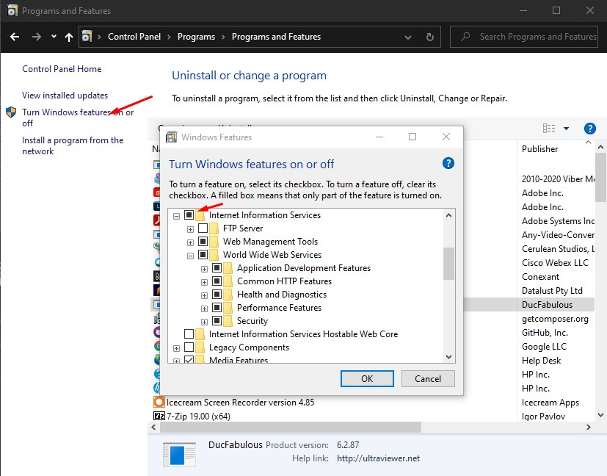

* 1. **Select Internet Information Services and click OK.**
  2. **Check is IIS enabled: Windows + R => type inetmgr and click OK.**
  3. **IIS Manager is opened.**

1. **Unzip code CoreWebApi.zip into any folder. Mine is placed in C:\Deploy\CoreWebApp**
2. **Create Application Pool and Website application in IIS:**

**Click on Application Pools and then Add application pool…**

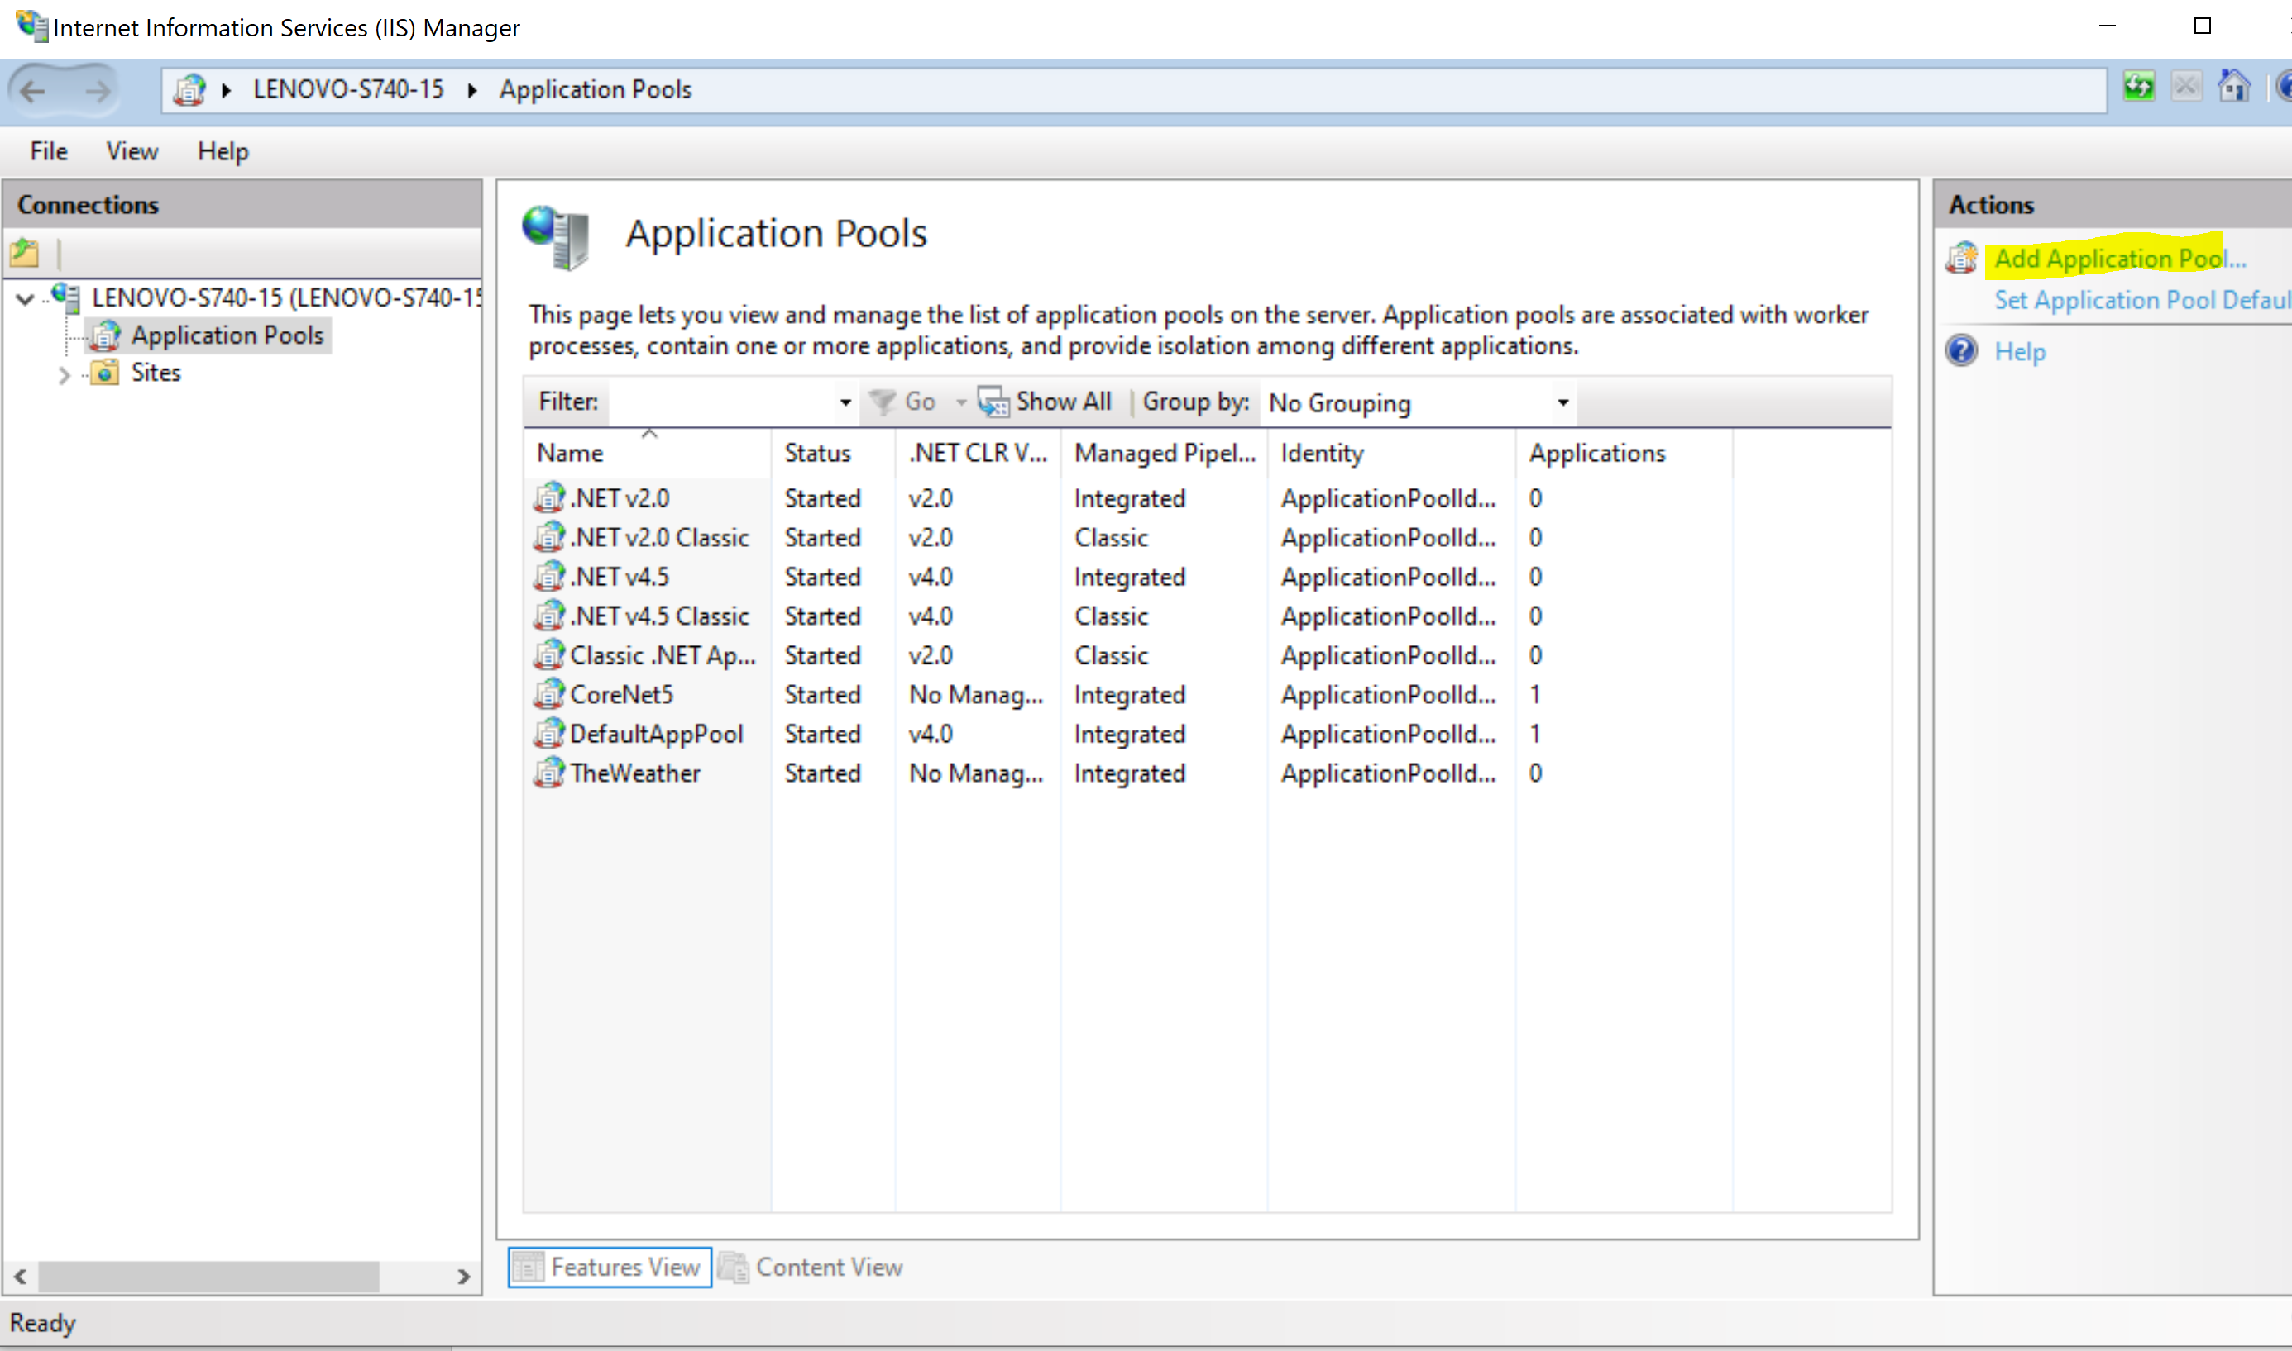

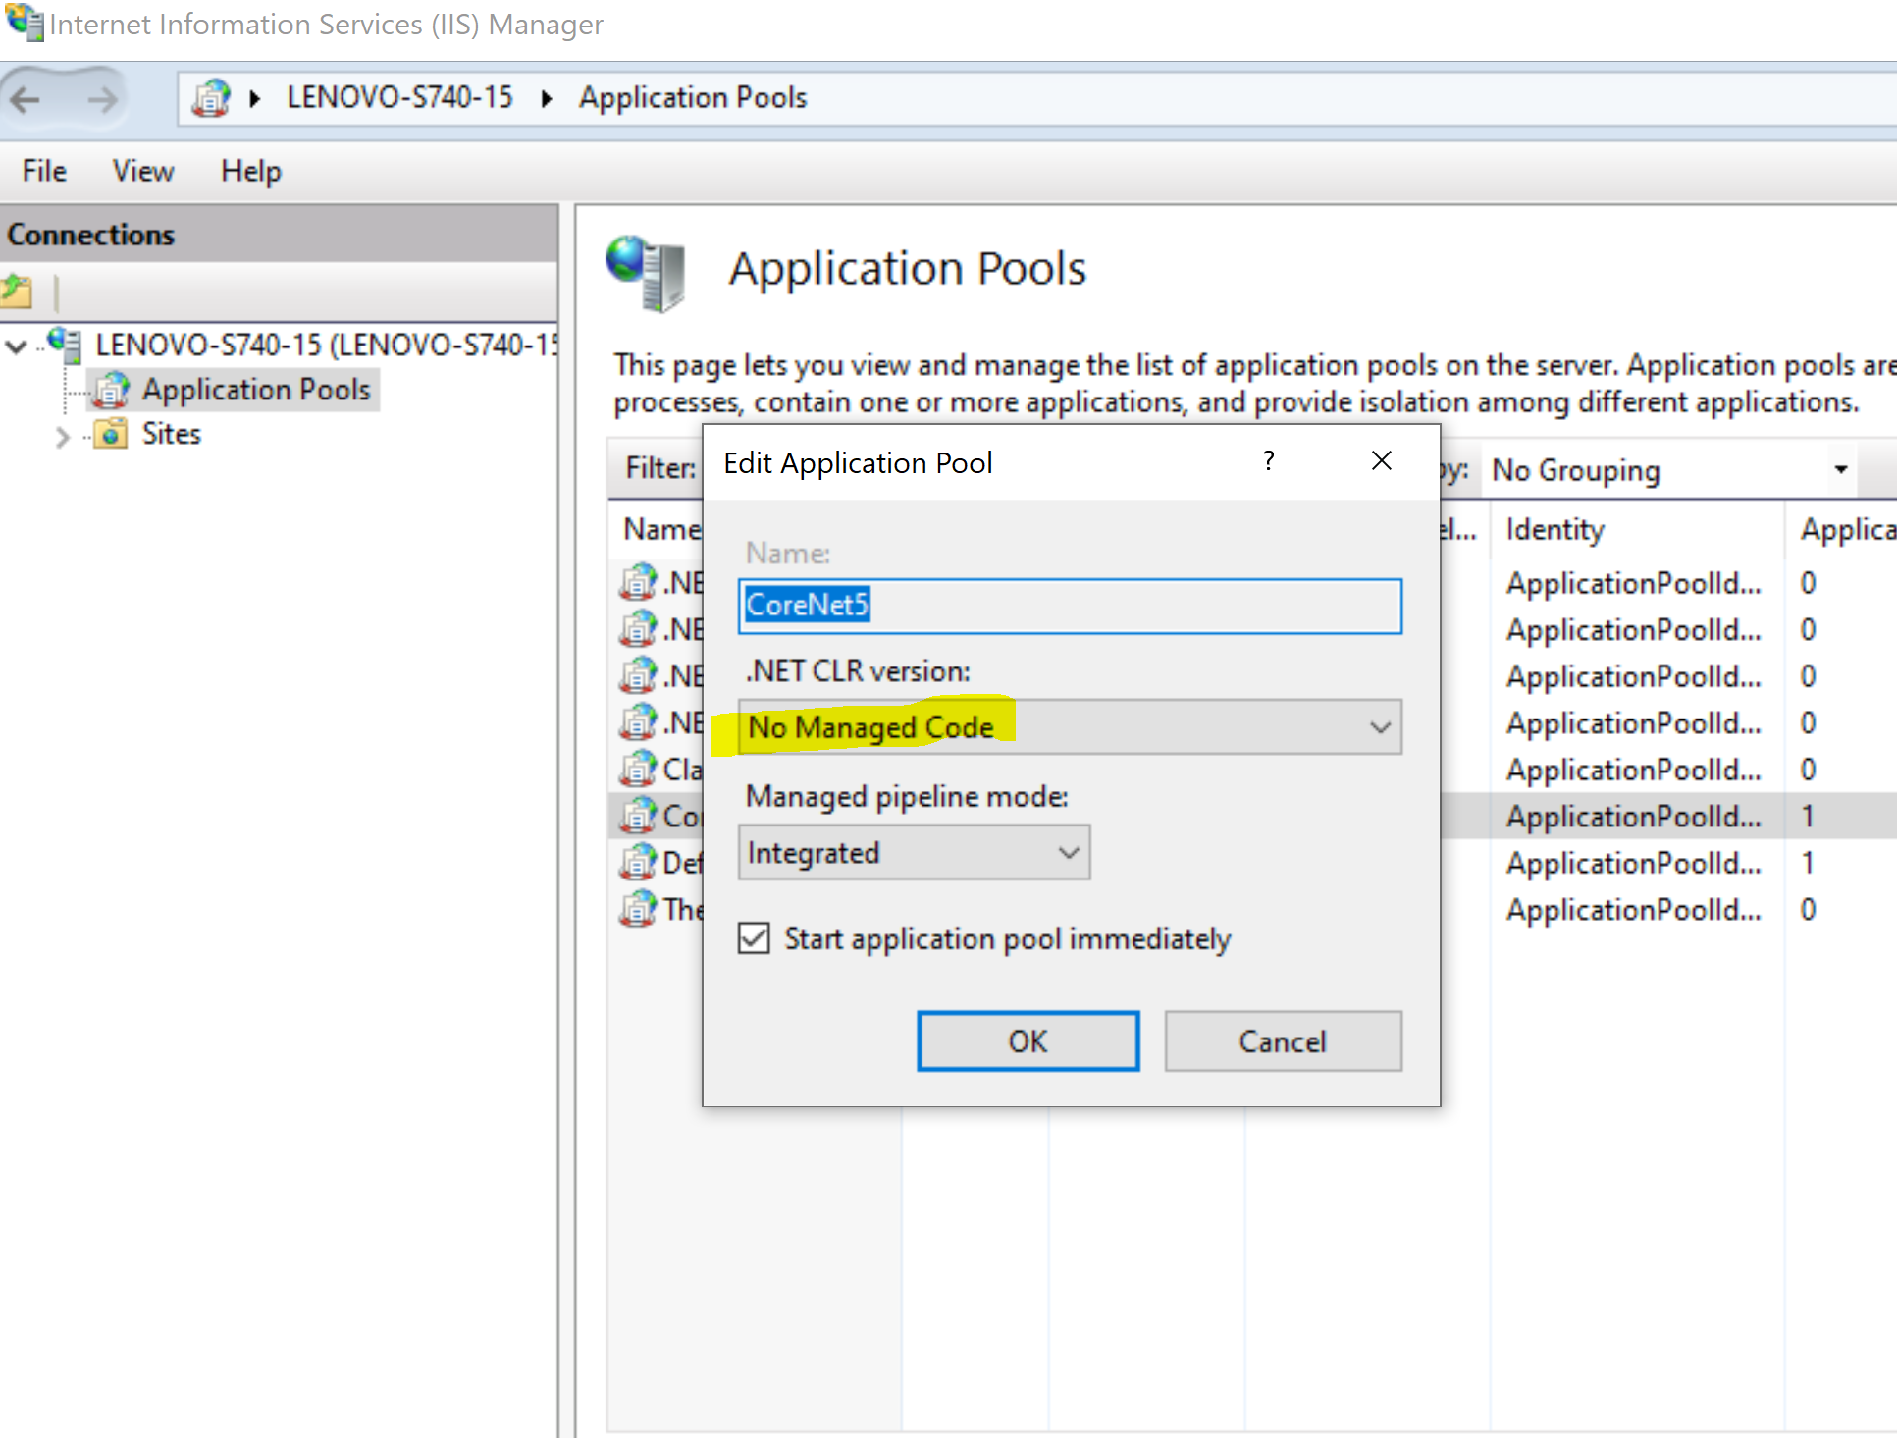

**Pool should allow 32-bit applications (in advanced settings of pool):**

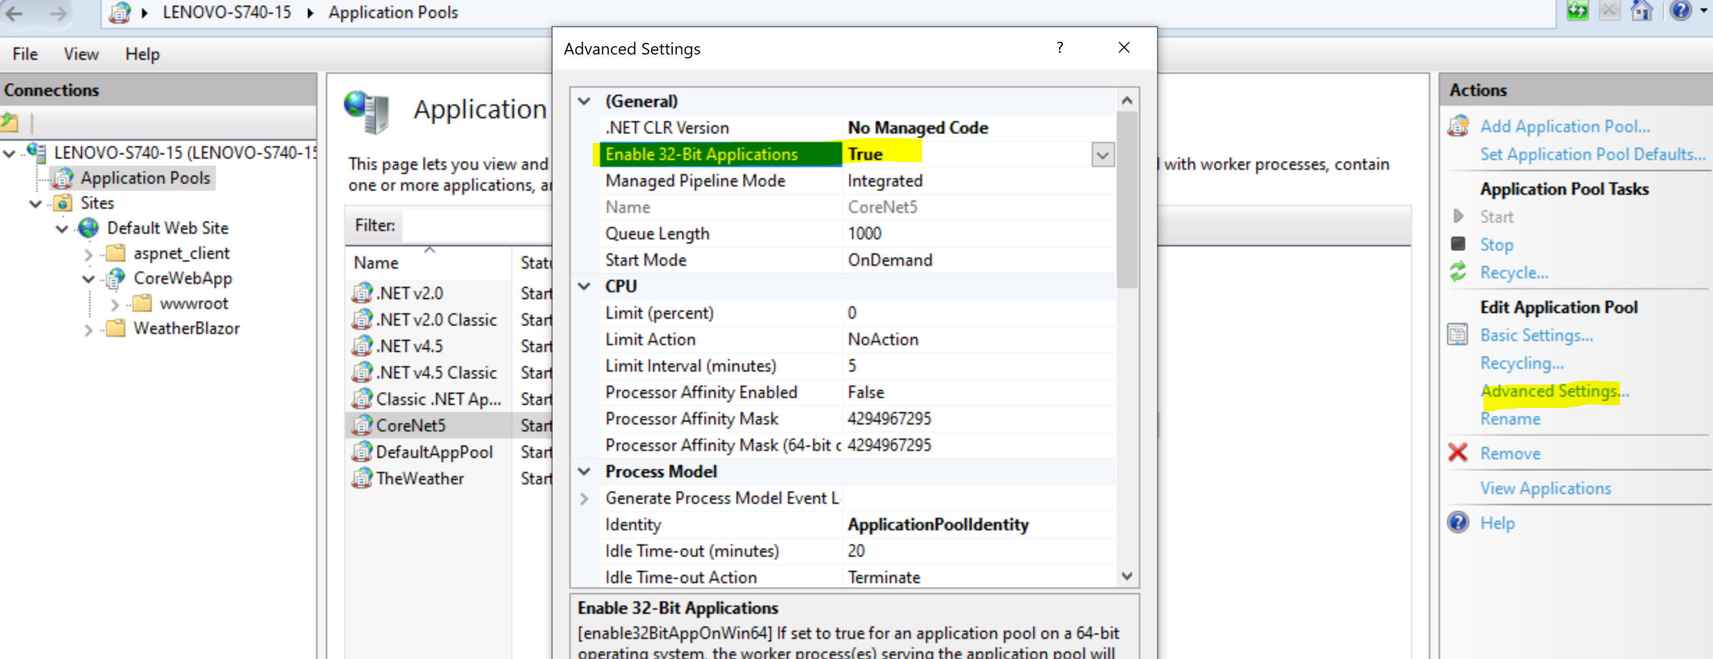

**New Application Pool will appear in the list of available pools:**

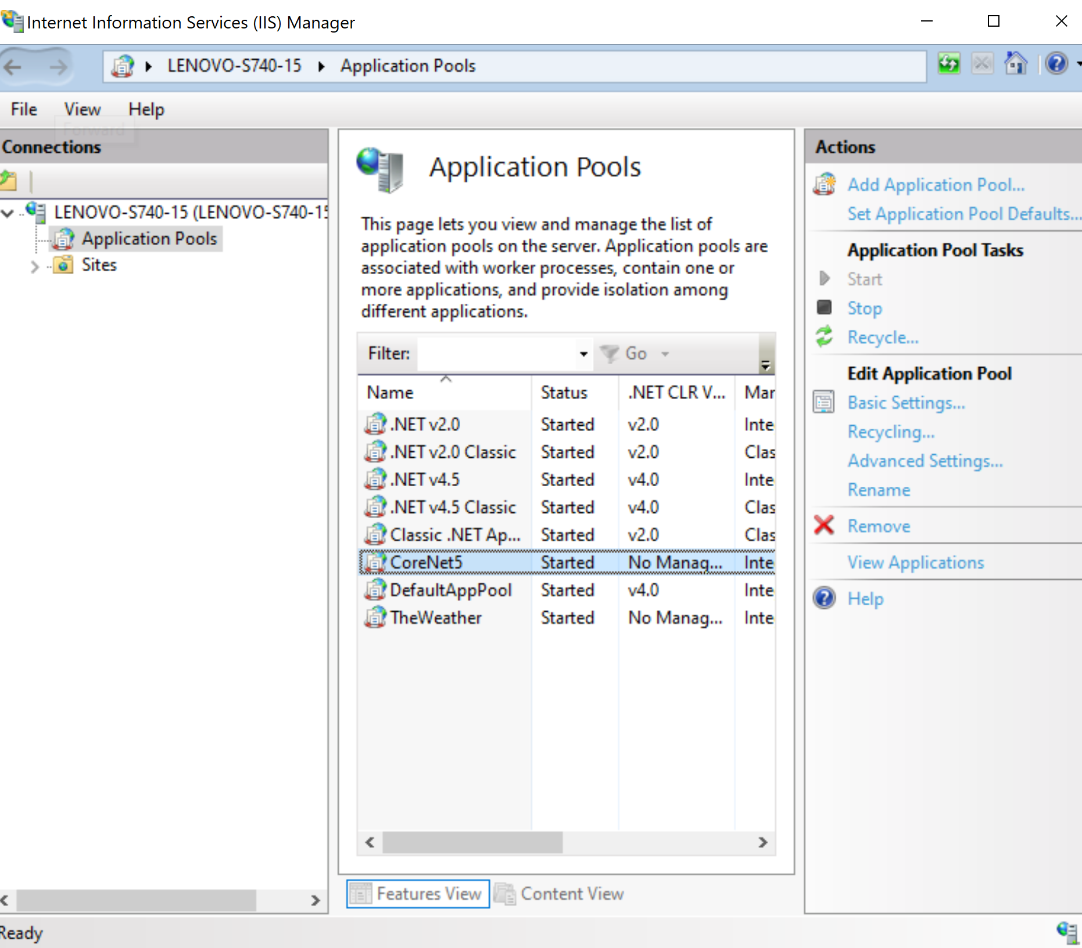

1. **Create website in IIS: Expand Sites, right click on Default Web Sites and choose Add Application. Fill required fields and click Select and choose application pool CoreNet5:**

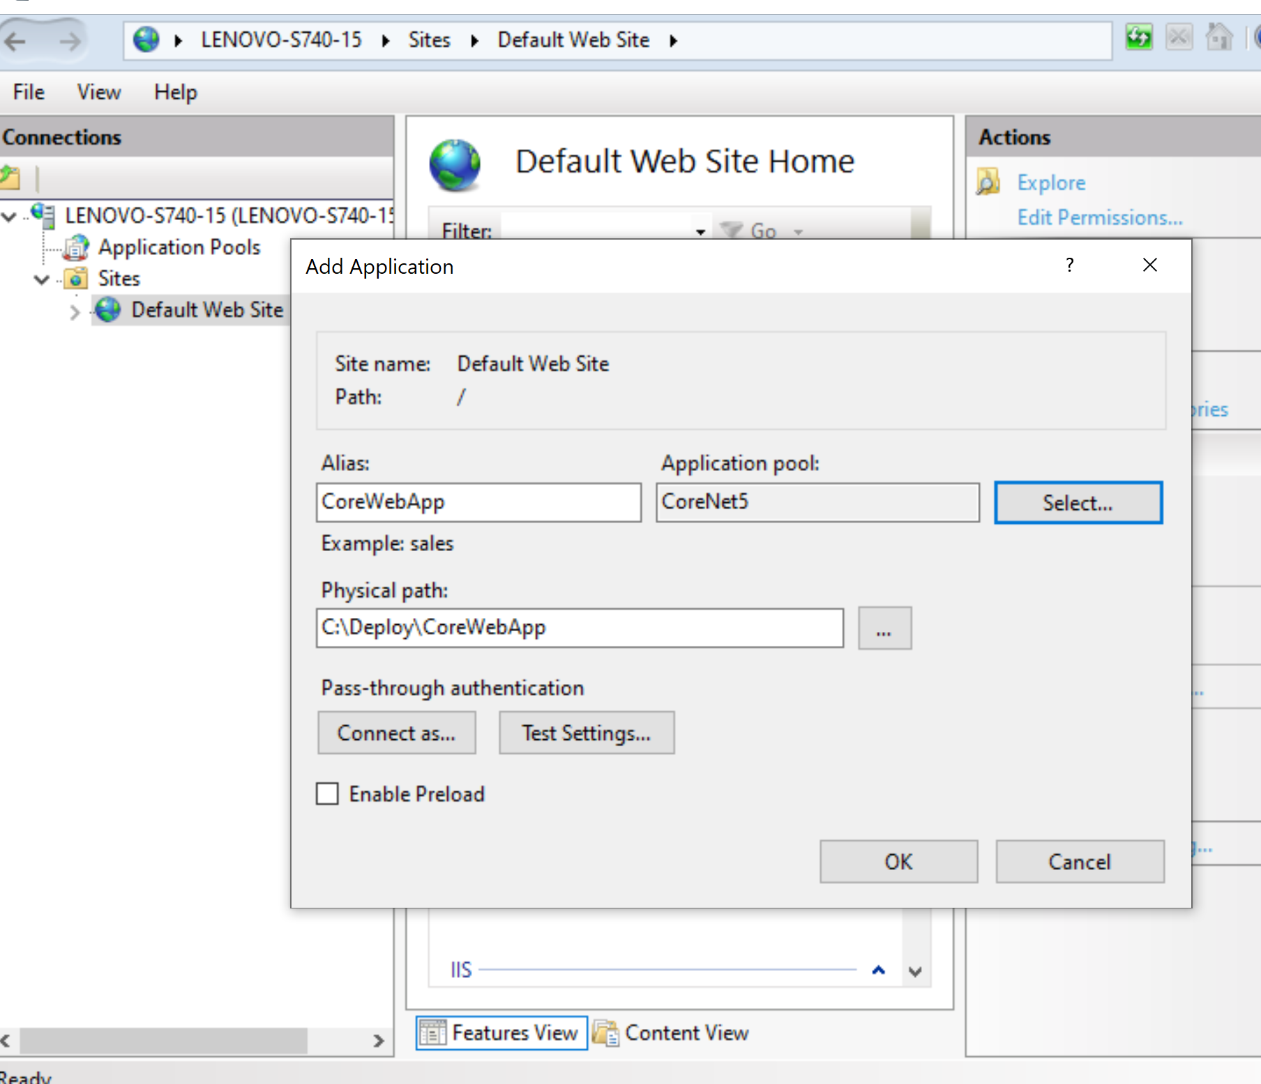

**Click Ok.**

**Application should be available by** <http://localhost/CoreWebApp>**:**

