Some tests:

1. Enter City Montreal and click Get Weather:

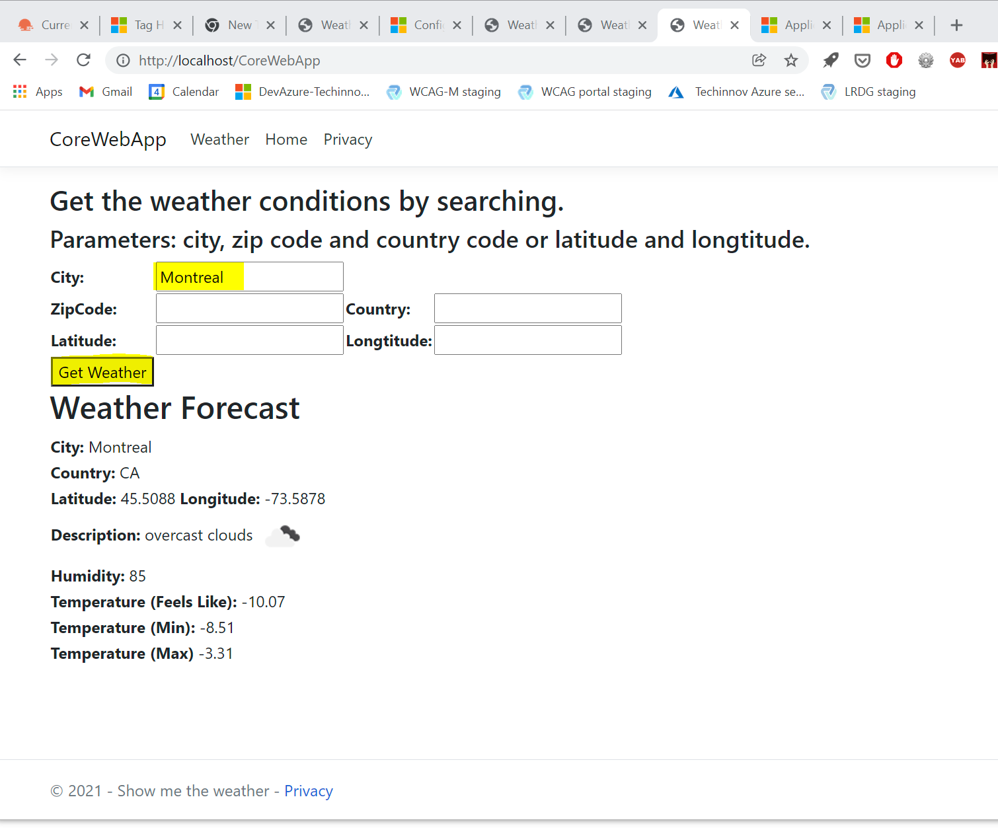

1. Enter city Paris and click Get Weather:

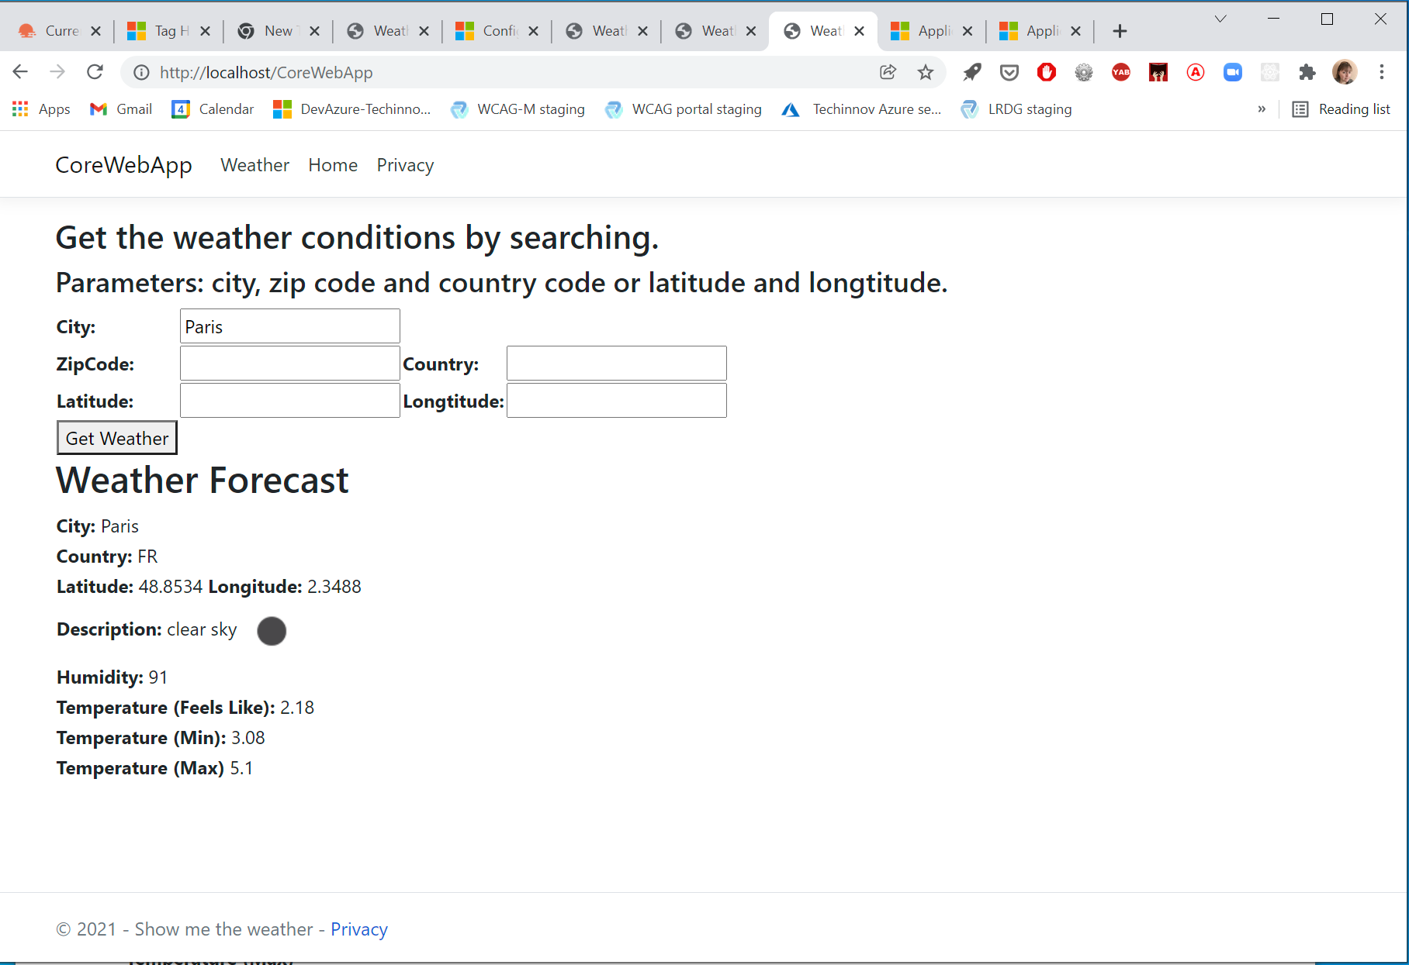

1. Enter unexisting City:

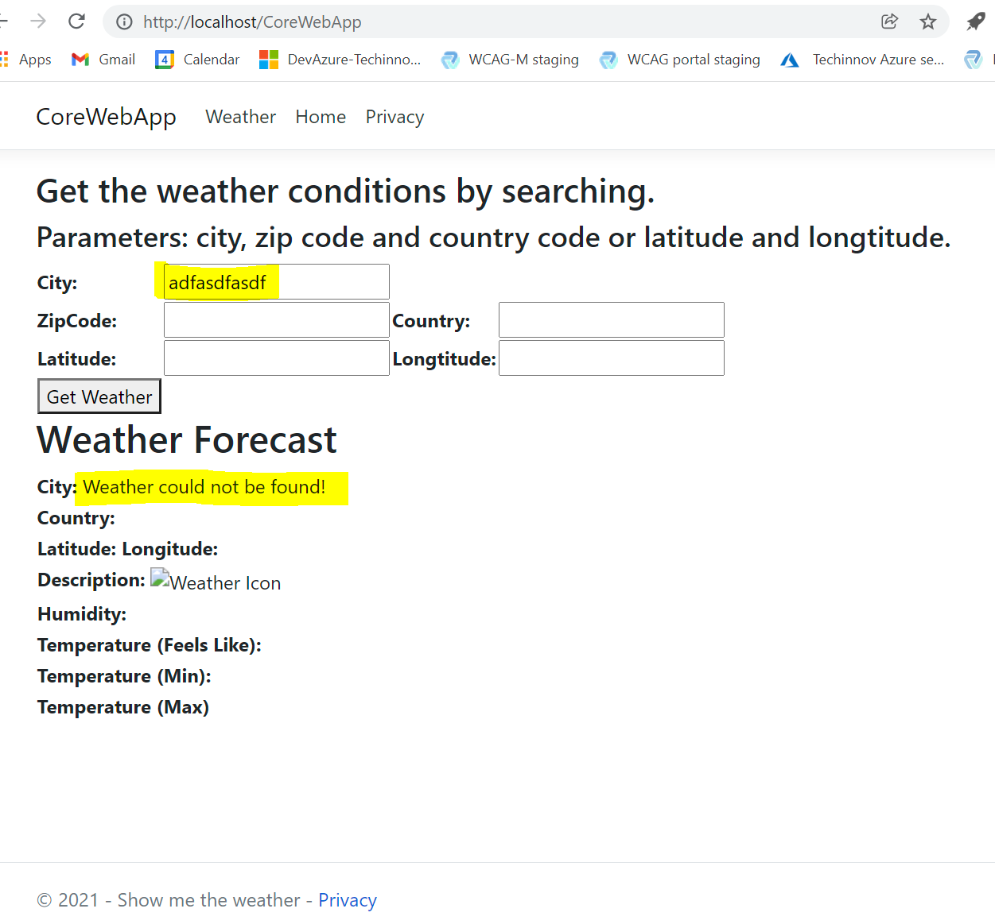

1. Input: Zip Code and Country:

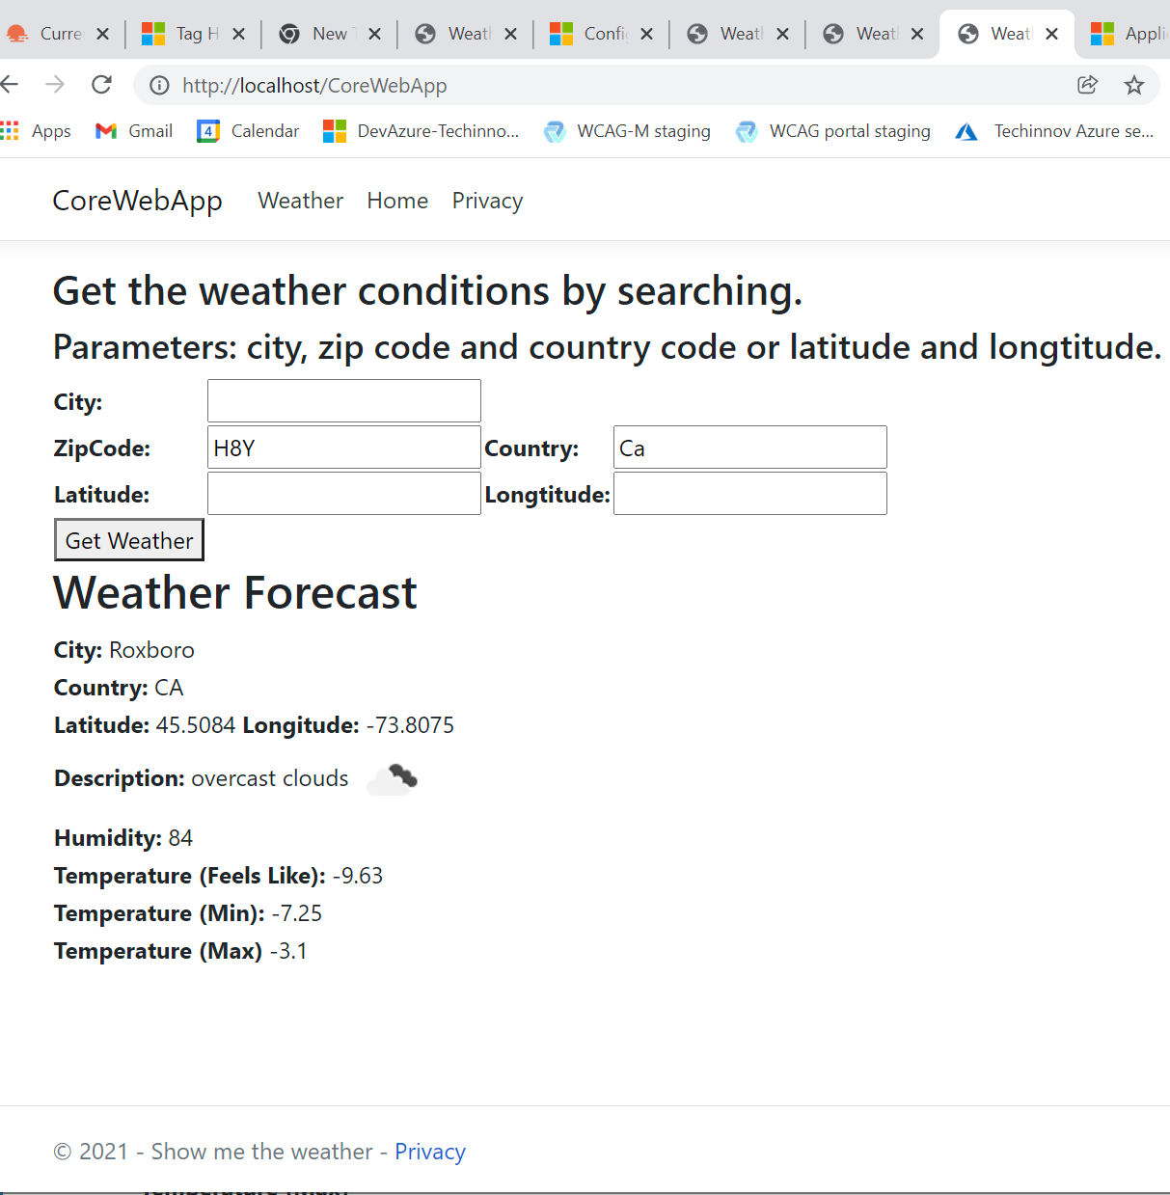

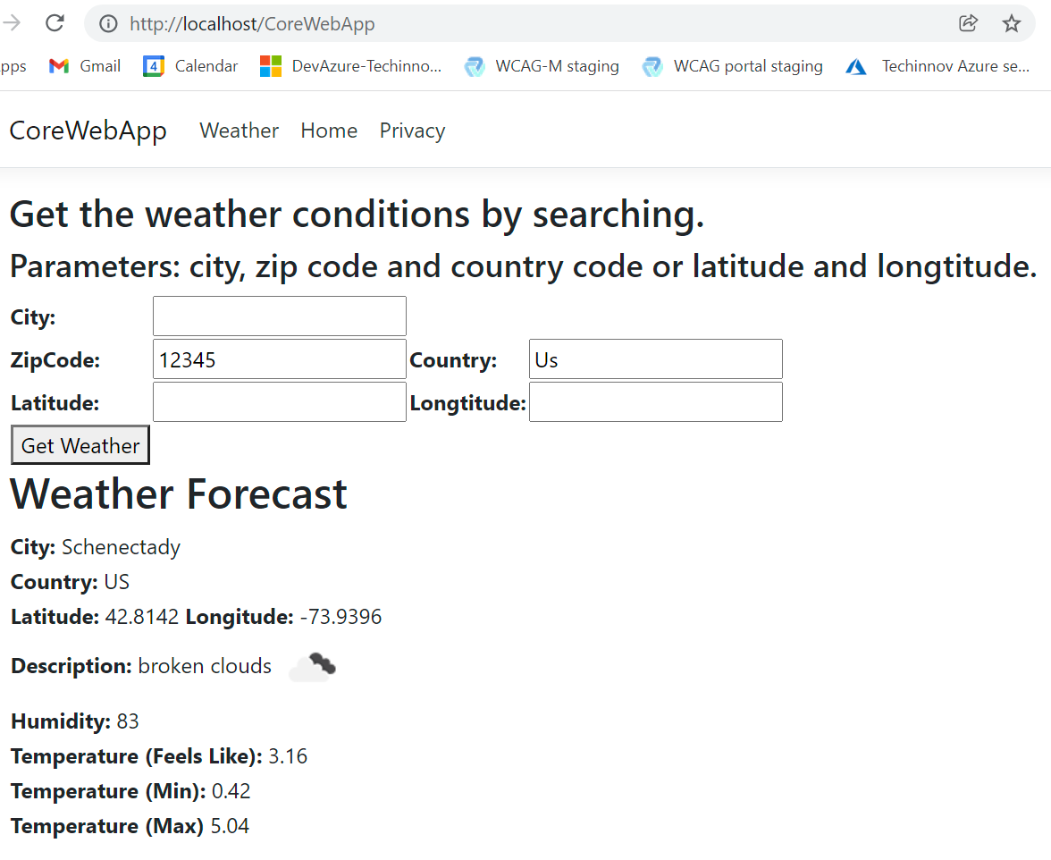

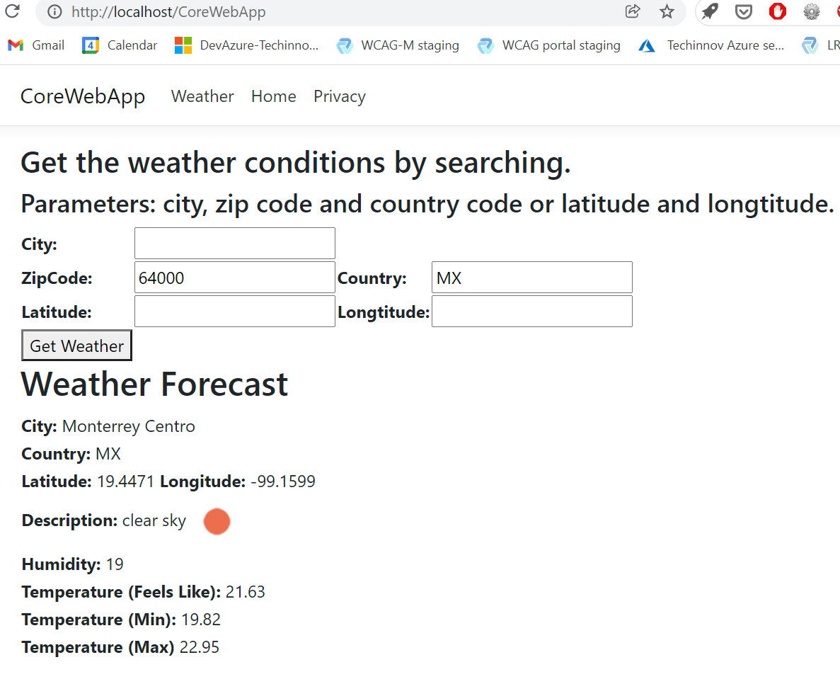

Some valid ZipCode/Country can’t be found: tried for Russia and Ukraine can’t find.

Get weather by GPS coordinates:

