
srs document
Computer programming 1

eM -LAB
University of Namibia
project
Group 1

Table of Contents Page
1.Introduction ...........................................................................................................1
1.1 Project title and team information...........................................................................1
1.2 Purpose of the document....................................................................................... 1
1.3 Scope of the system…………………………………………………………………………………… 1-2
1.4 Engineering domain and problem statement………………………………………………....... 2
2.System overview.................................................................................................2
2.1 System Description ................................................................................................3
2.2 Target User .............................................................................................................3
2.3 Technology Overview ………………………………………………………………………………………4
2.4 Firebase Data model ……………………………………………………………………………………...4
2.5 Assumptions and constraint ……………………………………………………………………..........5-7
3.Functional requirements...........................................................................................7
3.1 Requirements List ....................................................................................................7-9
4. Non-Functional requirements .................................................................................10
4.1 Performance ............................................................................................................10
4.2 Security....................................................................................................................10
4.3 Usability ...................................................................................................................10
4.5 Compatibility.............................................................................................................10
4.6 Reliability...................................................................................................................10
5. Use Case diagrams ....................................................................................................10
5.1 UML Use Case Diagram .............................................................................................10
5.2 Use Case Description ................................................................................................10-11

1.Introduction
1.1 Project Tittle:
EM-Lab
Team information:

Names | Student number | Course | Assigned role
1.Nitrato JM | 221070478 | Civil | Project Manager
2.Mokaxwa AKN | 22411233 | Civil | Project Manager
3.Jakob ANM | 225114682 | Electrical | Firebase
4.Muhendje KK | 225048477 | Agriculture | UI/UX
5.Kambala ANN | 225054310 | Mining | Documentation lead
6.Nailenge MN | 225105578 | Electrical | Documentation lead
7.Erasmus ES | 224144723 | Electrical | Lead developer
8.Nahango HH | 224158007 | Electrical | Documentation lead
9.Mbango IS | 222095016 | Mechanical | GitHub Manager
10. Absalom AA | 224043226 | Mechanical | Lead Developer
11.Nelondo G | 224102915 | Electronics | UI/UX
12.Tjazapi VS | 225102250 | Electrical | GitHub assistant
13.Nderura H | 222132809 | Mechanical | UI/UX
14.Hamuyela AKN | 224151444 | Electrical | Firebase
2.Munyateka PN | 225055481 | Mining | Lead Developer

1.2 Purpose of this document:
- This document describes the requirements and features of the EM-Lab app. Its main goal is to clearly explain what the app does, how it works and what is expected from it. It also helps everyone involved in this project to understand the requirements and ensure that the app is developed correctly.
1.3 Scope of the System (EM-Lab)
The EM-Lab system is mobile application designed to digitize and streamline laboratory operations with metallurgical and mineral processing environments. The system focuses on managing sample tracking, recording laboratory test results, and enabling efficient approval workflows between technicians and metallurgist.
The applications will allow users to:
- Register and manage the laboratory sample.
- Record and store test results digitally.
- View and track sample status in real time
- Approve or reject test results
- Maintain a centralized and secure database of laboratory.
The system will be developed using React Native and Expo for mobile interface and Firebase for backend services such as authentication and data storage. The application is intended to run on Android mobile devices.
The scope of the system is limited to core laboratory functionalities and does not include advanced analytics, external system integration, or complex reporting tools in its initial version.

1.4 Engineering domain and problem statement:
(i) Engineering Domain:
The EM-Lab app belongs to the Metallurgical engineering field, specifically within areas of:
- Mineral processing
- Assay laboratory operations
- Quality control and assurance
In metallurgical operations, laboratory testing plays a critical role in determining the composition and quality of minerals such as ores and concentrates. Engineers and technicians rely on accurate and timely data to make decision regarding processing efficiency, product quality, and operational adjustments.
The system supports key industry roles such as:
- Laboratory Technicians (data entry and sample handling)
- Metallurgists (analysis and approval of results)
- Quality Managers (analysis and reporting)
By digitizing this process, the system aligns with modern engineering practices that emphasize automation, data integrity, and operational efficiency.
(ii) Problem statement:
In many metallurgical laboratories, especially within mining and processing operations, critical process such as sample tracking and test result recording is still handled or through disconnected systems.
This leads to several challenges:
- Loss or misidentification of sample due to damaged or unclear paper labels
- Delays in recording and accessing test results, as data is first written on paper before being digitized.
- Lack of traceability, making it difficult to determine who handled a sample or recorded results
- Increased risk of human error, including incorrect data entry and duplication
- Inefficient communication between technicians and metallurgist, leading to delays in approvals
These issues can result in poor decision making, reduced operational efficiency, and financial losses in industrial environments.
The EM-Lab system aim to address these problems by providing a centralized digital platform that ensures accurate data recording, real-time access to information, and improved workflow efficiency.

2.System overview
2.1 System description:
The system supports full workflow of metallurgical operations, starting from when a sample is received up to when results are approved and used for decision making. When a sample arrive at the laboratory, they are registered in the system using unique ID, along with important details such as the source and date. This makes it easy to track each sample and avoids confusion or loss.
After testing, technicians enter results directly into the system instead of writing them on paper. This reduces mistakes and makes the results instantly available as paper may be lost.
Metallurgist can then review these results in the system and either approve or reject them. Once approved, the results are saved as official records and cannot be changed, ensuring reliability and traceability.
For smelting operations, furnace operators use the system to log temperature readings throughout their shift. The system keeps a record of these readings and provides warnings if temperature go outside the required range.
The system also allows users to view data, track trends, and generate reports, helping improve efficiency and decision making.

2.2 Target User
1.Laboratory Technicians:
Technical level: Basic to Intermediate
Environment: Metallurgical laboratory (sample preparation, fire essay, moisture test)
2.Metallurgist:
Technical level: Advanced (engineering + data analysis)
Environment: Process plant + smelter operations
3.Lab manager:
Technical level: Advanced (Quality systems and compliance)
Environment: Laboratory and Administrative office
4.Furnance Operator:
- Technical level: Basic to Intermediate
- Environment: Field + office (mine and site reporting)

2.3 Technology Overview:
EM-Lab is developed using modern cross transform and cloud-based technologies to ensure scalability, ease of maintenance and real time data synchronization across users in different environments.
2.3.1 Reactive native with Expo;
The mobile application is built using React native with Expo.
- Reactive native allows the development of a single codebase that runs on Android devices only, reducing development time and maintenance effort.
- Expo provides a development environment that simplifies app building, testing, and deployment.
2.3.2 Firebase:
The system uses Google Firebase as its backend infrastructure. It provides several integrated services used in the system:
- Firebase Fire store: used to store sample data, test results, furnace logs and user information.
- Firebase Authentication: Manages user login and access control for different roles such as technicians, metallurgists and managers.
- Real time Data Sync: Ensure that updates are instantly visible to all authorized users.
2.3.3
2.3.3 System Architecture:
The system follows a client cloud architecture:
- Mobile App: Built with react native responsible for user interaction, data entry and display results.
- Firebase: Handles data storage, authentication, real time sync and access control.

2.4 Firebase Fire store Data Model:
Collections Overview:
- Companies
- users
- samples
- test results
- furnaces
- temperature logs
- notifications
COMPANIES (companies)
companyName: string
createdBy: userId
createdAt: timestamp
isActive: boolean
USERS (Users)
fullName: string
email: string
role: lab technician | furnace operator | metallurgist | lab_manager
companyId: string
employeeId: string
phone: string
isActive: boolean
createdAt: timestamp
INVITES (invites)
email: string
role: lab_technician | furnace_operator | metallurgist
companyId: string
invitedBy: userId
status: pending | accepted | expired
createdAt: timestamp
expiresAt: timestamp
SAMPLES (samples)

companyId: string
sampleCode: string
sampleType: string
source: string
description: string
priority: low | medium | high
status: received | in_furnace | testing | completed
receivedBy: userId
receivedAt: timestamp
FURNACE OPERATIONS (furnace_operations)
companyId: string
sampleId: string
loadedBy: userId
temperature:
duration: number
status: pending | running | completed
startedAt: timestamp
completedAt: timestamp
TESTS (tests) companyId: string
sampleId: string
testType: string
assignedTo: userId
assignedBy: userId
status: pending | running | completed
startedAt: timestamp
completedAt: timestamp
images: array
RESULTS (results)
companyId: string
testId: string
sampleId: string
values: map
unit: string
images: array
recordedBy: userId
recordedAt: timestamp
approvalStatus: pending | verified | approved | rejected
verifiedBy: userId
verifiedAt: timestamp
finalApprovedBy: userId
finalApprovedAt: timestamp
remarks: string
ACTIVITY LOGS (activity_logs)
action: string
userId: string
companyId: string
sampleId: string
testId: string
resultId: string
timestamp: timestamp
details: string
NOTIFICATIONS (notifications)
userId: string
companyId: string
message: string
type: string
read: boolean
createdAt: timestamp
2.5 Assumptions and constraint:
2.5.1 Assumptions
The following assumptions are made during the design and development of the system:
- Users (laboratory technicians, metallurgists, and furnace operators) have basic digital literacy and can operate mobile applications.
- Mobile devices (Android smartphones or tablets) are available in laboratory and plant environments.
- Users will have periodic access to an internet connection for data synchronization with Firebase.
- Each sample and test process follows a defined workflow within the organization.
- Organizations using the system will assign unique identifiers for samples and furnaces.
- Users will comply with standard operating procedures for data entry and validation.
2.5.2 Constraints
The system is subject to the following constraints:
- Network Dependency: The system relies on internet connectivity for real-time synchronization with Firebase. Limited or unstable connectivity may affect real-time updates.
- Mobile Device Limitations: Performance and usability depend on the capabilities of Android
- Firebase Limitations: The system is constrained by Firebase Fire store quotas, including storage limits, read/write operations, and pricing tiers.
- Security and Access Control: User access is restricted based on roles defined in the system (e.g., technician, metallurgist, manager), limiting unauthorized actions.
- Data Accuracy Dependence: The reliability of system outputs depends on correct manual input from users during sample registration and test entry.
- Environmental Conditions: Some users operate in harsh industrial environments (heat, dust, noise), which may affect device handling and timely data entry.
3.Functional requirements
3.1 Requirements List:
🔹 User Authentication
- Users must log in using secure credentials
- Role-based access (Technician, Metallurgist, Operator, Admin)
🔹 Sample Management
- Create new sample
- Assign unique Sample ID
- Capture:
- Source (pit/blast/client)
- Date
- Project name
- Search and view sample details
🔹 Test Result Management
- Add test results to a sample
- Select test type (Cu %, U %, moisture, etc.)
- Input value + unit
- Submit results
🔹 Approval Workflow
Metallurgist can:
- Approve results
- Reject results with comments
- Approved results become read-only (locked)
🔹 Furnace Temperature Logging
- Select furnace
- Record hourly temperature
- Store timestamp automatically
- Display recent logs
🔹 Alerts & Notifications
- Notify metallurgist when results are submitted
- Alert operator if temperature exceeds limits
🔹 Reporting & Analytics
- View trends (e.g., grade over time)
- Filter by:
- Date
- Source
- Project
- Export reports
5. Non-Functional Requirements:
🔹 Performance
System must respond within 2 seconds
🔹 Reliability
Data must not be lost (cloud storage via Firebase)
🔹 Usability
Simple mobile interface (field-friendly)
🔹 Security
Role-based access control
Secure authentication
🔹 Scalability
Must support multiple sites
- Use Case diagrams
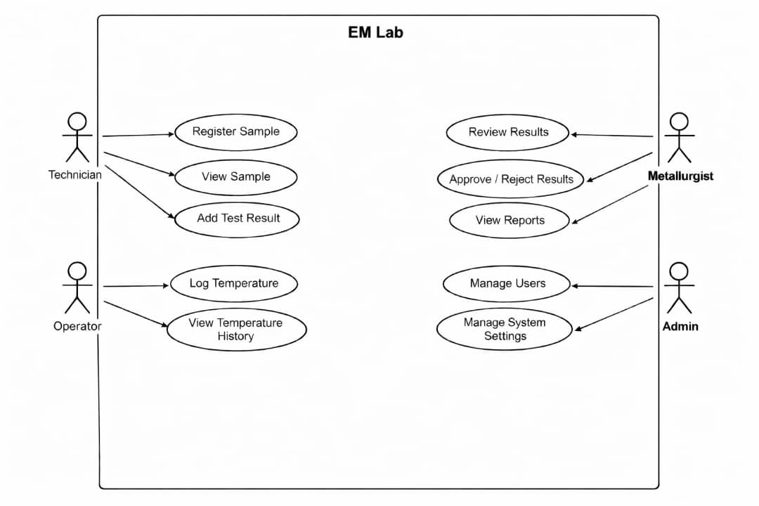
5.2 Use Case Description
🎭 Actors:
- Technician
- Metallurgist
- Operator
- Admin
📌 Main Use Cases:
1.Technician:
- Register Sample
- View Sample
- Add Test Result
2. Metallurgist:
- Review Results
- Approve/Reject Results
- View Reports
3. Operator:
- Log Temperature
- View Temperature History
4. Admin:
- Manage Users
- Manage System Settings

