TimeSheet Application

Note - Ids are auto generated for all except user table.

Database Schema
Consultant
ColumnName | Primary Key | Foreign Key | References | Required
Id | Yes
UserId | Yes | Yes | User | Yes
JobTitle |  |  |  | No
DateStarted |  |  |  | No
Address ( embedded ) |  | Yes | Address | No
DateOfBirth |  |  |  | No

Address ( Embeddable)
ColumnName | Primary Key | Foreign Key | References | Required
CompanyName
AddressLine1 |  |  |  | Yes
AddressLine2
AddressLine3
AddressLine4
AddressLine5
State |  |  |  | Yes
Country |  |  |  | Yes
ZipCode |  |  |  | Yes
City

CSV for test format
[UserId],[Job Title],[Date Started],[Address Line1],[Address Line2],[Address Line3],[Address Line 4],[Address Line 5],[State],[Country],[ZipCode],[City],[Date of Birth]
ConsultantContract
ColumnName | Primary Key | Foreign Key | References | Required
Id | Yes |  |  | Yes
ClientCompanyId |  | Yes | Company | Yes
ConsultantId |  | Yes | Consultant | Yes
DateStarted |  |  |  | No
HourlyRateCharged |  |  |  | No
Currency |  |  |  | No
EndDate
IsClosed
ProjectName

Company
ColumnName | Primary Key | Foreign Key | References | Required
Id | Yes |  |  | Yes
Company Name |  |  |  | Yes
Address ( Embedded ) |  | Yes |  | Yes
Type ( Client or Consultant ) |  |  |  | Yes

User
ColumnName | Primary Key | Foreign Key | References | Required
UserId | Yes
FirstName |  |  |  | Yes
LastName |  |  |  | Yes
MiddleName |  |  |  | No
CompanyId |  | Yes | Company | Yes
CompanyType
Roles |  |  |  | Yes

Aprovee
ColumnName | Primary Key | Foreign Key | References | Required
UserId |  | Yes | User
Type |  |  |  | Yes

Approvals
ColumnName | Primary Key | Foreign Key | References | Required
Id | Key
AproveeUserId |  | Yes | Aprovee
ContractIds ( Set of contact Ids ) |  | Yes | Contract

TimeSheet
ColumnName | Primary Key | Foreign Key | References | Required
Id | Yes |  |  | Yes
ContractId |  | Yes | Contract | Yes
ApprovedBy |  | Yes | User
Status
RejectReason
WeekStarting
Owner |  | Yes | User
TotalHoursWorked
TotalDaysWorked
TimeSheetEntries
TimeStamps ( embedded )

TimeSheetsTimeStamps ( embeddable )
SubmittedDate
CreatedDate
RejectedDate
ApprovedDate

TimeSheetEntry
ColumnName | Primary Key | Foreign Key | References | Required
Id | Yes |  |  | Yes
Date |  |  |  | Yes
NumberOfHours |  |  |  | Yes
Description
WorkTypeRef |  | Yes | WorkType | Yes
TimeSheetId |  | Yes | TimeSheet
PortionOfDay

WorkType ( NOT IN USE CURRENTLY )
ColumnName | Primary Key | Foreign Key | References | Required
Id | Yes
WorkType
Paid/Unpaid |  |  |  | Yes

ContactDetails
ColumnName | Primary Key | Foreign Key | References | Required
UserId | Yes
EmailAddress
FaxNumber
WorkPhoneNumber
EmergencyPhoneNumber

WaitingApproval
ColumnName | Primary Key | Foreign Key | References | Required
Id
TimeSheetId
AproveeSet

Waiting Approval needs transactional support.

ColumnName | Primary Key | Foreign Key | References | Required
Id
TimeSheetId
Owner

WaitingCorrection

Only update table if time sheet has been updated.
Only remove from list if has been accepted or rejected

Possibly New tables -
User Preferences
Client Preferences
Some concept of System Values

Database Model

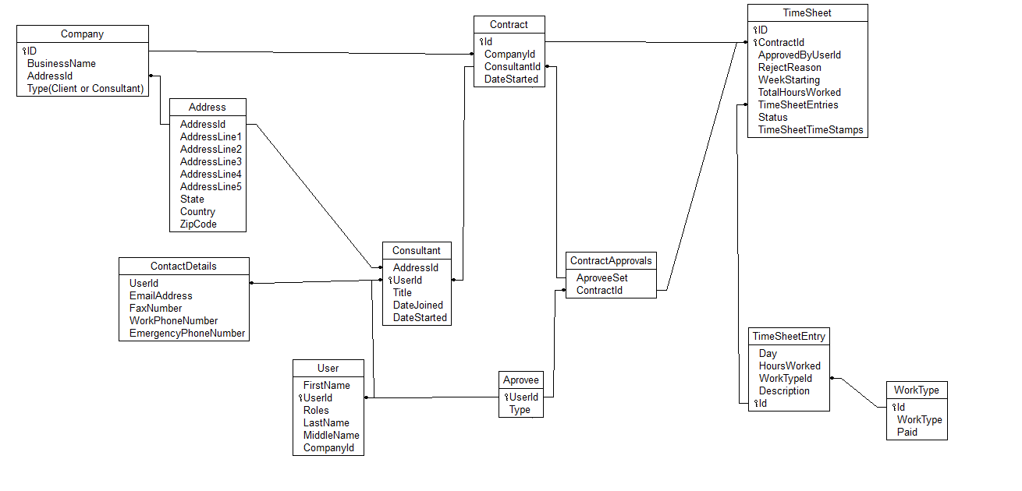

Use Cases

Consultant
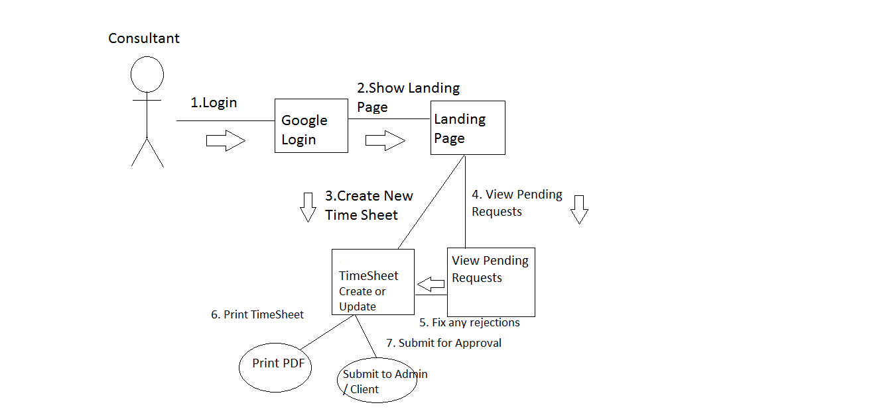
Queries Required ( Pseudo code )
1) For Creating new Time Sheet
- Find all open contracts for logged in user.
- If more than one then select from list.
- Find User Details.
- Find Company Details
2) For finding rejected time-sheets
- Find all TimeSheets for the logged in user where TimeSheet is Submitted and Rejected
3) Saving TimeSheet
- Stamp submitted date, submitted, total hours worked ( calculated from timesheet entry), startdate, all time sheet entries and save record

Time Sheet Entries
Fill in days of week / dates from WeekStarting
Save other Info
4) Updating Time sheet ( For correction )
Find all info from TimeSheet where id = xxx

Aprovee

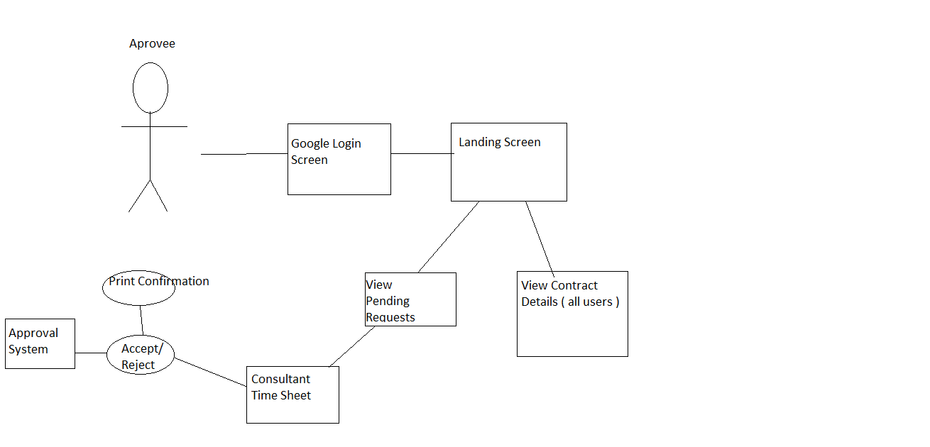
View pending requests
Find all Contract Ids from Aprovals where Aprovee is logged in user
Find all TimeSheets for found Contract Ids Order By UserId where submitted Is true and Not ( approved or rejected )
( Go to TimeSheets query to see how to gather time Sheet Info )

View Contract Details
Find my company from user table companyId
Lookup contracts where companyId=my companyId
List all consultants working and the rates they're working at

Accept / Reject
Mark found timeSheet as approved or rejected and mark approvedByUserId, and rejectedReason if rejected.

Admin
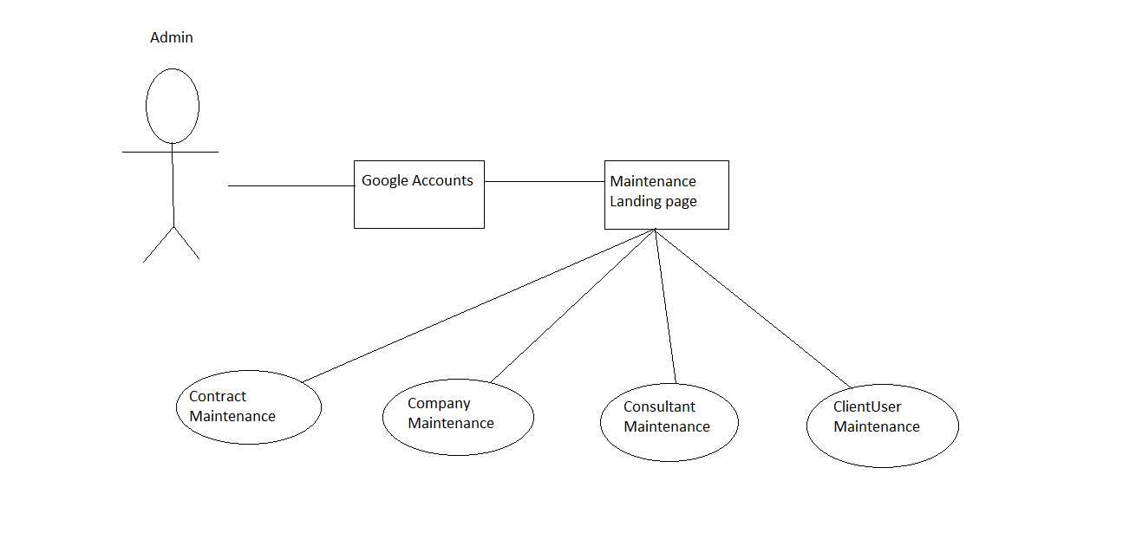

Reports Admin

