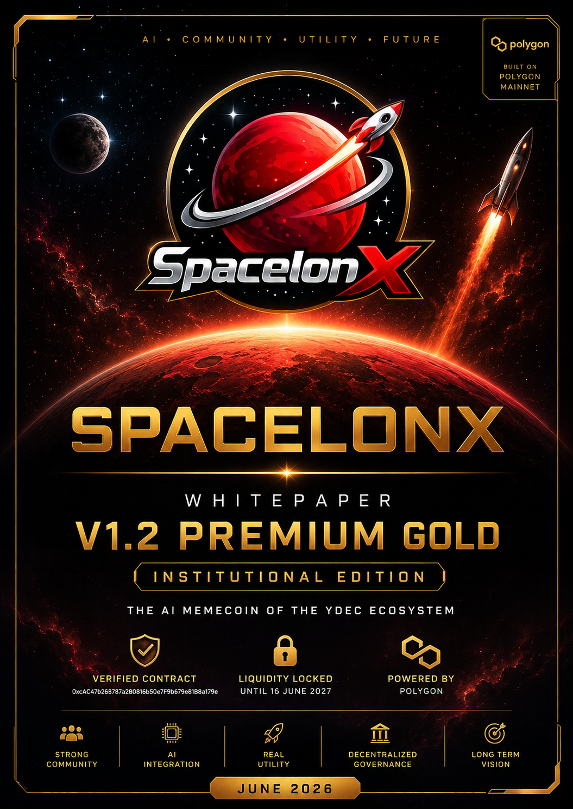

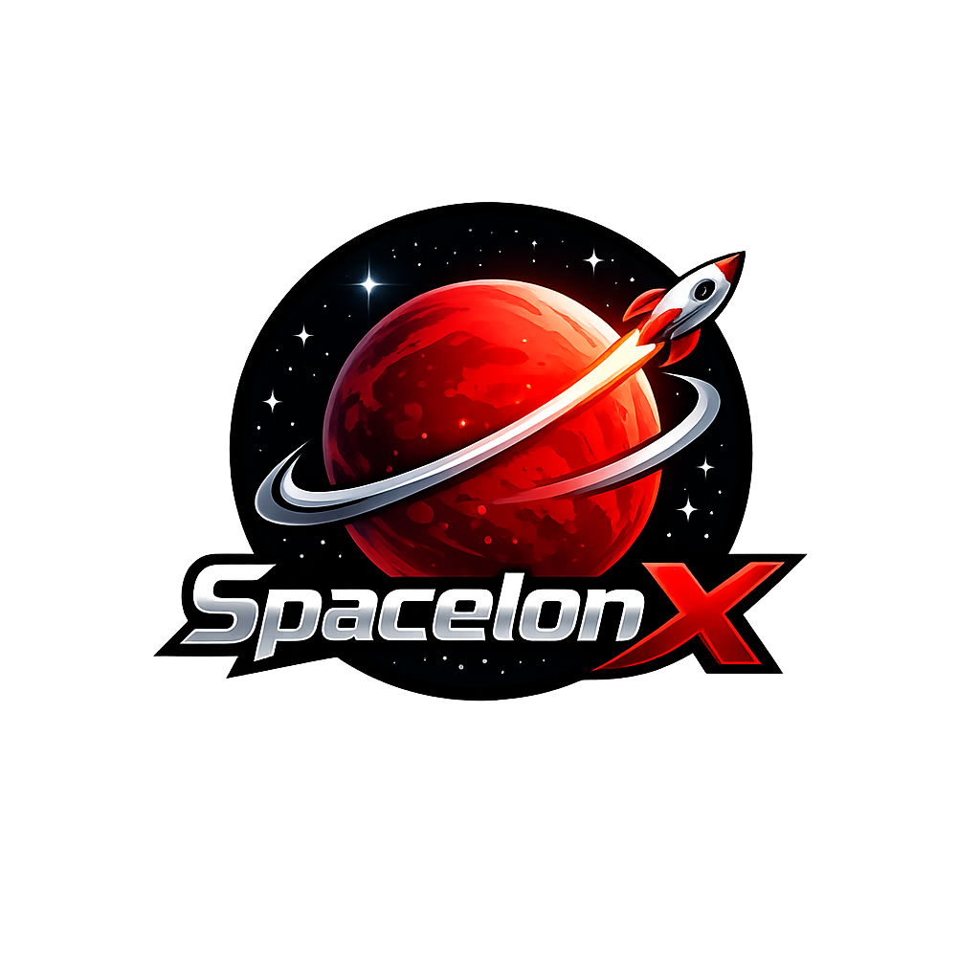
SPACELONX (SLX)
WHITEPAPER V1.2 PREMIUM GOLD
INSTITUTIONAL EDITION
The AI Memecoin of the YDEC Ecosystem | Polygon Mainnet | June 2026
Executive Summary
SpacelonX (SLX) is an AI-oriented memecoin deployed on Polygon Mainnet. The project is designed to connect community culture with practical digital services, decentralized governance and progressive utility inside the YDEC ecosystem.
The project aims to move beyond purely speculative memecoins by developing holder-focused services such as Nenette AI, staking, DAO governance, premium access layers and future integrations with YDEC-CALL, Oracle, Jarvis, Nono and Gouvernor Bank.
This Institutional Edition presents the official project narrative, token information, tokenomics, roadmap, staking model, governance framework and CoinGecko readiness package.
Official Project Information
Project name | SpacelonX
Ticker | SLX
Category | AI Memecoin
Blockchain | Polygon Mainnet
Token standard | ERC-20
Decimals | 18
Total supply | 10,000,000,000 SLX
Contract | 0xcAC47b268787a280816b50e7F9b679e81B8a179e
Website | https://silversurfer239.github.io/spacelonx-site/index.html
X | https://x.com/spacelonxslx
Telegram | https://t.me/spacelonx_community
Team | Anonymous Team
Vision
Bringing AI, Community and Utility to the Memecoin Universe.
SpacelonX is built around four core pillars: community, artificial intelligence, decentralized governance and long-term ecosystem development.
Why SpacelonX
Most memecoins are driven mainly by short-term market attention. SLX introduces a more structured model where community engagement is progressively connected to utility, access rights, governance and AI-powered services.
The objective is not to replace speculation entirely, but to support it with a more credible foundation, a visible roadmap and measurable project infrastructure.
Technical Overview
SLX is deployed on Polygon Mainnet as an ERC-20 token. Polygon was selected for low transaction costs, broad EVM compatibility and accessibility for retail users.
The SLX smart contract is verified on PolygonScan. Liquidity is deployed through QuickSwap V2 and the LP lock is presented as a core transparency element for the community.

Tokenomics
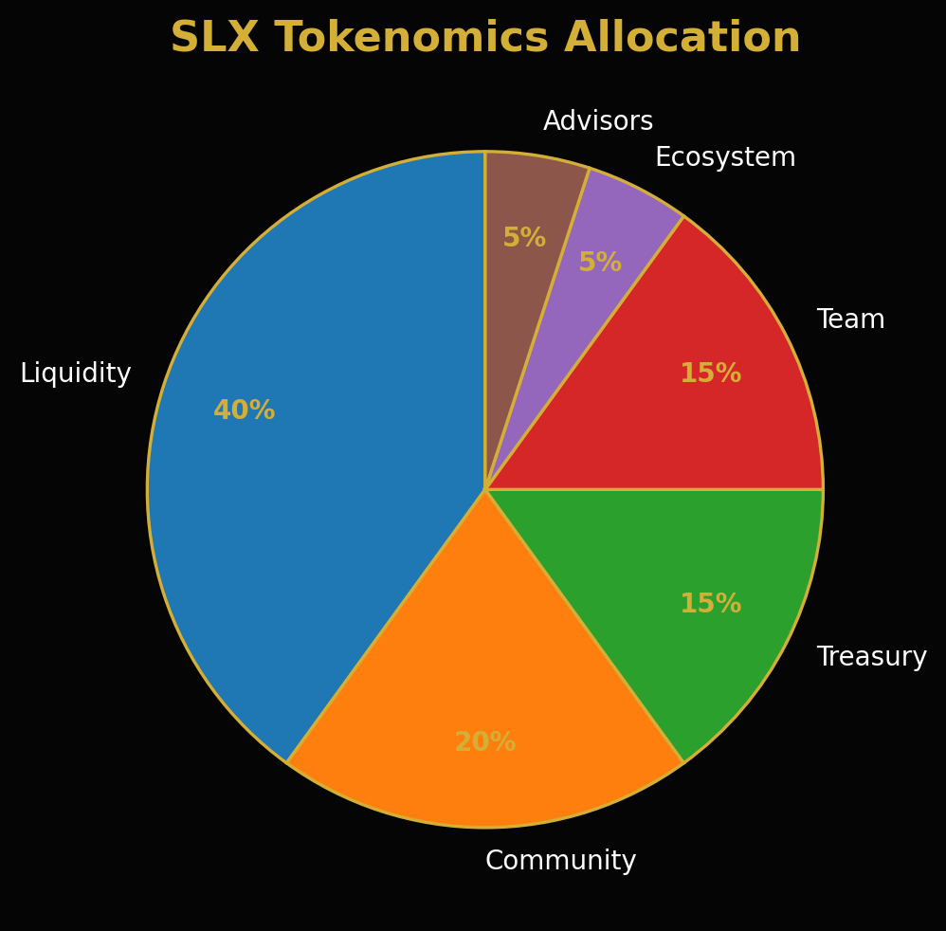
Allocation | Percentage
Liquidity | 40%
Community | 20%
Treasury | 15%
Team | 15%
Ecosystem | 5%
Advisors | 5%
Vesting Framework
Team and strategic allocations are presented with a progressive vesting framework designed to support long-term alignment and reduce short-term supply pressure.
Period | Unlock
0-6 months | 0%
6-12 months | 25%
12-18 months | 50%
18-24 months | 75%
24+ months | 100%
SLX Utility Ecosystem
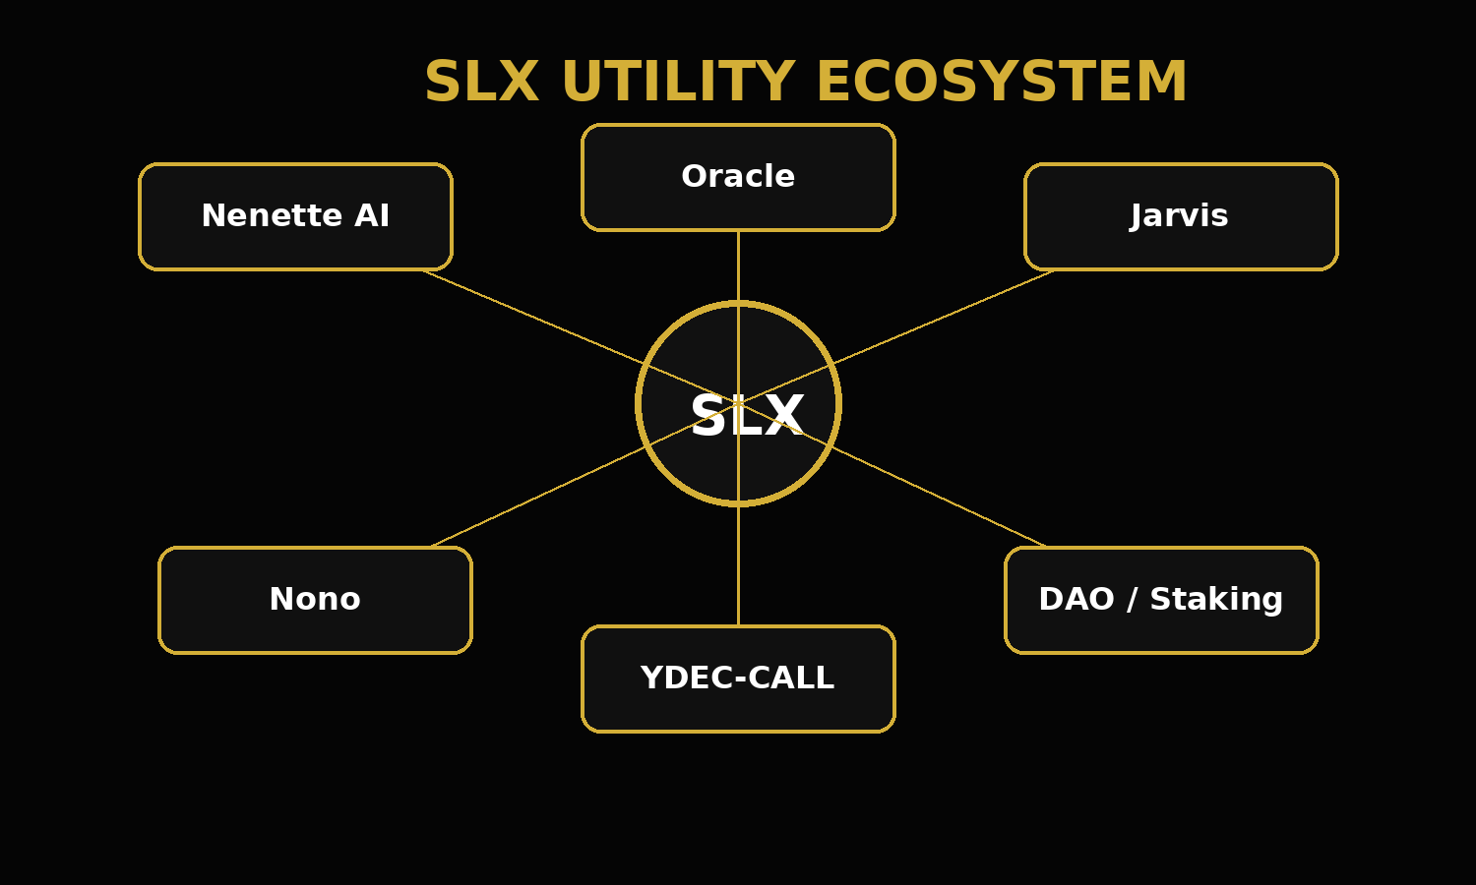
Nenette AI
Nenette AI is the planned assistant layer for SLX holders. Its purpose is to support portfolio monitoring, market alerts, DAO notifications, project updates and future integrations with the broader YDEC ecosystem.
Advanced features may be reserved for holders or stakers depending on token balance, staking tier or DAO decisions.
Premium Holder Services
Premium access may include early feature access, AI assistant tools, community badges, DAO participation rights and possible future airdrops.
Indicative tiers: Starter - 100,000 SLX; Premium - 500,000 SLX; VIP - 1,000,000 SLX.
Staking Model
The staking model is designed as a long-term community retention mechanism. The following APRs are indicative and may be adjusted before smart contract deployment or DAO validation.
30 days: 5% APR; 90 days: 12% APR; 180 days: 20% APR; 365 days: 35% APR.
DAO Governance
The DAO is intended to enable community participation in key project decisions. Potential voting topics include token burns, marketing budget, exchange listings, partnership priorities, treasury allocation and ecosystem development.
Roadmap 2026-2030
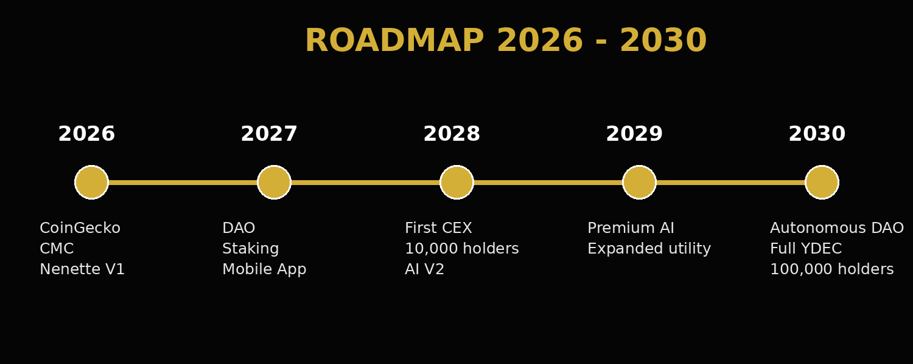
CoinGecko Readiness
The listing package should be supported by consistent public activity, a public GitHub repository, stable trading history, active social channels and a finalized whitepaper.
Recommended targets before resubmission: 500+ X followers, 300+ Telegram members, 500+ transactions, regular trading volume and weekly project updates.
Risk Disclosure
SpacelonX is an experimental digital asset project. Cryptocurrencies are volatile and may involve substantial risk of loss. This document is for information only and does not constitute financial, legal, tax or investment advice.
Users should conduct their own research before interacting with SLX or any related decentralized finance service.
Conclusion
SpacelonX aims to become more than a memecoin by combining community energy, AI-driven services, decentralized governance and a progressive utility layer across the YDEC ecosystem.

