- Open Packet sniffer [Wirehark] Application and Capture the Ethernet Interface
- Do this activity and capture frames.
  - Request for a web page from bu.edu or wiki.ros.org site which is not secured and search for some keyword (e.g., navigation) in the webpage search field and post it to the server.
- Explain the working of the HTTP protocol [HTTP GET and POST message] briefly with typed answers and answer highlighted screenshots for the above activity.
  - Analyze the sender and destination IP address, Port address and Physical address (Proxy Server)
  - Analyze the Host machine and webpage name in the file server
  - Check the acknowledgement frame for successful request and the unsuccessful request
  - Analyze how the uploaded data has reached the server
  - Find the following from frames received for the above activity
    - Is your browser running HTTP version 1.0 or 1.1? What version of HTTP is the server running? Ans:1.1
    - What languages (if any) does your browser indicate that it can accept to the server? Ans: En-US
    - What is the status code returned from the server to your browser? Ans:200 OK
    - When the HTML file that you are retrieving was last modified at the server? Ans:15th May 2017
    - How many bytes of content are being returned to your browser Ans: 368 B
    - By inspecting the raw data in the packet content window, do you see any headers within the data that are not displayed in the packet-listing window? If so, name one. Ans: Header length:20 Bytes

    - Can you tell whether your browser downloaded the two images serially, or whether they were downloaded from the two web sites in parallel? Explain.
- What is the server’s response (status code and phrase) in response to the initial HTTP GET message from your browser? Ans: Success
Make sure these sites are not secured since wireshark may not capture requests to/from if https is used.
- Open AUMS and download a file. Stop capture. Using statistics tools find the time taken for downloading the file. Answer : 1.217472s
- Open vidya(or any other website) and download a video file. Find the number of routing endpoints visited and the switches visited. Find the packet length transmitted and received, give the protocol hierarchy and the Flow graph
Answer : ENDPOINTS:
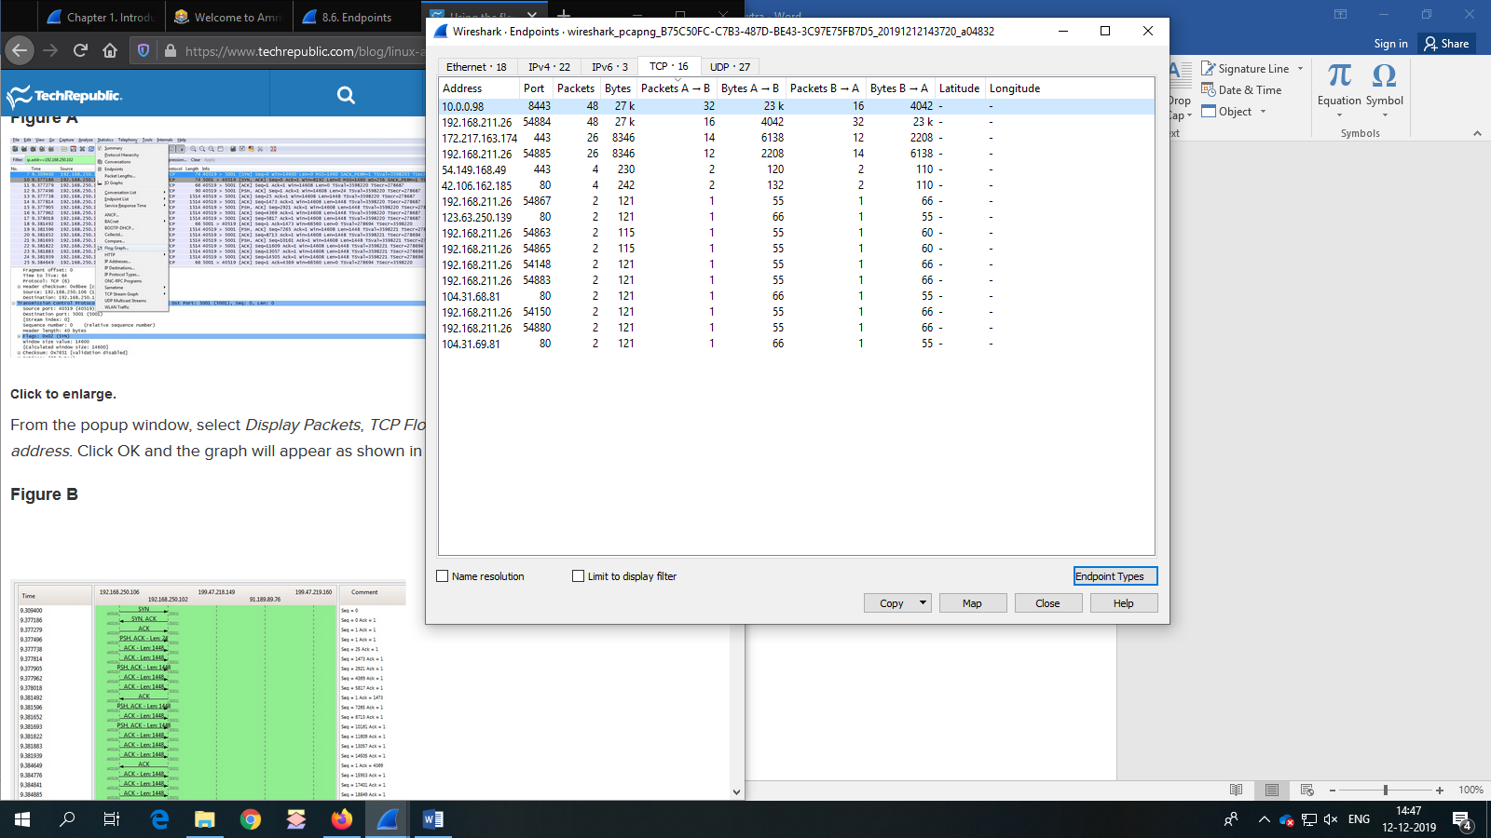

PROTOCOL HEIRARCHY:
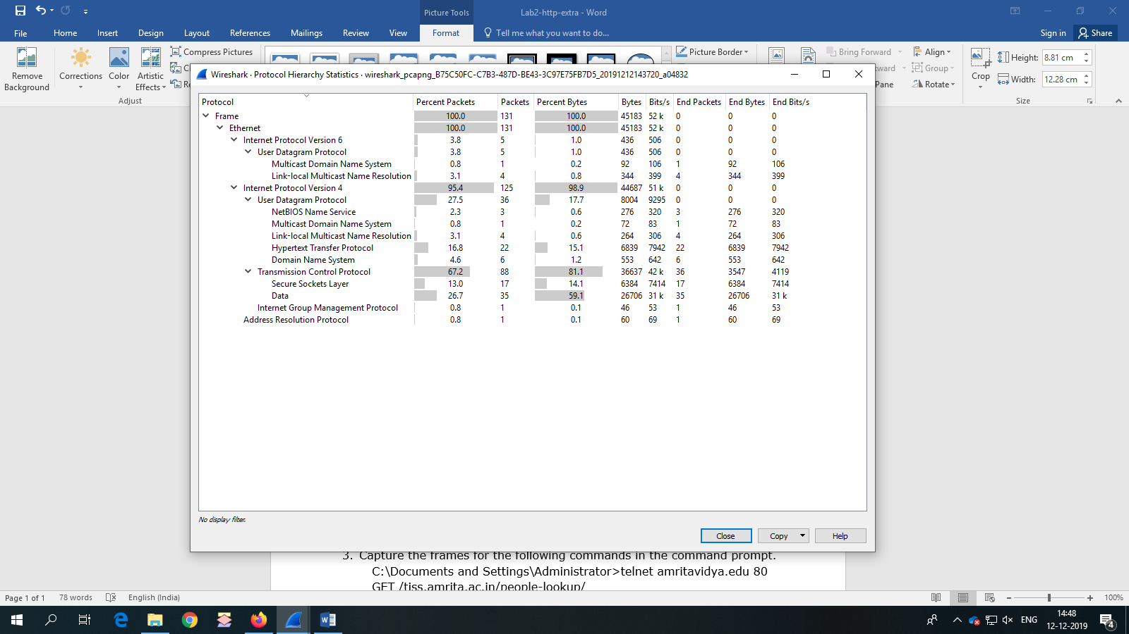

FLOW GRAPH:
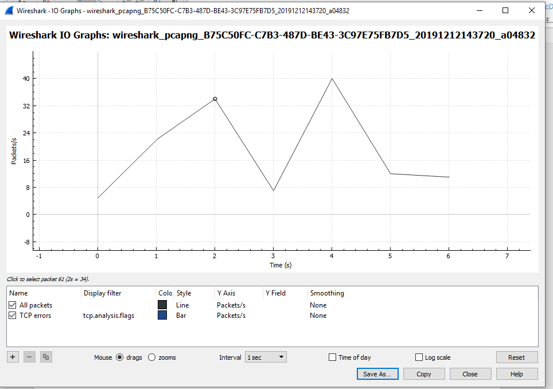

- Capture the frames for the following commands in the command prompt.
C:\Documents and Settings\Administrator>telnet amritavidya.edu 80
GET /tiss.amrita.ac.in/people-lookup/

