Investment operations workflow guide
  - Trade file validation and exception handling
Portfolio demonstration Version 1.0 November 2 2026
This guide demonstrates how an operations team can prepare a trade file, verify processing results, investigate exceptions and hand off cash differences for reconciliation. The proposed workflow separates preparation from approval and keeps uncertain upload outcomes open until they are confirmed.
The operating model, systems and examples are fictional. No employer procedures, client information or real transactions are included. The companion Excel workbook provides a separate cash reconciliation example; it is not a trade file or upload automation.

Proposed improvements
Activity | Illustrative starting process | Proposed process
Intake | Files arrive without a consistent version record. | Assign a batch ID and retain an unchanged source copy.
Validation | Checks depend on individual memory. | Apply a documented field and control total checklist.
Approval | The preparer can proceed without a recorded review. | Record independent approval of the exact file version.
Upload failure | A timeout can lead to an unverified retry. | Confirm the original request status before retrying.
Handoff | Exceptions are described in separate messages. | Use a shared record with an owner, evidence and a reviewer decision.

Scope and assumptions
Version 1 covers a single currency batch and one instruction per reference. The receiving system uses a firm approved template and provides instruction level status information. Multi leg switches, allocation files, foreign exchange, investment decisions and settlement confirmation require additional controls outside this example.
The starting process above is a constructed comparison. Time savings, error reduction and employer adoption have not been measured.

Process and responsibilities
A new file version returns to validation and independent approval. An unknown upload outcome returns to status investigation, not to automatic resubmission.
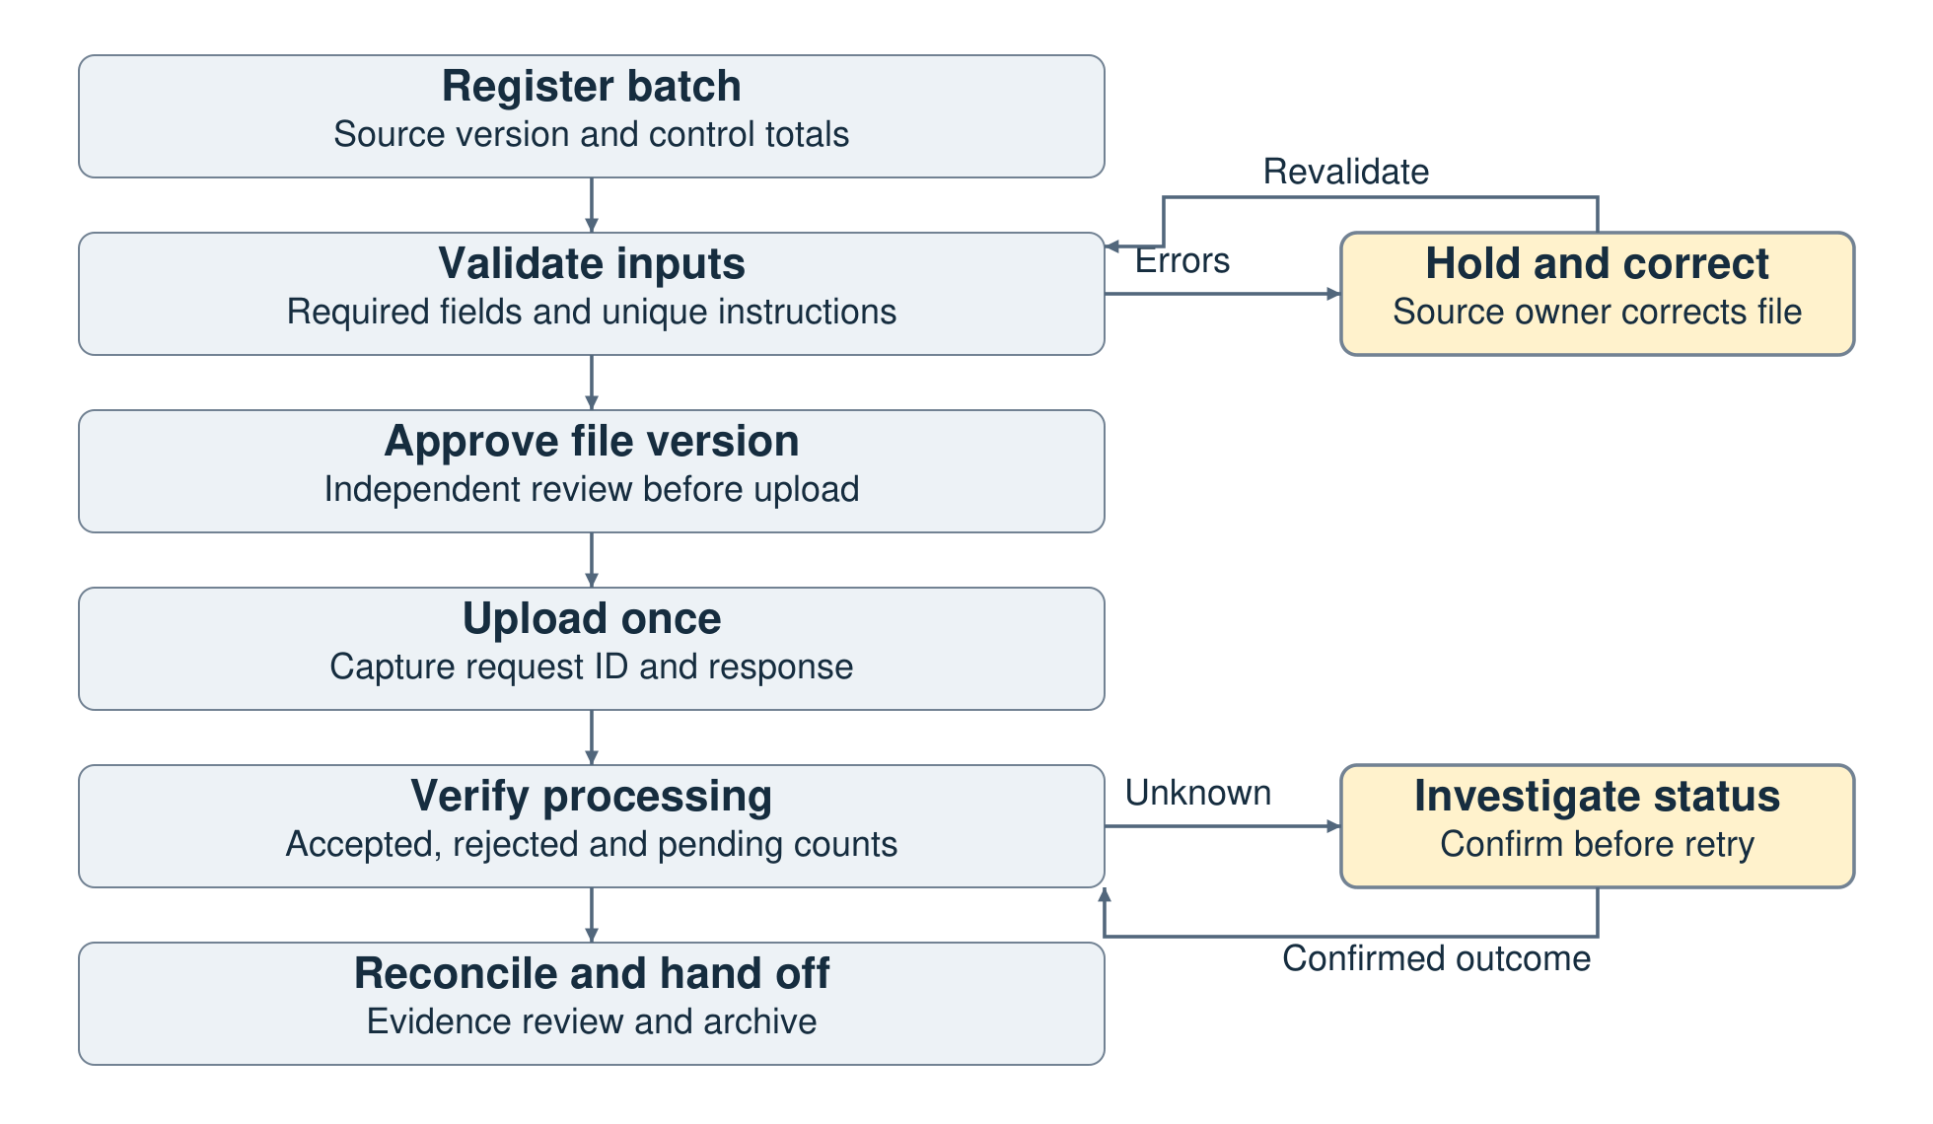

Responsibility matrix
Activity | Preparer | Reviewer | Systems support | Ops manager
Register source | R A | I | I | I
Validate file | R | A | C | I
Approve version | C | R A | C | I
Submit and verify | R | A | C | I
Resolve exceptions | R | C | R | A
Approve final handoff | R | R | C | A
R performs the work. A owns the final decision. C is consulted. I is informed. The preparer and approving reviewer are different people in this illustrative model.

File preparation and approval

1 Register the source
Assign a batch ID. Record the source filename and version, received time, expected instruction count, currency and relevant control totals. Retain the original source unchanged. Work on a versioned preparation copy and record who prepared it.

2 Validate required fields
Use the receiving system template to check account, unique instruction reference, fund or security identifier, instruction type, currency, quantity or amount, and the required trade and settlement dates. Confirm date meaning and amount direction. Missing fields and unsupported instructions stay on hold.

3 Check duplicates and totals
Check uniqueness at the instruction grain defined for this template. In this example one reference identifies one instruction for one account. Compare record count and separate debit and credit totals with the source manifest. Do not rely on a net cash total that can hide offsetting errors.

4 Obtain independent approval
Give the reviewer the exact file version, validation results, control totals and open exception list. Record the reviewer decision and time. Any correction produces a new version and requires renewed validation and approval before submission.

5 Submit the approved version once
Record the request ID, filename, version and submission time. Preserve the acknowledgement or error response. If the request times out, confirm whether it was processed before considering a retry. Do not infer rejection from a missing acknowledgement.

6 Verify the result and hand off
Account for every submitted instruction as accepted, rejected or pending. The sum of those counts must equal the submitted count. Investigate missing or duplicate responses. Accepted means received or processed at the relevant system stage; it does not by itself confirm settlement. Send cash breaks and supporting records to reconciliation.

Minimum evidence retained
Keep the original source, preparation version, validation result, independent approval, upload request ID, response file, instruction status counts and exception handoff together under the batch ID. Use the organization approved storage and retention rules in any real implementation.

Exception handling and escalation
The priorities below are proposed operating rules for this demonstration. A blocking issue stops the affected file or instruction before further processing. Other exceptions receive an owner and a due date agreed with the reviewer.
Exception | Required action | Owner | Evidence before closure
Missing or invalid field | Hold the instruction. Obtain a corrected source version and repeat validation. | Source owner | Corrected source reference and refreshed validation result.
Duplicate instruction | Compare source IDs, versions and prior request history. Establish whether it is an export duplicate or a posted duplicate. | Analyst with systems support | Original transaction evidence and an approved disposition.
Wrong account or currency | Stop processing the affected instruction and escalate to the reviewer. | Preparer and reviewer | Verified instruction details and approval of the corrected version.
Unknown upload result | Check the original request ID and processing history. Escalate if status remains uncertain. | Systems support | Confirmed accepted, rejected or pending status before any retry.
Rejected instruction | Preserve the rejection reason. Correct only the rejected population after approval. | Preparer | Rejected item list, new file version and reviewer approval.
Amount or date difference | Compare source definitions and transaction support. Quantify the difference without changing raw evidence. | Reconciliation analyst | Source support, explanation, and reviewer decision.
Potential timing item | Confirm later posting and whether the month end classification is appropriate. | Reconciliation analyst | Dated posting evidence and approval of any carrying item.

Closure conditions
An exception remains open until its disposition, evidence reference and reviewer decision are recorded. A status label alone is insufficient. Where a correction is needed, trace the approved correction to the new system record. Keep unresolved and carrying items visible in the next review.
Escalate an unknown upload status before retrying. Escalate a control total mismatch or unexplained duplicate before releasing the affected population. These rules take priority over a target processing time.

Reconciliation handoff worked example
The workbook compares fictional cash postings for October 2026 across three synthetic accounts. It contains 82 ledger rows and 80 statement rows. One statement posting on November 2 is outside the October cutoff. A comparison key combines account, currency and transaction reference.
Measure | Result
Ledger closing cash | CAD 101,855.00
Statement closing cash | CAD 112,045.00
Ledger less statement | CAD -10,190.00
Matching result | 72 of 83 keys matched with 11 exception keys
Gross absolute differences | CAD 15,880.00
Cash bridge residual | CAD 0.00 after classifying all differences

Duplicate ledger entry R0076
The ledger has two CAD 1,250 debits for the same key and the statement has one. The difference is CAD -1,250. The analyst must determine whether the duplicate arose in the extract or in posting. The workbook flags the duplicate before attempting an amount match.

Cutoff candidate R0078
The ledger shows a CAD 7,500 debit on October 30. The statement shows the same reference and amount on November 2. October includes the ledger debit and excludes the later statement posting. This is a timing candidate that requires posting evidence and review, not an automatically cleared item.

Offsetting items R0081 and R0082
Two ledger only entries of CAD +200 and CAD -200 have a combined difference of zero. Both remain open. Their gross amount is CAD 400, which makes the hidden work visible even when net cash is unchanged.

Missing reference R0080 L and R0080
Ledger record LED-0080 has no transaction reference. A statement entry has the same account, date and CAD 85 amount, but those similarities do not prove identity. Review item R0080-L quarantines the ledger record under an invalid key. It and R0080 stay open until source support establishes the correct reference.
All 11 exception reviews are open in the delivered sample. A zero bridge residual explains the CAD 10,190 difference; it does not resolve the underlying exceptions.

Measurement and acceptance checks

Workbook checks performed
The workbook was checked against an independently calculated expected result. The nine controlled input checks below restore their temporary changes before the file is saved.
Check | Expected behavior
Fee amount corrected | The matching status and linked summary update.
One cent difference | The item matches within the inclusive CAD 0.01 tolerance.
Two cent difference | The item remains an amount difference.
Closed with approval but no evidence | The review outcome remains Open.
All review prerequisites supplied | The review outcome becomes Documented.
Blank cash amount | The source row is invalid and closing cash is unavailable.
Numeric zero amount | Zero remains a valid amount rather than a missing input.
Cutoff extended through November 2 | The later posting enters scope and its date difference remains visible.
Source account changed | The source coverage control requires rebuilding the keys.

Pilot measurement and operating checklist

Measures for a future workflow pilot
Measure | Definition
First attempt acceptance rate | Instructions accepted on the first attempt divided by all submitted instructions. Pending outcomes remain in the denominator.
Time to resolution | Time from exception creation to approved closure. Report open item ages separately.
Evidence completeness | Closed items with evidence and reviewer approval divided by all closed items. Show n.a. when none are closed.
Manual touches | Recorded operator interventions per instruction, including investigations and resubmissions.
Collect a baseline before setting improvement targets. The workbook match rate is 86.7 percent because exceptions were deliberately seeded; it is not an operating benchmark. This proposed workflow has not been piloted in a production system, so no time or cost savings are claimed.

Operating checklist
Use the checklist at the start and end of a batch. A new or returning team member should complete a supervised sample and explain the unresolved cases before taking independent responsibility.
Check | Preparer initials | Reviewer initials
Original source and current file version identified
Required fields, duplicates and gross totals reviewed
Exact file version approved before submission
Every submitted instruction has a known status
Open exceptions have an owner and evidence request
Corrections and carrying items reviewed and archived

Handoff record and training review

Illustrative handoff record
Field | Example
Review ID | R0078
Account and reference | SYN-CAD-001 and TX0078
Period and cash difference | October 31 2026 and CAD -7,500.00
Observation | Ledger October 30 and statement November 2 posting dates.
Assigned owner | Reconciliation analyst
Next action | Obtain posting evidence and request a reviewer decision.
Stage and evidence | Open. Evidence not yet provided.
Reviewer decision | Pending. No carrying item has been approved.

Questions for a training walkthrough
Why is an upload timeout not proof of rejection? Why do the two CAD 200 entries remain open? What evidence is missing before R0078 can be classified and approved? Use the exception playbook and workbook to explain each answer.

References and limits
The control design draws on the general principles of independent approval, separation of duties and reconciliation described by UC San Diego. It is an original fictional procedure, not that university's policy or an employer procedure. System templates, permissions, service targets and retention rules would need to be defined before any real use.
UC San Diego Internal Controls Practices: https://blink.ucsd.edu/finance/accountability/controls/practices.html
Microsoft SUMIFS: https://support.microsoft.com/en-us/excel/functions/sumifs-function
Microsoft COUNTIFS: https://support.microsoft.com/en-gb/excel/functions/countifs-function

