Machine Learning Algorithms Documentation

Geiser, Gruen, Hefti, Kuster

08/01/2021

Table of Contents

**Data preparation** **Dataset - German Housing Data** Dataset of housing prices in the german market, scraped from Immo Scout24 and made available on <https://www.kaggle.com/scriptsultan/german-house-prices> The dataset contains 10’318 observations with 20 variables (containing continuous, categorical variables as well as count data)

**For the sake of keeping the document short, some code or/and output will not be shown in the document**

Origin data set cleaned and graphically analysed with different plots (scatterplots, boxplots, barplots etc.), variables transformed to integers and/or count data, right skewed variables log transformed and added to the dataframe.

# Week 1 - Linear Models

**Data Visualisation and Linear regressions**

## Scatterplot with regression line for log(Price) against log(Living_space)

We plot the response variable log(Price) against the predictor log(Living_Space) to get a first impression. The plot displays that there is may a positive correlation between the two variables. We further investigate this by a fitting a simple linear regression. 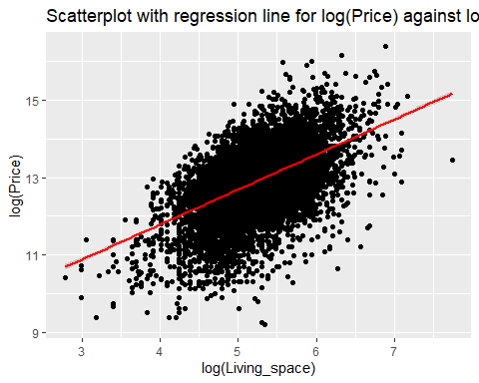

## Fitting a Simple Linear regression of log.price against log.living and check the coefficients

#linear model  
lm.log.price_living <- lm(log.price ~ log.living, data = data1)  
summary(lm.log.price_living)

##   
## Call:  
## lm(formula = log.price ~ log.living, data = data1)  
##   
## Residuals:  
## Min 1Q Median 3Q Max   
## -3.7836 -0.4079 0.0856 0.4683 2.7581   
##   
## Coefficients:  
## Estimate Std. Error t value Pr(>|t|)   
## (Intercept) 8.17522 0.07596 107.62 <0.0000000000000002 ***  
## log.living 0.90280 0.01455 62.05 <0.0000000000000002 ***  
## ---  
## Signif. codes: 0 '***' 0.001 '**' 0.01 '*' 0.05 '.' 0.1 ' ' 1  
##   
## Residual standard error: 0.7145 on 10316 degrees of freedom  
## Multiple R-squared: 0.2718, Adjusted R-squared: 0.2717   
## F-statistic: 3850 on 1 and 10316 DF, p-value: < 0.00000000000000022

#estimated regression coefficients including p-values  
coef(lm.log.price_living)

## (Intercept) log.living   
## 8.1752232 0.9028032

exp(coef(lm.log.price_living))

## (Intercept) log.living   
## 3551.847713 2.466508

**Result:** very significant p-values for log.price ~ log.living. We can assume that the variable log.living has an effect on the dependent variable log.price with a positive correlation, meaning: if the log.living parameter increases in value also the Price of the property will increase.

Due to the log transformation of the variables we have to exponentiate the values before the interpretation. For the intercept exp(8.17522)= 3551.84 and the slope exp(0.9028)=2.47, looking the p-values, which are very small, we have a strong evidence that the slope of log.living is not flat and therefore the variable has an effect on the log.price variable.

## Linear regression of log.price against log.living including the Type and finding the intercept for the different Types

##linear model  
lm.log.price_living_type <- lm(data = data1, log.price ~ log.living + Type)  
summary(lm.log.price_living_type)

##   
## Call:  
## lm(formula = log.price ~ log.living + Type, data = data1)  
##   
## Residuals:  
## Min 1Q Median 3Q Max   
## -3.9802 -0.3849 0.0716 0.4556 2.7356   
##   
## Coefficients:  
## Estimate Std. Error t value Pr(>|t|)   
## (Intercept) 7.47225 0.09409 79.414 < 0.0000000000000002 ***  
## log.living 0.99691 0.01679 59.378 < 0.0000000000000002 ***  
## TypeBungalow 0.24691 0.05737 4.304 0.000016956457415 ***  
## TypeCastle -0.33356 0.31169 -1.070 0.284573   
## TypeCorner house -0.14759 0.06058 -2.436 0.014857 *   
## TypeDuplex -0.06320 0.03900 -1.620 0.105186   
## TypeFarmhouse 0.26026 0.04599 5.659 0.000000015603919 ***  
## TypeMid-terrace house 0.24470 0.03679 6.651 0.000000000030494 ***  
## TypeMultiple dwelling 0.35983 0.05029 7.155 0.000000000000891 ***  
## TypeResidential property 0.17411 0.05094 3.418 0.000634 ***  
## TypeSingle dwelling 0.39721 0.04091 9.708 < 0.0000000000000002 ***  
## TypeSpecial property 0.46909 0.05103 9.193 < 0.0000000000000002 ***  
## TypeVilla 0.70309 0.05077 13.847 < 0.0000000000000002 ***  
## ---  
## Signif. codes: 0 '***' 0.001 '**' 0.01 '*' 0.05 '.' 0.1 ' ' 1  
##   
## Residual standard error: 0.6912 on 10305 degrees of freedom  
## Multiple R-squared: 0.3193, Adjusted R-squared: 0.3185   
## F-statistic: 402.8 on 12 and 10305 DF, p-value: < 0.00000000000000022

**Result:** due to the small p-values of the intercept and of the different types we have a strong evidence that the different types have an effect on the log.price ~ log.living. Only Type ‘Castle’ and Type ‘Duplex’ seem not having an effect. Because of the log transformation of the independent and dependent variables we have to interpret an increase of living space by 1% with an increase of the price variable by about 0.99% (according to the slope). The coefficient of log.living is the estimated elasticity of price with respect to living space.

## Linear regression of log.price against log.living including the ‘Type’ interaction

##linear model  
lm.log.price_living_type2 <- lm(data = data1, log.price ~ log.living * Type)  
##Measures of fit  
formula(lm.log.price_living_type)

## log.price ~ log.living + Type

#r.squared  
summary(lm.log.price_living_type)$r.squared

## [1] 0.3192727

#adj.r.squared  
summary(lm.log.price_living_type)$adj.r.squared

## [1] 0.31848

formula(lm.log.price_living_type2)

## log.price ~ log.living * Type

#r.squared  
summary(lm.log.price_living_type2)$r.squared

## [1] 0.3263949

#adj.r.squared  
summary(lm.log.price_living_type2)$adj.r.squared

## [1] 0.3248899

If we compare the R^2 and adj. R^2 of the additive and the multiplicative model (for interaction), we see only a little improvement. Therefore we might have to decide to continue with the less complex model.

## Fitted values

The function fitted() can be used to extract the predicted values for the existing observations

attach(data)  
#lm.log.price_living  
fitted.price_living <- fitted(lm.log.price_living)

#generate plot  
plot(log(Price)~ log(Living_space), main = 'Model log(Price) ~ log(Living_space)', col = 'navy', pch = 16)  
points(fitted.price_living ~ log(Living_space), col = 'red', pch = 16)  
abline(lm.log.price_living, col = 'yellow', lwd = 2.5)

## Residuals of model log(Price) ~ log(Living_space)

attach(data1)  
resid.price_living <- resid(lm.log.price_living)  
length(resid.price_living)

## [1] 10318

set.seed(100)  
id <- sample(x = 1:10318, size = 5)  
resid.price_living[id]

## 3786 503 3430 3696 4090   
## 0.5106768 -0.3315001 0.4470366 -0.9261093 1.0834033

fitted.price_living[id]

## 3786 503 3430 3696 4090   
## 13.77484 12.69884 13.46378 12.41883 13.03221

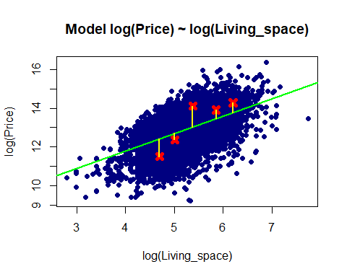

With this code we take 5 examples of the data set and plot it with the predicted values including the residuals (yellow line), which indicates the distance to the estimated regression line.

## Predicting values using splitted data set 99:1 ratio

#split dataset   
split99 <- round(nrow(data1)* 0.99)  
train <- data1[1:split99,]  
test <- data1[(split99 + 1):nrow(data1),]  
#linear regression model  
lm.train <- lm(log.price ~ log.living, data = train)  
summary(lm.train)

##   
## Call:  
## lm(formula = log.price ~ log.living, data = train)  
##   
## Residuals:  
## Min 1Q Median 3Q Max   
## -3.7888 -0.4043 0.0847 0.4633 2.7534   
##   
## Coefficients:  
## Estimate Std. Error t value Pr(>|t|)   
## (Intercept) 8.19143 0.07604 107.72 <0.0000000000000002 ***  
## log.living 0.90074 0.01456 61.84 <0.0000000000000002 ***  
## ---  
## Signif. codes: 0 '***' 0.001 '**' 0.01 '*' 0.05 '.' 0.1 ' ' 1  
##   
## Residual standard error: 0.711 on 10213 degrees of freedom  
## Multiple R-squared: 0.2725, Adjusted R-squared: 0.2724   
## F-statistic: 3825 on 1 and 10213 DF, p-value: < 0.00000000000000022

#predictions  
pred.new.living <- predict(object = lm.train, newdata = test)  
pred.new.living.CI <- predict(object = lm.train, interval = 'prediction', newdata = test)

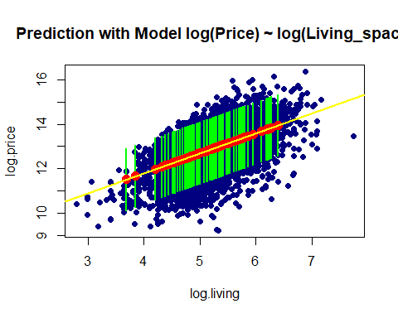

In this plot we see the estimated regression line (in yellow) with the estimated values (red dots) with the corresponding confident interval (green lines). The blue dots are the original dataset points.

## Testing the effect of a categorical variable and post-hoc contrasts

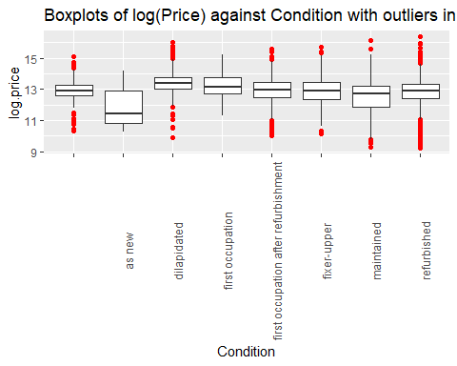

**Model**

lm.price_condition.1 <- lm(log.price ~ Condition, data = data1)  
summary(lm.price_condition.1)

##   
## Call:  
## lm(formula = log.price ~ Condition, data = data1)  
##   
## Residuals:  
## Min 1Q Median 3Q Max   
## -3.6043 -0.4304 0.0333 0.4884 3.6247   
##   
## Coefficients:  
## Estimate Std. Error t value  
## (Intercept) 12.95695 0.04213 307.553  
## Conditionas new -1.01885 0.24696 -4.126  
## Conditiondilapidated 0.47108 0.04838 9.738  
## Conditionfirst occupation 0.19331 0.09330 2.072  
## Conditionfirst occupation after refurbishment -0.05091 0.05685 -0.895  
## Conditionfixer-upper -0.10881 0.05398 -2.016  
## Conditionmaintained -0.42435 0.04906 -8.649  
## Conditionrefurbished -0.14229 0.04328 -3.288  
## Pr(>|t|)   
## (Intercept) < 0.0000000000000002 ***  
## Conditionas new 0.0000373 ***  
## Conditiondilapidated < 0.0000000000000002 ***  
## Conditionfirst occupation 0.03829 *   
## Conditionfirst occupation after refurbishment 0.37055   
## Conditionfixer-upper 0.04384 *   
## Conditionmaintained < 0.0000000000000002 ***  
## Conditionrefurbished 0.00101 **   
## ---  
## Signif. codes: 0 '***' 0.001 '**' 0.01 '*' 0.05 '.' 0.1 ' ' 1  
##   
## Residual standard error: 0.8071 on 10310 degrees of freedom  
## Multiple R-squared: 0.07146, Adjusted R-squared: 0.07083   
## F-statistic: 113.4 on 7 and 10310 DF, p-value: < 0.00000000000000022

aggregate(log.price ~Condition,   
 FUN = mean, data = data1)

## Condition log.price  
## 1 12.95695  
## 2 as new 11.93810  
## 3 dilapidated 13.42803  
## 4 first occupation 13.15025  
## 5 first occupation after refurbishment 12.90604  
## 6 fixer-upper 12.84814  
## 7 maintained 12.53260  
## 8 refurbished 12.81466

#model without slope, only intercept  
lm.price_condition.0 <- lm(log.price ~ 1, data = data1)  
summary(lm.price_condition.0)

##   
## Call:  
## lm(formula = log.price ~ 1, data = data1)  
##   
## Residuals:  
## Min 1Q Median 3Q Max   
## -3.6576 -0.4388 0.0287 0.5166 3.5125   
##   
## Coefficients:  
## Estimate Std. Error t value Pr(>|t|)   
## (Intercept) 12.867983 0.008243 1561 <0.0000000000000002 ***  
## ---  
## Signif. codes: 0 '***' 0.001 '**' 0.01 '*' 0.05 '.' 0.1 ' ' 1  
##   
## Residual standard error: 0.8373 on 10317 degrees of freedom

R uses “treatment contrasts” and therefore the Intercept refers to the first in alphabetical order, here “Null”. The other coefficients represent the difference. Whilst considering the boxplots, it seems rather suprising that ‘as new’ has the lowest mean price value. Condition ‘as new’, ‘dilapidated’, ‘first occupation’, ‘maintained’ to have a strong effect on the response variable. The results are very suprising, as new condition negatively influences the price and condition dilapidated increases the price. The results obtained seem weak, represented in the adj. R-squared with 0.07083.

#Anova  
anova(lm.price_condition.0, lm.price_condition.1)

## Analysis of Variance Table  
##   
## Model 1: log.price ~ 1  
## Model 2: log.price ~ Condition  
## Res.Df RSS Df Sum of Sq F Pr(>F)   
## 1 10317 7232.5   
## 2 10310 6715.7 7 516.86 113.36 < 0.00000000000000022 ***  
## ---  
## Signif. codes: 0 '***' 0.001 '**' 0.01 '*' 0.05 '.' 0.1 ' ' 1

To further test the predictor an lm is built without slopes for every type and then tested by an F-Test (Anova). Surprsingly, the Model with slopes for the Type seems to perform better as indicated through a lower RSS value.

#post-hoc contrasts  
library(multcomp)  
ph.test.1 <- glht(model = lm.price_condition.1, linfct = mcp(Condition = c('refurbished - dilapidated = 0')))  
summary(ph.test.1)

##   
## Simultaneous Tests for General Linear Hypotheses  
##   
## Multiple Comparisons of Means: User-defined Contrasts  
##   
##   
## Fit: lm(formula = log.price ~ Condition, data = data1)  
##   
## Linear Hypotheses:  
## Estimate Std. Error t value Pr(>|t|)  
## refurbished - dilapidated == 0 -0.61337 0.02576 -23.81 <0.0000000000000002  
##   
## refurbished - dilapidated == 0 ***  
## ---  
## Signif. codes: 0 '***' 0.001 '**' 0.01 '*' 0.05 '.' 0.1 ' ' 1  
## (Adjusted p values reported -- single-step method)

The post-hoc contrasts is used to test whether ‘dilapidated’ and ‘refurbished’ differ. The outcome states that ‘dilapidated’ increases the price. This confirms also the visual analysis of the boxplots, but still is suprising as explained above.

## Adding more categorical variables to the testing above

Year_built1 <- as.integer(data1$Year_built)  
floor1 <- as.integer(data1$Floors)  
typeof(Year_built1)

## [1] "integer"

lm.price_condition.2 <- update(lm.price_condition.1,. ~ . + Type + log.rooms +  
 State + Energy_efficiency_class + Year_built1 + Furnishing_quality + floor1)  
formula(lm.price_condition.2)

## log.price ~ Condition + Type + log.rooms + State + Energy_efficiency_class +   
## Year_built1 + Furnishing_quality + floor1

drop1(lm.price_condition.2, test = "F")

## Single term deletions  
##   
## Model:  
## log.price ~ Condition + Type + log.rooms + State + Energy_efficiency_class +   
## Year_built1 + Furnishing_quality + floor1  
## Df Sum of Sq RSS AIC F value  
## <none> 2148.4 -8631.8   
## Condition 7 17.57 2165.9 -8587.1 8.3684  
## Type 11 134.63 2283.0 -8215.5 40.7950  
## log.rooms 1 152.62 2301.0 -8138.9 508.7221  
## State 15 638.74 2787.1 -6784.8 141.9381  
## Energy_efficiency_class 9 33.56 2181.9 -8538.0 12.4294  
## Year_built1 1 56.88 2205.2 -8445.4 189.5786  
## Furnishing_quality 4 346.08 2494.4 -7562.8 288.3902  
## floor1 1 31.86 2180.2 -8527.7 106.1896  
## Pr(>F)   
## <none>   
## Condition 0.0000000003205 ***  
## Type < 0.00000000000000022 ***  
## log.rooms < 0.00000000000000022 ***  
## State < 0.00000000000000022 ***  
## Energy_efficiency_class < 0.00000000000000022 ***  
## Year_built1 < 0.00000000000000022 ***  
## Furnishing_quality < 0.00000000000000022 ***  
## floor1 < 0.00000000000000022 ***  
## ---  
## Signif. codes: 0 '***' 0.001 '**' 0.01 '*' 0.05 '.' 0.1 ' ' 1

Drop1 function performes automatically or each variable presence in the model an F test. According to the results all independent variables in the model seem to have an effect.

# Week 2 - Non-linearity

## Polynomials

By including polynomials (e.g. x1 + x1^2) we can model non linear relationships with a Linear Model.

**Graphical analysis**

log(Price) ~ log(Living_space)

## `geom_smooth()` using method = 'gam' and formula 'y ~ s(x, bs = "cs")'

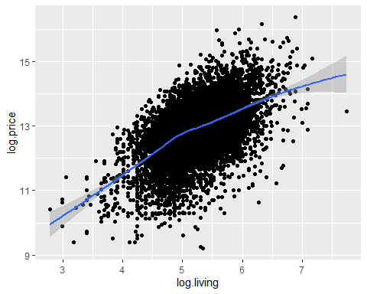

The graphical analysis shows a non-linear relationship for the predictor living_space.

**Model with a linear effect for log.living with log.rooms**

lm.living.1 <- lm(log.price ~ log.living + log.rooms)  
summary(lm.living.1)

##   
## Call:  
## lm(formula = log.price ~ log.living + log.rooms)  
##   
## Residuals:  
## Min 1Q Median 3Q Max   
## -3.9154 -0.3918 0.0788 0.4617 2.6939   
##   
## Coefficients:  
## Estimate Std. Error t value Pr(>|t|)   
## (Intercept) 7.41210 0.08773 84.49 <0.0000000000000002 ***  
## log.living 1.19671 0.02268 52.76 <0.0000000000000002 ***  
## log.rooms -0.41705 0.02492 -16.74 <0.0000000000000002 ***  
## ---  
## Signif. codes: 0 '***' 0.001 '**' 0.01 '*' 0.05 '.' 0.1 ' ' 1  
##   
## Residual standard error: 0.7051 on 10315 degrees of freedom  
## Multiple R-squared: 0.291, Adjusted R-squared: 0.2909   
## F-statistic: 2117 on 2 and 10315 DF, p-value: < 0.00000000000000022

Both predictors show a strong effect on the response variable price. Now we want to build a model with a quadratic effect for living space.

**Model with a cuadratic effect for log.living**

#model with a quadratic poly  
lm.living.2 <- lm(log.price ~ log.rooms + poly(log.living, degree = 2))  
summary(lm.living.2)

Now that we have added the quadratic effect(with degree = 2). The two models can be compared by an F-Test.

**Compare the two models by an F-Test**

#test in quadratic  
anova(lm.living.1, lm.living.2)

## Analysis of Variance Table  
##   
## Model 1: log.price ~ log.living + log.rooms  
## Model 2: log.price ~ log.rooms + poly(log.living, degree = 2)  
## Res.Df RSS Df Sum of Sq F Pr(>F)   
## 1 10315 5127.7   
## 2 10314 5067.1 1 60.652 123.46 < 0.00000000000000022 ***  
## ---  
## Signif. codes: 0 '***' 0.001 '**' 0.01 '*' 0.05 '.' 0.1 ' ' 1

The second model with a quadratic effect for living space has a better performance, as the RSS is lower than the one from the model without a quadratic effect. Additionally, the p-value indicates that the second model performs better. 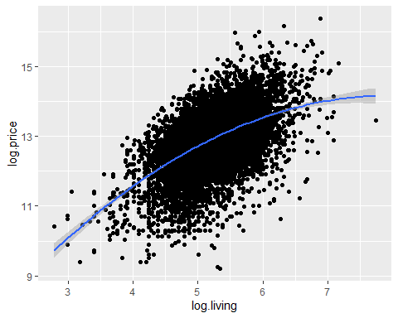

The quadratic fit seems to model the non-linear relationship of living space quite well. Nevertheless, we try to fit a cubic poly.

**Model with a cubic poly**

#model with a cubic poly  
lm.living.3 <- lm(log.price ~ log.rooms + poly(log.living, degree = 3))  
summary(lm.living.3)

anova(lm.living.2, lm.living.3)

## Analysis of Variance Table  
##   
## Model 1: log.price ~ log.rooms + poly(log.living, degree = 2)  
## Model 2: log.price ~ log.rooms + poly(log.living, degree = 3)  
## Res.Df RSS Df Sum of Sq F Pr(>F)  
## 1 10314 5067.1   
## 2 10313 5067.1 1 0.00072045 0.0015 0.9695

As expected the cubic term does not fit better, because the RSS is equal to the quadratic model, so we prefer the less complex model with degree 2.

## Generalised Additive Models - GAMs

**Graphical analysis**

**log(Price) ~ log(Rooms)**

## `geom_smooth()` using method = 'gam' and formula 'y ~ s(x, bs = "cs")'

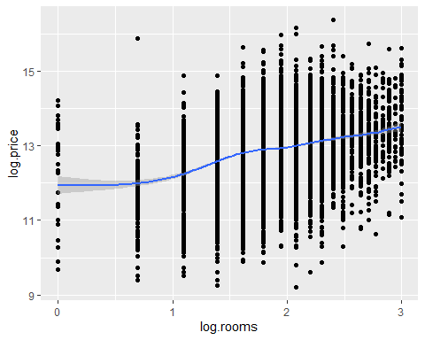

The graphical analysis shows a non-linear relationship for the predictor log.rooms. As from eyeballing it seems to not be a quadratic or cubic effect a GAM will be applied (as it chooses the degree of complexity automatically).

## GAMs for log(Price) ~ log(Rooms)

attach(data1)  
gam.log.price.log.rooms <- gam(log.price ~ s(log.rooms))  
summary(gam.log.price.log.rooms)

##   
## Family: gaussian   
## Link function: identity   
##   
## Formula:  
## log.price ~ s(log.rooms)  
##   
## Parametric coefficients:  
## Estimate Std. Error t value Pr(>|t|)   
## (Intercept) 12.867983 0.007783 1653 <0.0000000000000002 ***  
## ---  
## Signif. codes: 0 '***' 0.001 '**' 0.01 '*' 0.05 '.' 0.1 ' ' 1  
##   
## Approximate significance of smooth terms:  
## edf Ref.df F p-value   
## s(log.rooms) 7.888 8.623 145.8 <0.0000000000000002 ***  
## ---  
## Signif. codes: 0 '***' 0.001 '**' 0.01 '*' 0.05 '.' 0.1 ' ' 1  
##   
## R-sq.(adj) = 0.108 Deviance explained = 10.9%  
## GCV = 0.62562 Scale est. = 0.62509 n = 10318

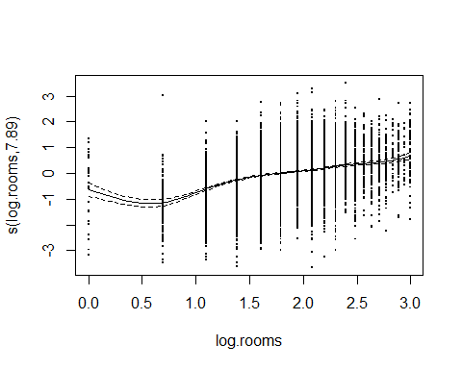

The GAM-model has an edf of 7.888 (so degree = almost 8). This shows as that the GAM function choose a polynomial of 7.888

## GAMs for log(Price) ~ log(Living_space) + s(log.rooms) + s(log(Garages))

gam.log.price.log.living <- gam(log.price ~ log.living + s(log.rooms) + s(log(Garages)))  
summary(gam.log.price.log.living)

##   
## Family: gaussian   
## Link function: identity   
##   
## Formula:  
## log.price ~ log.living + s(log.rooms) + s(log(Garages))  
##   
## Parametric coefficients:  
## Estimate Std. Error t value Pr(>|t|)   
## (Intercept) 6.46447 0.13313 48.56 <0.0000000000000002 ***  
## log.living 1.24132 0.02547 48.74 <0.0000000000000002 ***  
## ---  
## Signif. codes: 0 '***' 0.001 '**' 0.01 '*' 0.05 '.' 0.1 ' ' 1  
##   
## Approximate significance of smooth terms:  
## edf Ref.df F p-value   
## s(log.rooms) 4.964 6.084 67.976 < 0.0000000000000002 ***  
## s(log(Garages)) 8.215 8.681 3.852 0.0000691 ***  
## ---  
## Signif. codes: 0 '***' 0.001 '**' 0.01 '*' 0.05 '.' 0.1 ' ' 1  
##   
## R-sq.(adj) = 0.305 Deviance explained = 30.6%  
## GCV = 0.42626 Scale est. = 0.4255 n = 8437

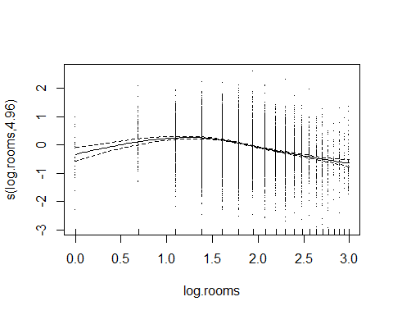

The GAM-model has an edf of 4.964 (so degree = almost 5) for log.rooms and an edf of 8.215 for log(Garages). Both independent variables seem to have a strong effect.

# Week 3 - Generalised Linear Models

## GLM - Possion Model

**Count Data**

With the GLM function and the family “possion” we could generalize the Linear model.

glm.rooms <- glm(Rooms ~ Type, family = "poisson", data = data)  
summary(glm.rooms)

##   
## Call:  
## glm(formula = Rooms ~ Type, family = "poisson", data = data)  
##   
## Deviance Residuals:   
## Min 1Q Median 3Q Max   
## -3.6463 -0.6320 -0.0781 0.3702 4.4559   
##   
## Coefficients:  
## Estimate Std. Error z value Pr(>|z|)   
## (Intercept) 2.02917 0.01848 109.821 < 0.0000000000000002 ***  
## TypeBungalow 0.17457 0.02838 6.152 0.000000000766 ***  
## TypeCastle 0.55104 0.12447 4.427 0.000009550749 ***  
## TypeCorner house 0.01343 0.03162 0.425 0.671   
## TypeDuplex 0.26787 0.01981 13.522 < 0.0000000000000002 ***  
## TypeFarmhouse -0.43417 0.02638 -16.456 < 0.0000000000000002 ***  
## TypeMid-terrace house -0.22653 0.01948 -11.626 < 0.0000000000000002 ***  
## TypeMultiple dwelling -0.38499 0.02917 -13.197 < 0.0000000000000002 ***  
## TypeResidential property 0.04744 0.02637 1.799 0.072 .   
## TypeSingle dwelling -0.38432 0.02252 -17.066 < 0.0000000000000002 ***  
## TypeSpecial property -0.47841 0.03056 -15.655 < 0.0000000000000002 ***  
## TypeVilla 0.14646 0.02522 5.806 0.000000006387 ***  
## ---  
## Signif. codes: 0 '***' 0.001 '**' 0.01 '*' 0.05 '.' 0.1 ' ' 1  
##   
## (Dispersion parameter for poisson family taken to be 1)  
##   
## Null deviance: 13951.1 on 10317 degrees of freedom  
## Residual deviance: 9350.9 on 10306 degrees of freedom  
## AIC: 47557  
##   
## Number of Fisher Scoring iterations: 4

#exponentiate coefficients  
exp(coef(glm.rooms))

## (Intercept) TypeBungalow TypeCastle   
## 7.6077922 1.1907296 1.7350632   
## TypeCorner house TypeDuplex TypeFarmhouse   
## 1.0135214 1.3071727 0.6477992   
## TypeMid-terrace house TypeMultiple dwelling TypeResidential property   
## 0.7972979 0.6804577 1.0485829   
## TypeSingle dwelling TypeSpecial property TypeVilla   
## 0.6809147 0.6197703 1.1577330

Before the Interpretation of the coefficients of a Poisson model the inverse, the exponential, is needed due to use of the link function (log() function). The Interpretation of the coefficients are: A house with no Type information has around 7.6 rooms and e.g. Villa has ca. 15.77% more rooms (ca. 8.8 rooms)

#to double check and convince ourselves as single house (type) is checked and predicted  
library(tidyverse)  
#which(data$Type == "")  
#data[99,]  
fitted.room <- fitted(glm.rooms)[99]  
fitted.room

## 99   
## 7.607792

specific.room <- data[99,]  
specific.room$Type <- "Villa"  
#specific.room  
predict(glm.rooms, type = "response",newdata = specific.room)

## 99   
## 8.807792

fitted.room * exp(coef(glm.rooms)["TypeVilla"])

## 99   
## 8.807792

This house with no specific Type, according to the model, is expected to have 7.607 Rooms. If we check the number of rooms after setting the Type to e.g. Villa the model expect 8.807 rooms and this is exactly the same number of rooms we get for the fitted room times the exponential estimated for Villa.

## Data simulation from the glm count data model

**Visualization of the glm count data model** 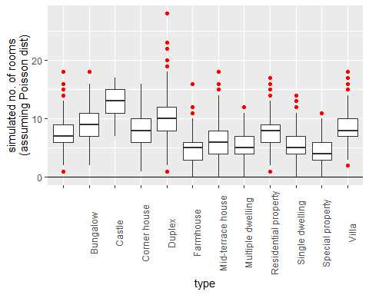

The results of the simulation seem to agree with the observed data (no negative values, similar variation, only integer values).

**GLM with binomial data factor variable**

glm.sq.price <- glm(cbind(Price, Living_space)~ State,  
 family = "binomial",  
 data = data)

## Warning in eval(family$initialize): non-integer counts in a binomial glm!

summary(glm.sq.price)

##   
## Call:  
## glm(formula = cbind(Price, Living_space) ~ State, family = "binomial",   
## data = data)  
##   
## Deviance Residuals:   
## Min 1Q Median 3Q Max   
## -59.255 -6.366 -1.195 3.473 61.109   
##   
## Coefficients:  
## Estimate Std. Error z value Pr(>|z|)  
## (Intercept) 8.34931 0.09536 87.558 < 0.0000000000000002  
## StateBaden-Württemberg -0.26983 0.09538 -2.829 0.004667  
## StateBayern -0.11439 0.09538 -1.199 0.230381  
## StateBerlin 0.22109 0.09549 2.315 0.020597  
## StateBrandenburg -0.34169 0.09542 -3.581 0.000342  
## StateBremen -0.45021 0.09601 -4.689 0.000002744267682783  
## StateHamburg 0.20992 0.09607 2.185 0.028878  
## StateHessen -0.35562 0.09538 -3.728 0.000193  
## StateMecklenburg-Vorpommern -0.77292 0.09544 -8.099 0.000000000000000555  
## StateNiedersachsen -0.78534 0.09538 -8.234 < 0.0000000000000002  
## StateNordrhein-Westfalen -0.52038 0.09537 -5.456 0.000000048613961012  
## StateRheinland-Pfalz -0.77836 0.09538 -8.160 0.000000000000000334  
## StateSaarland -1.13274 0.09552 -11.859 < 0.0000000000000002  
## StateSachsen -1.08280 0.09541 -11.349 < 0.0000000000000002  
## StateSachsen-Anhalt -1.36482 0.09544 -14.300 < 0.0000000000000002  
## StateSchleswig-Holstein -0.36652 0.09541 -3.842 0.000122  
## StateThüringen -1.20943 0.09555 -12.657 < 0.0000000000000002  
##   
## (Intercept) ***  
## StateBaden-Württemberg **   
## StateBayern   
## StateBerlin *   
## StateBrandenburg ***  
## StateBremen ***  
## StateHamburg *   
## StateHessen ***  
## StateMecklenburg-Vorpommern ***  
## StateNiedersachsen ***  
## StateNordrhein-Westfalen ***  
## StateRheinland-Pfalz ***  
## StateSaarland ***  
## StateSachsen ***  
## StateSachsen-Anhalt ***  
## StateSchleswig-Holstein ***  
## StateThüringen ***  
## ---  
## Signif. codes: 0 '***' 0.001 '**' 0.01 '*' 0.05 '.' 0.1 ' ' 1  
##   
## (Dispersion parameter for binomial family taken to be 1)  
##   
## Null deviance: 1039137 on 10317 degrees of freedom  
## Residual deviance: 812246 on 10301 degrees of freedom  
## AIC: 884878  
##   
## Number of Fisher Scoring iterations: 5

#exp(coef(glm.sq.price))

## `geom_smooth()` using formula 'y ~ x'

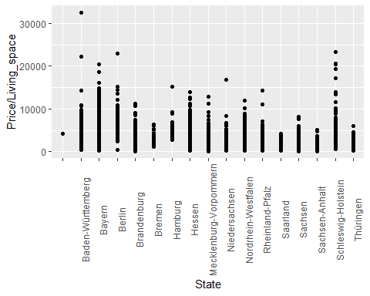

If we compare the Residual deviance and the corresponding degrees of freedom in the summary output we would expect in an truly Poisson distributed data that the residual deviance and the degrees of freedom would be approximately the same value. Therefore it could be overdispersed here and we use the “quasibinomial” family.

**GLM with quasi-binomial data factor variable**

glm.sq.price <- glm(cbind(Price, Living_space)~ State,  
 family = "quasibinomial",  
 data = data)  
summary(glm.sq.price)

##   
## Call:  
## glm(formula = cbind(Price, Living_space) ~ State, family = "quasibinomial",   
## data = data)  
##   
## Deviance Residuals:   
## Min 1Q Median 3Q Max   
## -59.255 -6.366 -1.195 3.473 61.109   
##   
## Coefficients:  
## Estimate Std. Error t value Pr(>|t|)   
## (Intercept) 8.3493 0.9998 8.351 <0.0000000000000002 ***  
## StateBaden-Württemberg -0.2698 1.0000 -0.270 0.787   
## StateBayern -0.1144 1.0000 -0.114 0.909   
## StateBerlin 0.2211 1.0012 0.221 0.825   
## StateBrandenburg -0.3417 1.0004 -0.342 0.733   
## StateBremen -0.4502 1.0066 -0.447 0.655   
## StateHamburg 0.2099 1.0072 0.208 0.835   
## StateHessen -0.3556 1.0000 -0.356 0.722   
## StateMecklenburg-Vorpommern -0.7729 1.0006 -0.772 0.440   
## StateNiedersachsen -0.7853 1.0000 -0.785 0.432   
## StateNordrhein-Westfalen -0.5204 0.9999 -0.520 0.603   
## StateRheinland-Pfalz -0.7784 1.0000 -0.778 0.436   
## StateSaarland -1.1327 1.0015 -1.131 0.258   
## StateSachsen -1.0828 1.0003 -1.083 0.279   
## StateSachsen-Anhalt -1.3648 1.0006 -1.364 0.173   
## StateSchleswig-Holstein -0.3665 1.0003 -0.366 0.714   
## StateThüringen -1.2094 1.0018 -1.207 0.227   
## ---  
## Signif. codes: 0 '***' 0.001 '**' 0.01 '*' 0.05 '.' 0.1 ' ' 1  
##   
## (Dispersion parameter for quasibinomial family taken to be 109.9222)  
##   
## Null deviance: 1039137 on 10317 degrees of freedom  
## Residual deviance: 812246 on 10301 degrees of freedom  
## AIC: NA  
##   
## Number of Fisher Scoring iterations: 5

The dispersion parameter ist now 109.92, This implies the variance increases faster than linearly. Anyway in this case there is no evidence that the State have an impact on the response variable.

**GLM - Binary Model**

Let’s fit a logistic regression model and add fit to the graph. For that purpose a binary variable has been created from the price variable. Is the Price over one Million Euro or not.

## `geom_smooth()` using formula 'y ~ x'

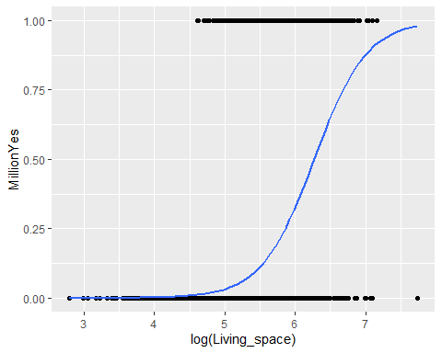

As expected higher log(Living_space) leads to a higher probability that the property price is higher than a million.

# Week 4 - Support Vector Machines

**load data and filter rows with variable ‘Type? == ’Multiple dwelling’ or ‘Villa’**

svm.data <- fread('german_housing_cleaned.csv',header =T, encoding='UTF-8')  
house <- svm.data %>% filter(Type == "Multiple dwelling" | Type == "Villa")  
  
#create new variable 'is.multi' with 'TRUE' 'FALSE' to use for the SVM model   
house[,is.multi := as.factor(Type == 'Multiple dwelling')]

**Split dataset**

split80 <- round(nrow(house)* 0.80)  
train <- house[1:split80,]  
test <- house[(split80 + 1):nrow(house),]

**Fit SVM and do a cross validation with cost 0.25, 0.5 and 1.00**

set.seed(1)  
model <- train(is.multi ~ Price + Living_space,  
 data = train, method = 'svmLinear2', trControl = trainControl(method = 'cv'))  
print(model)

## Support Vector Machines with Linear Kernel   
##   
## 611 samples  
## 2 predictor  
## 2 classes: 'FALSE', 'TRUE'   
##   
## No pre-processing  
## Resampling: Cross-Validated (10 fold)   
## Summary of sample sizes: 550, 550, 550, 549, 551, 550, ...   
## Resampling results across tuning parameters:  
##   
## cost Accuracy Kappa   
## 0.25 0.9296651 0.8593149  
## 0.50 0.9329438 0.8658320  
## 1.00 0.9313044 0.8625365  
##   
## Accuracy was used to select the optimal model using the largest value.  
## The final value used for the model was cost = 0.5.

With the method = ‘svmLinear2’ the model will be tested with different cost values. As the model with cost = 0.5 has the highest accuracy (0.9329385)the prediction will be made with this parameters.

**Prediction with SVM model with cost = 0.5**

For further prediction we will create a new dataframe with all possible combinations of points (Price in 10.000er steps, sqm in 1.00sqm steps)

house1 <- expand.grid(Price = seq(min(house$Price),max(house$Price), 10000),Living_space = seq(min(house$Living_space), max(house$Living_space),1))  
  
house1$is.multi <- predict(model, newdata = house1)

**Plot SVM** 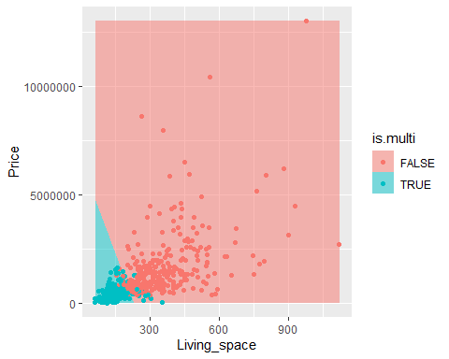

As the plot clearly shows there is a line -1 and 1 classification. In color turqoise we see all the objects that fall into category ‘Multiple dwelling’ and the rose colored area with the dots are of the Type ‘Villa’. The dots in the other color then the background are mismatched points that fall in the cost of 0.5.

## SVM with kernel = ‘radial’

Creating another binary variable from the price variable for a classification with an SVM which use Radial Base Function. Is the Price above 600’000 Euro or not.

Scaling for a nicer plot

**Plot x2 vs. x1, colored by y** 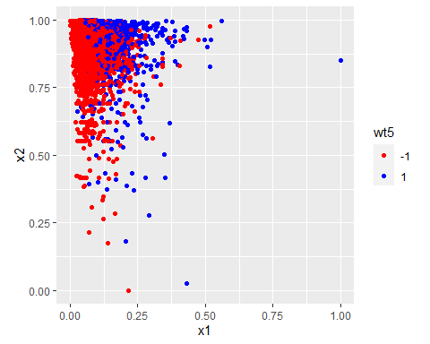

**Print average accuracy and standard deviation**

accuracy <- rep(NA, 5)  
set.seed(2)  
# Calculate accuracies for 10 training/test partitions  
for (i in 1:5){  
 testdf[, "train"] <- ifelse(runif(nrow(testdf)) < 0.8, 1, 0)  
 trainset <- testdf[testdf$train == 1, ]  
 testset <- testdf[testdf$train == 0, ]  
 trainColNum <- grep("train", names(trainset))  
 trainset <- trainset[, -trainColNum]  
 testset <- testset[, -trainColNum]  
 svm_model <- svm(data.wt5 ~ ., data = trainset, type = "C-classification", kernel = "radial")  
 pred_test <- predict(svm_model, testset)  
 accuracy[i] <- mean(pred_test == testset$data.wt5)  
}  
# Print average accuracy and standard deviation  
mean(accuracy)

## [1] 0.7770167

sd(accuracy)

## [1] 0.004420142

The accuracy mean is 0.7770 with a standard deviation of 0.0044, what will tell us that approx. 77.7% of the data will be classified correctly.

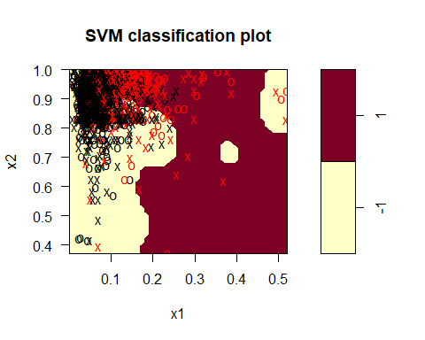 As we can see in this plot the classification use

# Week 5 - Neural Networks

## ANN - neuralnet package

preparing data for neuralnet

library(neuralnet)

**Prepare for Training**

set.seed(123)  
indices <- createDataPartition(df.house$data.Price, p = 0.8, list = FALSE)  
train <- df.house %>% slice(indices)  
test <- df.house %>% slice(-indices)  
boxplot(train$data.Price, test$data.Price, df.house %>% sample_frac(0.2) %>% pull(data.Price))

max <- apply(df.house, 2, max)  
min <- apply(df.house, 2, min)  
df.house_scaled <- as.data.frame(scale(df.house, center = min, scale = max - min))  
train_scaled <- df.house_scaled %>% slice(indices)  
test_scaled <- df.house_scaled %>% slice(-indices)

### Fit the Network

n <- names(train_scaled)  
f <- as.formula(paste("data.Price ~", paste(n[!n %in% "data.Price"], collapse = " + ")))  
nn <- neuralnet(f,data=train_scaled,hidden=c(5,3),linear.output=T)  
plot(nn)

pred_scaled <- compute(nn, test_scaled %>% select(-data.Price))  
  
pred <- pred_scaled$net.result * (max(df.house$data.Price) - min(df.house$data.Price)) + min(df.house$data.Price)  
#pred

And calculate the RMSE

sqrt(mean((test$data.Price - pred)^2))

## ANN - caret package

str(df.house)  
  
set.seed(42)  
tuGrid <- expand.grid(.layer1=c(1:4), .layer2=c(0,2), .layer3=c(0))  
  
trCtrl <- trainControl(  
 method = 'repeatedcv',   
 number = 5,   
 repeats = 5,   
 returnResamp = 'final'  
)  
  
models <- train(  
 x = df.house %>% select(-data.Price),  
 y = df.house_scaled %>% pull(data.Price),  
 method = 'neuralnet', metric = 'RMSE',   
 linear.output = TRUE,  
 #be careful, does only work on x!  
 preProcess = c('center', 'scale'),  
 tuneGrid = tuGrid,  
 trControl = trCtrl  
)

plot(models)

plot(models$finalModel)

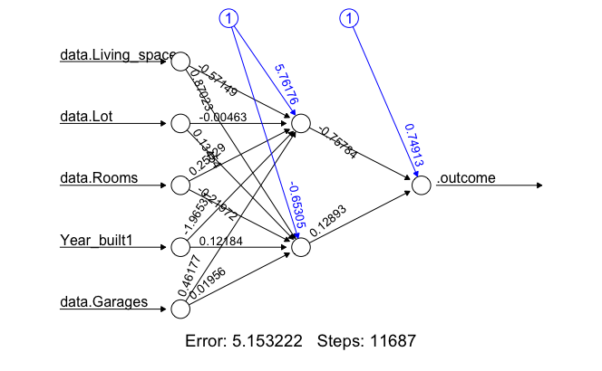

neuralnet

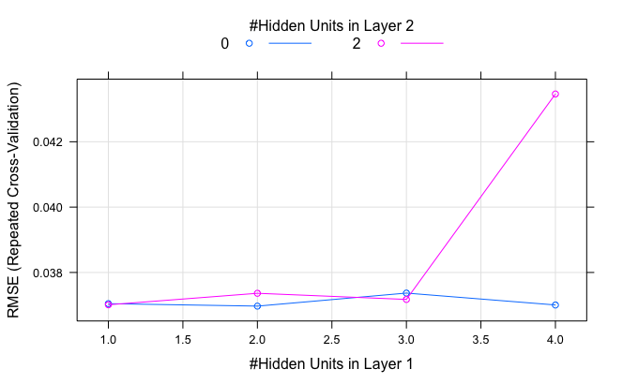

Plot neuralnet

All the parameter combinations listed in expand.grid() were used to create and test a model. For the test the repeated cross-validation (5-Fold cross-validation repeated 5 times) were used to identify the final model with the best cross validation performance. The final model has…

# Week 6 - Agent-based Modelling and Approximate Bayesian Computation

rm(list = ls(all = TRUE)) # clean the memory  
install.packages("devtools")  
devtools::install_github("PredictiveEcology/NetLogoR")  
  
#libraries  
library(NetLogoR)  
library(stringr)  
library(ggplot2)  
library(minpack.lm)  
  
  
for (i in 40:100){  
 for (j in 1:20) {  
 ### 1. DEFINE THE SPACE AND AGENTS ###  
   
 # simulations parameters  
 simtime<-100 # duration time of the simulation  
 number_agents<-i  
 number_pubs<-j # number of pubs (or homes. whatever) in the space named "world"  
 gridSize_x<-10 # number of patches in the grid where moving agents move around  
 gridSize_y<-10  
 displacement_normal<-0.1 # speed of moving agents   
 displacement_pub<-0.01 # if in the pub, agents move slower and spend more time there  
 plot_data_out<-numeric() # initialize variable to store data to be plotted later on  
   
 # world set up, this is about the static patches  
 w1 <- createWorld(minPxcor = 0, maxPxcor = gridSize_x-1, minPycor = 0, maxPycor = gridSize_y-1) # world defined by patches with coordinates Pxcor & Pycor  
 x_pub<-randomPxcor(w1,number_pubs) # random pub location on the world grid  
 y_pub<-randomPycor(w1,number_pubs)  
 w1 <- NLset(world = w1, agents = patches(w1), val = 0) # initialize all the patches to their internal state value = 0...  
 w1 <- NLset(world = w1, agents = patch(w1, x_pub, y_pub), val = 1) # ...except for the pubs with a value set to 1  
   
 # agents set up, this is about the moving objects (traditionally named turtles)  
 t1 <- createTurtles(n = number_agents, coords = randomXYcor(w1, n = number_agents), breed="S", color="black") # all agents are set to the state (breed) S=susceptible, colored black  
 t1 <- NLset(turtles = t1, agents = turtle(t1, who = 0), var = "breed", val = "I") # agent 0 is set to I=infected (patient 0 that contaminates the others)   
 t1 <- NLset(turtles = t1, agents = turtle(t1, who = 0), var = "color", val = "red") # ... and coloured red   
 t1 <- turtlesOwn(turtles = t1, tVar = "displacement", tVal = displacement_normal) # all initially move with standard speed (normal displacement)  
   
 plot(w1, axes = 0, legend = FALSE, par(bty = 'n')) # initialize graphics by displaying world patches  
 points(t1, col = of(agents = t1, var = "color"), pch = 20) # initialize graphics by displaying agents  
   
   
 ### 2. RUN THE SIMULATION TIME LOOP ###  
   
 for (time in 1:simtime) { # start the simulation time loop  
   
 t1 <- fd(turtles = t1, dist=t1$displacement, world = w1, torus = TRUE, out = FALSE) # each timestep move each agent forward with the fd() function, by a distance   
 t1 <- right(turtles = t1, angle = sample(-20:20, 1, replace = F)) # each timestep agents can randomly turn 20 deg right of 20 left (-20)  
   
 plot(w1, axes = 0, legend = FALSE, par(bty = 'n')) # update graphics  
 points(t1, col = of(agents = t1, var = "color"), pch = 20) # update graphics  
   
 meet<-turtlesOn(world = w1, turtles = t1, agents = t1[of(agents = t1, var = "breed")=="I"]) # contact if multiple agents are on the same patch with function turtlesOn()  
 t1 <- NLset(turtles = t1, agents = meet, var = "breed", val = "I") # get the state of the infected agent  
 t1 <- NLset(turtles = t1, agents = meet, var = "color", val = "red") # and change its colour  
   
 # agents that enter a pub spend more time there (have a lower displacement value)  
 pub <- turtlesOn(world = w1, turtles = t1, agents = patch(w1, x_pub, y_pub)) # check if agent is on a pub patch with function turtlesOn()  
 # # if enters the pub  
 t1 <- NLset(turtles = t1, agents = turtle(t1, who = pub$who), var = "displacement", val = displacement_pub)  
 # # if exits the pub  
 t1 <- NLset(turtles = t1, agents = turtle(t1, who = t1[-(pub$who+1)]$who), var = "displacement", val = displacement_normal)  
   
   
 Sys.sleep(0.1) # give some time to the computer to update all the thing graphically  
   
 # store time-course data for plotting in the end  
 contaminated_counter<-sum(str_count(t1$color, "red"))  
 tmp_data<-c(time,contaminated_counter)  
 plot_data_out<-rbind(plot_data_out, tmp_data) # store in a matrix  
   
 }  
   
   
 ### 3. PLOTTING AND FITTING SIMULATED DATA ###  
   
 # perform non-linear curve fitting of the data   
 df<-as.data.frame(plot_data_out)  
 names(df)<-c("time","contaminated_counter")  
 x <- df$time  
 y <- df$contaminated_counter  
   
 # give initial guesses and fit with 4-parameters logistic equation (fits well S-shaped generic curves)  
 model <- nlsLM(y ~ d + (a-d) / (1 + (x/c)^b) ,start = list(a = 3, b = 4, c = 600, d = 1000)) # initial guesses are set (arbitrarily) to 3,4,600,1000  
   
 # make a line with the fitting model that goes through the data  
 fit_x <- data.frame(x = seq(min(x),max(x),len = 100))  
 fit_y <- predict(model, newdata = fit_x)  
 fit_df <- as.data.frame(cbind(fit_x,fit_y))  
 names(fit_df)<-c("x","y")  
 fitted_function <- data.frame(x = seq(min(x),max(x),len = 100))  
 lines(fitted_function$x,predict(model,fitted_function = fitted_function))  
   
 # store summary statistics in a vector to be appended after each iteration to the output file  
 # # put in the filename all the parameters used to set the simulation run  
 simulation_run_name <- paste0("sim_",number_agents,"_",number_pubs)  
 varied_params <- c(number_agents,number_pubs)  
 summary_stat <- c( simulation_run_name, varied_params, as.vector(model$m$getPars()) )  
 # save summary statistics of all the performed simulations in file with:  
 # # Simulation ID  
 # # parameters used for that simulation  
 # # outcome of the curve (described by the fitting parameters)  
 write.table(as.data.frame(t(summary_stat)), "./summary_stat.csv", sep = ",", col.names = FALSE, row.names=FALSE, append = TRUE) # append to pile up the different runs in a single file  
   
 # graphical representation of simulation data and fitting  
 #ggplot(data = df, mapping = aes(y = y, x = x)) +  
 # ggtitle(paste0("Simulation ID: \t", simulation_run_name,  
 # "\nSimulation Params: agents=",number_agents,"; pubs=", number_pubs,  
 # "\nCurve Fit Params: \t",toString(round(model$m$getPars(),2)))) +  
 # xlab("time") +  
 # ylab("Agents contaminated") +  
 # geom_point(data=df, aes(y=y, x=x), colour="black") +  
 # geom_line(data = fit_df, colour="red")  
 }}

## ABC Code

set.seed(2)  
rm(list = ls(all = TRUE))  
#install.packages("abc")  
library(abc)  
  
sum_stat <- read.csv(file='summary_stat.csv', header=FALSE)  
head(sum_stat)  
  
# import simulation and observed data  
obs_data <- c(3,2,1143,1655)  
sim_param <- sum_stat[,2:3]  
sim_data <- sum_stat[,4:7]  
  
# Run ABC  
res <- abc(target=obs_data,  
 param=sim_param,  
 sumstat=sim_data,  
 tol=0.005,  
 transf=c("log"),  
 method="neuralnet")  
  
plot(res, param=sim_param)  
write.table(res$adj.values,"out_abc.csv", sep=",", row.name=FALSE)

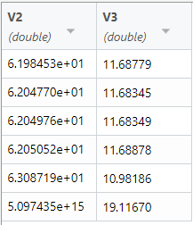

ABC_Output

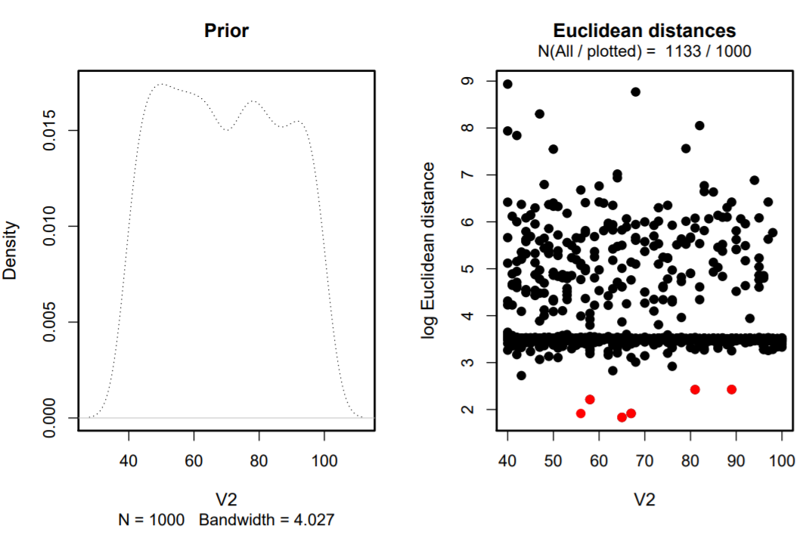

Prior and Euclidean distances_Agents

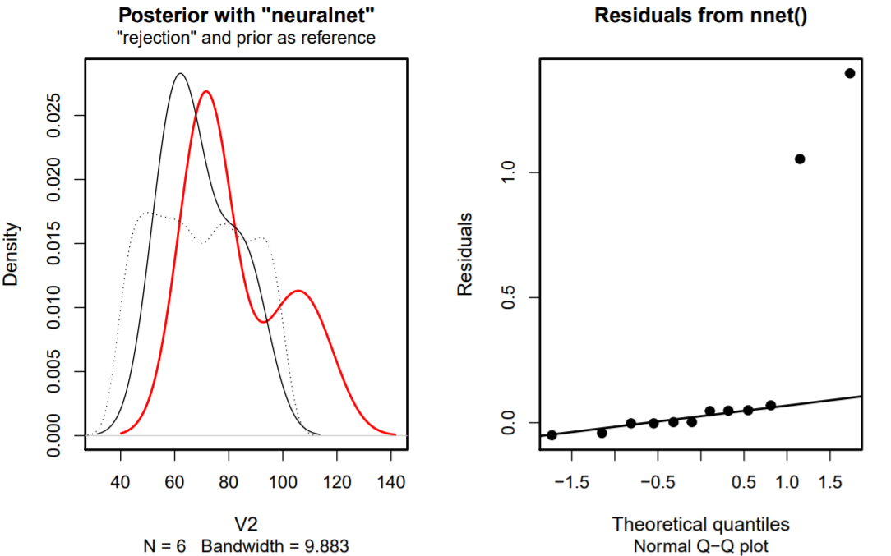

Posterior with neuralnet and Residuals from nnet()_Agents

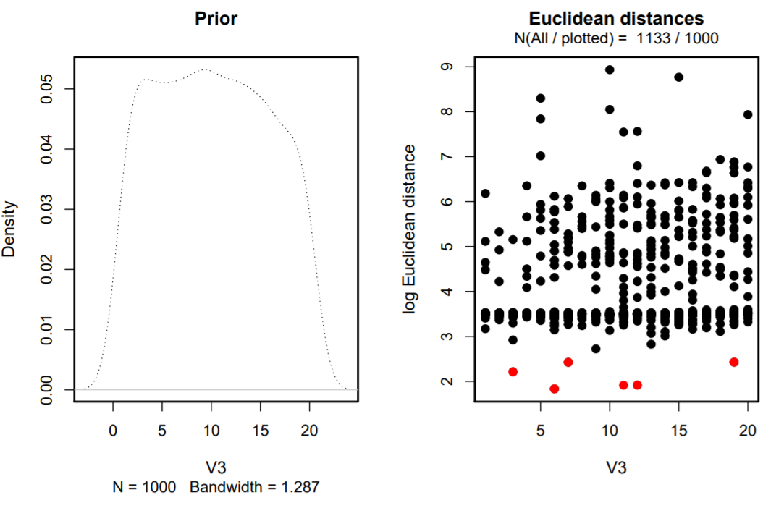

Prior and Euclidean distances_Barplots

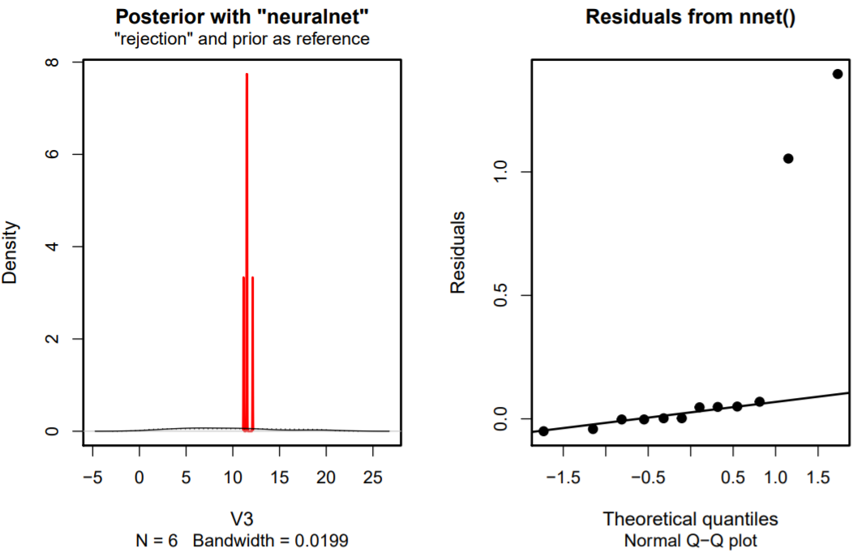

Posterior with neuralnet and Residuals from nnet()_Barplots