MYSQL Database Diagram

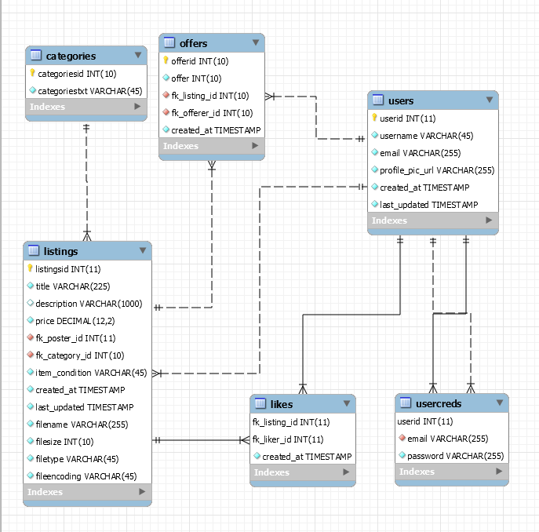

Tables:

1. users
   1. PK: userid
2. usercreds
   1. FK: userid -> users.userid,
   2. FK: email -> users.email
3. listings
   1. PK: listingsid
   2. FK: fk_poster_id -> users.userid
4. offers
   1. PK: offered
   2. FK: fk_listings_id -> listings.listingsid
   3. FK: fk_offerer_id -> users.userid
5. categories
   1. PK: categoriesid
6. likes
   1. FK: fk_listing_id -> listings.listingid
   2. FK: fk_liker_id -> user.userid