## **ST1501 Data Engineering**

## **CA1 Assignment Test**

|  |  |
| --- | --- |
| **Name** | Silviana |
| **Student ID** | P1939213 |
| **Module Class** | DIT/FT/2A/14 |

## Important Notes:

If your database design cannot support the said query scenario, please explain the reason. Marks can be awarded if you explain the reason clearly and provide an improvement to your design.

## SECTION A

**You should prepare the following diagram/screen shots of your database before the test start**

1. **Insert your Database Diagram here**

|  |
| --- |
| **Database diagram** |

1. **Take screen shorts all the records available. (The following is example of one table)**

**PromoPrice Table**

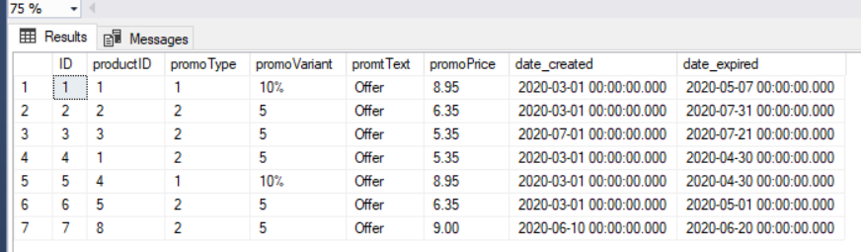

## SECTION B

Give your answer in the order of the questions show in your test items.

**Question 1**

|  |
| --- |
| Copy your question here (optional) |
| Provide the answer or SQL statement |
| Paste the screen shot of query result if applicable |

**Question 2**

|  |
| --- |
| Copy your question here (optional) |
| Provide the answer or SQL statement |
| Paste the screen shot of query result if applicable |

**Question 3**

|  |
| --- |
| Copy your question here (optional) |
| Provide the answer or SQL statement |
| Paste the screen shot of query result if applicable |

**Question 4**

|  |
| --- |
| Copy your question here (optional) |
| Provide the answer or SQL statement |
| Paste the screen shot of query result if applicable |