Name : SILVIANA

Class : DIT/FT/2A/14

Student ID : P1939213

Module : ST1501 - DATA ENGINEERING

1. List the product name and price of all products on offer.

Query:

GO

CREATE FUNCTION dbo.discounted_price

(

@base_price DECIMAL(10,2),

@discount_value DECIMAL(10,2),

@discount_unit VARCHAR(10),

@min_order_qty INT,

@quantity INT = 1

)

RETURNS DECIMAL(10, 2)

AS

BEGIN

DECLARE @discounted_price DECIMAL(10,2);

DECLARE @multiplier INT;

IF (ROUND(@quantity/@min_order_qty, 0) = @quantity/@min_order_qty) SET @multiplier = @quantity/@min_order_qty

ELSE SET @multiplier = FLOOR(@quantity/@min_order_qty)

IF (@discount_unit = '$') SET @discounted_price = @base_price * @quantity - @discount_value * @multiplier

IF (@discount_unit = '%') SET @discounted_price = @base_price * @quantity - @discount_value * @multiplier/100 * @base_price

RETURN @discounted_price

END

GO  
  
DECLARE @quantity INT;

SET @quantity = 3;

SELECT

p.product_name,

promo.promotion_name,

@quantity AS quantity,

promo.min_order_qty,

pp.base_price,

dbo.discounted_price(pp.base_price, promo.discount_value, promo.discount_unit, promo.min_order_qty, @quantity) AS current_price

FROM

product AS p

JOIN product_pricing AS pp ON pp.product_id = p.product_id

RIGHT JOIN product_promotion AS ppro ON ppro.product_id = p.product_id

RIGHT JOIN promotion AS promo ON promo.promotion_id = ppro.promotion_id

WHERE pp.is_active = 1 AND p.is_in_stock = 1 AND is_available = 1 AND GETDATE() > promo.valid_from AND GETDATE() < promo.valid_to  
ORDER BY promo.promotion_id

Result:

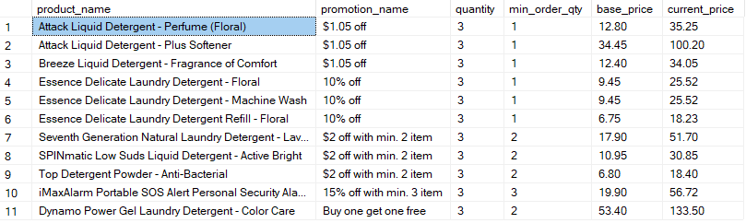

promotion_name, quantity, and min_order_qty are provided as context for the current_price

1. List product information and price in ascending order of the price. (Refer to Fig 1).

Query:

SELECT

p.*,

pp.base_price

FROM

product AS p

JOIN product_pricing AS pp ON pp.product_id = p.product_id

ORDER BY pp.base_price ASC;

Result:

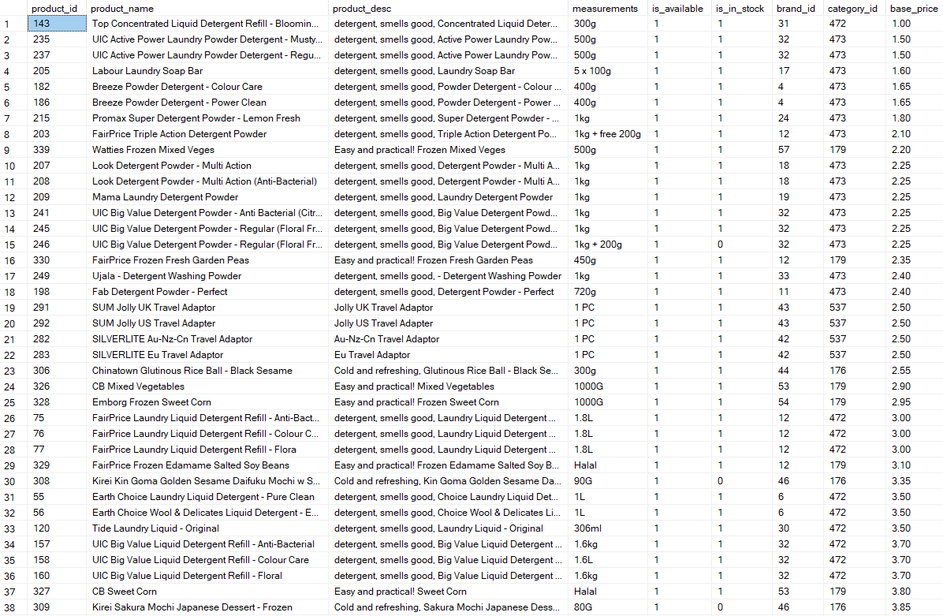

1. How many products belong to Household / Detergent and belong to either Breeze or Dynamo?

Query:

SELECT

pc3.category_name AS category_name,

pc2.category_name AS sub_category_name,

COUNT(*) AS 'count'

FROM product

JOIN product_category AS pc1 ON pc1.category_id = product.category_id

LEFT OUTER JOIN product_category AS pc2 ON pc1.parent_id = pc2.category_id

LEFT OUTER JOIN product_category AS pc3 ON pc2.parent_id = pc3.category_id

WHERE pc2.category_name = 'Detergents'

GROUP BY pc3.category_name, pc2.category_name;

Result:



1. What is the current price of a given product? (You can decide which product you want to find out.)

Query:

DECLARE @quantity INT;

SET @quantity = 3;

SELECT

p.product_id,

p.product_name,

promo.promotion_name,

@quantity AS quantity,

promo.min_order_qty,

pp.base_price,

dbo.discounted_price(pp.base_price, promo.discount_value, promo.discount_unit, promo.min_order_qty, @quantity) AS current_price,

promo.valid_from,

promo.valid_to

FROM

product AS p

JOIN product_pricing AS pp ON pp.product_id = p.product_id

RIGHT JOIN product_promotion AS ppro ON ppro.product_id = p.product_id

RIGHT JOIN promotion AS promo ON promo.promotion_id = ppro.promotion_id

WHERE pp.is_active = 1 AND p.is_in_stock = 1 AND is_available = 1 AND (p.product_id = 35 OR p.product_id = 1) AND GETDATE() > promo.valid_from AND GETDATE() < promo.valid_to

ORDER BY promo.promotion_id

Result:



Product 1 is a direct discounted item, and

Product 2 is a quantity based discounted item.