**In dire need of some coin**

**Hartan Mihai Silviu**

**Affilation :** Faculty of Automatic Control and Computer Engineering, Iasi

**Email:** [silviuhartan10@gmail.com](mailto:silviuhartan10@gmail.com)

**Academic Year**: 2018 - 2022



Game Description and plot

In dire need of some Coin is a 2D game for Windows PC’s taking place in an alternate universe, filled with One-Eye-Balled aliens which are hostile and angry with the intrusion of the main character, desperate to collect the coins which are available in this world to pay his debts from excessive gambling in his own cosmos.

Arvard, our local hero in the village of Adaramis was drowned in gambling bets. He really loved trying his luck in all the possible games, ale and some good roasted chicken. However, locals started to become angry with his unhealty behavior and lack of productivity and required that he will pay all his debts or he will be exiled forever. Desperate of the situation, he went to the village wizard and begged him to teleport his body into another place where he could acquire some quick quid. In spite of the risks involved, the wizard has cast the spell and sent him in the Sombrero galaxy, planet Kalliope.

Gameplay

The game consists of single player campaign where the player must defeat the enemies and collect all coins to progress through levels. Gameplay involves the possibility of choosing a hero class, depending on the preferrences of the player. Each hero character (Knight, Mage and Void Walker) posses a special ability with a view of helping them complete the current level. The predicaments in this game include: dealing with angry and scary-looking monsters, avoiding bombs that decrease your character’s health and managing to collect all the coins in order to complete the current level and advance towards the end of the game. The hero is also aided with heart-tokens which increase his current life by half.

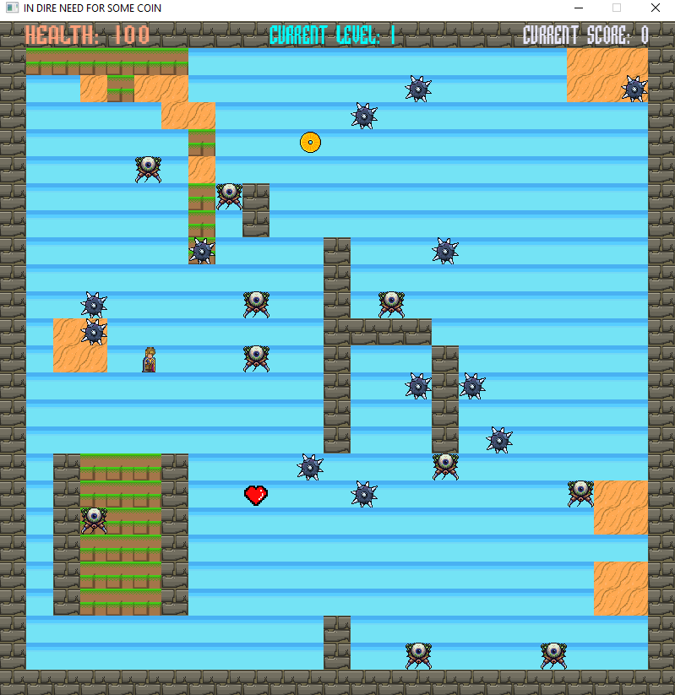

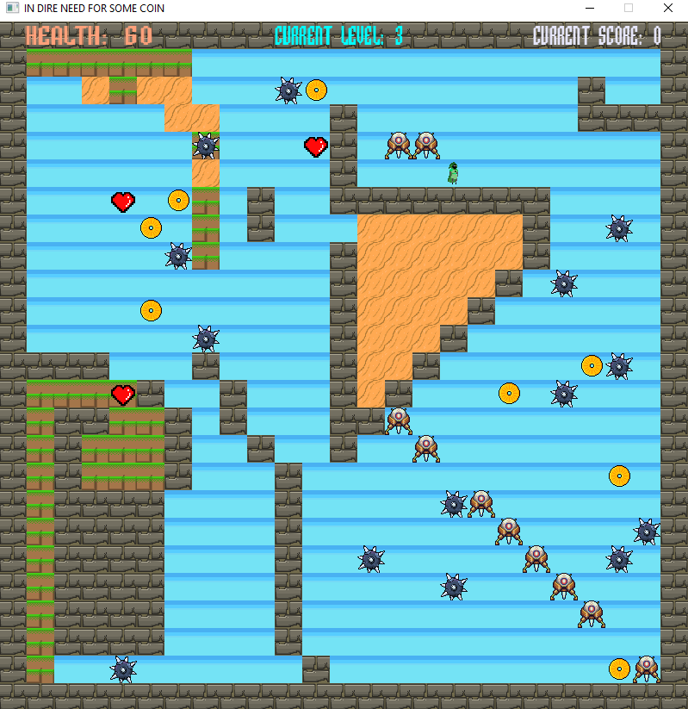

Characters

* **Hero class**

*Void Walker*: playable-character which posses a distinct ability: teleporting in alternate coordinates and thus evading the hostile aliens.

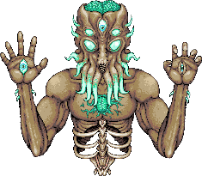

*Mage*: playable-character which posses a distinct ability: kill the monster which is in the closest proximity.(scary, right?)

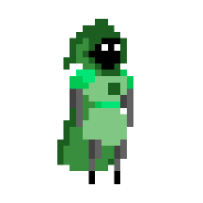

*Knight*: playable-character which posses a distinct ability: dealing damage to all monsters which are located on the same X or Y axis as him.

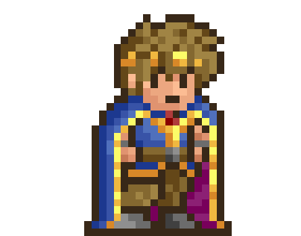

* **Mob class**

*Basic-Eye-Balled-Alien*: A hostile NPC, which moves pretty fast, is aware of the hero coordinates and will gladly kill him without hesitation*.*



*Upgraded-Eye-Balled-Alien*: A hostile NPC, which is the improved version of the basic-eye-balled guy: has increased health, damage and speed.

**

Mechanics

The hero can move with W, A, S, D keys and use his special ability(SPACE_BAR) if it is within it’s cooldown.

The hero cannot move past stone blocks.

.

NPC’s follow the hero trajectory and have the ability to attack if they find themselves on the same coordinates as the character.

There are some traps(spiky balls) which activate when you step on them. However, mobs may step on them too and hence, this may be used in your advantage.



You can collect heart tokens to increase your current health and consequently, survive the level.



The menus( Main menu, character menu, endgame menu) can be navigated with KEY-UP, KEY-DOWN, and options may be selected with ENTER.

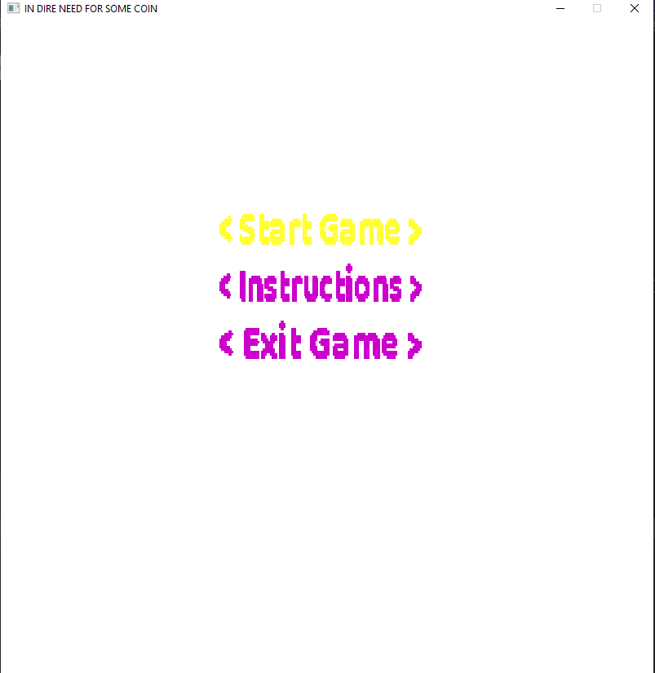.

Util links:

<https://github.com/silviuh/first_game>