22BRS1194

SHRUTI SINGH

Creating tables:

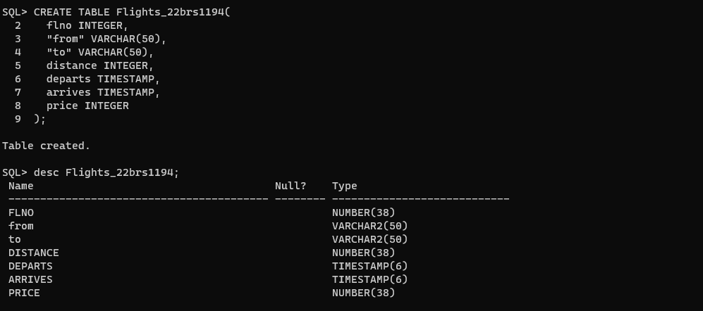

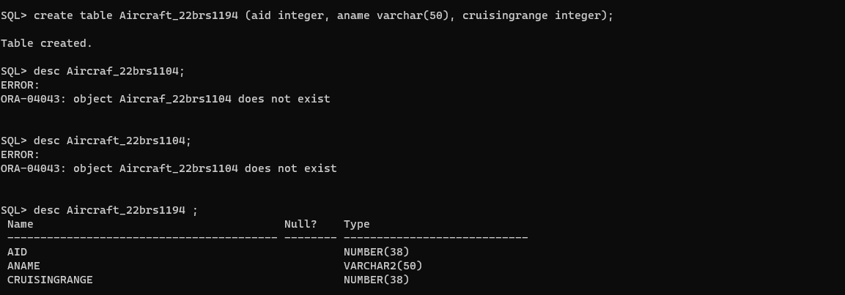

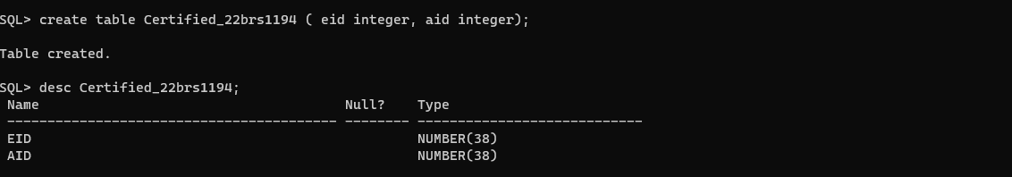

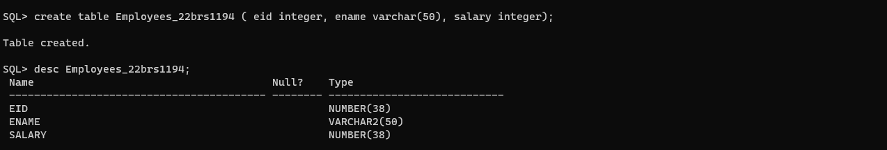

SQL> CREATE TABLE Flights_22brs1194(

2 flno INTEGER,

3 "from" VARCHAR(50),

4 "to" VARCHAR(50),

5 distance INTEGER,

6 departs TIMESTAMP,

7 arrives TIMESTAMP,

8 price INTEGER

9 );

Table created.

SQL> desc Flights_22brs1194;

Name Null? Type

----------------------------------------- -------- ----------------------------

FLNO NUMBER(38)

from VARCHAR2(50)

to VARCHAR2(50)

DISTANCE NUMBER(38)

DEPARTS TIMESTAMP(6)

ARRIVES TIMESTAMP(6)

PRICE NUMBER(38)

SQL> create table Aircraft_22brs1194 (aid integer, aname varchar(50), cruisingrange integer);

Table created.

SQL> desc Aircraf_22brs1104;

ERROR:

ORA-04043: object Aircraf_22brs1104 does not exist

SQL> desc Aircraft_22brs1104;

ERROR:

ORA-04043: object Aircraft_22brs1104 does not exist

SQL> desc Aircraft_22brs1194 ;

Name Null? Type

----------------------------------------- -------- ----------------------------

AID NUMBER(38)

ANAME VARCHAR2(50)

CRUISINGRANGE NUMBER(38)

SQL> create table Certified_22brs1194 ( eid integer, ename varchar(50), salary integer);

Table created.

SQL> desc Certified_22brs1194;

Name Null? Type

----------------------------------------- -------- ----------------------------

EID NUMBER(38)

ENAME VARCHAR2(50)

SALARY NUMBER(38)

SQL> create table Employees_22brs1194 ( eid integer, ename varchar(50), salary integer);

Table created.

SQL> desc Employees_22brs1194;

Name Null? Type

----------------------------------------- -------- ----------------------------

EID NUMBER(38)

ENAME VARCHAR2(50)

SALARY NUMBER(38)

SQL> drop table Certified_22brs1194;

Table dropped.

SQL> create table Certified_22brs1194 ( eid integer, aid integer);

Table created.

SQL> desc Certified_22brs1194;

Name Null? Type

----------------------------------------- -------- ----------------------------

EID NUMBER(38)

AID NUMBER(38)

Q1.

Inserting values: