

Industrial Training Report

On
SOFTWARE TESTING AND AUTOMATION TESTING
Semester Eight

BY
STEPHAN LIMBU
(C30105220038)

Bachelor of Information and Communication Technology
School of Science and Technology
Asia eUniversity
This report is prepared to fulfill the requirement of CIT400 Final Project

By:
STEPHAN LIMBU
C30105220038

SCHOOL OF SCIENCE AND TECHNOLOGY
ASIA e UNIVERSITY

SEMESTER EIGHT
APPROVAL SHEET
This is to certify that the Industrial Training Report entitled “Industrial Training Report on Quality Assurance at Wolfmatrix” submitted by Stephan Limbu in partial fulfillment of the requirements for the degree of Bachelor in Information, Communication and Technology (BICT) has been examined and approved.
The internship work was carried out at Wolfmatrix under the supervision of Mr. Prabin Sapkota. The report has been found satisfactory in terms of content, presentation, and fulfillment of the academic requirements prescribed by Virinchi College.

…………………… ………………...........
Mr. Binay Malla Mr. Chiranjibi Shrestha
Acadenic Coordinator Industrial Training Coordinator

DISCLAIMER
This industrial training report has been prepared as a partial fulfillment of the academic requirements for the completion of the Industrial Training program under the respective faculty and institution. The report is based on the practical knowledge, professional experience, observations, and technical skills acquired during the training period at Wolfmatrix Technologies.
The contents included in this report are prepared solely for academic and educational purposes. All the information presented in this report reflects the learning experience gained during the internship period in the areas of software testing, automation testing, system validation, deployment testing, and quality assurance activities. Every effort has been made to ensure that the information provided is accurate and relevant to the tasks performed during the training duration.
Some organizational information, workflows, and technical procedures discussed in this report are based on practical exposure and understanding obtained during the internship. However, confidential business information, proprietary data, and sensitive organizational details have not been disclosed in order to maintain professional ethics and company confidentiality policies.
The report does not intend to copy or reproduce any official organizational documents. Any references to company resources, tools, or technologies are included only for educational explanation and report documentation purposes. The conclusions and observations stated in this report are based on personal learning experiences and understanding developed throughout the industrial training period.

ACKNOWLEDGEMENT
I would like to express my heartfelt gratitude and sincere appreciation to Wolfmatrix Technologies for providing me with the valuable opportunity to undertake my industrial training in the field of Software Testing and Automation Testing. This training period has been a highly beneficial and enriching experience that allowed me to gain practical exposure to real-world software development and testing environments.
I am especially thankful to the management team, supervisors, mentors, and all staff members of the organization for their continuous guidance, encouragement, and support throughout the internship duration. Their professional mentoring, technical assistance, and willingness to share knowledge helped me understand various aspects of software quality assurance, automation testing, deployment processes, ticket validation, and agile development practices. The supportive working environment motivated me to learn new technologies and improve my technical as well as professional skills.
I would also like to express my sincere appreciation to my training supervisor for providing regular feedback, assigning meaningful tasks, and guiding me whenever difficulties were encountered during testing and automation activities. The practical exposure to tools such as Playwright, JavaScript, Visual Studio Code, DBeaver, and different testing environments greatly enhanced my confidence and understanding of software testing methodologies.
Furthermore, I would like to extend my gratitude to my college/faculty members and academic supervisors for their valuable suggestions, encouragement, and academic guidance during the preparation of this industrial training report. Their continuous support played an important role in successfully completing both the training program and the report documentation.
Finally, I would like to thank all individuals who directly or indirectly contributed to making this industrial training experience successful, educational, and professionally rewarding.

ABSTRACT
This industrial training report presents the activities, learning experiences, and practical exposure gained during the internship period at Wolfmatrix. The training mainly focused on software testing, automation testing, system validation, and testing methodologies used in real-world software development environments. During the training period, different testing techniques such as manual testing, smoke testing, functional testing, API testing, deployment testing, and automation testing were performed. Automation testing tools such as Playwright, JavaScript, VS Code, and DBeaver were used to create and manage automation modules and test environments. The training also provided exposure to software development methodologies, ticket management systems, test case preparation, testing in multiple environments (test, stage, and production), and collaboration with development teams. This experience enhanced both technical knowledge and professional skills required in the software industry.
TABLE OF CONTENTS
DISCLAIMER I
ACKNOWLEDGEMENT II
ABSTRACT III
LIST OF FIGURES V
LIST OF ABBREVIATIONS VII
1.1 Overview 1
1.2 Background of Organization 1
1.3 Nature of Business 1
1.4 Organization Structure 2
CHAPTER 2: IT INFRASTRUCTURE OF THE ORGANIZATION 4
2.1 Structure of IT Department 4
2.2 Network Infrastructure 4
2.3 Hardware 4
2.4 Software 4
2.5 IT Strategies and Plan 5
CHAPTER 3: PROJECT COMPLETED DURING TRAINING 6
3.1 Main Project Description 6
3.2 Roles and Responsibilities 8
3.3 System Development Methodology 10
3.4 System Robustness Through Synchronization 11
3.5 Tools and Technologies Used 12
3.6 Lessons Learned 12
REFERENCES 17
APPENDIX 18

LIST OF FIGURES
FIGURE 1 COMPANY HIERARCHY 3
FIGURE 2 LANDING PAGE 18
FIGURE 3 ADMIN DASHBOARD 18
FIGURE 4 VEHICLE OWNER DASHBOARD 19
FIGURE 5 SHIPPER DASHBOARD 19
LIST OF TABLES
Table 1 Tools and Technologies: 12

LIST OF ABBREVIATIONS
S.N. | Abbreviation | Full Form
1 | API | Application Programming Interface
2 | CEO | Chief Executive Officer
3 | CI/CD | Continuous Integration / Continuous Deployment
4 | COO | Chief Operating Officer
5 | CTO | Chief Technical Officer
6 | DB | Database
7 | IDE | Integrated Development Environment
8 | IT | Information Technology
9 | JS | JavaScript
10 | KPI | Key Performance Indicator
11 | OS | Operating System
12 | QA | Quality Assurance
13 | QA Team | Quality Assurance Team
14 | SRS | Software Requirement Specification
15 | SQL | Structured Query Language
16 | TQMS | Transport Quality Management System
17 | UI | User Interface
18 | URL | Uniform Resource Locator
19 | UAT | User Acceptance Testing
20 | VS Code | Visual Studio Code

CHAPTER 1: INTRODUCTION

1.1 Overview
Industrial training is an important part of academic learning that helps students gain practical knowledge and professional experience in a real working environment. The training bridges the gap between theoretical concepts and practical implementation.
The training at provided hands-on experience in software testing and automation testing. The major responsibilities included testing web applications, validating tickets, preparing test cases, developing automation modules, and testing software deployments.
The training also improved problem-solving skills, communication skills, teamwork, and understanding of modern software development processes.

1.2 Background of Organization
is a software development and digital transformation company established in 2014 with offices in Nepal and Australia. The company provides custom software development, web and mobile application development, cloud services, AI solutions, and staff augmentation services.
The company focuses on helping startups, small businesses, and enterprises through innovative and scalable software solutions. Wolfmatrix has successfully completed many projects for international clients from countries such as Australia, the United States, and the United Kingdom.

1.3 Nature of Business
The major business areas of include:
- Custom Software Development
- Web Application Development
- Mobile Application Development
- Cloud and Data Services
- Staff Augmentation
- Maintenance and Support
- Product Ideation
The company develops scalable software solutions and provides software engineering support to startups and businesses worldwide.

1.4 Organization Structure
The organization structure of Wolfmatrix Technologies consists of different departments working together for project development and management.
Major Leadership Team:
- Chief Executive Officer (CEO)
The CEO is the highest-ranking executive in the organization who is responsible for overall company management, strategic planning, decision-making, and business growth.
- Chief Technical Officer (CTO)
The CTO manages the technological direction of the company. They oversee software development, technical innovation, system architecture, and implementation of new technologies.
- Chief Operating Officer (COO)
The COO is responsible for managing the daily operational activities of the organization and ensuring that business processes run efficiently and effectively.
- Business Development Department
This department focuses on identifying new business opportunities, managing client relationships, promoting company services, and increasing organizational growth and revenue.
- Software Development Team
The software development team is responsible for designing, developing, maintaining, and improving software applications and systems according to project requirements
- Quality Assurance and Testing Team
This team ensures the quality and reliability of software products by performing different types of testing, identifying bugs, validating system functionality, and maintaining software standards.
- Support and Operations Team
The support and operations team handles system maintenance, technical support, deployment monitoring, troubleshooting, and operational activities to ensure smooth system performance.
The company follows a collaborative working environment where teams coordinate closely for software development, testing, deployment, and maintenance.
Figure of the company hierarchy is presented below:
Executives (CEO, CTO, COO)

Team Leads (Business and Technical)

Development Team (Front-end and Back-end developer and QA)

Supportive and Operations Team

Figure 1 Company Hierarchy

CHAPTER 2: IT INFRASTRUCTURE OF THE ORGANIZATION

2.1 Structure of IT Department
The IT department at consists of software developers, quality assurance engineers, automation testers, project managers, cloud engineers, and support teams.
The department works in agile methodologies where development and testing activities are carried out simultaneously for efficient project delivery.

2.2 Network Infrastructure
The organization uses modern network infrastructure and cloud-based systems to manage projects and communication. Different environments such as test, stage, and production servers are maintained for software deployment and testing.
Collaboration and communication tools are used for ticket management, project tracking, and client coordination.

2.3 Hardware
The organization uses modern computer systems and networking devices to support software development and testing activities. Major hardware components include:
- Desktop Computers and Laptops
- High-speed Internet Connectivity
- Servers and Cloud Infrastructure
- Backup Storage Devices
- Networking Equipment

2.4 Software
The following software and tools were used during the training period:
- Visual Studio Code (VS Code)
- Playwright
- JavaScript
- DBeaver
- Clockify
- Ticket Management Systems
- Spreadsheet Tools
- Web Browsers for Testing

2.5 IT Strategies and Plan
The company focuses on delivering high-quality software solutions using modern technologies and agile development practices. Their major strategies include:
- Continuous software testing and validation
- Automation testing for efficient workflow
- Client-centered software development
- Cloud and scalable infrastructure
- Quality assurance and deployment monitoring

CHAPTER 3: PROJECT COMPLETED DURING TRAINING

3.1 Main Project Description
During the industrial training period at Wolfmatrix Technologies, the major project assigned was the testing and validation of the LODBOD Logistics Management System integrated with the TQMS synchronization system. The project involved testing web and mobile-based logistics applications that connect transport companies, drivers, fleet owners, and customers through a centralized logistics management platform.
LODBOD Official Website is a logistics and transportation management platform designed to simplify vehicle booking, shipment management, fleet operations, and live logistics tracking. The system provides digital solutions for transportation management through web and mobile applications.
The training activities mainly focused on software quality assurance, manual testing, automation testing, deployment validation, and synchronization testing between the LODBOD system and the TQMS platform.
About TQMS and LODBOD Synchronization
The TQMS (Transport Quality Management System) was integrated with the LODBOD platform to ensure smooth synchronization of transportation data, vehicle information, contracts, payment records, and operational workflows between systems. The synchronization process played an important role in improving data consistency, reducing manual errors, and enhancing overall system reliability.
The synchronization system helped:
- Maintain consistent transportation and logistics records
- Synchronize vehicle and shipment information across platforms
- Improve operational efficiency and workflow automation
- Reduce duplicate data entry and manual processing
- Ensure accurate tracking and validation of transport operations
- Support real-time data updates between systems
Testing the synchronization process was one of the major responsibilities during the training period. Multiple synchronization scenarios were tested to verify that data was properly exchanged between TQMS and LODBOD without errors or delays.
Major Modules Tested in LODBOD:
- Vehicle Booking System
- Driver and Fleet Management
- Shipment and Load Management
- User Authentication and Authorization
- Live Tracking System
- Contract Management Flow
- Payment Verification System
- Deployment Validation
- Ticket and Issue Management
- TQMS Synchronization System
The project also involved testing across multiple environments such as:
- Test Environment
- Stage Environment
- Production Environment
Automation testing activities were performed using Playwright and JavaScript to automate repetitive testing tasks and improve software testing efficiency. Test cases and testing spreadsheets were continuously updated according to project requirements and assigned tickets.
The project provided practical exposure to real-world logistics management systems, system synchronization processes, deployment workflows, and software quality assurance practices used in professional software industries.

3.2 Roles and Responsibilities
During the training period, several responsibilities were assigned related to the testing, validation, and synchronization of the LODBOD and TQMS systems.
Major Roles and Responsibilities
1. Manual Testing
Performed manual testing on web and mobile applications to identify bugs, validate workflows, and verify software functionality according to business requirements.
2. Automation Testing
Developed and maintained automation testing modules using Playwright and JavaScript to automate repetitive testing processes such as login validation, form testing, and workflow verification.
3. TQMS and LODBOD Synchronization Testing
Performed synchronization testing between TQMS and LODBOD systems to ensure accurate data exchange and operational consistency.
The synchronization testing included:
- Vehicle synchronization validation
- Contract flow synchronization
- Payment synchronization verification
- Data consistency checking
- Cross-platform workflow validation
- Real-time synchronization testing
This testing helped improve system robustness, reliability, and operational efficiency.
4. Test Case Preparation
Prepared and updated test cases and spreadsheets based on Software Requirement Specification (SRS) documents and assigned project tickets.
5. Deployment and Environment Testing
Validated software deployments in:
- Test Environment
- Stage Environment
- Production Environment
Deployment testing ensured that new updates and features worked correctly after release.
6. Smoke and Functional Testing
Conducted smoke testing and functional testing after deployments and feature updates to ensure system stability and functionality.
7. Ticket Validation and Bug Verification
Tested tickets assigned by developers and validated issue resolutions before deployment to production environments.
8. Reporting and Documentation
Maintained testing reports, spreadsheets, issue validation records, and synchronization test documentation for project tracking and quality assurance purposes.
These responsibilities improved practical understanding of software testing methodologies, logistics system operations, synchronization workflows, teamwork, and professional software engineering practices.

3.3 System Development Methodology
The LODBOD project followed the Agile Software Development Methodology for software development, testing, and deployment management.
Agile methodology focuses on:
- Continuous development
- Incremental software improvement
- Frequent testing and validation
- Collaboration among teams
- Continuous feedback and issue resolution
The development and testing teams worked collaboratively to improve the LODBOD platform and synchronization system through continuous updates, ticket management, and deployment cycles.
Agile Practices Used in the Project
- Daily collaboration between development and QA teams
- Continuous ticket tracking and validation
- Incremental deployment process
- Frequent synchronization testing
- Continuous improvement through feedback
- Rapid bug fixing and feature enhancement
Testing Methodologies Used
The following testing methodologies were used throughout the project:
- Manual Testing
- Automation Testing
- Smoke Testing
- Functional Testing
- Regression Testing
- API Testing
- Deployment Testing
- Synchronization Testing
- User Interface Testing
Automation tools such as Playwright, JavaScript, and Visual Studio Code were used to improve testing efficiency and reduce repetitive manual effort.
The integration of TQMS with LODBOD also required additional synchronization validation to ensure reliable communication between systems and robust operational performance.

3.4 System Robustness Through Synchronization
One of the important aspects of the project was improving the robustness and reliability of the logistics system through synchronization between TQMS and LODBOD.
Benefits of the Synchronization System
- Improved data consistency across platforms
- Reduced operational errors and duplication
- Faster information processing and workflow automation
- Enhanced live tracking and transport management
- Reliable contract and payment synchronization
- Better deployment validation and monitoring
- Improved overall system stability and performance
Continuous synchronization testing ensured that both systems communicated accurately and efficiently during real-world logistics operations.
This synchronization mechanism significantly contributed to maintaining reliable business operations and improving user experience within the logistics platform.

3.5 Tools and Technologies Used
During the industrial training and LODBOD project testing activities, different tools and technologies were used for development, automation, database management, and testing purposes.
Table 1 Tools and Technologies:
Tools/Technologies | Purpose
Playwright | Automation Testing
JavaScript | Automation Script Development
Visual Studio Code (VS Code) | Code Editor
DBeaver | Database Management
Clockify | Task Tracking
Spreadsheet Tools | Test Case Management
Web Browsers | System Testing and Validation
Ticket Management System | Bug and Issue Tracking
These tools provided practical exposure to modern software testing environments and industry-standard testing practices.

3.6 Lessons Learned
The industrial training at Wolfmatrix Technologies provided valuable practical knowledge and professional experience in the field of software testing, automation testing, and logistics management systems. The training helped bridge the gap between theoretical academic concepts and real-world industrial practices.
Throughout the internship period, several technical, professional, and interpersonal skills were developed while working on the LODBOD and TQMS synchronization systems.
Major Lessons Learned
1. Understanding of Software Testing Methodologies
The training provided practical exposure to different software testing methodologies such as:
- Manual Testing
- Automation Testing
- Smoke Testing
- Functional Testing
- Regression Testing
- API Testing
- Deployment Testing
This helped in understanding how software quality assurance is maintained in real development environments.
2. Knowledge of Automation Testing Tools
Hands-on experience was gained in automation testing using:
- Playwright
- JavaScript
- Visual Studio Code (VS Code)
Automation scripts were developed and maintained for repetitive testing tasks, which improved understanding of automation frameworks and testing efficiency.
3. Experience with Real-World Logistics Systems
Working on the LODBOD logistics platform provided practical understanding of:
- Logistics and transportation management systems
- Fleet and shipment workflows
- Live tracking systems
- Vehicle booking processes
- Payment and contract management systems
This experience improved understanding of how enterprise-level logistics platforms operate.
4. Understanding of System Synchronization
The integration and synchronization between TQMS and LODBOD systems helped in learning:
- Data synchronization processes
- Cross-system validation techniques
- Real-time data consistency management
- Workflow synchronization testing
- System robustness and reliability improvement
This provided practical knowledge about how interconnected systems communicate and maintain operational consistency.
5. Experience in Multi-Environment Testing
Testing activities were performed in:
- Test Environment
- Stage Environment
- Production Environment
This helped in understanding deployment workflows, environment configurations, and release validation processes used in software industries.
6. Improvement in Problem-Solving Skills
During testing and debugging activities, several issues and system errors were identified and analyzed. This improved:
- Analytical thinking
- Debugging skills
- Error identification techniques
- Issue validation processes
- Decision-making abilities
7. Understanding Agile Development Practices
The project followed Agile Software Development Methodology, which helped in understanding:
- Team collaboration
- Continuous development and testing
- Ticket management systems
- Sprint-based workflows
- Continuous feedback and improvement processes
This provided knowledge of professional software development practices used in modern IT companies.
8. Enhancement of Communication and Teamwork
Working closely with developers, testers, and supervisors improved:
- Professional communication skills
- Team collaboration abilities
- Reporting and documentation practices
- Workplace discipline and responsibility
The collaborative environment helped in adapting to professional workplace culture.
9. Importance of Documentation and Reporting
Maintaining test cases, spreadsheets, ticket reports, and validation documents highlighted the importance of proper documentation in software development and quality assurance processes.
10. Career and Professional Development
The industrial training experience enhanced confidence, technical competency, and professional understanding required for future career opportunities in:
- Software Testing
- Quality Assurance
- Automation Testing
- Software Development Industry
Overall, the training period at Wolfmatrix Technologies was highly educational and professionally rewarding, providing both technical expertise and practical industry exposure.

REFERENCES
Wolfmatrix Technologies. (n.d.). About us. Wolfmatrix Technologies. Retrieved May 15, 2026, from https://wolfmatrix.com/about-us/
Wolfmatrix Technologies. (n.d.). Services. Wolfmatrix Technologies. Retrieved May 15, 2026, from https://wolfmatrix.com/services/
LODBOD. (n.d.). LODBOD logistics platform. Retrieved May 15, 2026, from https://lodbod.com/home
LODBOD Live System. (n.d.). Test logistics management system. Retrieved May 15, 2026, from http://test.lodbod.com/
Microsoft. (n.d.). Visual Studio Code documentation. Retrieved May 15, 2026, from https://code.visualstudio.com/docs
Microsoft Playwright Team. (n.d.). Playwright documentation. Retrieved May 15, 2026, from https://playwright.dev/docs/intro
DBeaver Corporation. (n.d.). DBeaver documentation. Retrieved May 15, 2026, from https://dbeaver.io/docs/

APPENDIX
Landing page of Lodbod
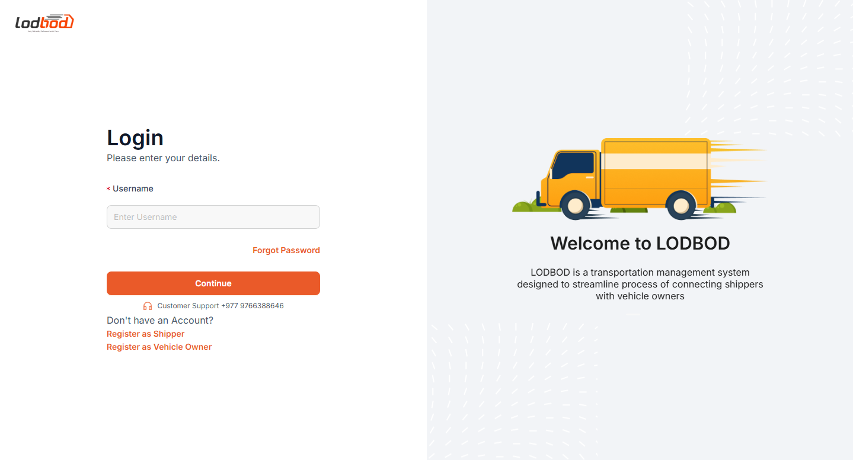
Figure 2 Landing Page
Admin Dashboard
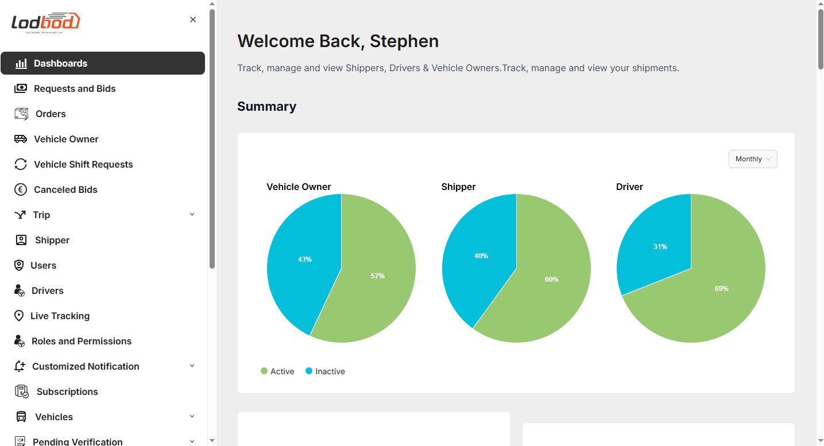
Figure 3 Admin Dashboard
Vehicle Owner Dashboard
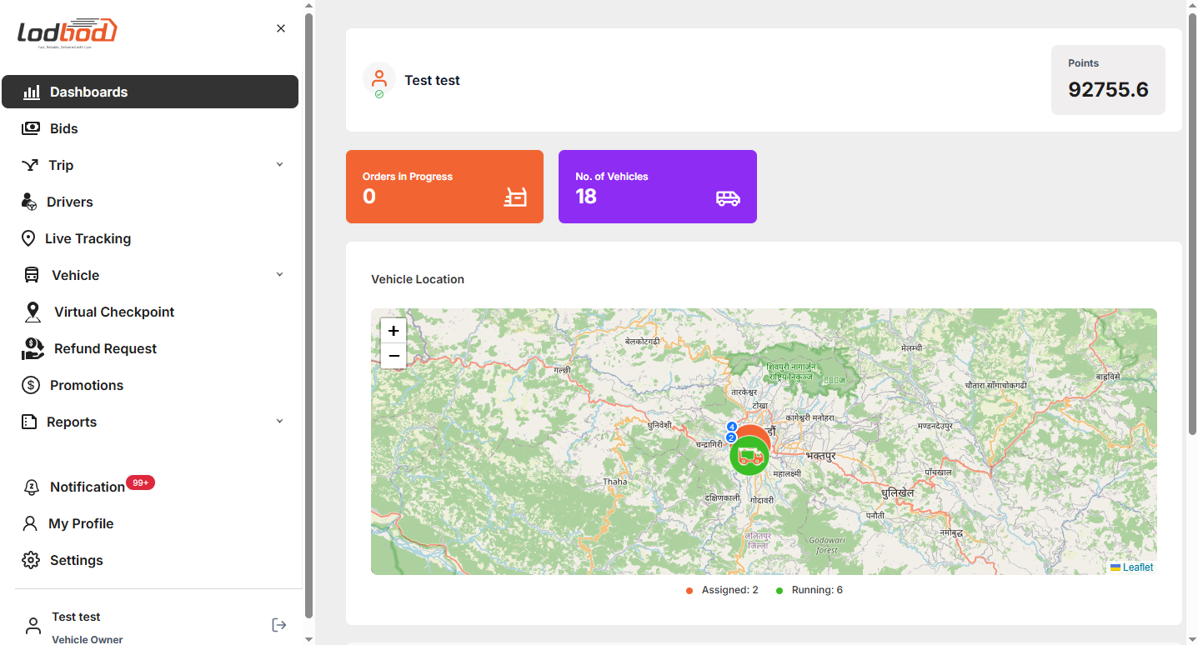
Figure 4 Vehicle Owner Dashboard
Shipper Dashboard
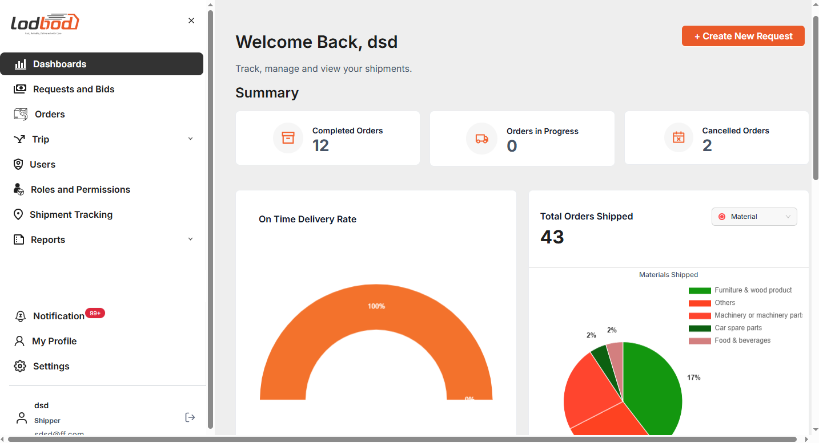
Figure 5 Shipper Dashboard

