# Index

Index 1

1 Introduction 3

1.1 Purpose 3

1.2 Scope 3

1.3 Goals 4

1.4 Actors 4

1.5 Definitions and abbreviations 4

1.5.1 Definition 4

1.5.2 Abbreviations 4

1.6 Stakeholders 4

1.7 Reference documents 5

1.8 Overview 5

2 Overall description 6

2.1 Product perspective 6

2.2 Product functions 6

2.2.1 Use Case Diagram 7

2.3 User characteristics 7

2.4 Constraints 7

2.4.1 Regulations 7

2.4.2 Reliability requirements 7

2.4.3 Hardware limitation 7

2.4.4 Criticality 7

2.4.5 Performance requirements 7

2.4.6 Security 7

2.5 Assumptions and Dependencies 7

3 Specific Requirements 8

3.1 External Interface Requirements 8

3.1.1 User Interfaces 8

3.1.2 Hardware Interfaces 8

3.1.3 Software Interfaces 8

3.1.4 Communication Interfaces 8

3.2 Functional Requirements 8

3.2.1 Login 8

# Introduction

## Purpose

This document represents the Requirements Analysis and Specification Document (RASD). Its aim is to capture all the functional and non-functional requirements that the system-to-be has to respect, in order to satisfy the stakeholders goals, under certain domain properties. This document also contains Use Case Diagrams, Sequence Diagrams and Class Diagrams that can be useful to better understand how the system is organized. Further, this document is a valid basis for system testing, verification and validation and has also a contractual value.

## Scope

The aim of our project is to develop a digital management system for a car-sharing service that exclusively employs electric cars. The system should provide the functionality normally provided by car-sharing services. Users must be able to register to the system by providing their credentials and payment information, then they receive back a password that can be used to access the system. Registered users must be able to find the locations of available cars within a certain distance from their current location or from a specified address. The system provide also the possibility to reserve a single car, but with some constraint: for example if a car is not picked up, the user must pays a fee. On the other hands, if an user reaches a reserved car, he must be able to tell the system he’s nearby his reserved car, so the car will be unlocked and the user can enter and start his rent.

Car-sharing system initiate the charging of money as soon as the engine ignites, and the system starts charging the user for a given amount of money per minute. Indeed the user is notified of the current charges through a screen on the car. The system stops charging the user as soon as the car is parked in a safe area and the user exits the car.

The set of safe areas for parking cars is predefined by the management system, so we are able to contact a database in order to catch some information about the current position of the car, and then the system can decide if it is parked in a safe area.

Although, the system must be able to define certain user’s behavior with the car-sharing services and apply some discount (or charging) in consequence of determinate action.

Users will be able to use a mobile application for use the car-sharing services and register himself during the first rent, and also to register himself with a web application created to improve the comfort of registration.

## Goals (france)

## Actors (france)

## Definitions and abbreviations (france)

### Definition

### Abbreviations

## Stakeholders

The stakeholders of our project are:

* **Users**: they are involved in our project because they will use our system, in particular they will have the possibility to choose between the web application or the mobile application.
* **Car-sharing service**: our system will offer a web application and a mobile application, developed to manage in a better way all the car-sharing system provided by related company.
* **System administrators**: they are the managers of our system.
* **Testers**: they will have to check if our system respects all the requirements that have been identified.

## Reference documents

* International standard IEEE Systems and software engineering: Life cycle processes — Requirements engineering (ISO/IEC/ IEEE 29148).
* AA 2016-2017 Software Engineering 2 — Project goal, schedule, and rules.

## Overview

Our document is organized in four main parts:

* **Introduction**: in this section, we give an overview of the scope and goals of our system-to-be. We also identify the main actors that will be involved in our system and give the basic definitions of some words we will often use in this document.
* **Overall description**: in this part, we try to focus our attention on constraints and assumptions concerning our system-to-be and the world around it. This section also considers some possible future implementations that could be added to our system.
* **Specific requirements**: this section is the body of our document. All the specific requirements that our system need are described here and they are associated with different kinds of diagrams, in order to create a model of the real system.
* **Bibliography**: in this part we specify the documents or books we have referred to.

# Overall description

## Product perspective (gian)

## Product functions

The main function of the systems is to allow users to reserve an electric car, provided by our car-sharing service. The user can also manage his/her reservation, deleting or confirming it. System encourages users’ environmental friendly behaviour providing them discount in case of trip with at least 2 passengers. It also provides special deals if the users take care of plugging-in the car on the electric grid because he/she contribute to the wellness of the system.

* Users:
  + Sign up into the system (simo)
  + Log into the system (simo)
  + Manage account (simo)
  + Research cars (gian)
  + Select car (gian)
  + Reserve car (gian)
  + Delete reservation (gian)
  + Unlock the car in order to use it (gian)
  + View car status (france)
  + View charge during the trip (france)
  + View map (france secondo noi non va messa questa funzionalità perchè non posso interagire con la mappa ma solo vederla quindi non c’è uno use case)
  + Enable “Money saving” option (france)
  + Plug-in the car in order to get the discount (france)
  + Visualize “trip review” (simo)
  + Conclude the rent and pay (simo)

### Use Case Diagrams

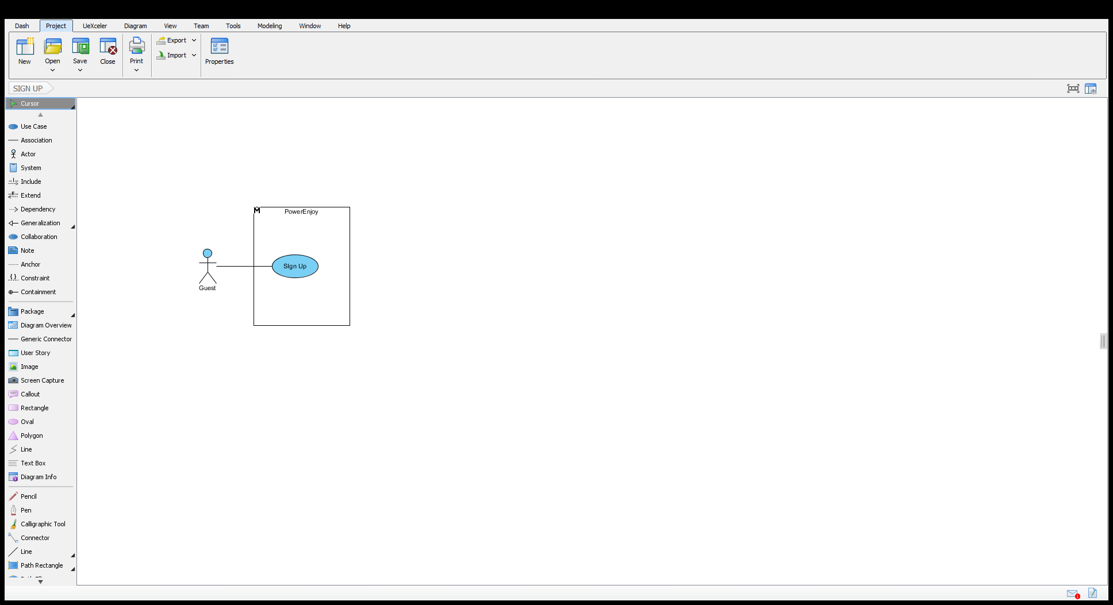

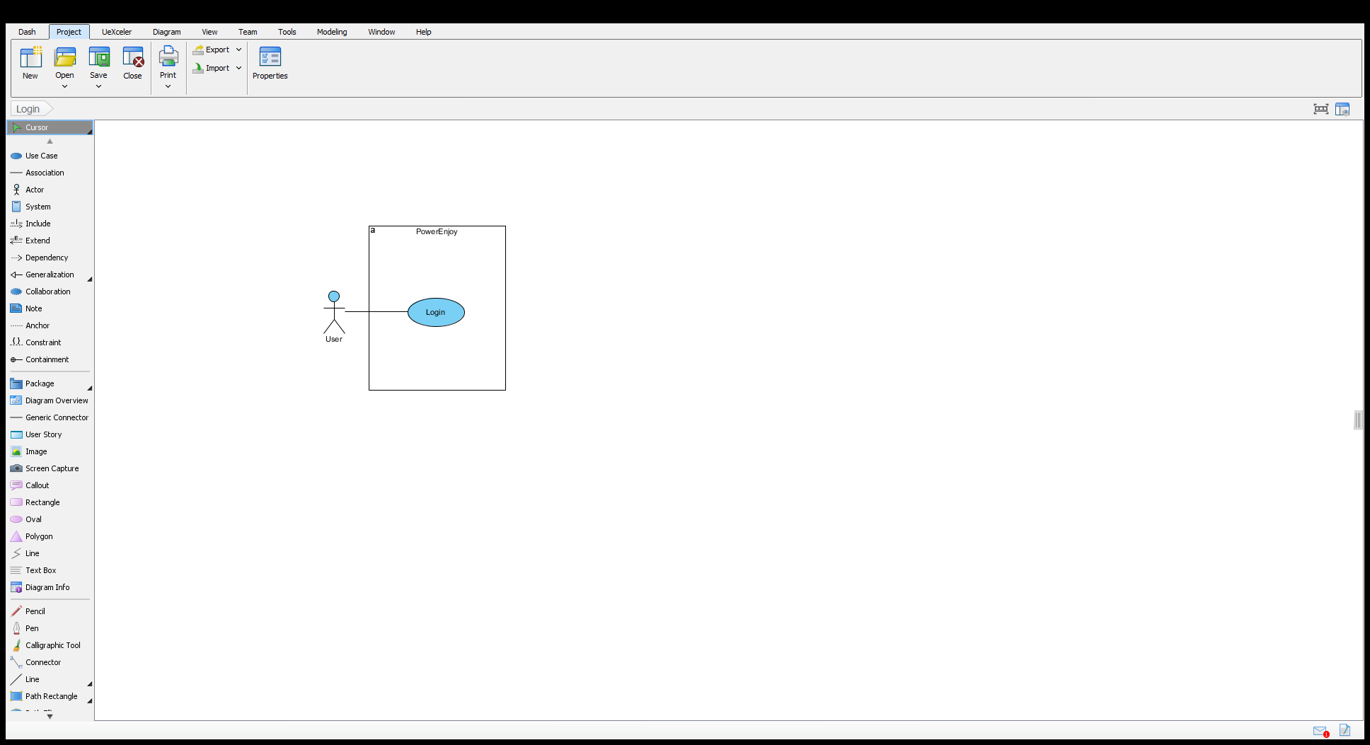

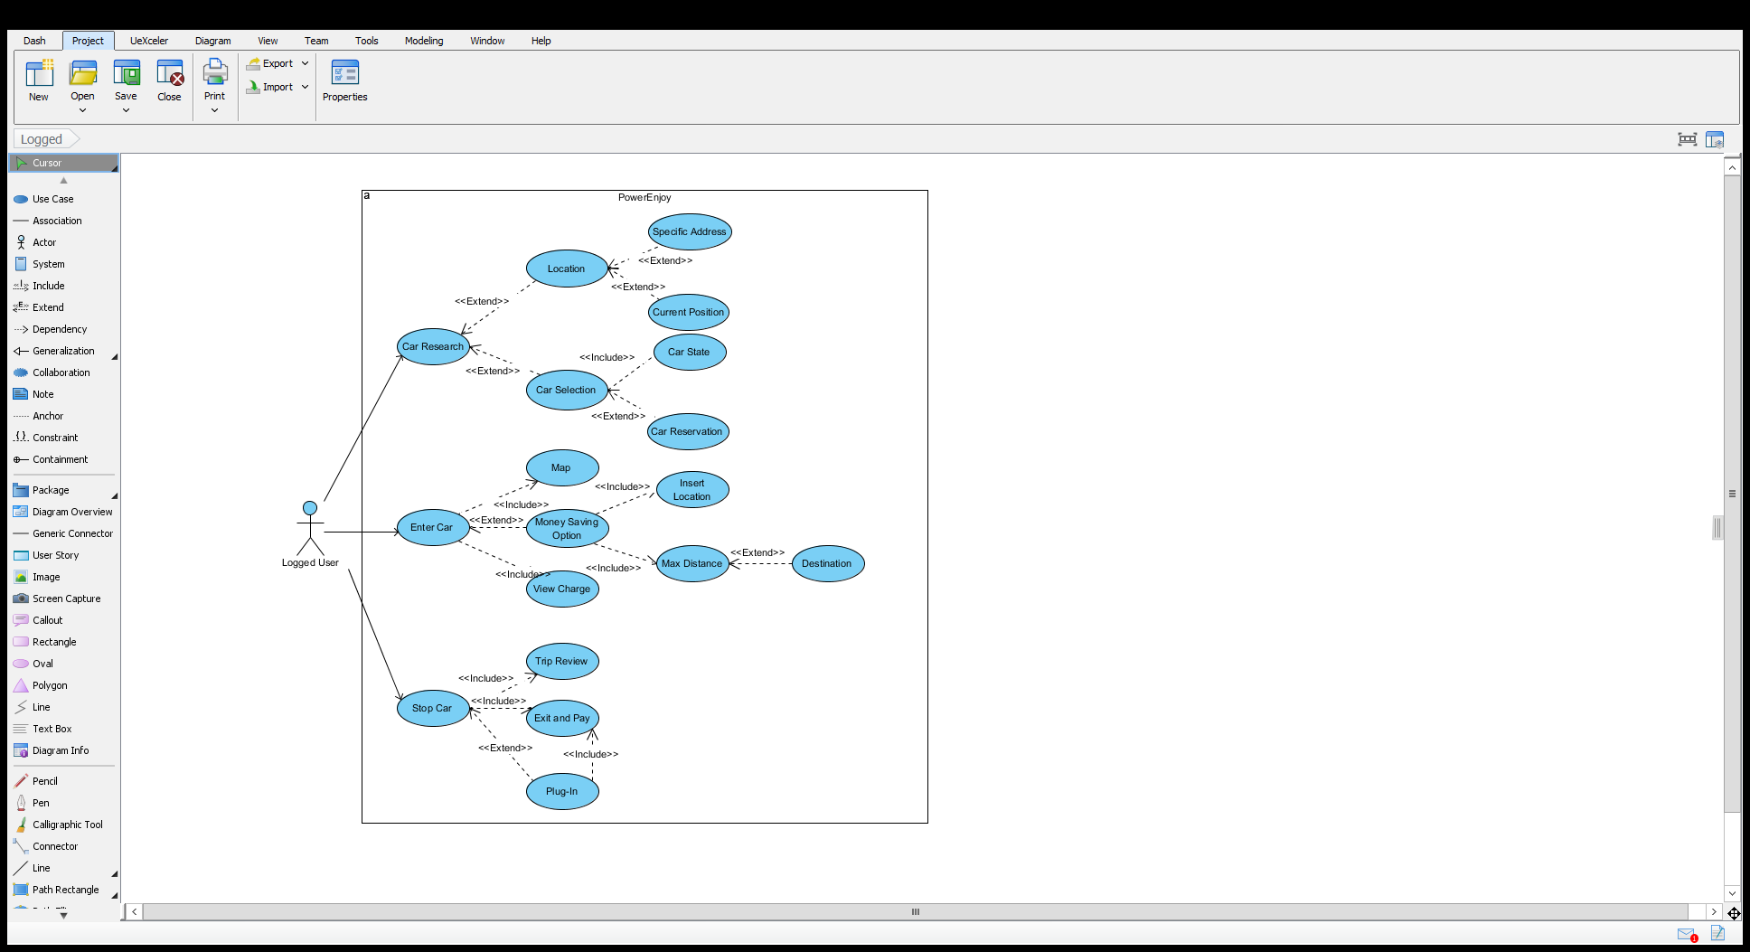

## User characteristics (gian)

## Constraints

### Regulations

### Reliability requirements

### Hardware limitation

### Criticality

### Performance requirements

### Security

## Assumptions and Dependencies

# Specific Requirements

## External Interface Requirements

### User Interfaces

### Hardware Interfaces

### Software Interfaces

### Communication Interfaces

## Functional Requirements

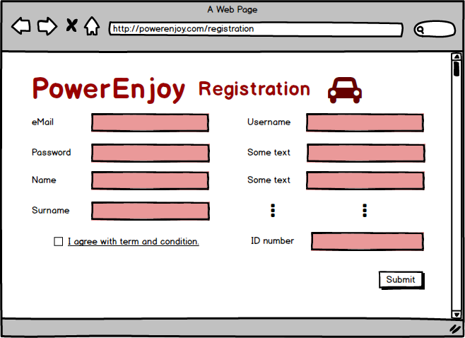

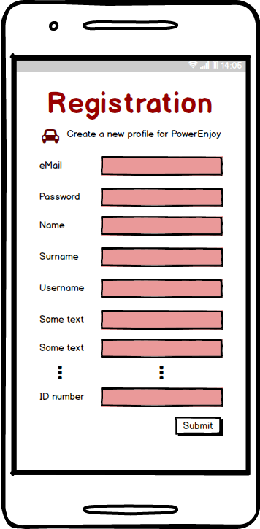

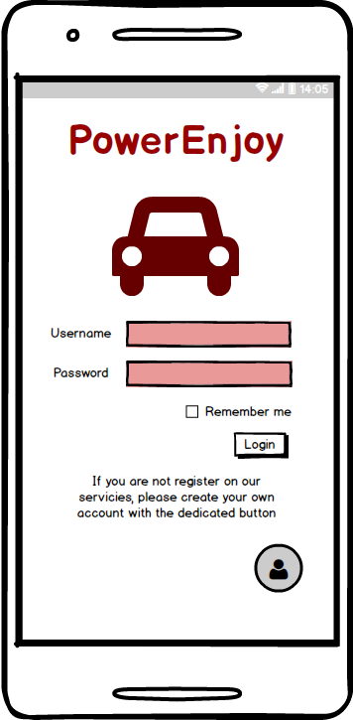

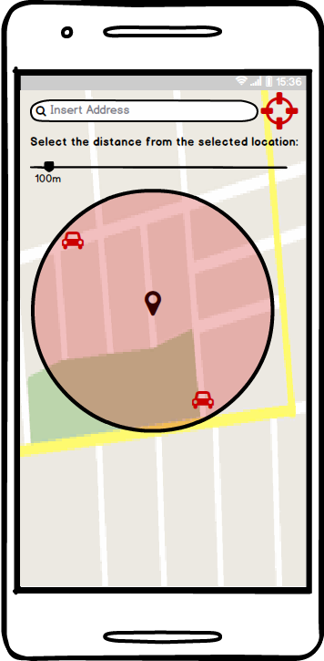

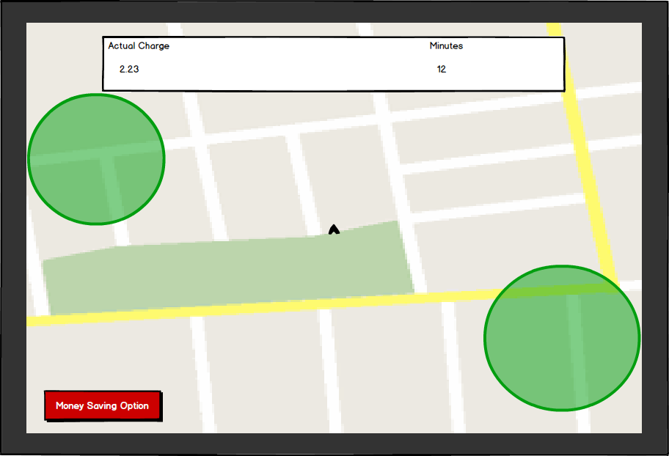

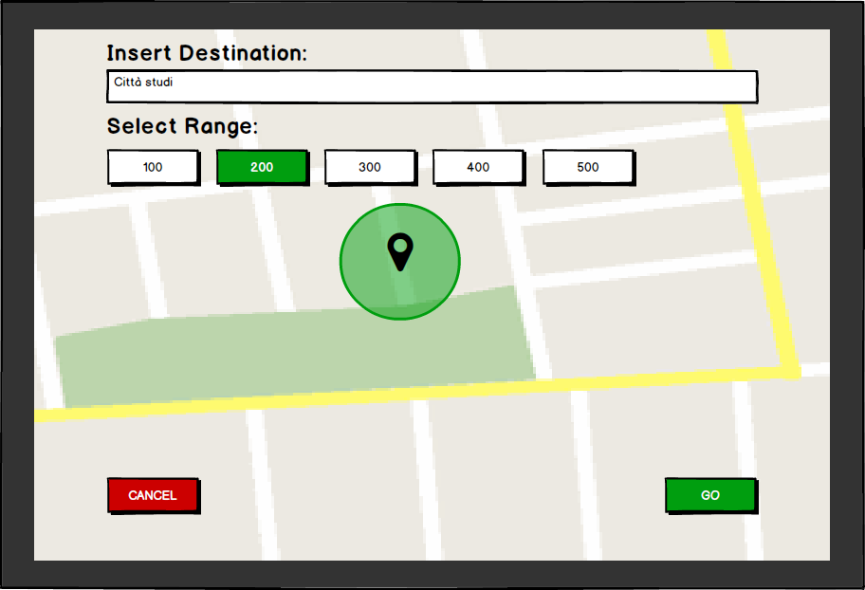

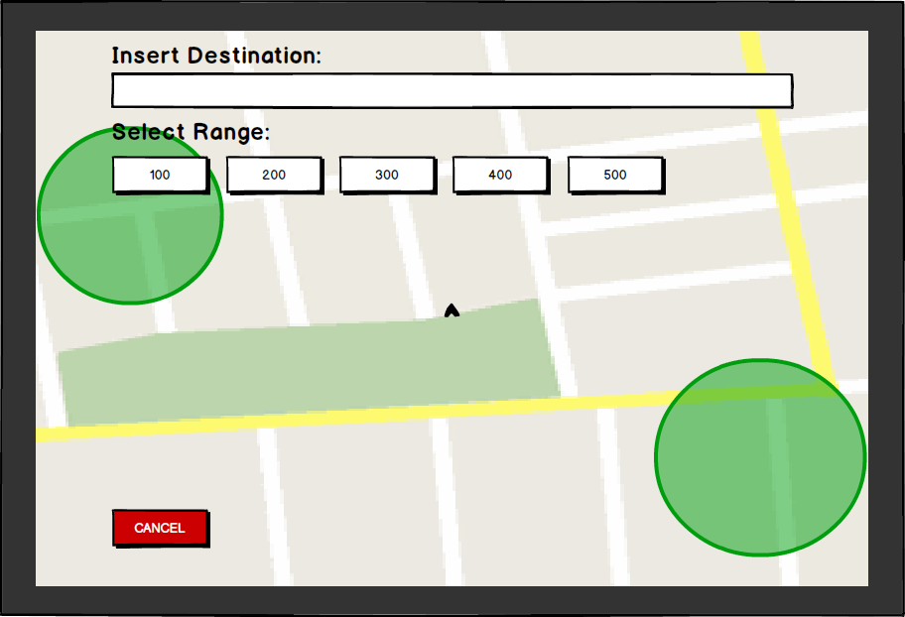

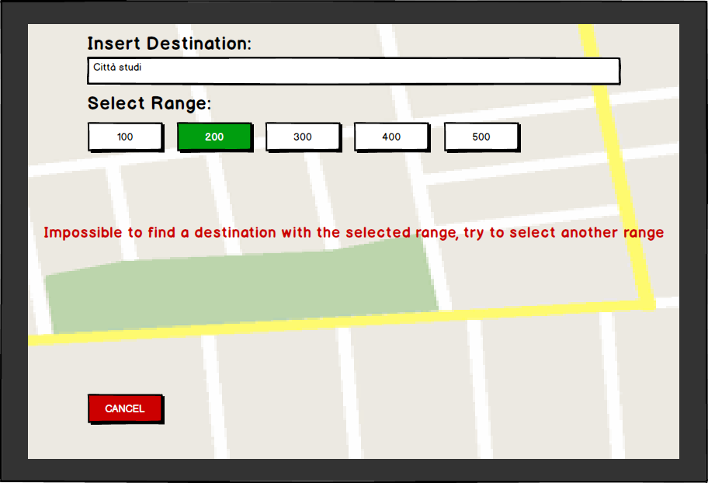

### Login

|  |  |
| --- | --- |
|  |  |
|  |  |