**SOFTWARE REUQIREMENTS SPECIFICATIONS**

**1. INTRODUCTION**

E-Office is an web-based application providing solutions to government employees a personalized user experience that is simple to use, improves quality services to the government. It keeps track of appointment status, meeting scheduling, office automation, complaint status, Incident reports. The system is set up and run so that users may submit recommendations and complaints, see the status of working progress to the authority department, which can then respond to them through internal meetings, management, and automations.

**1.1 PURPOSE**

The purpose of this document is to provide the smart government services to localbody and citizens and to handle the grevience of the people, streamline meeting and appointment process in digital way.

**1.2 DOCUMENT CONVENTIONS**

This document user for the following conventions:

|  |  |
| --- | --- |
| DB | Database |
| DDB | Distributed Database |
| ER | Entity Relationship |

**1.3 INTENDED AUDIENCE AND READING SUGGESTIONS**

This project is a prototype for the E-office system . This has been implemented under the guidance of college professors. This project is useful for the flight management team and as well as to the passengers.

**1.4 PROJECT SCOPE**

The purpose of the E-office system is to create a convenient and easy-to-use application for people.

## 2. OVERALL DESCRIPTION

**2.1 Citizen Charter**

Citizen Charter(CC) which is a written commitment by public service providers regarding the flow of service and service delivery processes to the citizens, aiming to make public service delivery more effective and efficient.

* **Service details:**  
  The e-office system will provide a range of services to users, allowing them to choose according to their specific needs and requirements. These services may include document management, task management, communication tools, workflow automation, and collaboration features.
* **Service Related Document:**  
  Service-related documents are essential for providing information, guidelines, and instructions about the services offered by the e-office system. These documents help users understand the capabilities, features, and usage of the services, ensuring that they can effectively utilize and benefit from them.
* **Service log history:**  
  Service log history refers to a record or history of activities, events, and changes related to the services provided by the e-office system. It captures details about service incidents, maintenance activities, updates, and any other relevant information that helps in tracking and monitoring the service's performance and changes over time.

**2.2 PRODUCT FEATURES**

The major features of the Citizen Character as shown in below

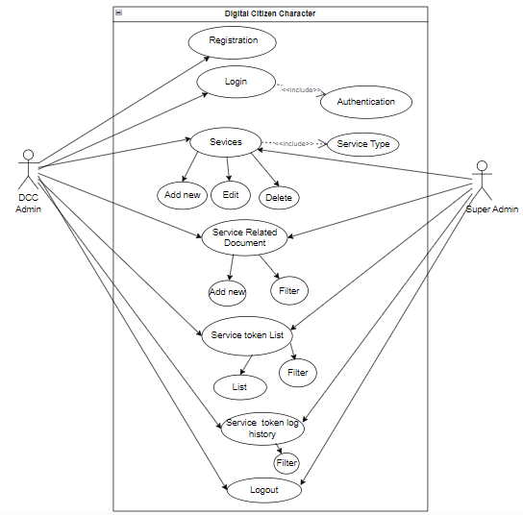

The diagram shows the layout of digital citizen charter system – use case model

**2.2 Activity Diagram**

Activity diagram is another important behavioral diagram in UML diagram to describe dynamic aspects of the system. Activity diagram is essentially an advanced version of flow chart that modeling the flow from one activity to another activity. The activity diagram for this system is as follows:

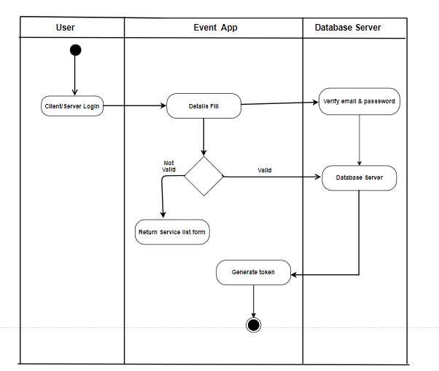

*Figure 1 Activity Diagram for Service token*

**2.3 USER CLASS AND CHARACTERISTICS**

Users of the system should be able to retrieve information of people who are getting what services from the database. User admin able to perform all the task like add, view ,edit the services and also add service related documents. The customer should be able to do the following functions:

The user admin should have the following functionalities:

USER ADMINISTRATIVE  
• Add/Delete a services  
• Add service related document.  
• Update information.

**2.4 OPERATING ENVIRONMENT**

The operating environment for the e-office system is as listed below.

* distributed database
* client/server system
* Operating system: Windows, linux
* database: Postgres
* backend: laravel

## 3. SYSTEM FEATURES AND REQUIREMENTS

## 3.1 FUNCTIONAL REQUIREMENTS

These are the guidelines for what the system should do, how it should respond to different inputs, and how it ought to function in certain circumstances. The Meeting Management System, Office Automation System, Citizen Charter, and Grievances Handling System are the four minor initiatives that make up the E-Office.

I was assigned to the components of the projects Digital Citizen Charter. These are the following functional requirements citizen charter are:

* Users are able to register and authenticate their identities securely for accessing the Digital Citizen Charter platform.
* Provide the complete information about the different services offered including their features, conditions, and prerequisites.
* Give access to relevant documents such as user guides, configuration guides, and integration guides that provide instructions and guidelines for utilizing the services effectively.
* Maintain a record of activities, incidents, and changes ensuring accountability and facilitating monitoring and analysis.

## 3.2 EXTERNAL INTERFACE REQUIREMENTS

### 3.1 USER INTERFACES

* Front-end software: CSS, Javascipt, vue.js
* Back-end software: Postgres database, laravel

**3.2 HARDWARE INTERFACES**

* Windows

|  |  |
| --- | --- |
| **Software used** | **Description** |
| Operating system | We have chosen Windows operating system for its best support and user-friendliness. |
| Database | To save the records we have chosen SQL+ database. |
| laravel | To implement the project we have chosen laravel language for its more interactive support. |

**3.3 SOFTWARE INTERFACES**

## 4. NONFUNCTIONAL REQUIREMENTS

* **Product requirements**

**Memory:** The system must be taking up less memory space for data manipulation.

**Accuracy:** The results must be accurately displayed according to the query, meaning that all the programs written must be tested properly with multiple possible inputs.

**Speed:** Reduce unnecessary dependencies, limit the use of packages and create manageable modules for each operation for smooth operation.

**Reliability:** The e-office system should be reliable and available for use when needed. It should minimize system failures, crashes, and data loss. It should also have backup and recovery mechanisms in place to ensure the integrity and availability of data.

* **External requirements**

The system must comply with legal and financial acts. It should maintain transparency but should not disclose information to unrelated parties. The system should be liable for providing ease of access for the users.