# Table of Content

LIST OF FIGURE ii

LIST OF TABLE iii

GYM Management System 1

AIM: 1

PROJECT DESCRIPTION: 1

PURPOSE: 1

PROBLEM STATEMENT 1

UML DIAGRAMS: 2

1. USE CASE DIAGRAM: 2
2. CLASS DIAGRAM: 4
3. ACTIVITY DIAGRAM: 7
4. SEQUENCE DIAGRAM: 9
5. COLLABORATION DIAGRAM 11
6. STATE CHART DIAGRAM: 12
7. DEPLOYMENT DIAGRAM: 13

RESULT: 14

# LIST OF FIGURE

Figure 1 Use Case Diagram 3

Figure 2 Class Diagram 6

Figure 3 Activity Diagram of Customer 8

Figure 4 Sequence Diagram 10

Figure 5Collaboration Diagram 11

Figure 6 State Diagram 12

Figure 7 Deployment Diagram 13

# LIST OF TABLE

Table 1 Class Diagram Details 5

# Repair Management System

## AIM:

To draw the diagrams (use case, activity, sequence, collaboration, class, deployment, state chart) for the Repair Management System.

## PROJECT DESCRIPTION:

To simplify the process of applying membership in repair , software has been created by designing through rational rose/visual paradigm tool. Initially the customer login to the system and submit his/her details. These details are stored in the database through verification process done by the owner and the membership card/membership is issued to the applicant.

## PURPOSE:

If the entire process of ‘Issue of Membership Card/Membership’ is done in manual manner then it may take time and also the record can be misplaced after certain time. Consider the fact that the number of customers for gym membership is increasing every month/year, a Management System becomes essential to meet the demand. So this system uses programming and database to explain the work involved in this process:

## PROBLEM STATEMENT:

Repair Management System is used in managing of membership details and easy the process of issuing the membership card of all customers. This system adopts a comprehensive approach to minimize the manual work, time in a cogent manner.

## UML DIAGRAMS:

The following UML diagrams describe the process involved in the Repair management system.

## USE CASE DIAGRAM:

The Use case diagram shows the interaction between system and user. This diagram contains the actors, use cases. The relationship used in the Use Case Diagram are:

* 1. **Association between User and Use Case:** It shows the connection between actor and system. It shows which actor will interact with system. It is represented by a solid line. In Use Case diagram actor must be associated with at least one use case and can be associated with multiple use case also.
  2. **Extend Relation:** The function of the base Use Case is extended by optional case. It add more functionality to the system.
  3. **Include Relation:** The function of base use case include a mandatory child Use Case called Include Use Case. It shows the behavior of the included Use Case in a part of including (base) use case.

The diagram shown below contains different Actor and Use Case which are listed as follows:

**Actors:** Customer, Admin

**Use Case:** Login, Request for Membership, Form, Accept Membership Request, Verification, Issue Membership Card, Notification, Payment, Advance Payment and discount and logout.

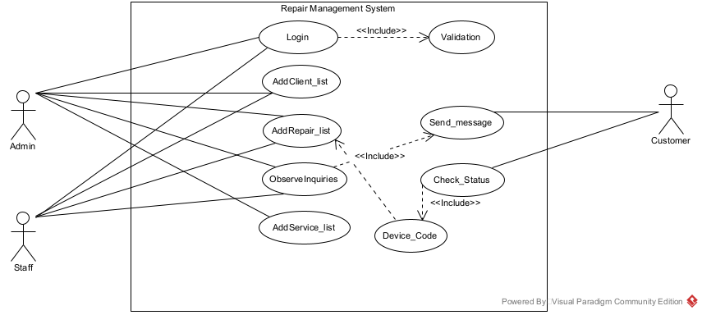

*Figure 1 Use Case Diagram*

## CLASS DIAGRAM:

This diagram show the classes in the system and the association between these classes. This diagram consists of the classes, attributes and their operation.

* 1. **Class:** Class is a classification of object which encapsulates the data and associated behavior. It gives the blue print or description of the object that can be created from it.
  2. **Attributes:** Attributes are often refer as class data.
  3. **Operation:** Operation is refer as function or method

The Class diagram also consist of relationship which represent how classes in the system are related to each other. The relationship used in following diagram are:

1. **Association:** An association is a relationship between the classes that indicate some meaningful message. It is the link which is used to connect one class with other class.
2. **Generalization:** It is a process of extracting common information from two or more classes and combining them into generalized super class. It is known as “Is a” relationship.

The diagram consists of the following classes, attributes and their operations.

***Table 1 Class Diagram Details***

|  |  |  |
| --- | --- | --- |
| **Classes** | **Attributes** | **Operations** |
| Owner | Rv_id, Name, Username, Address, Email , Phone_No | Login(username,password),  View(), Add(), VerificationForm() |
| Login | Username, Password | Validation() |
| Customer | C_id, Name, Username,  Address, Email , Phone_No | Login(username,password),  View(), FillForm() |
| Payment | M_id, Name, Payment Date,  Amount | View(), Update() |
| Credit | M_id, Name, Amount | View(), Update() |
| Cash | M_id, Name, Payment Date,  Amount | View(), Update() |
| AdvancePayment | M_id, Name, Payment Date,  Amount, Discount | View(), Update() |
| MemberForm | M_id, Name, Address, Mobile_No , Phone_No, Age, Gender, MemberDetails,  Payment Date, Amount, | View(), Update() |

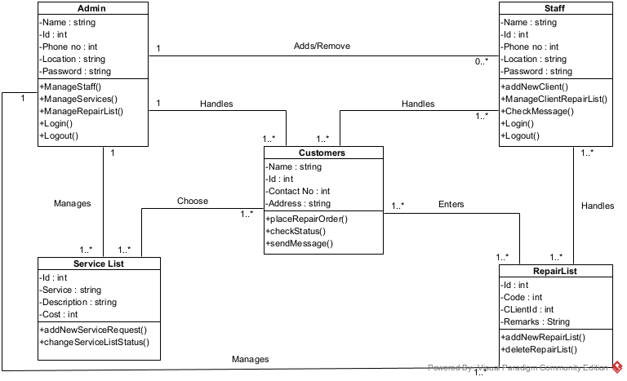

*Figure 2 Class Diagram*

## ACTIVITY DIAGRAM:

Activity Diagram is the diagram that shows sequential and parallel activities in a process. The diagram shows the sequence of action some of which may be parallel and it also shows both control flow and data flow. The notation used in following activity diagram are:

* 1. **Initial State or Starting Point:** A small filled circle followed by an arrow represents the starting point for an activity diagram.
  2. **Activity or Activity State:** It represents the non-interruptible action of object. It is represent by rectangle with rounded corners. Login, Take a Membership, Fill the Form, Notification, Payment, Credit and Cash are the activity.
  3. **Action flow:** It shows the transition from one action state to another. It is represent by arrow flow.
  4. **Decision and branching:** A diamond shape symbol is used when an activity requires a decision prior to moving on the next activity.
  5. **Guards:** Guards are the statement written next to the decision diamond symbol to indicate true or false condition.
  6. **Synchronization bar:** This bar is used to show the parallel sub-flows or concurrent threads. Notification, Payment, Cash, Credit are joint with synchronization bar.
  7. **Final state or end point:** An arrow pointing to a filled circle nested inside another circle represents the final state.

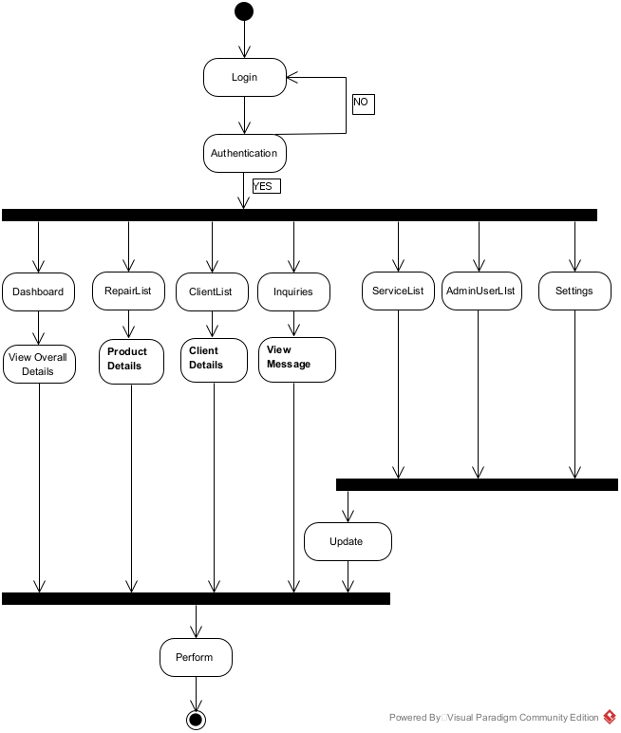

*Figure 3 Activity Diagram of Customer*

## SEQUENCE DIAGRAM:

Sequence Diagram describes the flow of message, events and action between the objects. It is used to visually represent the external event and internal event that system must handle and what operation system have to perform based on the event.

The notation used in following sequence diagram are:

* 1. **Participants/life line:** It represents an object or entity that acts in the sequence diagram.
  2. **Actor:** Actor represents an entity that interact with the system and its object.
  3. **Message:** Message represents the communication between the object.
     1. **Synchronous message:** It is a type of message which needs response or reply from the destination object before the interaction can move forward. It is represented by solid arrow head.
     2. **Asynchronous message:** It is a type of message which do not wait for a reply for the further interaction. It is represented by open arrow head and there is no any reply message.
     3. **Create message:** It is a kind of message which is used to instantiated a new object in the sequence diagram.
  4. **Activation or Execution Occurrence:** It represents the time an object needs to complete the task. A thin gray rectangle is placed vertically with lifeline to represents activation which shows whether the object is busy in executing a process or waiting for a reply.
  5. **Alternative (Alt) frame:** This fragment is used when the choice between two or more statement has to make. It is similar to (if-else) logic.

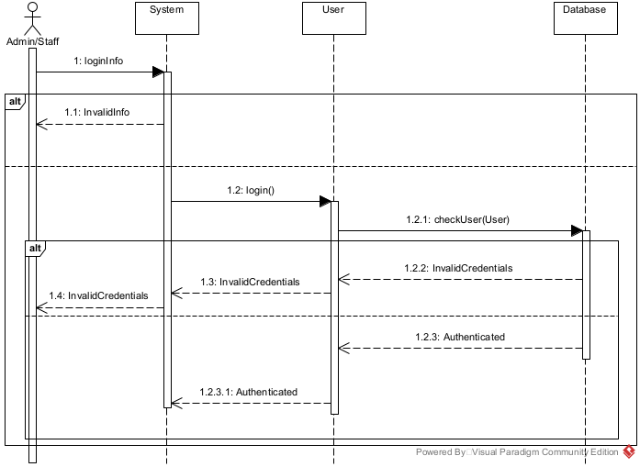

*Figure 4 Sequence Diagram*

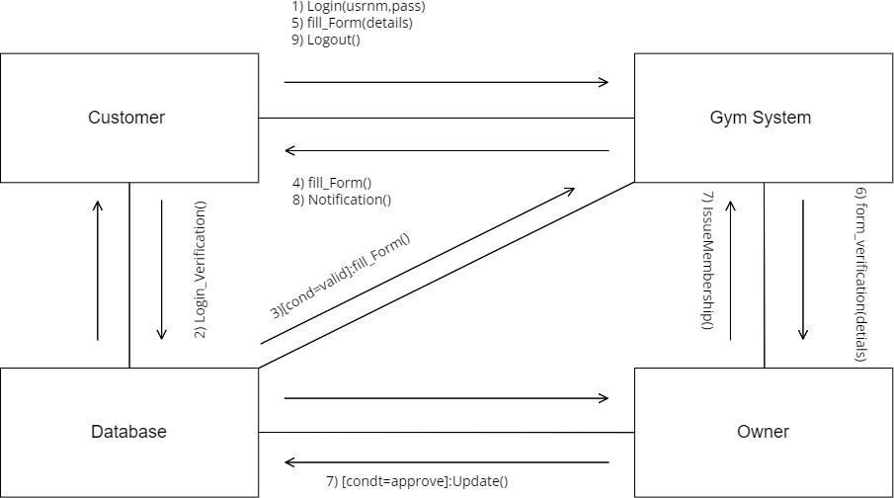

## COLLABORATION DIAGRAM

This diagram contains the object and actors. A collaboration diagram is similar to sequence diagram but the message in number format. In a collaboration diagram sequence diagram is indicated by the numbering the message. A collaboration diagram, also called a communication diagram or interaction diagram. A sophisticated modeling tool can easily convert a collaboration diagram into a sequence diagram and the vice versa.

*Figure 5Collaboration Diagram*

## STATE CHART DIAGRAM:

The state chart diagram contains the states in the rectangle boxes with round corners and starts is indicated by the dot and finish is indicated by dot encircled.

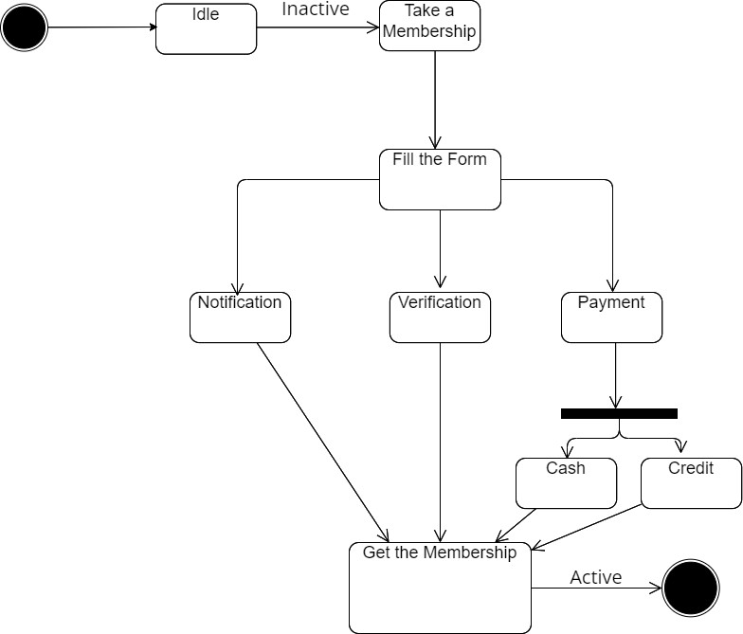

*Figure 6 State Diagram*

## DEPLOYMENT DIAGRAM:

The customer login to the Gym Management System and submits their details. These details are stored in the database (Local Database, Online Database) and verification process done by the Owner. Then the membership card is issued to the customer.

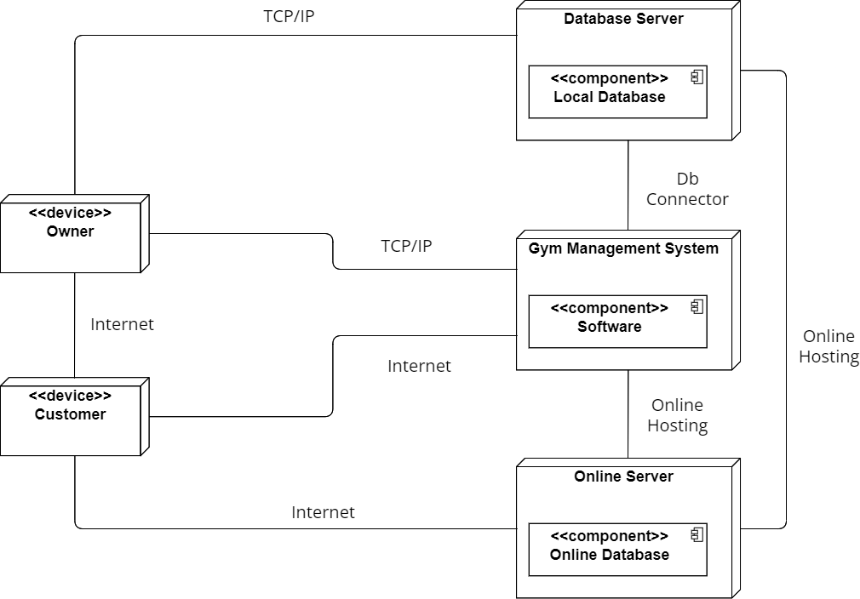

*Figure 7 Deployment Diagram*

## RESULT:

Thus the diagram (use case, activity, sequence, collaboration, class, deployment, state chart) for the Repair Management System has been designed, executed and output is verified.