Symmetry and Scale Separation in Convolutional Neural Networks
Task 2 Report
Simachew Alamneh | CNN | September 2026

1. Introduction
In Task 1 we built a CNN and a feed-forward network (FFNN) with only NumPy and compared them on Fashion-MNIST. On the images as they come (centred), both networks reach about 85% test accuracy (FFNN 85.6%, CNN 84.8%). The CNN, however, has four times fewer parameters (27,562 against 109,386), a smaller gap between training and test accuracy (5.7 against 7.2 points), and it keeps more of its accuracy when the images are shifted or zoomed a little. It is also much slower to train in our implementation (331 s against 38 s).
This report explains why. The main objective of the training is to understand why the CNN is good for image classification, and the explanation has two parts. The first is symmetry: a shoe is still a shoe wherever it is in the picture. The second is scale separation: an image is built from small details (edges), which form parts, which form objects, so we can look at small regions first and combine them at larger scales. For each part I give the mathematics and then show a number from an experiment that checks it. The checks were done with a small NumPy script (symmetry_checks.py) and the experiment numbers come from our own Task 1 run.

2. Symmetry: basic definitions
We treat an image as a function on the pixel grid: x(u) is the pixel value at position u = (row, column). Shifting the image by a vector s gives a new image
(T_{s} x)(u) = x(u − s)
A function f is invariant to shifts if f(T_{s}x) = f(x): the output does not change when the input moves. A layer F is equivariant if F(T_{s}x) = T_{s}F(x): if the input moves, the output moves in the same way. We want the first layers of a network to be equivariant (they need to know where a feature is) and the final decision to be invariant (the class does not depend on the position).

3. Convolution is translation equivariant
The convolution used in CNNs (strictly a cross-correlation) is
(x ⋆ w)(u) = ∑_{v} x(u + v) w(v)
where w is a small kernel (for example 3×3) and the sum runs over the kernel positions. The same kernel is used at every position u.
Theorem 1. For every kernel w and shift s, (T_{s}x) ⋆ w = T_{s}(x ⋆ w).
Proof. At position u: ((T_{s}x) ⋆ w)(u) = ∑_{v} x(u + v − s) w(v). This is exactly (x ⋆ w)(u − s), which is (T_{s}(x ⋆ w))(u). ∎
So shifting the input and then convolving gives the same result as convolving and then shifting the feature map. A ReLU applied to each pixel also commutes with shifts, and a composition of equivariant layers is equivariant, so a whole stack of convolution and ReLU layers is equivariant.
Theorem 2 (convolution is the only choice). If a linear map L commutes with all shifts, then it is a convolution.
Proof. Let δ_{v} be the image that is 1 at pixel v and 0 elsewhere; then δ_{v} = T_{v}δ₀ and any image is x = ∑_{v} x(v) δ_{v}. By linearity and commutation with shifts, Lx = ∑_{v} x(v) T_{v}(Lδ₀). With h = Lδ₀ this reads (Lx)(u) = ∑_{v} x(v) h(u − v), a convolution. ∎
This is why the CNN is not just a trick. If we want a linear layer that respects translations, convolution is the only option. As a matrix, such a layer is circulant (each row is the previous row shifted), so it has only as many free numbers as the kernel has. A dense layer from 784 pixels to 784 outputs has 614,656 weights, a 3×3 convolution has 9. In our CNN the first layer has 80 parameters and produces 8 × 26 × 26 = 5,408 outputs; a dense layer with the same input and output sizes would need 784 × 5,408 = 4,239,872 weights. This explains the four times smaller parameter count.
Numerical check. We took a Fashion-MNIST ankle boot (shrunk so it has empty margin) and a Sobel kernel. The largest difference between "shift then convolve" and "convolve then shift" was 0 for the valid convolution used in our CNN (Figure 1). A random dense layer of the same size gave a relative error of 1.405. One limit: with valid convolution the equality is exact only while the object stays inside the image; parts that move over the border are cut off.
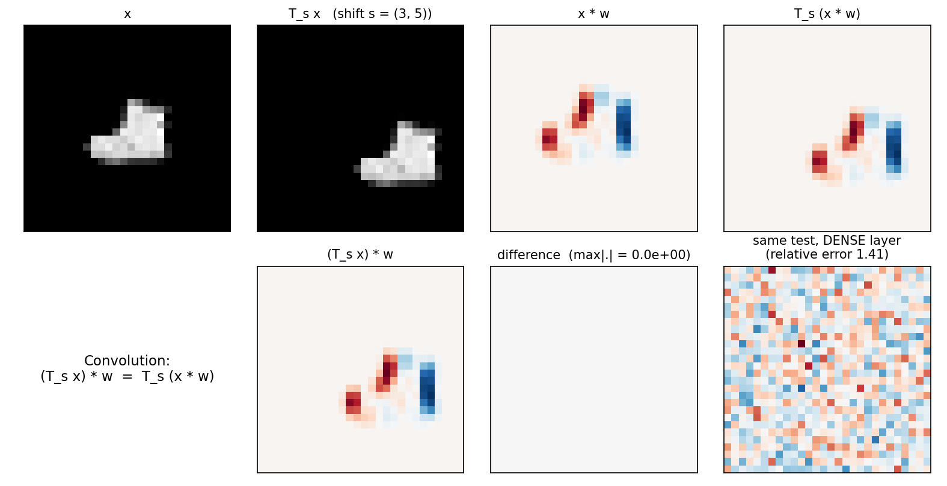
Figure 1. Shift then convolve equals convolve then shift (difference panel is zero). A dense layer does not have this property (bottom right).

4. Pooling: from equivariance to invariance
Our CNN uses 2×2 max pooling with stride 2: (Px)(u′) = max_{v ∈ {0,1}²} x(2u′ + v). Pooling does two things. The maximum does not change if a strong response moves inside its 2×2 window, so we get local invariance, and the resolution is halved, so we get a coarser picture.
Theorem 3. For stride 2, P(T_{2s}x) = T_{s}P(x). Shifts that are multiples of the stride are handled exactly. For an odd shift, the 2×2 windows group the pixels differently and in general no shift of the pooled output reproduces the result.
Proof. P(T_{2s}x)(u′) = max_{v} x(2u′ + v − 2s) = max_{v} x(2(u′ − s) + v) = (Px)(u′ − s). ∎
We checked this: the identity holds with error 0 for even shifts, while for a 1-pixel shift the best coarse shift still leaves an error of 3.159. This effect is called aliasing.
Global pooling. If at the end we sum (or average, or take the maximum) over all positions, g(x) = ∑_{u} x(u), then g(T_{s}x) = g(x) exactly. So "equivariant layers followed by a global pooling" gives an exactly shift-invariant classifier.
Table 1 shows how much a representation changes when the test image is shifted diagonally by s pixels, using 8 random convolution-ReLU-maxpool filters. Values near 0 mean invariant, values near 1.4 mean the representation is completely different.
Table 1. Relative change of the representation after a shift of s pixels.
Shift (px) | Raw pixels | Flattened pooled maps | Global sum of pooled maps
0 | 0.000 | 0.000 | 0.0000
1 | 0.660 | 0.422 | 0.0436
2 | 0.981 | 0.772 | 0.0000
3 | 1.202 | 1.017 | 0.0436
4 | 1.333 | 1.214 | 0.0000
5 | 1.402 | 1.311 | 0.0436
6 | 1.414 | 1.388 | 0.0000

The global sum is exactly invariant for even shifts and changes by only 4.4% for odd shifts. The flattened maps, which keep the position of every feature, are only a little better than raw pixels for larger shifts. Our CNN uses the flattened version (Flatten followed by dense layers) instead of global pooling, so it only has invariance over a small range. This matches Task 1: the CNN kept 88.0% of its accuracy after a 1-pixel shift (FFNN 78.3%) and 62.0% after 2 pixels (FFNN 44.0%), but after 3 and 4 pixels both were about equal (27.2% against 26.2%, and 18.6% against 18.9%). We did not train a global-pooling version, so we cannot say how much it would improve this.

5. Where the symmetry stops: rotation and zoom
Convolution is built for translations only. For a rotation R we have the following.
Lemma. (Rx) ⋆ (Rw) = R(x ⋆ w). Rotating the input gives the rotated output only if the kernel is rotated as well.
Proof. Write ((Rx) ⋆ w)(u) = ∫ x(R⁻¹(u + v)) w(v) dv and substitute v = Rv′ (rotations keep the area). We get ∫ x(R⁻¹u + v′) w(Rv′) dv′, which is the convolution of x with the rotated kernel w(R·), evaluated at R⁻¹u. So (Rx) ⋆ w = R(x ⋆ R⁻¹w); replacing w by Rw gives the lemma. ∎
In words, a vertical-edge detector on a rotated picture is a horizontal-edge detector on the original. We checked it with exact 90° rotations: with the same kernel, "rotate then convolve" differs from "convolve then rotate" by a relative error of 1.445; with the rotated kernel the error is 0 (Figure 2). A CNN has one set of kernels, so it does not treat a rotated object as the same object unless it learns the rotated kernels from data.
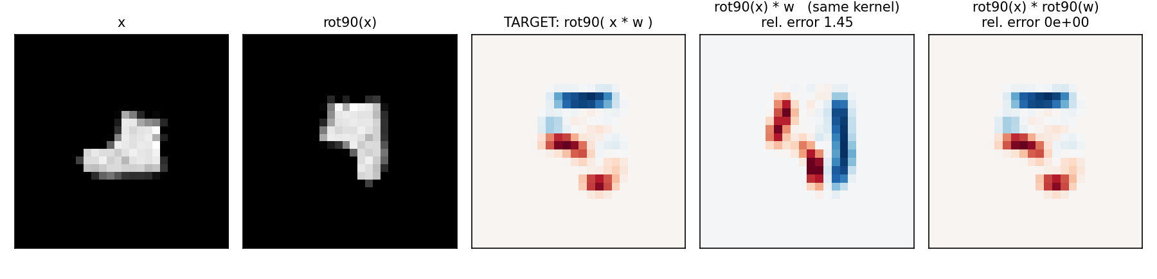
Figure 2. Rotation. The third panel is the target. Same kernel on the rotated image (fourth) is wrong; rotated kernel (fifth) is exact.
A square pixel grid only has exact rotations by multiples of 90°. Rotations like 45° or 60° need interpolation, which blurs the image, so no network can be exactly equivariant to them on pixels. Also, the symmetry should match the problem: rotating a "6" by 180° gives a "9".
How to add rotation symmetry. One can train with rotated images (data augmentation), or use a group-equivariant CNN (Cohen and Welling, 2016). For 90° rotations, the layer uses the kernel in its four rotations and produces four feature maps; rotating the input rotates every map and shifts the four maps cyclically by one position. Taking the maximum over the four and then a global sum gives an exactly rotation-invariant number. We checked this: the relation holds with error 0, and the invariant number changes by 0 under a 90° rotation, against 24.1% for an ordinary convolution followed by a global sum. For a 45° rotation, which is not a symmetry of the grid, it still changes by 11.7%. We did not train such a network.
Zoom. For a zoom by a one gets in the same way (D_{a}x) ⋆ w = a² D_{a}(x ⋆ w_{a}) with w_{a}(v) = w(av), so a zoomed image needs a kernel of a different size. A fixed 3×3 kernel is not scale-equivariant; networks use filters of several sizes for this.
Task 1 results. Table 2 and Figure 3 show the accuracy kept (as a percentage of the accuracy on the original test images). Both networks were trained only on original images.
Table 2. Accuracy kept after transforming the test images (our Task 1 run).
Transformation | FFNN | CNN
rotate 15° | 62.7% | 77.2%
rotate 30° | 23.6% | 30.0%
rotate 45° | 13.0% | 13.5%
rotate 60° | 8.1% | 7.8%
rotate 90° | 5.5% | 3.1%
shift 1 px | 78.3% | 88.0%
shift 2 px | 44.0% | 62.0%
shift 3 px | 26.2% | 27.2%
shift 4 px | 18.9% | 18.6%
zoom 0.7 | 40.0% | 66.0%
zoom 0.85 | 71.7% | 90.6%
zoom 1.15 | 83.8% | 90.4%
zoom 1.3 | 69.8% | 79.4%

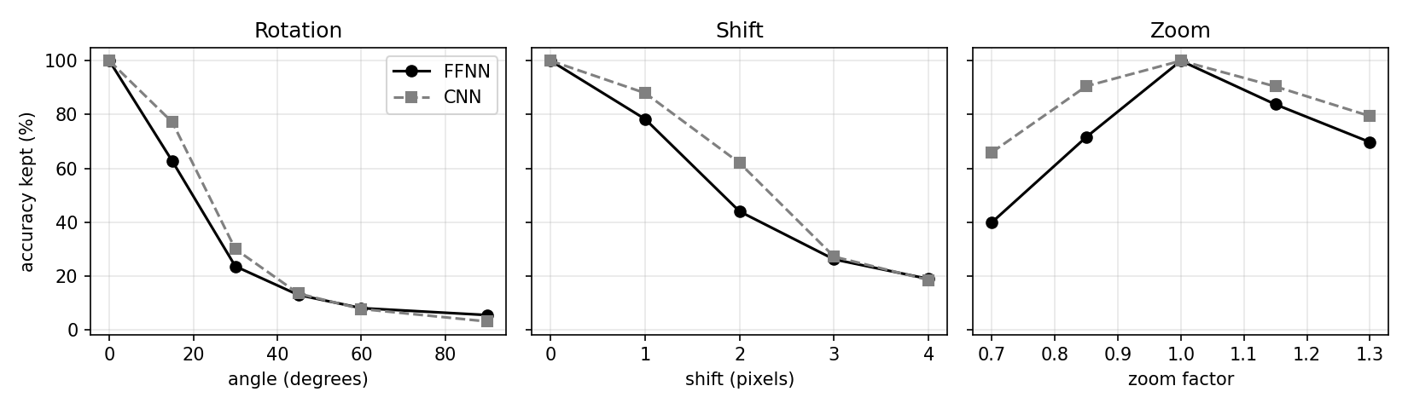
Figure 3. Accuracy kept for the FFNN and the CNN under rotation, shift and zoom.
The CNN is better for small rotations, small shifts and zooms, but neither network is invariant. At 60° and 90° both are below the 10% chance level of a 10-class problem, which agrees with the lemma: nothing in the architecture handles rotation.

6. Scale separation
The idea is to understand the picture scale by scale. Small local patterns (edges) are combined into larger ones (parts) and then into objects, and interactions between distant regions can be summarised coarsely. A CNN follows this: small kernels look at local neighbourhoods, and pooling makes the picture coarser so the next layer covers a larger part of the original image. Our CNN is conv, ReLU, pool, conv, ReLU, pool, then flatten and dense layers.
Receptive field. The receptive field of a unit is the set of input pixels that can change it. If r_{l} is its size after layer l and j_{l} is the distance in input pixels between neighbouring units, then for a layer with kernel size k_{l} and stride s_{l}:
r_{l} = r_{l−1} + (k_{l} − 1) j_{l−1}, j_{l} = j_{l−1} s_{l}
The reason is that a unit looks at k_{l} neighbouring units of the previous layer, which are j_{l−1} pixels apart, and a stride multiplies the spacing for all later layers. For our CNN this gives Table 3.
Table 3. Receptive field of one unit in our CNN.
Layer | Kernel | Stride | Receptive field | Jump
conv1 3x3 | 3 | 1 | 3 × 3 | 1
pool1 2x2 | 2 | 2 | 4 × 4 | 2
conv2 3x3 | 3 | 1 | 8 × 8 | 2
pool2 2x2 | 2 | 2 | 10 × 10 | 4
Dense (after flatten) | - | - | 28 × 28 (all) | -

We also measured it: we increased each input pixel of a random conv-pool-conv-pool network and recorded which pixels change one output unit. The result is a 10 × 10 block of 100 pixels, as the formula says (Figure 4). Without stride the receptive field grows by 2 per 3×3 layer (eight layers see only 17 pixels), but with pooling after each convolution it roughly doubles at each stage (3, 4, 8, 10, 18, 22, 38, 46 for eight layers), so it covers the whole 28-pixel image after about seven layers. Small kernels are therefore enough to see a whole image.
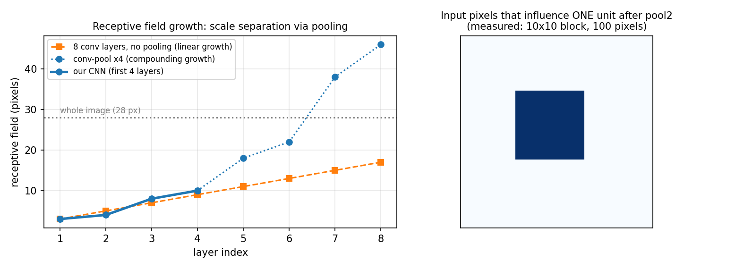
Figure 4. Left: receptive field growth with and without pooling. Right: the measured 10 × 10 receptive field of one unit after the second pooling.
Cost. Scale separation and weight sharing save parameters, but not operations. Each weight is used at many positions, so the CNN needs 443,360 floating-point operations per image against 218,560 for the FFNN, and about 9 times more activation memory in training (4,440 KB against 490 KB). This explains why the CNN was slower in Task 1.
Why it helps learning. Poggio et al. (2017) show that for functions built by composing simple local functions, deep networks that follow this structure need a number of parameters that depends on the small local input size (here a 3×3 patch) and not on the full input dimension (784). We did not test this theorem; it only explains the direction of our results.
Stability to small deformations. Mallat (2012) showed for the scattering transform, which is a cascade of convolutions, absolute values and averaging, that the representation is approximately invariant to translations up to the averaging scale and changes little under small deformations of the image. A rotation by angle θ is a deformation of size about 2 sin(θ/2), which is 0.26 for 15° and 1.0 for 60°; a zoom by a has size |1 − 1/a|, for example 0.13 for 1.15×. Small deformations are tolerated and large ones are not, which is what Table 2 shows (15° rotation and 1.15× zoom are tolerated, 60° is not). This is only a rough trend and I did not prove the theorem.
Feature hierarchy. The file results/feature_hierarchy.png from our run shows the learned features. The CNN first-layer kernels look like small edge detectors (each unit sees 3×3 pixels), the second-layer maps respond to larger structures (8×8 pixels), while the FFNN first-layer weights look like unstructured noise because each unit is connected to the whole image and nothing forces locality.

7. Link with the Task 1 results
- Fewer parameters (27,562 against 109,386): locality and weight sharing (Theorem 2 and Section 3).
- Same accuracy on centred images: when objects are always at the same place, there is nothing for the symmetry to help with, and the FFNN can learn absolute positions.
- Better when images are randomly shifted by up to 3 pixels (77.3% against 74.6%): now equivariance and local invariance matter. This is from one run, so it shows the direction and not an exact gap.
- Smaller train-test gap (5.7 against 7.2 points): a smaller hypothesis class; each image acts like many shifted images.
- Advantage only for shifts of 1 or 2 pixels: pooling invariance is local (Theorem 3) and the flatten layer keeps position.
- Both fail at 60° and 90°: convolution is not rotation equivariant (Lemma).
- CNN slower and heavier: weight sharing saves parameters, not operations; our NumPy implementation is also not as optimised as GPU libraries.

8. Limitations
- The Task 1 numbers come from one training run on 10,000 training images with small models. Differences of about one point or less are within noise.
- The numerical checks use one image and fixed kernels. The theorems are general; the numbers only confirm them.
- Rotated and zoomed images were made with bilinear interpolation, which blurs them, so part of the accuracy loss comes from the interpolation.
- The results of Poggio et al. and Mallat are quoted in informal form. We did not train a global-pooling CNN or a rotation-equivariant CNN; they are natural next experiments.

9. Conclusion
The CNN works well for images because its structure matches two properties of images. Convolution is exactly the linear operation that respects translation symmetry, so one small kernel can be reused at every position, which reduces the parameters and the overfitting. Pooling turns this equivariance into (local) invariance, and stacking convolution and pooling makes the receptive field grow quickly, so a few small layers build features from edges to parts to the whole object. The same mathematics shows the limits: rotation and scale are not symmetries of the layers, and a flatten layer keeps position, so the invariance is only over a small range. The Task 1 results agree with this: fewer parameters, less overfitting, better robustness to small transformations, the same accuracy on centred data, higher computation cost, and failure under large rotations.

References
Bronstein, M. M., Bruna, J., Cohen, T., and Veličković, P. (2021). Geometric Deep Learning: Grids, Groups, Graphs, Geodesics, and Gauges. arXiv:2104.13478.
Cohen, T., and Welling, M. (2016). Group Equivariant Convolutional Networks. ICML.
Mallat, S. (2012). Group Invariant Scattering. Communications on Pure and Applied Mathematics, 65(10).
Poggio, T., Mhaskar, H., Rosasco, L., Miranda, B., and Liao, Q. (2017). Why and when can deep, but not shallow, networks avoid the curse of dimensionality: a review. International Journal of Automation and Computing, 14.
Zhang, R. (2019). Making Convolutional Networks Shift-Invariant Again. ICML.
Xiao, H., Rasul, K., and Vollgraf, R. (2017). Fashion-MNIST: a Novel Image Dataset for Benchmarking Machine Learning Algorithms. arXiv:1708.07747.

