Sima Kalam

IS 601 - Individual Project: Web Application Part / Final

Github repository:

https://github.com/simak95/PythonDockerFlaskPycharm

* 1. *a.* ***YOUR*** *project showing postman listing all records:*

1. Graphical user interface, text, application, email, website

   Description automatically generated
   1. *b.* ***YOUR*** *project showing postman showing one record with a get request:*
   2. Graphical user interface, text, application

      Description automatically generated

* 1. *c.* ***YOUR*** *project showing postman creating a record by showing the post request and the results in the record listing*
  2. *d.* ***YOUR*** *project showing postman edit a record by showing the put request and the results in the record listing*
  3. *e.* ***YOUR*** *project showing postman delete a record by showing the delete request and the results in the record listing*

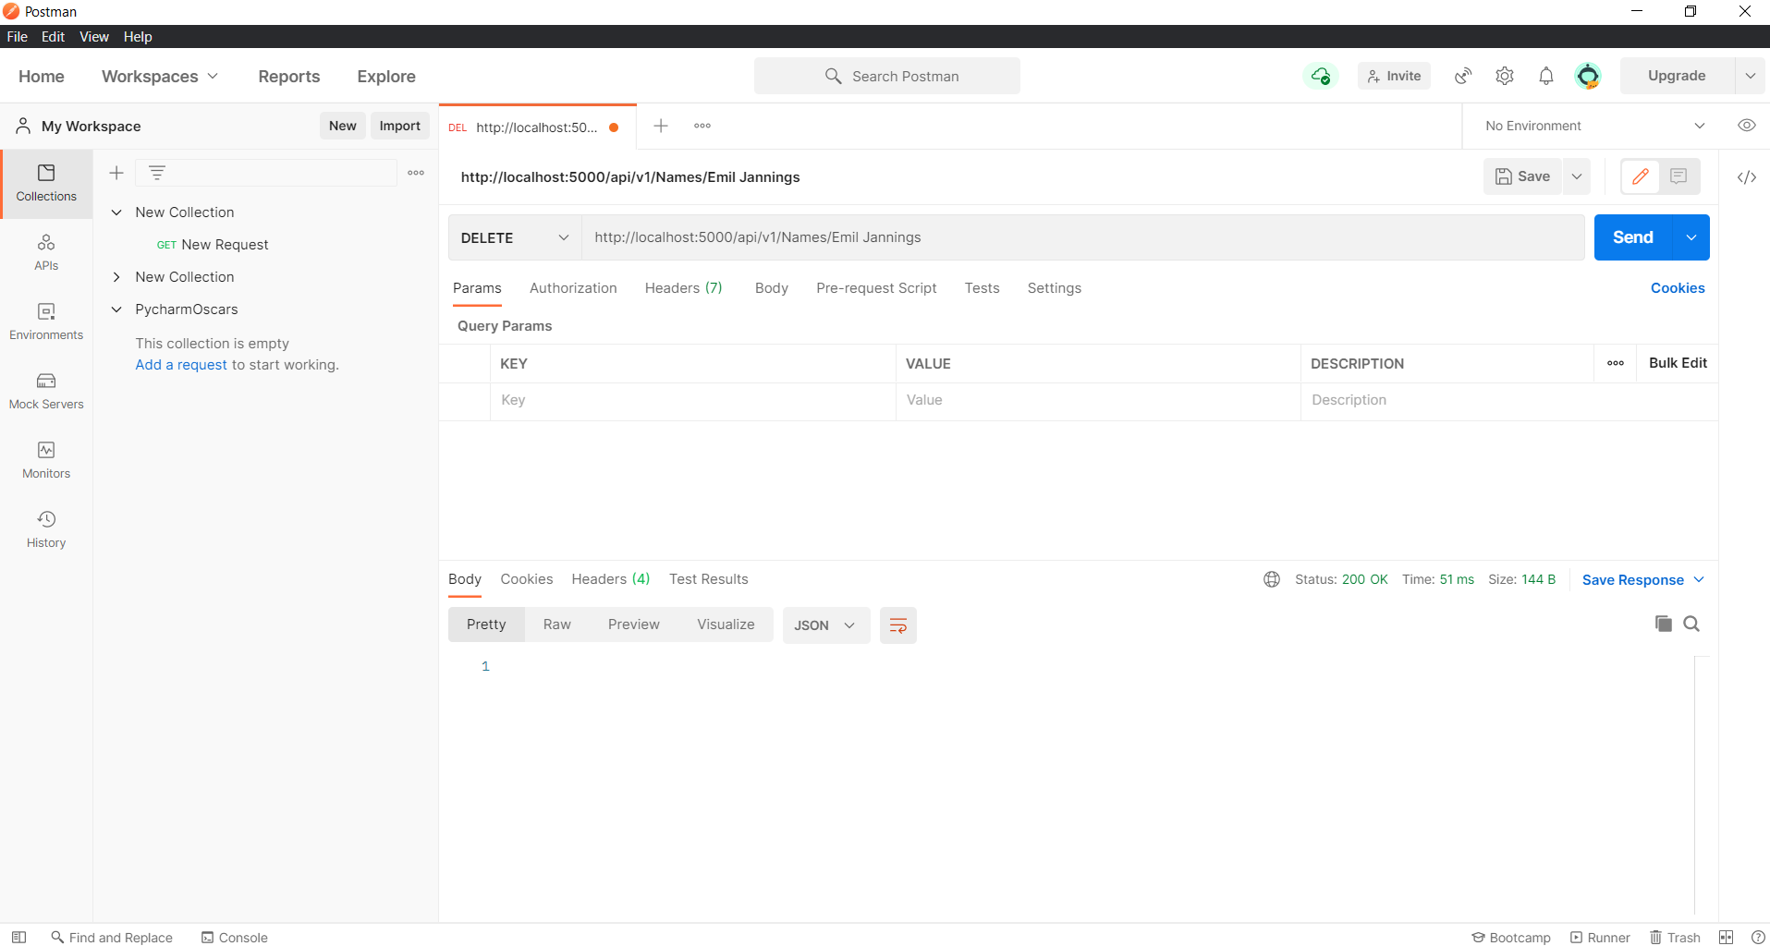

Deleted Index 1 Record

