**Method of Moments (MoM)**

Summary for week 11

1. **Method of Moment procedure**
   1. Let’s have a general equation

$L(f)=g$ where *L* – linear operator (differential, integral, integro-differential)

*g* – source function

*f* – unknown function to be solved, meeting the boundary condition

* 1. Function *f* is approximated by a series

$$f=\sum_{n=1}^{∞}{α_{n}f_{n}}≈\sum_{n=1}^{N}{α_{n}f_{n}}$$

where $f_{n}$– basis functions, $α_{n}$– unknown coefficients, $n=1, 2, 3, ..$

Substituing *f* into *L*, using linearity of *L* we get

* 1. Let’s define scalar (dot, inner) product (skalární součin) also called ‚moment’

$$〈f,g〉=\int_{Ω}{fg}dΩ$$

where $Ω$ is a solution domain, $〈f,g〉$ is linear, commutative, with module $\left|f\right|=〈f,f^{*}〉$ and metric (distance)

* 1. Define a set of weighting (test) $w_{m}$, *m* = 1, 2, 3, .. and apply scalar product of $〈w_{m},L\left(f\right)=g〉$. We get a set of linear equations

$$\sum_{n=1}^{N}{α_{n}〈w_{m},L\left(f_{n}\right)〉}=〈w_{m},g〉$$

or in expanded form

$\left[\begin{matrix}α_{1}〈w_{1},L\left(f_{1}\right)〉 & ⋯ & α_{n}〈w_{1},L\left(f_{n}\right)〉 \\ ⋮ & ⋱ & ⋮ \\ α_{1}〈w_{m},L\left(f_{1}\right)〉 & ⋯ & α_{n}〈w_{m},L\left(f_{n}\right)〉\end{matrix}\right]=\left[\begin{matrix}〈w_{1},g〉 \\ ⋮ \\ 〈w_{m},g〉\end{matrix}\right]$

In matrix form we have

$\left[A_{mn}\right]\left[α_{n}\right]=\left[g_{m}\right]$ where $A_{mn}=〈w_{m},L\left(f_{n}\right)〉$ and $g_{m}=〈w_{m},g〉$

${\left[α_{n}\right]}^{-1}={\left[A_{mn}\right]}^{-1}\left[g_{m}\right]$

If $w_{m}=δ\left(x-x_{m}\right)$ where $δ\left(x\right)$ is a Dirac pulse in $x=0$, the method is called ‚point matching‘.

If $w_{m}=f_{n}$ the method is called Galerkin.

1. **Example. Charge distribution on a plate.**

Given a metallic plate of the size $2a×2a$ with a potential *U* to the ground. Evaluate surface charge distribution.

Solution.

Potential of electrostatic field at any point in space induced by the charge on a plate is

$$φ\left(x,y,z\right)=\int_{-a}^{a}{\int_{-a}^{a}{\frac{σ\left(x^{'},y^{'}\right)}{4πεR}dx^{'}dy^{'}}}$$

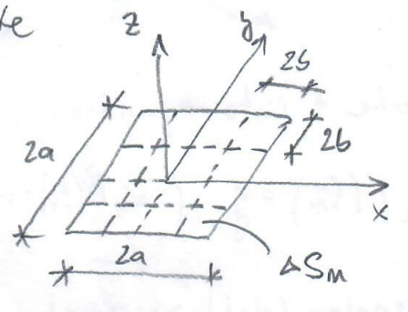

where $σ$ is surface charge density, $R= \sqrt{{\left(x-x^{'}\right)}^{2}+{\left(y-y^{'}\right)}^{2}+z^{2}}$.

*Note*. Green’s function. Given Poisson equation

$∆φ=-ρ_{0}/ε$,

where $ρ_{0}$ is volume charge density of a free charge in volume V.

If an unit point charge in the form of a Dirac function is applied for $ρ_{0}$ then

$∆G\left(r-r^{'}\right)=-δ\left(r-r^{'}\right)/ε$

where $G\left(r-r^{'}\right)$ is a Green’s function (GF). Here, GF is a unit potential due to the unit point charge. Generally, GF is the response of electromagnetics system to unit excitation (delta function source). It has analogous importance as the impulse response for circuits. GF solution of Poisson’s eq. in electrostatic is

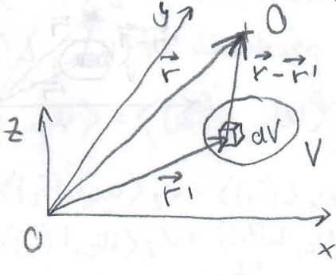 G $\left(r-r^{'}\right)=\frac{1}{4πεR}$

where $R= \sqrt{{\left(x-x^{'}\right)}^{2}+{\left(y-y^{'}\right)}^{2}+{\left(z-z^{'}\right)}^{2}}$.

A scalar potential is then evaluated using superposition as

* 1. **Boundary condition $φ=U$**  on the plate (situated in $z=0$) must be satisfied and gives an integral equation (IE)  
     of the problem

$$U=\int_{-a}^{a}{\int_{-a}^{a}{\frac{σ\left(x^{'},y^{'}\right)}{4πεR}dx^{'}dy^{'}}}$$

where $L=\int_{S}{G\left(r-r^{'}\right)dS}$. Once $σ$ is determined, a capacity can be evaluted as $C=\frac{Q}{U}=\frac{1}{U}\iint_{S}{σ}dS$.

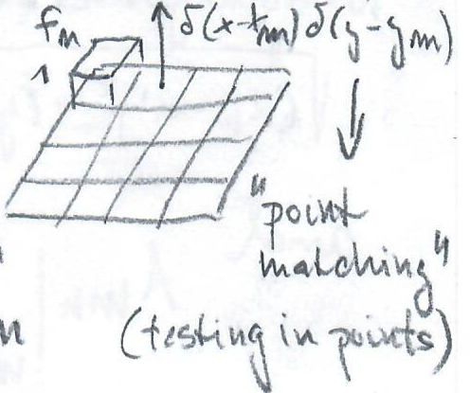The plate is divided into $N$ cells of the size .

* 1. The choice of the **basis** and **weighting functions**

$f_{n}=\begin{matrix}1 & on ∆S_{n} \\ 0 & elsewhere\end{matrix}$ and

$w_{m}=δ\left(x-x_{m}\right)δ\left(y-y_{m}\right)$, resp.

*Note*. Sampling theorem – Dirac function property.

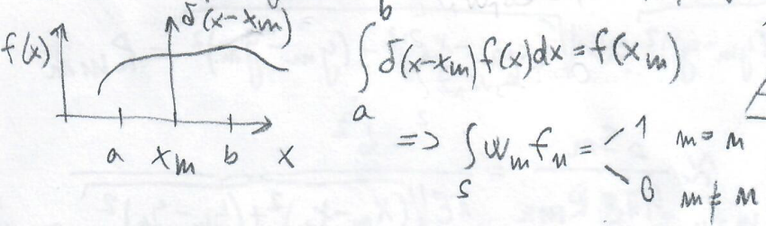

thus

* 1. - 2.4.

1. Applying scalar product $〈w_{m},L\left(f\right)〉=〈w_{m},g〉$ we receive

$$\left[A_{mn}\right]\left[α_{n}\right]=\left[U_{m}\right]$$

where

$A_{mn}=\int_{∆x_{n}}{\int_{∆y_{n}}{\frac{dx^{'}dy^{'}}{4πε\sqrt{{\left(x_{m}-x^{'}\right)}^{2}+{\left(y_{m}-y^{'}\right)}^{2}}}}}$

or alternatively

1. Applying a series for $σ≈\sum_{n=1}^{N}{α_{n}f_{n}}$ into IE of the problem we get one equation with *N* unknowns $α_{n}$

$$U=\int_{-a}^{a}{\int_{-a}^{a}{\frac{σ\left(x^{'},y^{'}\right)}{4πεR}dx^{'}dy^{'}=}}\sum_{n=1}^{N}{α_{n}\int_{-a}^{a}{\int_{-a}^{a}{\frac{f_{n}}{4πεR}dx^{'}dy^{'}}}}$$

$$U=α_{1}\int_{∆x_{1}}{\int_{∆y_{1}}{\frac{f_{1}}{4πεR}dx^{'}dy^{'}+α_{2}\int_{∆x_{2}}{\int_{∆y_{2}}{\frac{f_{2}}{4πεR}dx^{'}dy^{'}+…+}}}}α_{N}\int_{∆x_{N}}{\int_{∆y_{N}}{\frac{f_{N}}{4πεR}dx^{'}dy^{'}}}$$

In order to obtain a solution for these *N* amplitude coefficients, *N* linearly independent equations are necessary. These equations may be produced by choosing *N* observation points ( $x_{m}, y_{m})$ each at the center of the $∆S_{n}$ element.

$$\begin{matrix}U=α_{1}\int_{∆x_{1}}{\int_{∆y_{1}}{\frac{f_{1}}{4πε\sqrt{{\left(x_{1}-x^{'}\right)}^{2}+{\left(y_{1}-y^{'}\right)}^{2}}}dx^{'}dy^{'}+…+}}α_{N}\int_{∆x_{N}}{\int_{∆y_{N}}{\frac{f_{N}}{4πε\sqrt{{\left(x_{1}-x^{'}\right)}^{2}+{\left(y_{1}-y^{'}\right)}^{2}}}dx^{'}dy^{'}}} \\ ⋮ \\ U=α_{1}\int_{∆x_{1}}{\int_{∆y_{1}}{\frac{f_{1}}{4πε\sqrt{{\left(x_{N}-x^{'}\right)}^{2}+{\left(y_{N}-y^{'}\right)}^{2}}}dx^{'}dy^{'}+…+}}α_{N}\int_{∆x_{N}}{\int_{∆y_{N}}{\frac{f_{N}}{4πε\sqrt{{\left(x_{N}-x^{'}\right)}^{2}+{\left(y_{N}-y^{'}\right)}^{2}}}dx^{'}dy^{'}}}\end{matrix}$$

In matrix form

$\left[U_{m}\right]=\left[α_{n}\right]\left[A_{mn}\right]$

where

$$A_{mn}=\int_{-a}^{a}{\int_{-a}^{a}{\frac{f_{n}dx^{'}dy^{'}}{4πε\sqrt{{\left(x_{m}-x^{'}\right)}^{2}+{\left(y_{m}-y^{'}\right)}^{2}}}}}=\int_{∆x_{n}}{\int_{∆y_{n}}{\frac{dx^{'}dy^{'}}{4πε\sqrt{{\left(x_{m}-x^{'}\right)}^{2}+{\left(y_{m}-y^{'}\right)}^{2}}}}}$$

**Diagonal (self) elements** ($m=n$) are calculated by placing them into the origin of coordinate system,  
i.e. $x_{m}=0$, $y_{m}=0$. $A_{mm}$ represents a potential at the center $∆S_{n}$ due to the unit charge over $∆S_{n}$.

$$A_{mn}=\int_{-b}^{b}{\int_{-b}^{b}{\frac{dx^{'}dy^{'}}{4πε\sqrt{{x^{'}}^{2}+{y^{'}}^{2}}} =\frac{2b}{πε}ln\left(1+\sqrt{2}\right)=0.8814\frac{2b}{πε}}}$$

**Non-diagonal elements** ($m≠n$) are calculated by replacing the variable distance with $x^{'}=x_{n}$ and $y^{'}=y_{n}$

$$\sqrt{{\left(x_{m}-x^{'}\right)}^{2}+{\left(y_{m}-y^{'}\right)}^{2}}≈\sqrt{{\left(x_{m}-x_{n}\right)}^{2}+{\left(y_{m}-y_{n}\right)}^{2}}=R_{mn}$$

thus we get

$$A_{mn}≈\frac{∆S}{4πεR_{mn}}=\frac{b^{2}}{πε\sqrt{{\left(x_{m}-x_{n}\right)}^{2}+{\left(y_{m}-y_{n}\right)}^{2}}}$$

References

[1] R. F. Harrington, Field Computation by Moment Method, The Macmillan Company, 1968.

[2] Macháč, Novotný, Škvor, Vokurka, Numerické metody v EM poli, ČVUT, 2002, kap. 5.