# MIO project 1 – microstrip

1. *Determine the maximum values of realizable characteristic impedance $Z_{\text{max}}$. Suppose etching technology with a minimum width of the strip $w=0.1 \text{mm}$. Frequency $f_{0}=13 \text{GHz}$.*
$Z_{\text{max}}=207.57 Ω$

$Z_{\text{max}}= 98.1886 Ω$

$Z_{\text{max}}= 149.767 Ω$

$Z_{\text{max}}= 92.0149 Ω$

2. *Determine the minimum values of realizable characteristic impedances $Z_{\text{min}}$ on the chosen frequency. Single-mode propagation conditions must be satisfied.*  
   Formulas: $Z_{ν}=2μ_{0}hf_{\text{m}}^{\text{TE10}}$, where we assume $f_{\text{m}}^{\text{TE10}}=f_{0}$. Also, the condition $$λ_{0}=\frac{\text{c}}{f_{0}\sqrt{ϵ_{r}}}>2w$$  
   for single-mode propagation is satisfied for all substrates at the given frequency.
   1. $Z_{\text{min}}≈41.494 Ω$.
   2. $Z_{\text{min}}≈4.149 Ω$.
   3. $Z_{\text{min}}≈32.673 Ω$.
   4. $Z_{\text{min}}≈20.747 Ω$.
3. *For all substrates, compute skin depth $δ$ at your design frequency $f_{0}$ and check which frequency holds for $t > 5δ$.*  
   Formulas: $δ=\sqrt{\frac{2}{ωμσ_{c}}}$, where $σ_{c}=5.88⋅{10}^{7}\text{ S}⋅{\text{m}}^{\text{-1}}$. Therefore $f{\left.​\right|}_{t=5δ}=\frac{25}{πt^{2}μσ_{c}}$.
   1. $δ_{13\text{GHz}}≈5.757⋅{10}^{-7}$ and $f{\left.​\right|}_{t=5δ}≈372.7 \text{MHz}$.
   2. $δ_{13\text{GHz}}≈5.757⋅{10}^{-7}$ and $f{\left.​\right|}_{t=5δ}≈372.7 \text{MHz}$.
   3. $δ_{13\text{GHz}}≈5.757⋅{10}^{-7}$ and .
   4. and .
4. *Chart

   Description automatically generatedIn the frequency band $\left(1 \text{GHz}, 20 \text{GHz}\right)$* *, determine the frequency dependence of the loss factor in $\text{dB}/\text{cm}$ for lines with characteristic impedance $Z_{ν}=50 Ω$ realized on all substrates. Draw all dependencies into a single graph.*
5. *Chart, line chart

   Description automatically generatedChoose substrates 3 and 4, frequency $f=f_{0}$ and determine the dependence of loss factor in $\text{dB}/\text{cm}$ on $Z_{ν}$. Draw both dependencies into a single graph.*
6. *Chart

   Description automatically generatedFor a line with $Z_{ν}=50 Ω$ realized on substrate 1 and 2 on $f=f_{0}$, determine the influence of the thickness of copper cladding on loss factor in $\text{dB}/\text{cm}$. Suppose the thickness of the copper cladding in the commercially available interval from $9 \text{μm}$*  *to $210 \text{μm}$. The other dimensions remain constant. Draw both dependencies into a single graph. Comment on the odd results from the AWR simulation or limit maximal thickness in case of MATLAB solution.*  
     
   For this task, I’ve chosen the MATLAB simulation which posed two limits: the conductor width to dielectric thickness ratio must be between 0.05 and 20, and the conductor thickness to dielectric thickness ratio can’t exceed 0.1. Since both limits regard the dielectric thickness and also because this parameter is the only one which differs from substrate 1, I’ve chosen to adjust that as well: .
7. *Chart, line chart

   Description automatically generatedChoose a substrate and choose those lines with maximum and minimum realizable $Z_{ν}$ designed on frequency $f=f_{0}$. Determine how $Z_{ν}$ changes due to $t$ changes. Vary $t$ in the interval $9 \text{μm}$*  *to $210 \text{μm}$* , *the other parameters are constant. Draw both dependencies into a single graph. In case of MATLAB solution, limit the maximal cladding thickness.*  
   Chosen substrate: 4
8. *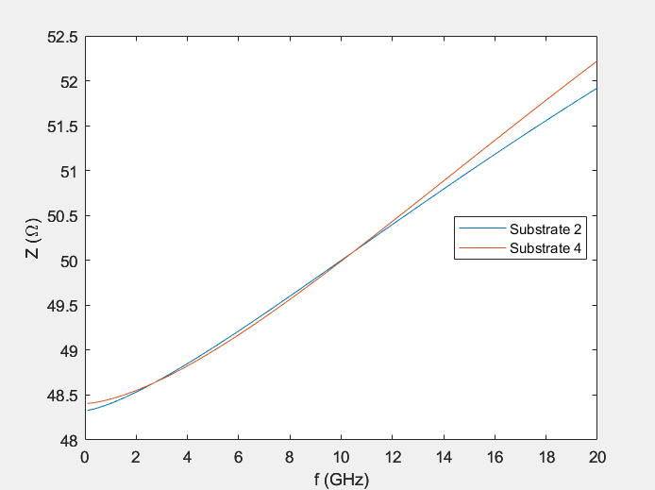For substrates 2 and 4 and lines with $Z_{ν}=50 Ω$ designed on frequency $f=f_{0}$, determine how $Z_{ν}$ and effective permittivity $ϵ_{\text{ef}}$ depend on frequency. Choose a frequency in the band from $0.1 \text{GHz}$*  *to $20 \text{GHz}$, let other parameters remain constant. Draw both dependencies into a single graph.*  
   Note: Again, due to the thickness limits, I had to adjust $h_{2}=7⋅0.127 \text{μm}$.  
   