PUNJAB MUNICIPAL INFRASTRUCTURE DEVELOPMENT COMPANY




PROJECT STATUS – NOV, 2016

SMART CITY MISSION

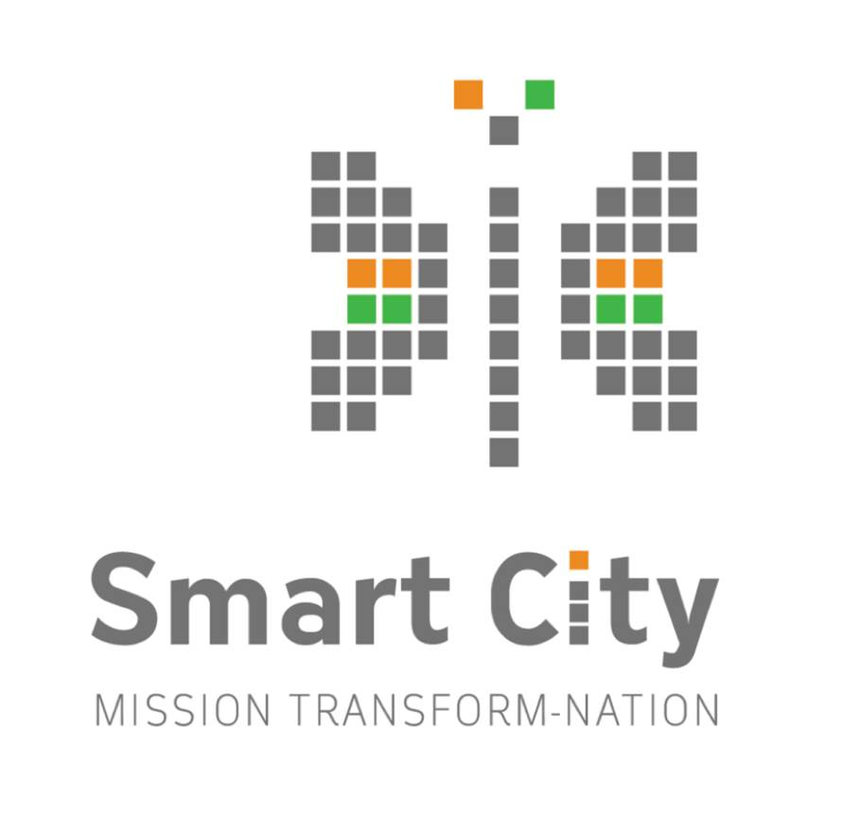

Phone 0172-2619179

contact.pmidc@gmail.com
www.pmidc.punjab.gov.in

SMART CITIES MISSION

- Launched on 25th June 2015.
- Consultants finalized by PMIDC in Oct 2015 for 3 cities
  - Amritsar : M/s Jones Lang LaSalle(USA) in consortium with
Tata Consulting Engineers Ltd. and Townland
Consultants Pvt. Ltd. (Hongkong)
  - Ludhiana : M/s AECOM India Pvt. Ltd (Lead Member) & IBM
India Ltd
  - Jalandhar : IIDC Limited (Lead Member) in association with
Urban Mass Transit Company Limited (UMTC) & Building Design Partnership Limited (BDP-U.K)
- GoI has evaluated the proposals and included Ludhiana among the first 20 cities to be developed under the Smart City Mission and an amount of Rs. 200.00 Cr. was also released on 9.5.2016.
- The revised Smart City Proposal of Amritsar and Jalandhar submitted to MoUD, GOI on 30th June,2016 for competing in stage II competition for inclusion under the Smart City Mission. Both the cities have been selected among the 27 cities declared by MoUD, Govt. of India on 23.9.2016. The proposal for formation of SPV for these two cities have been forwarded for notification. Also the RFP for engagement of Project Management Consultant of these cities have been forwarded for approval by the competent authority.
- As per Govt. of India guidelines, the State Govt. has formulated and notified Special Purpose Vehicle (SPV) namely; Ludhiana Smart City Limited (LSCL) on 22.03.2016 and incorporated LSCL on 28.04.2016 by the Registrar of Companies, Govt. of India. The first Board of Directors meeting of the Ludhiana Smart City Limited has been convened on 31.5.2016.
- As per guidelines of SCM, M/s AECOM Asia Pvt. Ltd. and Price Waterhouse Coopers Pvt. Ltd. (PWC) has been appointed as project management consultant (PMC) to assist LSCL in project implementation. An agreement has been signed with the Project Management Consultant on 12.8.2016.
- The Project Management Consultant has identified projects to be executed related to PAN city as well as under area based development. The Consultant has prepared the timeline for feasibility studies and design, DPRs preparation and issue of RFP. The same is enclosed as Annexure-I.
Financial Plan Ludhiana
The total estimated cost of the proposed projects including CAPEX & OPEX has been prepared to the tune of Rs. 5547.14 Cr.
- CAPEX
(All figures in Crores)
S. No. | Projects | Area Wide
1. Pan City Proposals
A | Sanitation including public toilets & Solid Waste Management | 350.00
B | Integrated traffic and transport management system (ITMS) | 450.00
C | Water Supply – Surface water based water supply 24x7 scheme | 2600.00
D | Integrated ICT based digital platform for management of urban infrastructure and safe city project including Smart street lighting. | 250.00
E | Installation of LED street lighting and smart poles | 150.00
F | Rehabilitation of Buddha Nallah | 1300.00
 | Sub-total | 5100.00
2. Area Wide Proposals –
A | Portable Water | 43.16
B | Waste Water | 5.00
C | Power | 68.05
D | Common Utility Tunnel | 157.95
E | Storm Water Management | 51.65
F | Waste Management | 7.52
G | Urban Design & Landscape | 286.97
H | Transportation | 431.20
 | Sub-total | 1051.50
 | Grand Total (1+2) | 6151.50
- OPEX
i. | PAN City Projects | Rs.1005.00 Cr.
ii. | Area Based Projects | Rs.140.64 Cr.
 | Total O&M (for 10 years) | Rs.1145.64 Cr.

Total Project Cost (CAPEX + OPEX): INR 7297.14 Cr
The detail of status of projects and the timeline for implementation i.e. feasibility report, preparation of DPRs, floating of RFP etc. is enclosed as Annexure-I
Amritsar:
Amritsar city has also been included among the Smart Cities to be developed under the Smart City Mission of Govt. of India. The process of formation of SPV i.e. Amritsar Smart City Limited is in progress. Further for engagement of Project Management Consultant, the RFP has been forwarded to the higher authorities for approval. The tentative projects to be included under the Smart City Mission is as follows:-
- CAPEX
Components | Estimated cost
(a) Area Development (Retrofitting) and redevelopment-Walled City | 1616.60 Cr.
- 24 x 7 water supply  - 24 x 7 electricity,  - traffic calming,  - smart meters,  - storm water drainage,  - Underground cables,  - Open space and improvement of open areas, multilevel car parking and hybrid electrical vehicles  - Wi-Fi | 50.00 Cr.  2.10 Cr.  22.00 Cr.  50.00 Cr.  100.00 Cr.  40.00 Cr.  76.75 Cr  16.00 Cr.
- Redevelopment of public amenities, | 196.00 Cr.
- Relocation of dense polluting of urban cluster with economy based cluster. | 784.00 Cr.
- Convergence with State and Central Schemes | 303.63 Cr.
(b) PAN City Projects | 1214.40 Cr.
- Mobility and traffic improvement, smart surveillance, street lights LED with solar panels, intelligent traffic management system, cycle tracks, footpaths, BRTS | 656.90 Cr.
- Sanitation and Solid waste management | 442.50 Cr.
- E-Governance, Central Command and Control Centre, City wide Wi-Fi, GIS mapping, ICT application. | 90.00 Cr.
Total: | 2831.00 Cr.
- OPEX :690.00 Cr.

Total Project Cost (CAPEX + OPEX) :3520.00 Cr.

RESOURCE PLAN: The financing options for the components identified under the SCP Amritsar are planned considering the capital available from the GoI & GoP and will be made available for the period of 5 years. Different sources of funding which can be used to fund SCP Amritsar are:
Funding:
Sr.No. | Fund Source | Rs. in Crore
1. | Centre funding | 488.00
2. | State Funding | 488.00
3. | Private Sector | 1176.00
4. | Funding Central & State Govt. Schemes | 787.63
 | - SBM including SWM | 301.50
 | - IPDS 24x7 (energy supply) | 3.80
 | - AMRUT 24x7 (water supply) | 150.00
 | - HRIDAY | 60.00
 | - NULM | 60.00
 | - BRTS | 50.00
 | - Tourism Deptt. | 6.33
 | - Sewerage Board, MCA & PMIDC | 156.00
 | Grand Total: | 2806.47 Cr.

Jalandhar.
Jalandhar city has also been included among the Smart Cities to be developed under the Smart City Mission of Govt. of India. The process of formation of SPV i.e. Jalandhar Smart City Limited is in progress. Further for engagement of Project Management Consultant, the RFP has been forwarded to the higher authorities for approval. The tentative projects to be included under the Smart City Mission is as follows:-

- CAPEX
Components | Estimated cost
Area Development (Retrofitting) | 952.27
Burton Park Sport Hub (Redevelopment) | 567.13
Public Transport (Pan City ) | 134.11
ITSPUPS (Pan City ) | 190.75
LED Street Light (Pan City) | 140.25
Total | 1984.50

- OPEX
i. | Area based projects | Rs. 816.94 Cr.
ii. | Pan City projects | Rs.629.94 Cr.
 | Total O&M Cost | Rs.1446.88 Cr.

Total Project Cost (CAPEX + OPEX): INR 3431.38 Cr
Funding
S. No. |  | Fund Source | Rs. in Cr.
1. |  | Centre Funding | 490.0
2. |  | State Funding | 490.0
3. |  | Private Sector | 551.17
4. |  | Funding Central & State Govt. Schemes
 | i. | AMRUT for ABD | 9.10
 | ii. | AMRUT for Pan City | 89.47
 | iii | MNRE Subsidy for Solar | 59.73
 | Iv | Support through Govt/PSU Company projects (City Based Gas Distribution, Department of Sports, LED Streetlight Project) | 186.62
5 |  | Debt | 108.42
 | Total (1 to 5) |  | 1984.50

