**Team #7**

|  |  |  |
| --- | --- | --- |
| **Team Member Name** | **PID** | **UCSD Email ID** |
| Mikhail Boulgakov | A13543506 | mboulgak@ucsd.edu |
| Simar Chhabra | A13891316 | sichhabr@ucsd.edu |
| Eldon Tay | A12963052 | ektay@ucsd.edu |
| Amritansh Gupta | A13831681 | amg080@ucsd.edu |
| Nirha Patel | A13695370 | nrp001@ucsd.edu |
| Val Gonzalez | A13188505 | vgd001@ucsd.edu |

**Milestone 2 - Planning Phase**

**Risk Analysis**

1.

**Risk:** Having team members not caught up with latest team decisions and direction

**Description:** As we near the end of the quarter our team’s individual workloads have increased and some may struggle to make all team meetings leading to being ‘out of the loop’ on what has to be done next

**Severity:** High

**Resolution:** We will notify the team ASAP if we will be late to a meeting. The person who misses the meeting will also be responsible to catch up on what they have missed. We will also take meeting notes to help people who missed the meetings know what they missed. Finally, our meetings will be during weekends, during a time when it is very likely that everyone can make it (using whenisgood.net for finding a time that works for everyone)

**Status:** Resolved

2.

**Risk:** Not enough experience working on downloading tracks through noiseTrade

**Description:** As a team we all have zero to very little experience working on downloading tracks through noiseTrade

**Severity:** High

**Resolution:** Allocating time to learn how to utilize noiseTrade and starting so early in our iteration. Taking this time into account when estimating time for stories. The person who is assigned this task has already started learning how to use noisetrade.

**Status:** Resolved

3.

**Risk:** Not enough experience working with firebase to store user information

**Description:** As a team we all have zero to very little experience working with firebase to store information

**Severity:** Medium

**Resolution:** We will be having a lab in week 8 on the use of firebase. We will all complete the lab and become aware of its basic use and documentation for reference.

**Status:** Resolved

4.

**Risk:** Not splitting software development work equally

**Description:** Having people with more software dev. experience carry the bulk of the software dev. work.

**Severity:** Low

**Resolution:** Now that we have worked through our first milestone we have gained familiarity with our working styles and strengths. We are comfortable to reach out to others to offer help or ask for help. We will also split up the tasks among people as opposed to splitting User stories like we did last time (some user stories were much harder and more time consuming than others).

**Status:** Resolved

5.

**Risk:** General lethargy and lack of will to work

**Description:** Nearing the end of the quarter,  our team may start to suffer from burnout and not want to complete any work when we need to

**Severity:** Low

**Potential Resolution:** We will try to encourage each other and be responsible, but it will ultimately come down to each individual to find their own motivation to complete their own work

**Status:** Unresolved

**Velocity Calculation**

Our velocity is **0.56**.

We had originally estimated tasks to be 36.75 hours for iteration 1 and 12.25 for iteration 2. Based on the burndown chart values and the amount of hours that we each calculated we put in, we actually put around 70 hours for iteration 1 and around 18 hours for iteration 2. So we calculated the velocity for each iteration and then calculated the weighted mean from it. So the weighted velocity can be considered the mean between these two values weighted 75% towards iteration 1 and 25% for iteration 2 (since iteration 1 accounts for 75% of the story hours - 36.75/(36.75+12.25) or basically 36.75/49). Considering these, we calculate

(0.75*36.75/70+0.25*12.25/18) = (0.75*0.525+0.25*0.68)/1 = 0.56375.

We round this down 0.56, so the velocity is 0.56.

**Planning Poker**

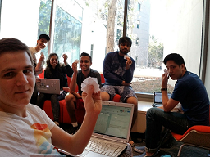

|  |  |  |  |  |  |  |  |  |
| --- | --- | --- | --- | --- | --- | --- | --- | --- |
|  | Val | Michael | Simar | Eldon | Amrintash | Nirha | Agreed | False Assumptions Uncovered |
| **Vibe activity** | 3 | 0.5 | 0.5 | 1 | 1 | 1 | 1 | We can reuse quite a bit of code from Flashback Mode |
| **Firebase download** | 3 | 3 | 4+ | 3 | 4 | 3 | 4 | No assumptions uncovered |
| **Get user's NoiseTrade account** | 1.5 | 1.5 | 1 | 1 | 1.5 | 1 | 1.5 | No assumptions uncovered |
| **Calculate priorities 2.0** | 1 | 0.5 | 1 | 0.5 | 1 | 3 | 1 | We can reuse existing priority method in SongDatabase with new parameters |
| **Open NoiseTrade** | 2 | 1 | 2 | 0.5 | 1 | 0.5 | 1 | Just one function call in android |
| **UI for displaying name** | 1 | 0.5 | 0.5 | 1 | 0.5 | 1 | 0.5 | No assumptions uncovered |
| **Download files to res/raw** | 3 | 2 | 2 | 2 | 3 | 3 | 3 | No assumptions uncovered |
| **Unzip files** | 2 | 2 | 1 | 1 | 1 | 3 | 1 | Android provides a class that does this for us |
| **User's google account** | 2 | 1 | 2 | 1.5 | 2 | 2 | 2 | No assumptions uncovered |
| **Google friends** | 1.5 | 1 | 1.5 | 0.5 | 1 | 1 | 1 | No assumptions uncovered |
| **UI for sorting** | 1.5 | 1 | 0.5 | 1 | 1 | 0.5 | 1 | No assumptions uncovered |
| **Sort Tracks** | 3 | 2 | 2 | 3 | 3 | 1 | 1.5 | We can just use java sort with a custom comparator. The list view will automatically update if the underlying array updates |
| **Made up name for anon user** | 2 | 1.5 | 1 | 1 | 1 | 3 | 1 | You don't have to come up with a state of the art algorithm. Just have a list of names and append numbers to them |
| **UI for vibe mode** | 1 | 0.5 | 2 | 2 | 1 | 0.5 | 0.5 | We already have this feature implemented in album activity, so it should be easy to add |
| **Test Vibe Mode** | 1 | 1 | 1 | 1 | 1 | 1 | 1 | We just agreed that we'll spend an hour on every test to make sure that it all works properly |
| **Test Download Songs** | 1 | 1 | 1 | 1 | 1 | 1 | 1 | " |
| **Test prioritize tracks played by friends** | 1 | 1 | 1 | 1 | 1 | 1 | 1 | " |
| **Test sorting tracks** | 1 | 1 | 1 | 1 | 1 | 1 | 0.5 | We then decided that the UI tasks will be very easy to do in espresso, so they should not take a whole hour |
| **Test display name** | 1 | 1 | 1 | 1 | 1 | 1 | 0.5 | " |
| **Tracklist Testing** | 1 | 1 | 1 | 1 | 1 | 1 | 0.5 | " |
| **Developer Story (3)** | 2 | 4+ | 4+ | 3 | 4+ | 2 | 9 | The large numbers were from people who included fixing the bugs the tests found, and the small ones were from people who just counted writing the tests. We decided that we don’t know how long testing will take (since we might find bugs), and allocated 50% of the hours spent working on the features to the tests. |
| **Developer Story**  **(4)** | 1 | 4+ | 3 | 1 | 4+ | 2 | 3 |

**Zenhub**

* *Zenhub Board:* [*https://app.zenhub.com/workspace/o/cse-110-winter-2018/cse-110-team-project-team-7/boards?repos=119468919*](https://app.zenhub.com/workspace/o/cse-110-winter-2018/cse-110-team-project-team-7/boards?repos=119468919)
* *Burndown Chart:* [*https://app.zenhub.com/workspace/o/cse-110-winter-2018/cse-110-team-project-team-7/reports?report=burndown&milestoneId=3141370&labels=average%2520story%2520points,open%2520milestones,closed%2520milestones&labels:not=undefined&showPRs=false*](https://app.zenhub.com/workspace/o/cse-110-winter-2018/cse-110-team-project-team-7/reports?report=burndown&milestoneId=3141370&labels=average%2520story%2520points,open%2520milestones,closed%2520milestones&labels:not=undefined&showPRs=false)
* *User Stories:* Insert links to user stories, make sure they are also linked to their respective tasks
  + <https://app.zenhub.com/workspace/o/cse-110-winter-2018/cse-110-team-project-team-7/issues/91>
  + <https://app.zenhub.com/workspace/o/cse-110-winter-2018/cse-110-team-project-team-7/issues/87>
  + <https://app.zenhub.com/workspace/o/cse-110-winter-2018/cse-110-team-project-team-7/issues/86>
  + <https://app.zenhub.com/workspace/o/cse-110-winter-2018/cse-110-team-project-team-7/issues/88>
  + <https://app.zenhub.com/workspace/o/cse-110-winter-2018/cse-110-team-project-team-7/issues/89>
  + <https://app.zenhub.com/workspace/o/cse-110-winter-2018/cse-110-team-project-team-7/issues/90>
* *Scenario-Based System Tests:* Insert links to Scenario-Based System Tests, make sure they are also linked to their respective user stories and iterations
  + <https://app.zenhub.com/workspace/o/cse-110-winter-2018/cse-110-team-project-team-7/issues/116>
  + <https://app.zenhub.com/workspace/o/cse-110-winter-2018/cse-110-team-project-team-7/issues/117>
  + <https://app.zenhub.com/workspace/o/cse-110-winter-2018/cse-110-team-project-team-7/issues/118>
  + <https://app.zenhub.com/workspace/o/cse-110-winter-2018/cse-110-team-project-team-7/issues/119>
  + <https://app.zenhub.com/workspace/o/cse-110-winter-2018/cse-110-team-project-team-7/issues/120>
  + <https://app.zenhub.com/workspace/o/cse-110-winter-2018/cse-110-team-project-team-7/issues/121>
  + <https://app.zenhub.com/workspace/o/cse-110-winter-2018/cse-110-team-project-team-7/issues/115>

**User Interface Progressions/Screens (Wireframes)**

**All UI images are posted as a comment for their respective user story.**

Vibe Mode Activity (#91)

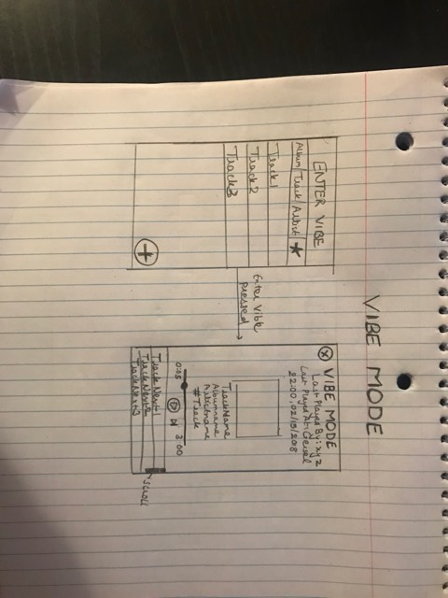

Download Songs (#87)

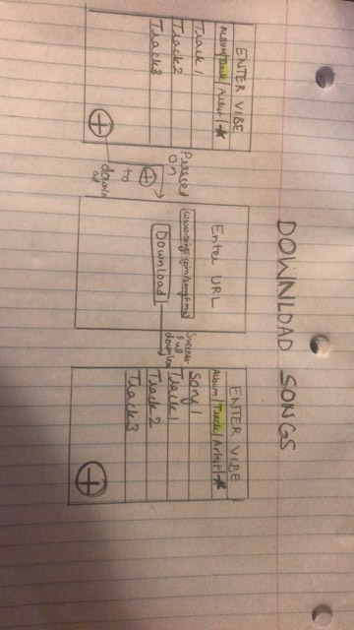

Prioritize tracks played by friends (#86)

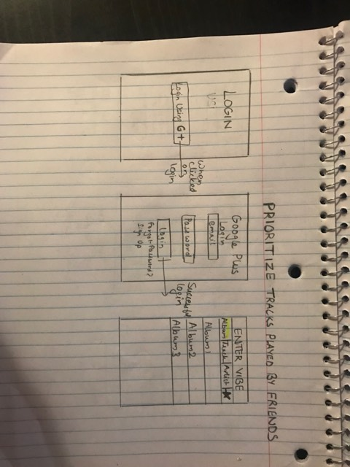

Sorting Tracks (#88)

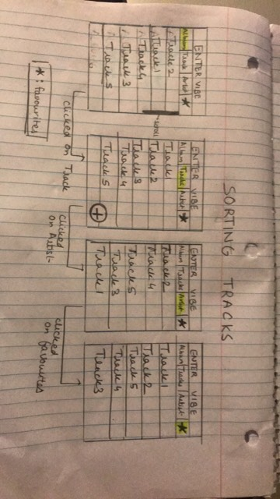

Display Name (#89)

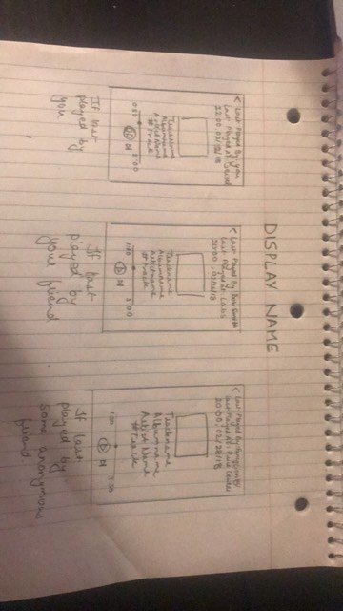

See Complete Track List (#90)

