01.

Page1.html

code

<!DOCTYPE html>

<html lang="en">

<head>

    <meta charset="UTF-8">

    <meta name="viewport" content="width=device-width, initial-scale=1.0">

    <title>Portfolio - Introduction & Overview</title>

    <link rel="stylesheet" href="styles.css">

</head>

<body>

    <div class="container">

        <section class="page" id="page1">

            <h1>Simar Ilahi</h1>

            <p class="about-me">Hello! I'm Simar, a passionate software developer with a background in full-stack development and a keen interest in AI and machine learning. I enjoy solving complex problems and building impactful applications.</p>

            <div class="profile-picture">

                <img src="Simar.png">

            </div>

            <div class="skills">

                <h2>Skills & Strengths</h2>

                <ul>

                    <li>JavaScript & React</li>

                    <li>Python & Django</li>

                    <li>Problem Solving</li>

                    <li>Team Collaboration</li>

                    <li>Project Management</li>

                </ul>

            </div>

            <div class="contact-info">

                <h2>Contact Information</h2>

                <p>Email: simarilahii99@gmail.com</p>

                <p>Phone: +94775232259</p>

                <p>LinkedIn: <a href="#">linkedin.com/in/simar-ilahi-455469231</a></p>

                <p>Portfolio: <a href="#">simarportfolio.com</a></p>

            </div>

        </section>

        <a href="page2.html" class="next-page-link">Go to Projects & Achievements</a>

    </div>

</body>

</html>

Screenshot

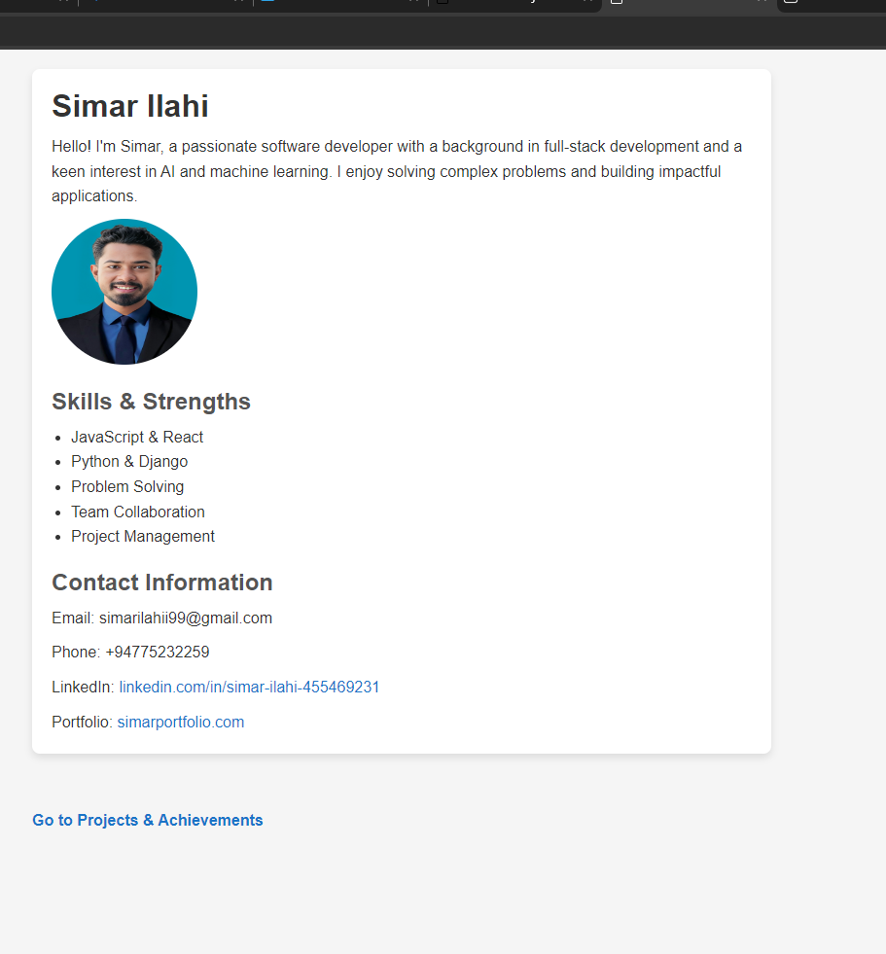

Page2.html

Code

<!DOCTYPE html>

<html lang="en">

<head>

    <meta charset="UTF-8">

    <meta name="viewport" content="width=device-width, initial-scale=1.0">

    <title>Portfolio - Projects & Achievements</title>

    <link rel="stylesheet" href="styles.css">

</head>

<body>

    <div class="container">

        <section class="page" id="page2">

            <h2>Projects</h2>

            <div class="project">

                <h3>Project One</h3>

                <p>A web application that helps users manage tasks effectively. This project was built using React and Node.js.</p>

                <img src="Designer12.jpeg">

                <p>Technologies: React, Node.js, MongoDB</p>

            </div>

            <div class="project">

                <h3>Project Two</h3>

                <p>An e-commerce platform designed for seamless shopping experiences. Developed with Django and integrated with a payment gateway.</p>

                <img src="Designer13.jpeg">

                <p>Technologies: Django, PostgreSQL, Stripe API</p>

            </div>

            <div class="achievements">

                <h2>Achievements</h2>

                <ul>

                    <li>Certified Full Stack Developer</li>

                    <li>Employee of the Month - July 2023</li>

                    <li>Published a research paper on AI-driven data analysis</li>

                </ul>

            </div>

        </section>

        <a href="page1.html" class="previous-page-link">Back to Introduction & Overview</a>

    </div>

</body>

</html>

Screenshot

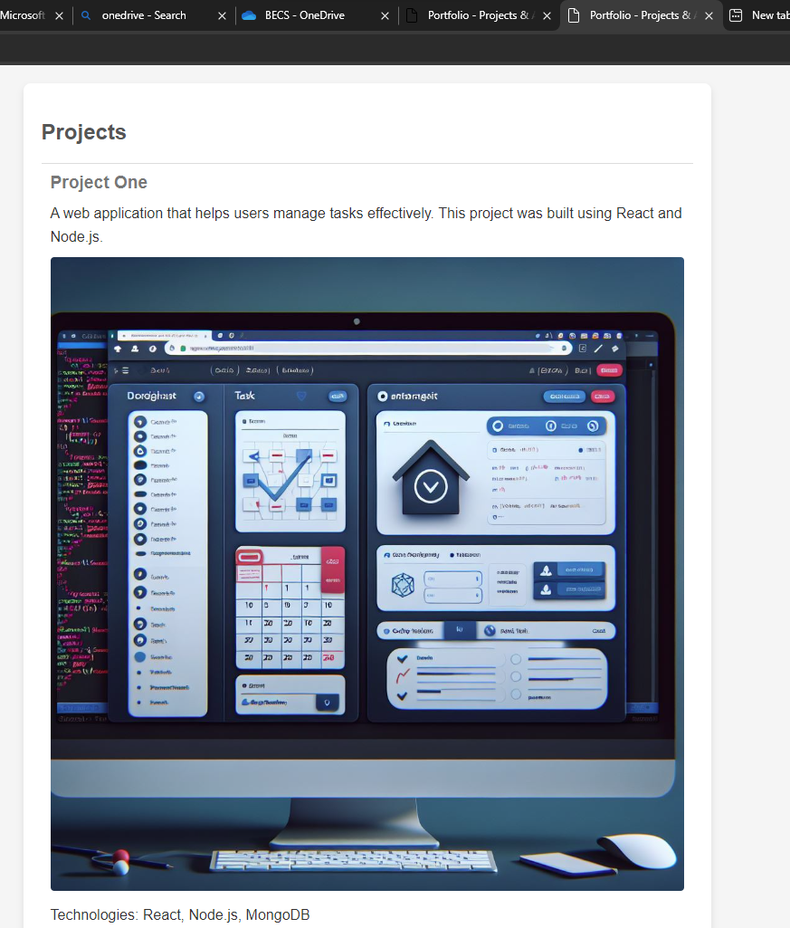

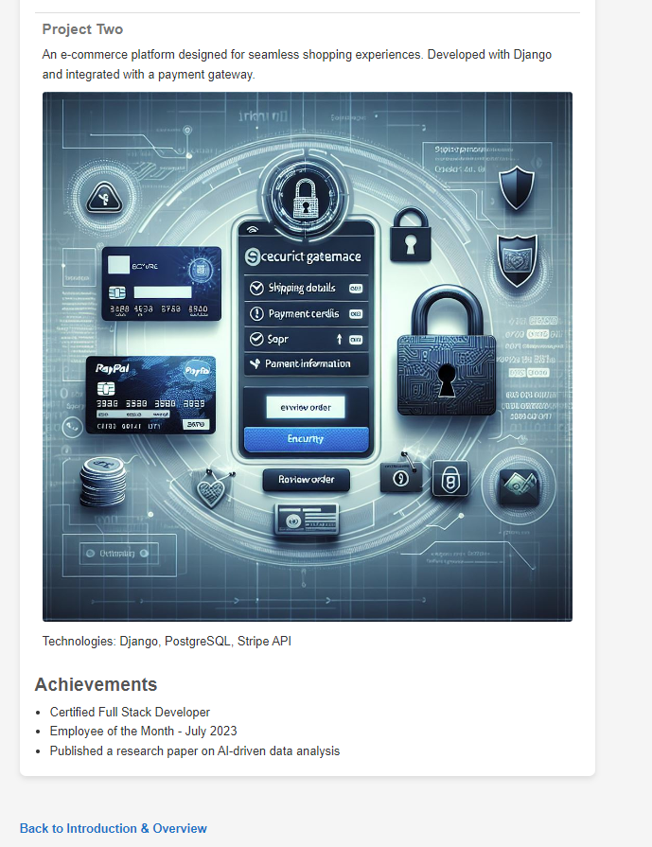

Styles.css

Code

\* {

    margin: 0;

    padding: 0;

    box-sizing: border-box;

}

body {

    font-family: Arial, sans-serif;

    color: #333;

    background-color: #f5f5f5;

}

.container {

    width: 80%;

    max-width: 800px;

    margin: auto;

    padding: 20px;

}

.page {

    margin-bottom: 40px;

    padding: 20px;

    background-color: #fff;

    border-radius: 8px;

    box-shadow: 0 4px 8px rgba(0, 0, 0, 0.1);

}

h1 {

    font-size: 2em;

    color: #333;

}

h2 {

    font-size: 1.5em;

    color: #555;

    margin-top: 20px;

}

h3 {

    font-size: 1.2em;

    color: #777;

}

.about-me, .skills ul, .contact-info p, .project p, .achievements ul {

    margin-top: 10px;

    line-height: 1.6;

}

.profile-picture img {

    width: 150px;

    height: 150px;

    border-radius: 50%;

    margin-top: 10px;

}

.skills ul, .achievements ul {

    list-style: disc;

    padding-left: 20px;

}

.contact-info a {

    color: #007acc;

    text-decoration: none;

}

.contact-info a:hover {

    text-decoration: underline;

}

.project {

    margin-top: 20px;

    padding: 10px;

    border-top: 1px solid #ddd;

}

.project img {

    width: 100%;

    height: auto;

    margin-top: 10px;

    border-radius: 4px;

}

.achievements ul {

    margin-top: 10px;

    list-style: disc;

    padding-left: 20px;

}

.next-page-link, .previous-page-link {

    display: inline-block;

    margin-top: 20px;

    color: #007acc;

    text-decoration: none;

    font-weight: bold;

}

.next-page-link:hover, .previous-page-link:hover {

    text-decoration: underline;

}