Microservice and Spring Boot

While implementing the project, we had to deal with multiple applications that can be written in different programming languages and use different data storage technologies. The Microservices as an architecture style can deploy application modules independently, perform different management operations on different modules, and generate small services for different modules. Each functional element can eventually become a functional unit that can be replaced and upgraded independently, and each small service communicates with each other through HTTP [1].

By programming with Spring Boot, we can easily create standalone Spring projects that generate independent units of microservice functionality and integrate with mainstream frameworks.

Python-Spring Boot (Java) Communication

Fast API

Redis

MongoDB with spark connector

Cosine Similarity Spark implementation

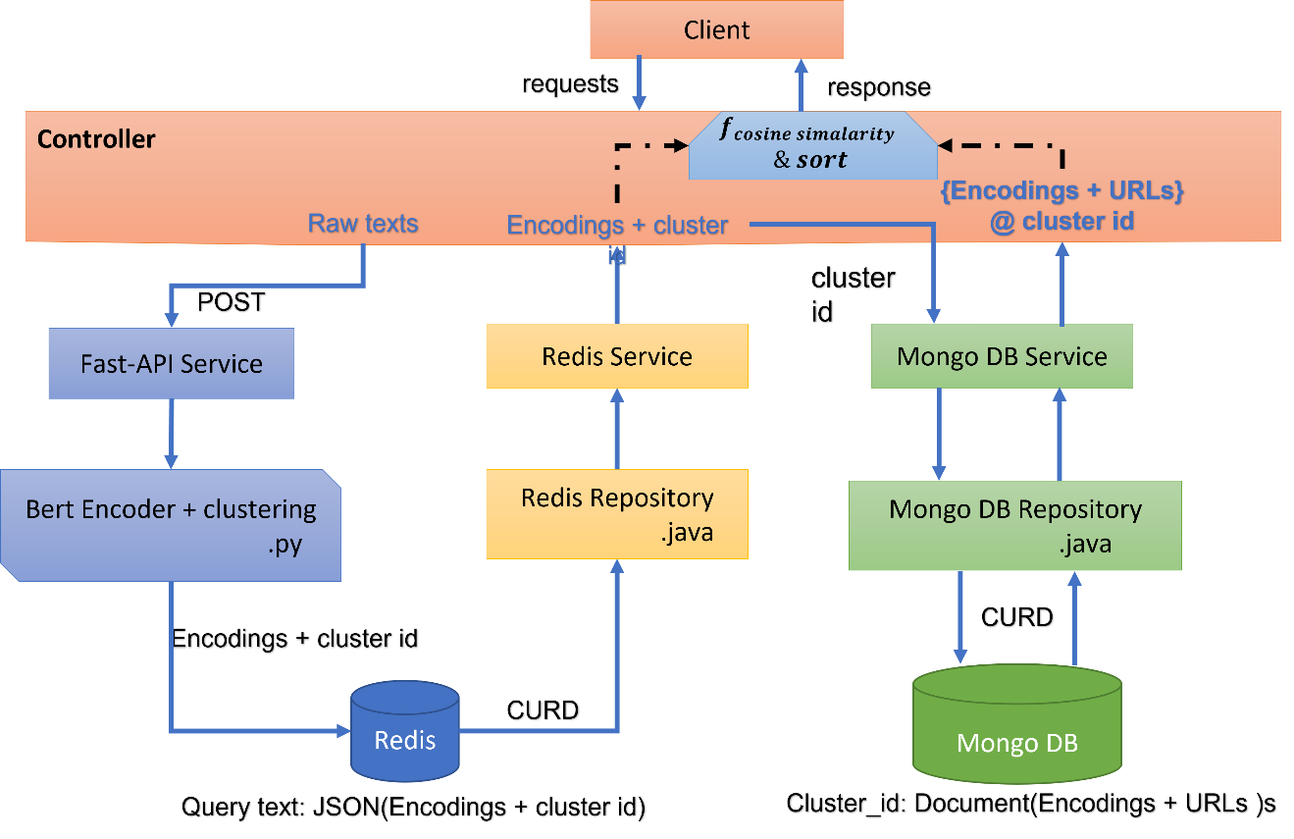

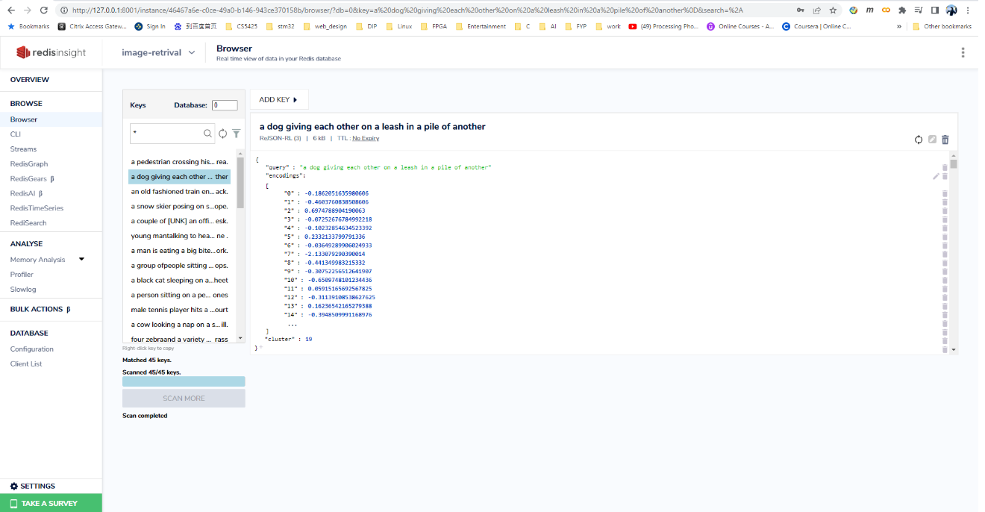

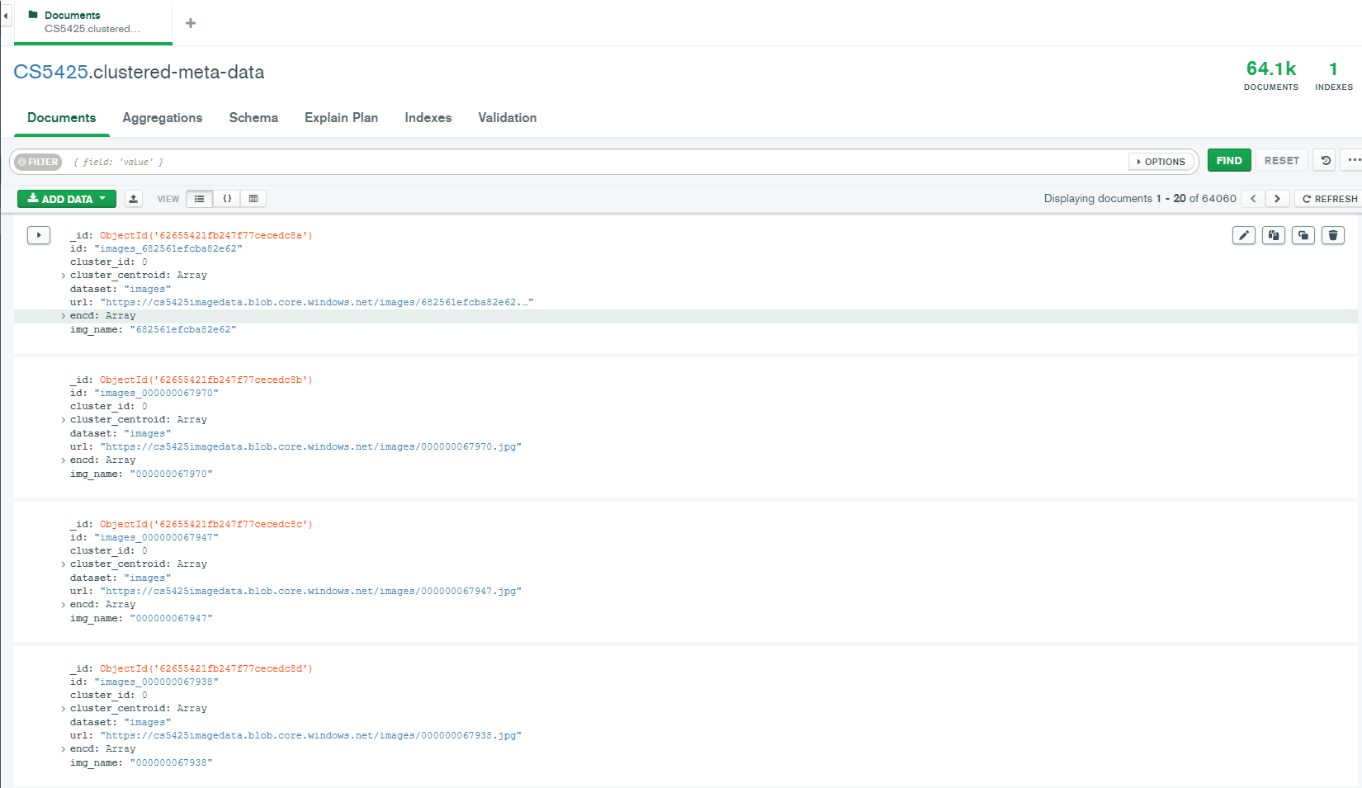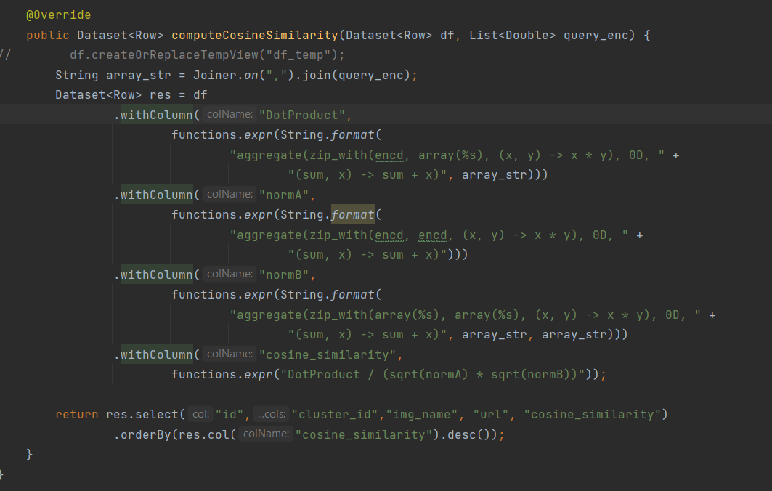

# Bibliography

|  |  |
| --- | --- |
| [1] | J. Lewis and M. Fowler, "Microservices," 25 March 2014. [Online]. Available: https://martinfowler.com/articles/microservices.html. [Accessed 16 April 2022]. |