Prerequisites for the TOTEM Communication Middleware
on Windows OS

This document describes the installation in Windows environments of the software required for the TOTEM Communication Middleware. The screen shots are from an installation on Windows 7, but it should be the same procedure on Windows XP and on Windows 8.

- List of required software

- Erlang version R14B04 or greater
- RabbitMQ Server version 2.7.0 or greater
- Python version 2.7.2 or greater
- Pika version 0.9.5 or greater

- Installation of Erlang

Erlang is the programming language used by the RabbitMQ Server. You need to have it installed before installing RabbitMQ Server.

- Go to the following url: http://www.erlang.org/download.html
- Download the file R14B04 Windows Binary File
- Start the installation. As shown in the following screen shots, default installation options should be chosen.
- If Microsoft DLL's are already present, as it is the case here, you don't need to select it.

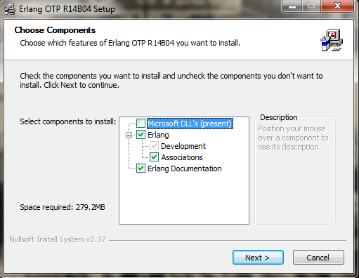

- If you are on a Windows 32 bits, just choose C:\Program Files\erl5.8.5 (in this case, it should be the default destination folder). If you are on a Windows 32 bits, just choose C:\Program Files\erl5.8.5 (in this case, it should be the default destination folder).

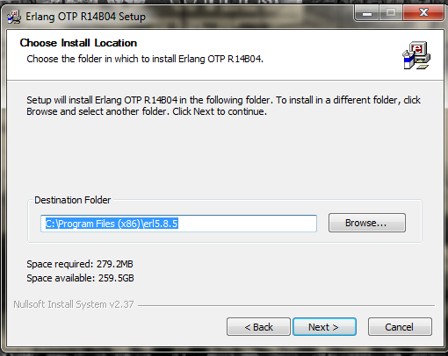

- You don't need to create any shortcuts

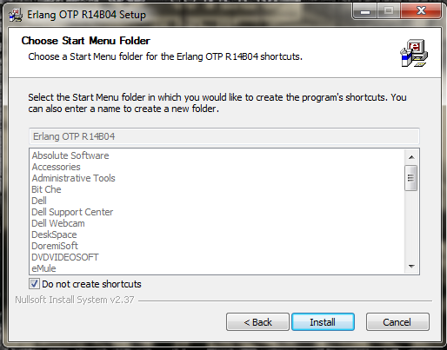
- Installation of RabbitMQ

  - Go to the following url: http://www.rabbitmq.com/install-windows.html
  - Download the file rabbitmq-server-2.7.0.exe
  - Start the installation, as described in the following screen shots. You need neither to install RabbitMQ Service component, nor the Start Menu component.

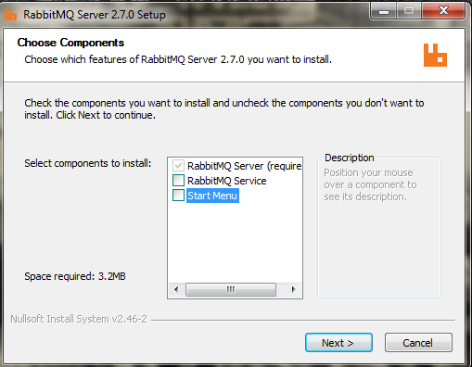

  - Again, the default destination folder should be the good one.
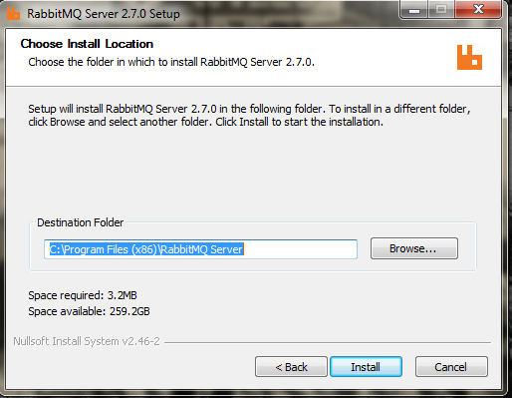

  - Configure your Path

You need to add the directory C:\Program Files (x86)\RabbitMQ Server\rabbitmq_server-2.7.0\sbin to your Path, in order to use the RabbitMQ commands in a shell. To do that:

- Open the Start Menu, right click on Computer and select Properties

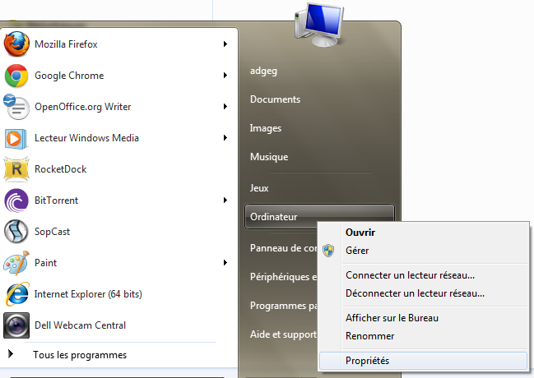

- Select Advanced System Parameters

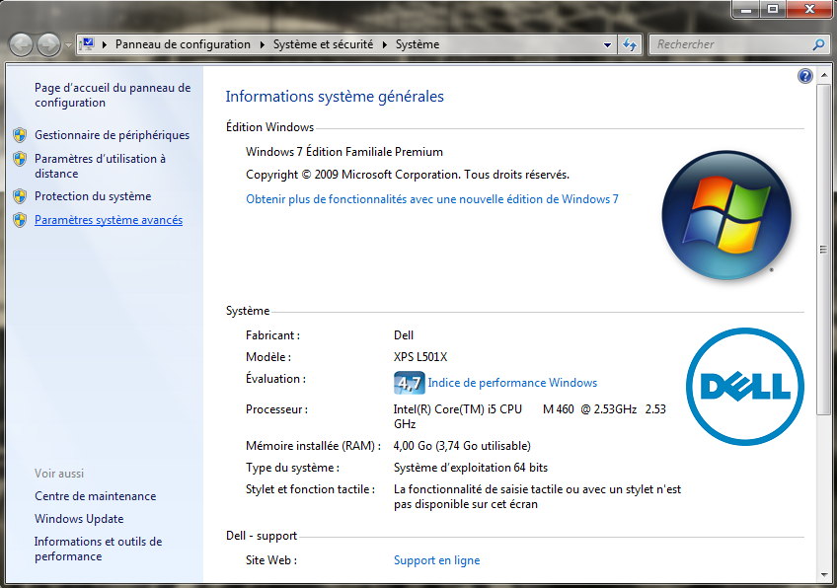
- Check that you are in the Advanced System Parameters tab, and select Environment Variables

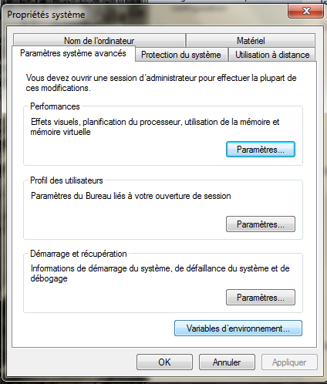

- Select the Path variable, click on the Edit button, add a semicolon at the end of your variable value, and add the directory

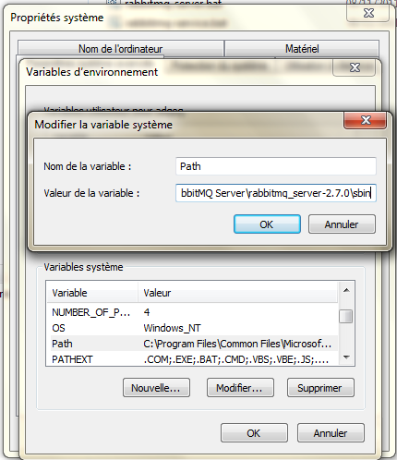

- To test your RabbitMQ installation, open a command shell (in the Start menu, select run and type cmd), and execute the following commands:

$ rabbitmq-server -detached
Activating RabbitMQ plugins ...
0 plugins activated:
$ rabbitmqctl status
{pid,29069},
{running_applications,[{rabbit,"RabbitMQ","2.7.0"},
{os_mon,"CPO CXC 138 46","2.2.4"},
{sasl,"SASL CXC 138 11","2.1.8"},
{mnesia,"MNESIA CXC 138 12","4.4.12"},
{stdlib,"ERTS CXC 138 10","1.16.4"},
{kernel,"ERTS CXC 138 10","2.13.4"}]},
{os,{unix,linux}},
{erlang_version,"Erlang R14B04 (erts-5.8.5) [source] [smp:2:2] [rq:2] [async-threads:30] [hipe] [kernel-poll:true]\n"},
{memory,[{total,13530064},
{processes,5231824},
{processes_used,5230144},
{system,8298240},
{atom,735113},
{atom_used,725095},
{binary,90528},
{code,6057690},
{ets,404068}]},
{vm_memory_high_watermark,0.3999999999490175},
{vm_memory_limit,1569166131}]
...done.
$ rabbitmqctl stop
Stopping and halting node rabbit@rabbit ...
...done.

- Installation of Python

Python is the programming language used by the server side of TOTEM communication middleware.

- Go to the following url: http://www.python.org/getit/
- Download the file Python 2.7.2 Windows Installer
- Start the installation. Again, as it is shown in the following screen shots, default installation options should be chosen.

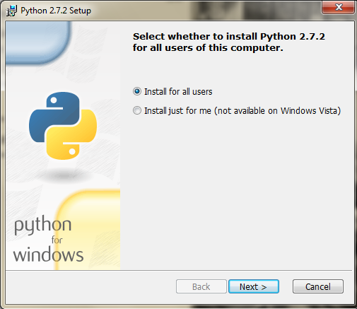

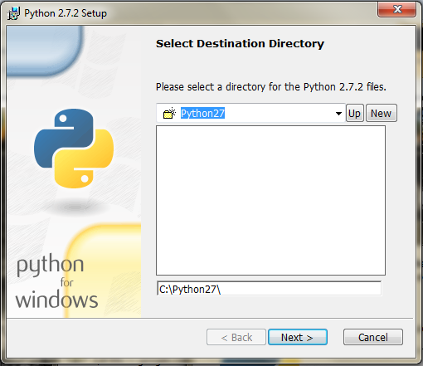

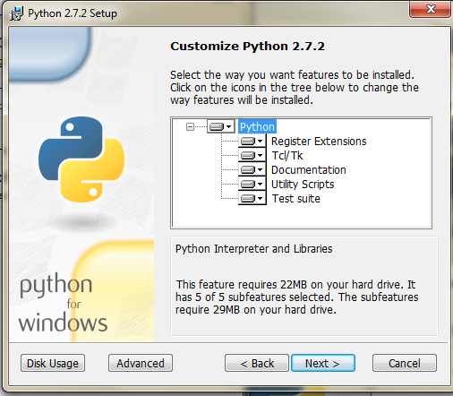

- Configure your Path

You need add the directory C:\Python27 to your Path, in order to use the Python commands in a shell. Repeat the procedure described in 3.4. to add this directory to your Path.
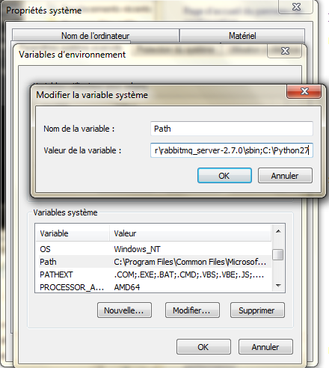

- To test your Python installation, open a command shell and execute the following commands:

$ python
Python 2.7.2 (default, Jun 12 2011, 15:08:59) [MSC v.1500 32 bit (Intel)] on win32
Type "help", "copyright", "credits" or "license" for more information.
>>> exit()

- Installation of Pika

Pika is the Python library used by TOTEM Communication Middleware to communicate with RabbitMQ.

- Go to the following url: http://pypi.python.org/pypi/pika
- Download the archive pika-0.9.5.tar.gz
- Extract this archive
- Create a directory C:\Program Files(x86)\Pika, and add the directory pika-0.9.5 into this directory
- Create a global variable PYTHONPATH
- In the same window used just before to custom the Path variable, select New
- For the variable name, type: PYTHONPATH
- For the variable value, type: C:\Program Files(x86)\Pika\pika-0.9.5;

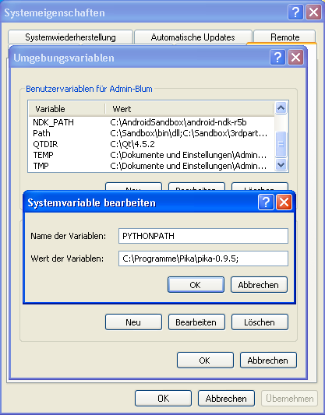

- To test your Pika installation, open a command shell and execute the following commands:

$ python
Python 2.7.2 (default, Jun 12 2011, 15:08:59) [MSC v.1500 32 bit (Intel)] on win32
Type "help", "copyright", "credits" or "license" for more information.
>>> import pika
>>> exit()

- Testing the whole installation

To test your whole installation, in a command shell, go in the directory TOTEM-Prerequisites-test, and execute the following command:
$ test.bat
STARTING TEST
Stopping and halting node rabbit@rabbit ...
Error: unable to connect to node rabbit@rabbit: nodedown
diagnostics:
- nodes and their ports on rabbit: [{rabbitmqctl20353,1280}]
- current node: rabbitmqctl20353@rabbit
- current node home dir: C:\Documents and Settings\USER
- current node cookie hash: vzNwDAjGU3kEGjpjdLjEnA==
Activating RabbitMQ plugins ...
0 plugins activated:
[x] Sent 'Hello World!'
END OF TEST
FORCE CLOSE OF CONSUMER
Stopping and halting node rabbit@rabbit ...
...done.

