SESSION 28: EXCEL ANALYTICS (CONTD.)

Assignment 2

- Associated Data Files You should form a table on a worksheet titled “class list” that includes the names and test scores of your students. You have 7 students in your class, their names are: Allen, Borlin, Catlin, Dorsey, Eugene, Finneran, and Greco. Their scores on the first 3 tests are as follows:
Test 1 Test 2 Test 3

Allen Test 89 Test 78 Test 89 Borlin Test 67 Test 56 Test 66 Catlin Test 78 Test 76 Test 76 Dorsey Test 56 Test 34 Test 45 Eugene Test 26 Test 100 Test 99 Finerran Test 99 Test 98 Test 97 Greco Test 78 Test 87 Test 88

- Problem Statement

- Below your table, create a graph showing the students’ rounded averages. Be sure to include appropriate labeling and spacing, so that the graph is non-repetitive and the scale is appropriate. Hint: A score of 100 is the highest possible.

- Insert a new worksheet. Use the Goal Seek feature to find the value that Eugene needed on Test 1 in order to earn honors for the course. Show your work by displaying an updated table. Title the worksheet “Eugene’s dream.” Hint: Do not worry about rounding Eugene’s new “score” for Test 1. If done properly, the rest of your table should update accordingly.

- From the data on your “class list” worksheet, provide the Descriptive Statistics of your students’ rounded averages.

For the output, create a new worksheet and choose to display “summary statistics”. Rename this worksheet “Descriptive Statistics”.

The above question answers submitted as per attachment questions received from mail from Acadgild.
Answers are submitted as downloadable excel file. The following are the picture file from excel
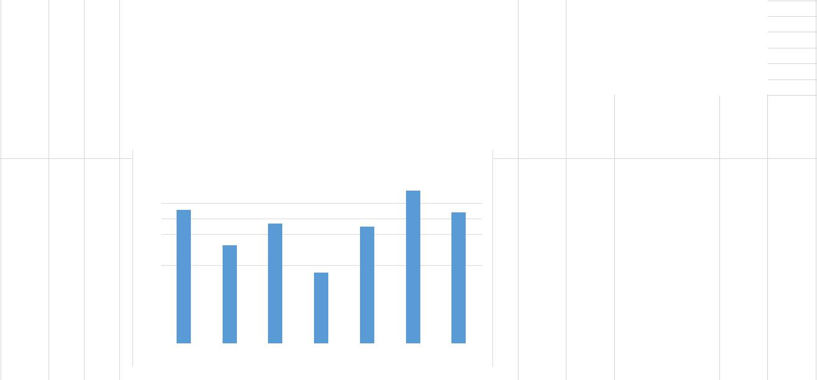

Name | Test 1 Test 2 Test 3 |  |  | Average | Rounded Average | Honors | Grade |  | 60 |  | Number of Honors | 1
Allen | 89 | 78 | 89 | 85.33333333 | 85.3 | No | B |  | 70 |  | Number of Grade "A" | 1
Borlin | 67 | 56 | 66 | 63 | 63 | No | D |  | 80 |  | Number of Grade "B" | 2
Catlin | 78 | 76 | 76 | 76.66666667 | 76.7 | No | C |  | 90 |  | Number of Grade "C" | 2
Dorsey | 56 | 34 | 45 | 45 | 45 | No | F |  |  |  | Number of Grade "D" | 1
Eugene | 26 | 100 | 99 | 75 | 75 | No | C |  |  |  | Number of Grade "F" | 1
Finerran | 99 | 98 | 97 | 98 | 98 | Yes | A
Greco | 78 | 87 | 88 | 84.33333333 | 84.3 | No | B

 |  |  |  |  |  |  |  |  |  |  | Rounded Average
 |  |  |  | 100 |  |  |  |  |  |  |  |  | 98
 |  |  |  | 100 |  | 85.3 |  |  |  |  |  |  | 84.3
 |  |  |  | 90 |  |  |  |  |  |  | 76.7
 |  |  |  | 80 |  |  |  |  |  |  | 76.7 |  | 75
 |  |  |  | 70 |  |  |  | 63
 |  |  |  | 60
 |  |  |  | 60 |  |  |  |  |  |  | 45
 |  |  |  | 50
 |  |  |  | 40
 |  |  |  | 30
 |  |  |  | 20
 |  |  |  | 10
 |  |  |  | 0
 |  |  |  |  |  | Allen |  | Borlin |  |  | CatlinDorsey |  | EugeneFinerranGreco
 | Name | Test 1 | Test 2 |  |  |  | Test 3 |  |  | Average |  |  | Rounded Average
 | Allen | 89 |  |  | 78 |  |  | 89 |  |  | 85.33333333 |  | 85.3
 | Borlin | 67 |  |  | 56 |  |  | 66 |  |  | 63 |  | 63
 | Catlin | 78 |  |  | 76 |  |  | 76 |  |  | 76.66666667 |  | 76.7
 | Dorsey | 56 |  |  | 34 |  |  | 45 |  |  | 45 |  | 45
 | Eugene | 88.93 |  |  | 100 |  |  | 99 |  |  | 95.97622222 |  | 96
 | Finerran | 99 |  |  | 98 |  |  | 97 |  |  | 98 |  | 98
 | Greco | 78 |  |  | 87 |  |  | 88 |  |  | 84.33333333 |  | 84.3

Goal seek used for cell F6 (for value 96) and changed value in B6.
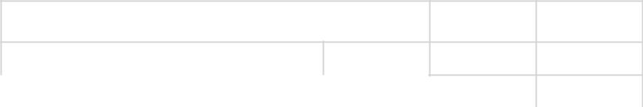

SUMMARY STATISTICS

 | Number of Honors | 1
 | Number of Grade "A" | 1
 | Number of Grade "B" | 2
 | Number of Grade "C" | 2
 | Number of Grade "D" | 1
 | Number of Grade "F" | 1

Countif formulas used and shown in sheet "class list"

