Simay 0tlaca 30804. CS303-Phase2 Simulation Report

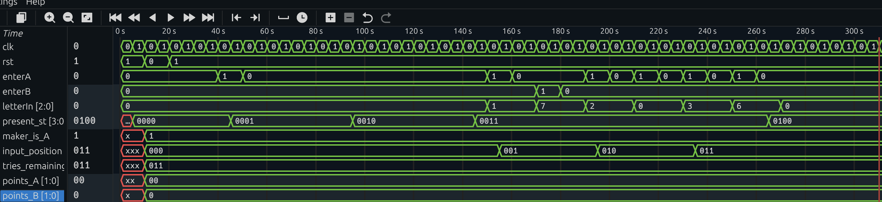

Figure 1: Round 1 - Game Start and Code-Maker Input (0s - 300s)
Test 1 - Player A starts the game: At t≈25s, Player A presses enterA button, and the FSM transitions from ST_WAIT (0000) to ST_DISPLAY_SCORE (0001). The maker_is_A signal is set to 1, indicating Player A is the code-maker.
Test 2 - Player A enters the code: Starting at t≈100s (State 0011 - ST_INPUT_CODE), Player A enters the 4-letter code (A, C, E, L) using letterIn values 1, 2, 3, 6. The input_position increments from 000 to 011 with each valid letter entry.
Test 2a - enterB button should not work: At t≈140s, while in ST_INPUT_CODE state, enterB is pressed with letterIn=7. The input_position remains at 001, proving that the code-breaker's button is correctly ignored during code-maker's turn.
Test 2b - "-" is not accepted as a letter: At t≈180s, enterA is pressed with letterIn=0 (which represents "-"). The input_position remains at 010, confirming that the invalid letter code is rejected.
At t≈280s, after the 4th letter is entered, the FSM transitions to ST_DISPLAY_BREAK (0100).
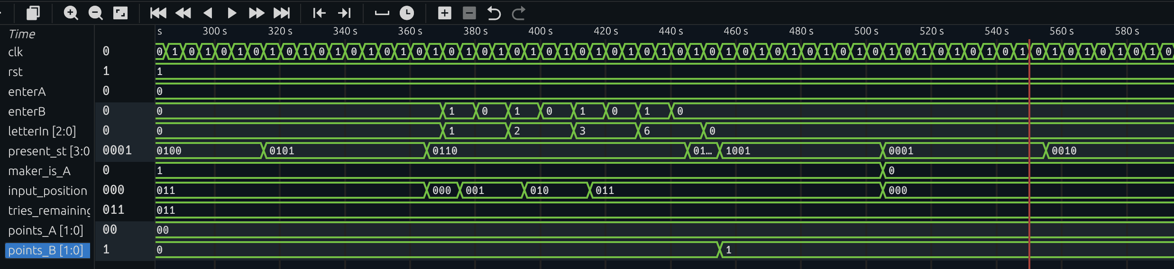

Figure 2: Round 1 - Code-Breaker Guesses Correct Code (300s - 580s)
Test 3 - Player B guesses the correct code: At t≈340s, the FSM enters ST_DISPLAY_TRIES (0101), showing "L-3" (3 lives remaining). Then at t≈380s, it transitions to ST_INPUT_GUESS (0110) where Player B enters their guess.
Player B enters the correct code (A, C, E, L) using letterIn values 1, 2, 3, 6. The input_position increments from 000 to 011 as each letter is entered.
At t≈450s, the FSM transitions to ST_CHECK_RESULT (0111) to verify the guess. Since all letters match, at t≈460s the FSM moves to ST_ADD_POINTS (1001) and points_B increments from 0 to 1, indicating Player B wins Round 1.
Role Swap: At t≈510s, the FSM returns to ST_DISPLAY_SCORE (0001) for Round 2. The maker_is_A signal changes from 1 to 0, confirming that roles have swapped - Player B is now the code-maker and Player A is the code-breaker.
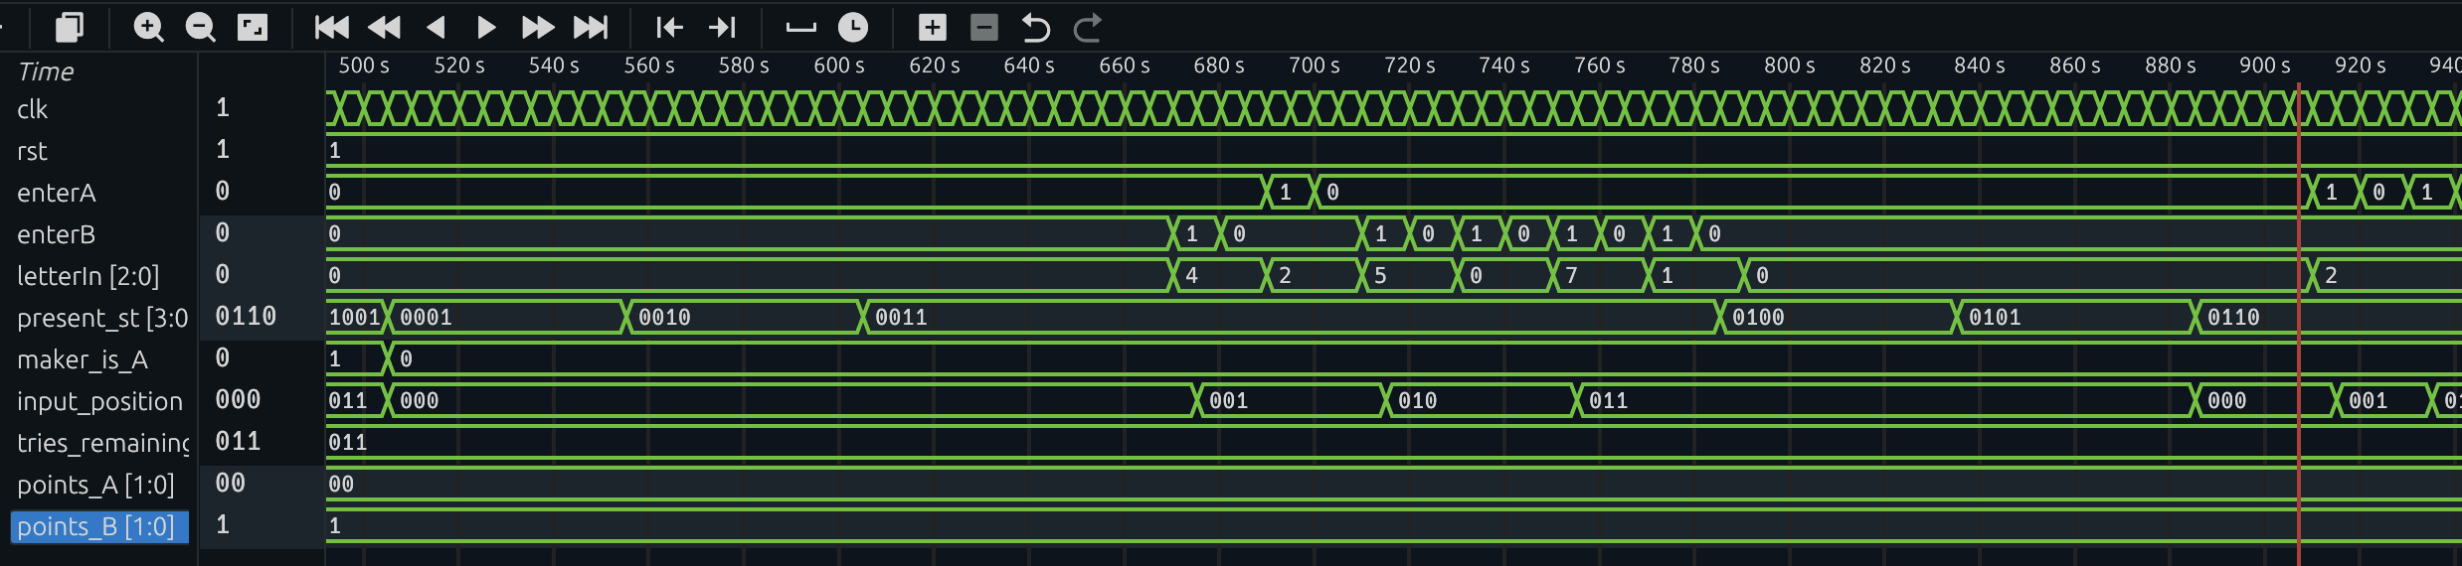

Figure 3: Round 2 - Player B Enters Code as Code-Maker (500s - 940s)
Role Swap Confirmation: At t≈505s, the maker_is_A signal is now 0, confirming Player B is the code-maker for Round 2.
Test 4 - Player B enters the code: Starting at t≈600s (State 0011 - ST_INPUT_CODE), Player B enters a 4-letter code (F, H, U, A) using letterIn values 4, 5, 7, 1. The input_position increments from 000 to 011 with each valid letter entry.
Test 4a - enterA button should not work: At t≈680s, while in ST_INPUT_CODE state, enterA is pressed with letterIn=1. The input_position remains at 001, proving that the code-breaker's (Player A) button is correctly ignored during code-maker's (Player B) turn.
Test 4b - "-" is not accepted as a letter: At t≈720s, enterB is pressed with letterIn=0 (which represents "-"). The input_position remains at 010, confirming that the invalid letter code is rejected.
At t≈800s, after the 4th letter is entered, the FSM transitions to ST_DISPLAY_BREAK (0100), then ST_DISPLAY_TRIES (0101), and finally ST_INPUT_GUESS (0110) where Player A will attempt to guess the code.
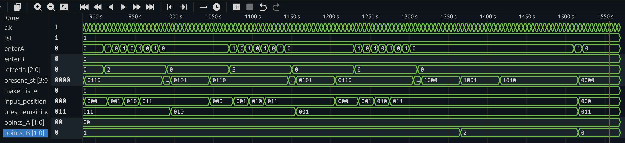

Figure 4: Round 2 - Player A Fails to Guess the Code (900s - 1520s)
Test 5 - Player A does not guess the correct code:
Player A makes three incorrect guesses, using all available lives:
Guess 1 (t≈920s-980s): Player A enters C,C,C,C (letterIn=2,2,2,2). At t≈990s, the FSM transitions from ST_CHECK_RESULT (0111) to ST_DISPLAY_TRIES (0101), and tries_remaining decrements from 011 to 010 (3→2).
Guess 2 (t≈1050s-1130s): Player A enters E,E,E,E (letterIn=3,3,3,3). At t≈1150s, tries_remaining decrements from 010 to 001 (2→1).
Guess 3 (t≈1200s-1280s): Player A enters L,L,L,L (letterIn=6,6,6,6). This is the final attempt.
Game Over Sequence: At t≈1310s, since all 3 lives are exhausted, the FSM transitions to ST_REVEAL_CODE (1000) to display the correct code. At t≈1350s, it moves to ST_ADD_POINTS (1001) and points_B increments from 1 to 2, meaning Player B wins the match.
At t≈1400s, the FSM enters ST_FINISH (1010), indicating the game is over. Finally, at t≈1500s, after a button press, the FSM returns to ST_WAIT (0000), resetting points_B to 0 and tries_remaining to 011 (3), ready for a new game.

