Stack monitoring
  - Cloud is a distributed system. Thus hosting an application on a cloud means creating a virtual environment to simulate the target one
  - => virtual stack.
  - Stack monitoring is injecting an application (layer) in this stack to
    - Check the stack of the stack
    - Influent, correct or modify it.

How to use it
  - Tools to use it:
    - External console
    - Alert, notification and uptime checks
  - User application needs no overhead management tasks
  - May be installed on different type of cloud (google cloud, Amazon web service, ) or custom clusters.

Stack image

Charts and Dashboards
Visual representation of one or more metrics. Gives statistics on a running application on the cloud.
May represent different hardware and software aspects of the stack. May also represent user custom metrics.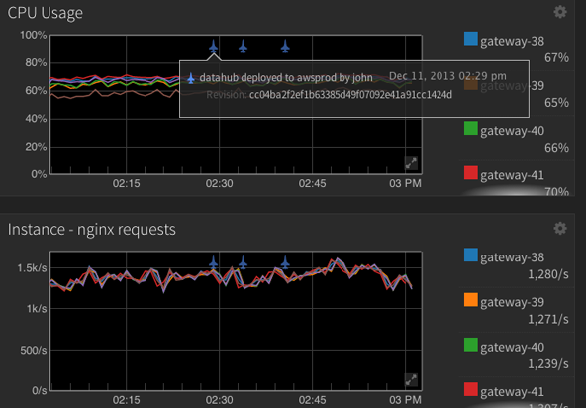

Uptime checks and events
  - Check the system's health by sending requests to the user applications, services, or URLs from various locations around the world.
  - Custom check policy to make the checks and the notification more accurate.

Improve Signal-to-Noise
Advanced alerting capabilities, including rate of change, cluster aggregation, and multi-condition policies, help you ensure that you are notified when critical issues occur while reducing the likelihood of false positives.

Fix Problems Faster

