CS 148 Database Design for the Web

Shane McCafferty

Final Project

Maxine Davis Art Database

Version <1.0>

|  |  |  |  |
| --- | --- | --- | --- |
| Time Log | | | |
| Date | Time Spent (in hours) | Description | Author |
| 11/10/13 | 1.5 | Making Specs sheet | Shane McCafferty |
|  |  | Your estimated time to complete assignment __25.0__ hours |  |
|  |  |  |  |
| 11/20/13 | 2.0 | framework | Shane McCafferty |
|  |  |  |  |
| 11/24/13 | 3.0 | Filling out home.php and deciding what to do form for | Shane McCafferty |
|  |  |  |  |
| 11/26/13 | 5.0 | Creating form.php and getting it functional | Shane McCafferty |
|  |  |  |  |
| 12/4/13 | 7.0 | Working on admin page, making a list box that selects records from the database to display. | Shane McCafferty |
|  |  |  |  |
| 12/6/13 | 3.0 | Revamping specs sheet and making updates ER diagram, schema, and data dictionary | Shane McCafferty |
|  |  |  |  |
|  |  |  |  |
|  |  |  |  |
|  |  |  |  |
|  |  |  |  |
|  |  |  |  |
|  |  |  |  |
|  |  |  |  |
|  |  |  |  |
|  |  |  |  |
|  |  |  |  |
|  |  |  |  |
|  |  |  |  |
|  |  |  |  |

**Table Of Contents**

Database/Website Specifications 4

Introduction 4

Purpose 4

Definitions, acronyms, and abbreviations 4

Overview 4

Overall Description 5

Data Dictionary 5

E-R Diagram 5

Schema 5

Story Board 5

Specific requirements 5

**Software Requirements Specifications**

## Introduction

### Purpose

The purpose is making a website that will have a fully functional form to submit potential customer data directly from the website into the database. This will be used for tracking and processing orders, and tailored to Maxine Davis’ Art business

### Definitions, acronyms, and abbreviations

HTML – Hypertext markup language – used to define your content.

PHP – Personal Home Page – language that helps to customize html.

CSS – Cascading Style Sheets – used to define the look of a web site.

W3 Validation – refers to both Html and CSS validation tool provided by the

Schema- SQL statements for database creation

Data Dictionary- Defines database tables and fields and their value types

ER Diagram- A visual representation of the relational database which shows the entities and their relationships.

### Overview

More details follow on the structure of the website and the database, including the ER-Diagram, Schema, Data Dictionary, and the Storyboard for the website.

## Overall Description

As mentioned above the site will be about Maxine Davis’ art and will include a fully functional form that will submit data entered directly into our relational database. This could potentially be used for customer interaction and the placing/tracking of orders. It will also send an email conformation page. Also features an Admin page where records can be added, altered, and deleted.

### Data Dictionary

**Data Dictionary – Maxine Davis Glass Art**

**tblArt**

| **Column** | **Type** | **Null** | **Default** | **Comments** | **MIME** |
| --- | --- | --- | --- | --- | --- |
| pkArtID | int(20) | No |  | Auto-incrementing |  |
| fldTitle | varchar(25) | No |  |  |  |
| fldCategory | varchar(20) | No |  |  |  |
| fldLength | varchar(8) | No |  |  |  |
| fldWidth | varchar(8) | No |  |  |  |
| fldHeight | varchar(8) | No |  |  |  |
| fldWeight | varchar(8) | No |  |  |  |
| fldQtyinStock | int(6) | No |  |  |  |
| fldImageName | varchar(35) | No |  |  |  |
| fldRetailPrice | decimal(5,2) | No |  |  |  |
| fldWholesalePrice | decimal(5,2) | No |  |  |  |
| fldColor | varchar(25) | No |  |  |  |

**tblOrder**

| **Column** | **Type** | **Null** | **Default** | **Links to** | **Comments** | **MIME** |
| --- | --- | --- | --- | --- | --- | --- |
| pkOrderID | int(20) | No |  |  | Auto-Incrementing |  |
| fkEmail | varchar(25) | No |  | tblCustomer -> pkEmail | foreign key |  |
| fldOrderDate | timestamp | No | CURRENT_TIMESTAMP |  |  |  |
| fldDateShipped | date | No |  |  |  |  |

**tblCustomer**

| **Column** | **Type** | **Null** | **Default** | **Comments** | **MIME** |
| --- | --- | --- | --- | --- | --- |
| pkEmail | varchar(35) | No |  |  |  |
| fldFirstName | varchar(15) | No |  |  |  |
| fldLastName | varchar(20) | No |  |  |  |
| fldStreetAddress | varchar(35) | No |  |  |  |
| fldCity | varchar(20) | No |  |  |  |
| fldState | char(2) | No |  |  |  |
| fldZip | int(5) | No |  |  |  |
| fldPhoneNumber | varchar(15) | No |  |  |  |
| fldRegisteredDate | timestamp | No | CURRENT_TIMESTAMP |  |  |
| fldGender | varchar(8) | No |  |  |  |

**tblArtOrder**

| **Column** | **Type** | **Null** | **Default** | **Links to** | **Comments** | **MIME** |
| --- | --- | --- | --- | --- | --- | --- |
| fkArtID | int(11) | No |  | tblArt -> pkArtID |  |  |
| fkOrderID | int(11) | No |  | tblOrder -> pkOrderID |  |  |

### E-R Diagram

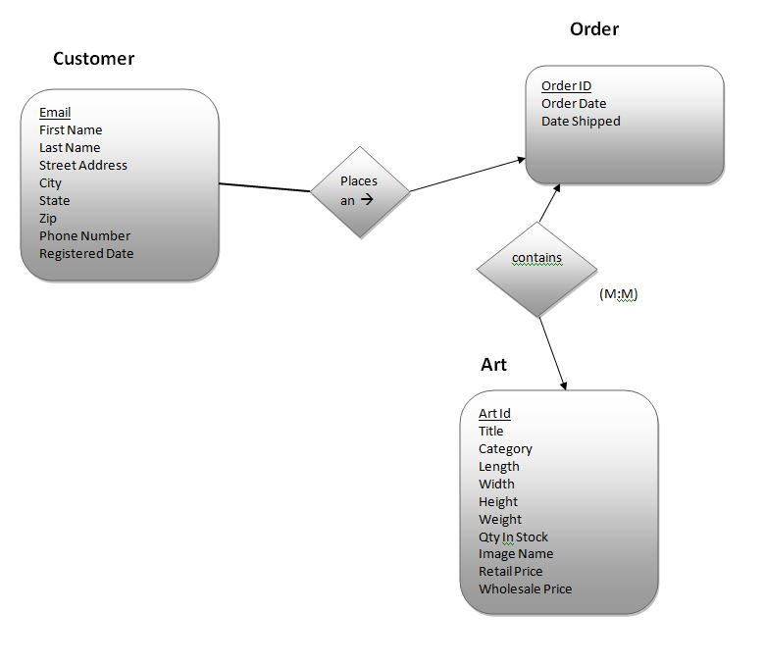

### Schema

SET SQL_MODE="NO_AUTO_VALUE_ON_ZERO";

CREATE TABLE IF NOT EXISTS `tblArt` (

`pkArtID` int(20) NOT NULL AUTO_INCREMENT,

`fldTitle` varchar(25) NOT NULL,

`fldCategory` varchar(20) NOT NULL,

`fldLength` varchar(8) NOT NULL,

`fldWidth` varchar(8) NOT NULL,

`fldHeight` varchar(8) NOT NULL,

`fldWeight` varchar(8) NOT NULL,

`fldQtyinStock` int(6) NOT NULL,

`fldImageName` varchar(35) NOT NULL,

`fldRetailPrice` decimal(5,2) NOT NULL,

`fldWholesalePrice` decimal(5,2) NOT NULL,

`fldColor` varchar(25) NOT NULL,

PRIMARY KEY (`pkArtID`)

) ENGINE=InnoDB DEFAULT CHARSET=utf8 AUTO_INCREMENT=16 ;

CREATE TABLE IF NOT EXISTS `tblArtColor` (

`fkArtID` int(11) NOT NULL,

`fkColor` varchar(15) NOT NULL,

`yes_no` varchar(3) NOT NULL COMMENT 'whether is has this color or not',

KEY `fkArtID` (`fkArtID`),

KEY `fkColor` (`fkColor`)

) ENGINE=InnoDB DEFAULT CHARSET=utf8;

CREATE TABLE IF NOT EXISTS `tblArtOrder` (

`fkArtID` int(11) NOT NULL,

`fkOrderID` int(11) NOT NULL,

KEY `fkArtID` (`fkArtID`),

KEY `fkOrderID` (`fkOrderID`)

) ENGINE=InnoDB DEFAULT CHARSET=utf8;

CREATE TABLE IF NOT EXISTS `tblColor` (

`pkColor` varchar(15) NOT NULL,

KEY `pkColor` (`pkColor`)

) ENGINE=InnoDB DEFAULT CHARSET=utf8;

CREATE TABLE IF NOT EXISTS `tblCustomer` (

`pkEmail` varchar(35) NOT NULL,

`fldFirstName` varchar(15) NOT NULL,

`fldLastName` varchar(20) NOT NULL,

`fldStreetAddress` varchar(35) NOT NULL,

`fldCity` varchar(20) NOT NULL,

`fldState` char(2) NOT NULL,

`fldZip` int(5) NOT NULL,

`fldPhoneNumber` varchar(15) NOT NULL,

`fldRegisteredDate` timestamp NOT NULL DEFAULT CURRENT_TIMESTAMP,

`fldGender` varchar(8) NOT NULL,

PRIMARY KEY (`pkEmail`)

) ENGINE=InnoDB DEFAULT CHARSET=utf8;

CREATE TABLE IF NOT EXISTS `tblOrder` (

`pkOrderID` int(20) NOT NULL AUTO_INCREMENT,

`fkEmail` varchar(25) NOT NULL COMMENT 'foreign key',

`fldOrderDate` timestamp NOT NULL DEFAULT CURRENT_TIMESTAMP,

`fldDateShipped` date NOT NULL,

PRIMARY KEY (`pkOrderID`),

KEY `fkEmail` (`fkEmail`)

) ENGINE=InnoDB DEFAULT CHARSET=utf8 AUTO_INCREMENT=23 ;

ALTER TABLE `tblArtColor`

ADD CONSTRAINT `tblArtColor_ibfk_1` FOREIGN KEY (`fkArtID`) REFERENCES `tblArt` (`pkArtID`),

ADD CONSTRAINT `tblArtColor_ibfk_2` FOREIGN KEY (`fkColor`) REFERENCES `tblColor` (`pkColor`);

ALTER TABLE `tblArtOrder`

ADD CONSTRAINT `tblArtOrder_ibfk_1` FOREIGN KEY (`fkArtID`) REFERENCES `tblArt` (`pkArtID`),

ADD CONSTRAINT `tblArtOrder_ibfk_2` FOREIGN KEY (`fkOrderID`) REFERENCES `tblOrder` (`pkOrderID`);

ALTER TABLE `tblOrder`

ADD CONSTRAINT `tblOrder_ibfk_1` FOREIGN KEY (`fkEmail`) REFERENCES `tblCustomer` (`pkEmail`);

### Story Board

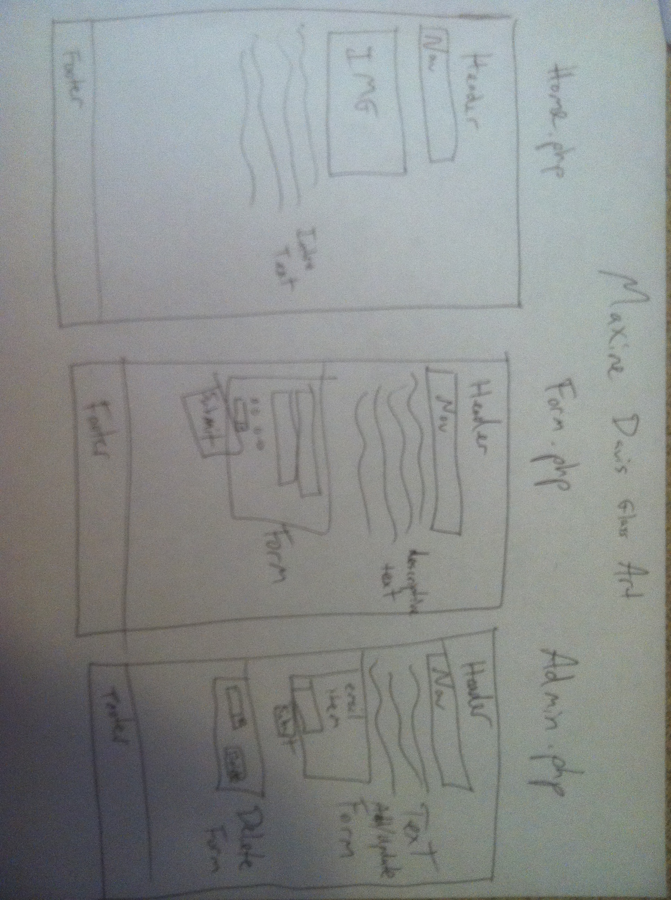

## My Specific requirements

Here is just a list of things I will require you really need to write the specific requirements as they relate to your project.

1. *Data Dictionary explaining the tables, their fields, and the value types*
2. *Schema listing the SQL statements to create the database*
3. *3 page website including a home page, form page, and info display page*
4. *ER- diagram showing the relational database*
5. *Functional form that dumps info entered by the user into our relational database*
6. *Form for entering in customer data as well as what they ordered*
7. *Automatically generated SQL statements based off of the form submission.*
8. *Admin page where records can be added, altered, and deleted*
9. *An automated email message letting the customer know that their order is confirmed*