CS 148 Database Design for the Web

Shane McCafferty

Assignment Five

Maxine Davis Art Database Full

Version <1.0>

|  |  |  |  |
| --- | --- | --- | --- |
| Time Log | | | |
| Date | Time Spent (in hours) | Description | Author |
| 11/5/13 | 1.5 | Making Specs sheet | Shane McCafferty |
|  |  | Your estimated time to complete assignment __35.0__ hours |  |
|  |  |  |  |
|  |  |  |  |
|  |  |  |  |
|  |  |  |  |
|  |  |  |  |
|  |  |  |  |
|  |  |  |  |
|  |  |  |  |
|  |  |  |  |
|  |  |  |  |
|  |  |  |  |
|  |  |  |  |
|  |  |  |  |
|  |  |  |  |
|  |  |  |  |
|  |  |  |  |
|  |  |  |  |
|  |  |  |  |
|  |  |  |  |
|  |  |  |  |
|  |  |  |  |
|  |  |  |  |
|  |  |  |  |
|  |  |  |  |

**Table Of Contents**

Database/Website Specifications 4

Introduction 4

Purpose 4

Definitions, acronyms, and abbreviations 4

Overview 4

Overall Description 5

Data Dictionary 5

E-R Diagram 5

Schema 5

Story Board 5

Specific requirements 5

**Software Requirements Specifications**

## Introduction

### Purpose

The purpose is making a website that will have a fully functional form to submit potential customer data directly from the website into the database. This will be used for tracking and processing orders. Also will be able to input items into the database from the form

### Definitions, acronyms, and abbreviations

HTML – Hypertext markup language – used to define your conent.

PHP – Personal Home Page – language that helps to customize html.

CSS – Cascading Style Sheets – used to define the look of a web site.

W3 Validation – refers to both Html and CSS validation tool provided by the

Schema- SQL statements for database creation

Data Dictionary- Defines database tables and fields and their value types

ER Diagram- A visual representation of the relational database which shows the entities and their relationships.

### Overview

More details follow on the structure of the website and the database, including the ER-Diagram, Schema, Data Dictionary, and the Storyboard for the website.

## Overall Description

As mentioned above the site will be about Maxine Davis’ art and will include a fully functional form that will submit data entered directly into our relational database. This could potentially be used for customer interaction and the placing/tracking of orders.

### Data Dictionary

**Data Dictionary – Maxine Davis Glass Art**

**tblArtColor**

| **Column** | **Type** | **Null** | **Default** | **Links to** | **Comments** | **MIME** |
| --- | --- | --- | --- | --- | --- | --- |
| fkArtID | int(11) | No |  | tblArt -> pkArtID |  |  |
| fkColor | varchar(15) | No |  | tblColor -> pkColor |  |  |
| yes_no | varchar(3) | No |  |  | whether is has this color or not |  |

**tblArt**

| **Column** | **Type** | **Null** | **Default** | **Comments** | **MIME** |
| --- | --- | --- | --- | --- | --- |
| pkArtID | int(20) | No |  | Auto-incrementing |  |
| fldTitle | varchar(25) | No |  |  |  |
| fldCategory | varchar(20) | No |  |  |  |
| fldLength | varchar(8) | No |  |  |  |
| fldWidth | varchar(8) | No |  |  |  |
| fldHeight | varchar(8) | No |  |  |  |
| fldWeight | varchar(8) | No |  |  |  |
| fldQtyinStock | int(6) | No |  |  |  |
| fldImageName | varchar(35) | No |  |  |  |
| fldRetailPrice | decimal(5,2) | No |  |  |  |
| fldWholesalePrice | decimal(5,2) | No |  |  |  |
| fldColor | varchar(25) | No |  |  |  |

**tblOrder**

| **Column** | **Type** | **Null** | **Default** | **Links to** | **Comments** | **MIME** |
| --- | --- | --- | --- | --- | --- | --- |
| pkOrderID | int(20) | No |  |  | Auto-Incrementing |  |
| fkEmail | varchar(25) | No |  | tblCustomer -> pkEmail | foreign key |  |
| fldOrderDate | timestamp | No | CURRENT_TIMESTAMP |  |  |  |
| fldDateShipped | date | No |  |  |  |  |

**tblCustomer**

| **Column** | **Type** | **Null** | **Default** | **Comments** | **MIME** |
| --- | --- | --- | --- | --- | --- |
| pkEmail | varchar(35) | No |  |  |  |
| fldFirstName | varchar(15) | No |  |  |  |
| fldLastName | varchar(20) | No |  |  |  |
| fldStreetAddress | varchar(35) | No |  |  |  |
| fldCity | varchar(20) | No |  |  |  |
| fldState | char(2) | No |  |  |  |
| fldZip | int(5) | No |  |  |  |
| fldPhoneNumber | varchar(15) | No |  |  |  |
| fldRegisteredDate | timestamp | No | CURRENT_TIMESTAMP |  |  |
| fldGender | varchar(8) | No |  |  |  |

**tblColor**

| **Column** | **Type** | **Null** | **Default** | **Comments** | **MIME** |
| --- | --- | --- | --- | --- | --- |
| pkColor | varchar(15) | No |  |  |  |

**tblArtOrder**

| **Column** | **Type** | **Null** | **Default** | **Links to** | **Comments** | **MIME** |
| --- | --- | --- | --- | --- | --- | --- |
| fkArtID | int(11) | No |  | tblArt -> pkArtID |  |  |
| fkOrderID | int(11) | No |  | tblOrder -> pkOrderID |  |  |

### E-R Diagram

View [E-R diagram](http://www.uvm.edu/~simccaff/cs148/assignment4.1/er.docx) here

### Schema

**SCHEMA for MaxineDavisArt**

**Tables**

CREATE TABLE tblArt (

pkArtID VARCHAR(20) PRIMARY KEY,

fldTitle VARCHAR(25),

fldCategory VARCHAR(20),

fldLength VARCHAR(10),

fldWidth VARCHAR(10),

fldHeight VARCHAR(10),

fldWeight VARCHAR(10),

fldQtyinStock INT(6),

fldImageName VARCHAR(35),

fldRetailPrice DECIMAL(5,2),

fldWholesalePrice DECIMAL(5,2)

);

CREATE TABLE tblCustomer (

pkEmail VARCHAR(35) PRIMARY KEY,

fldFirstName VARCHAR(15),

fldLastName VARCHAR(20),

fldStreetAddress VARCHAR(35),

fldCity VARCHAR(20),

fldState CHAR(2),

fldZip INT(5),

fldPhoneNumber INT(10),

fldRegisteredDate TIME_STAMP,

fldGender VARCHAR(8)

);

CREATE TABLE tblArtColor (

fkArtID INT(11) REFERENCES `SIMCCAFF_MaxineDavisArt`.`tblArt`,

fkColor VARCHAR(15) REFERENCES `SIMCCAFF_MaxineDavisArt`.`tblColor`,

yes_no VARCHAR(5)

);

CREATE TABLE tblOrder (

pkOrderID VARCHAR(20) PRIMARY KEY,

fkEmail VARCHAR(25) REFERENCES `SIMCCAFF_MaxineDavisArt`.`tblCustomer`,

fldOrderDate DATE,

fldDateShipped DATE

);

CREATE TABLE tblColor (

pkColor VARCHAR(20) PRIMARY KEY,

);

CREATE TABLE tblOrderArt(

fkOrderID VARCHAR(20) not null references tblOrder(pkOrderID),

fkArtID VARCHAR(20) not null references tblArt(pkArtID),

PRIMARY KEY (fkOrderID, fkArtID)

);

### Story Board

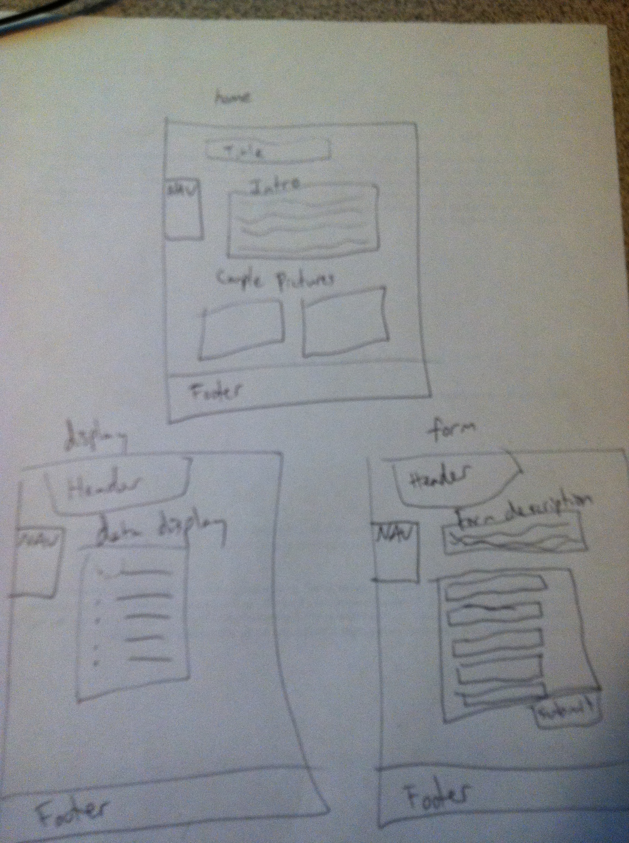

## My Specific requirements

Here is just a list of things I will require you really need to write the specific requirements as they relate to your project.

1. *Data Dictionary explaining the tables, their fields, and the value types*
2. *Schema listing the SQL statements to create the database*
3. *3 page website including a home page, form page, and info display page*
4. *ER- diagram showing the relational database*
5. *Functional form that dumps info entered by the user into our relational database*
6. *Able to input/edit database from the form*
7. *Register page, along with a place orders page*