# Oops, I did it again!

I have been contributing my photos to Google Maps since 2017. Until today, my pictures have collected almost two million views.

Some of them make me proud: El Capitan in Yosemite National Park, streets and corners of San Francisco, all the Bay area food you can eat and capture on a camera. And what is the most popular one? Not El Captain, not the ocean, not even cosy coffee shops in Prague but… IKEA in Palo Alto (300+ thousand views).

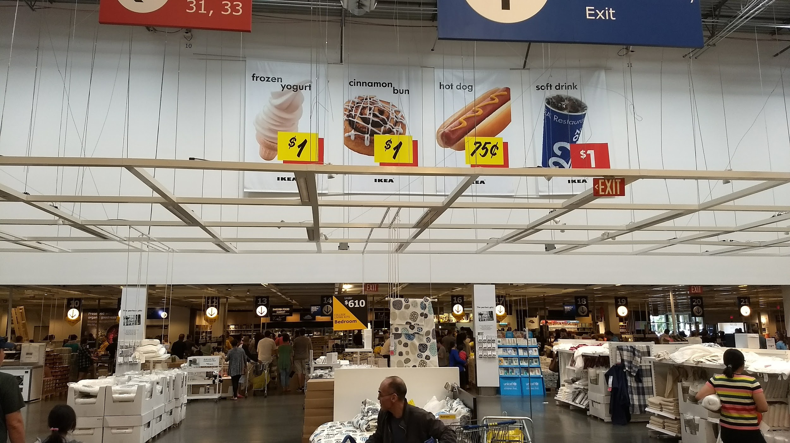

In hindsight, it is obvious why. My Motorola X4 camera can’t compete with Google Pixel or even iPhone. When my photo gets popular, it is because most people did not find the scene worth capturing but the place is popular on Google Maps. My photo is not nice but it is nevertheless useful.

Similarly, there are pieces of my work and code, I am proud of. And other pieces that - for some reason - people keep using. Because it is not always easy to separate them in advance, I will keep this blog as a journal of my experiments and my mistakes. The blog itself is an experiment with fastai’s [fastpages](https://github.com/fastai/fastpages). And in the process of setting it up, I accidentally send [a very stupid pull request](https://github.com/fastai/fastpages/pull/120) to the original repo. So, everything is going just great.