Day 3: Building a docker container with an image via dockerfile for a war to be deployed

Dockerfile:

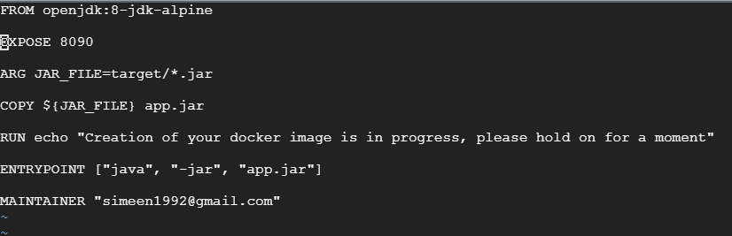

Docker Build Command

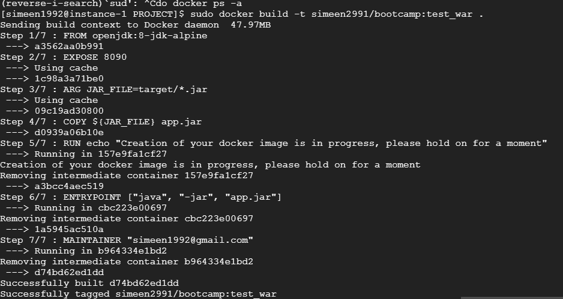

Docker Images created



Image being run to create a container:



Docker container up and running with image deployed



Docker image pushed to dockerhub.io

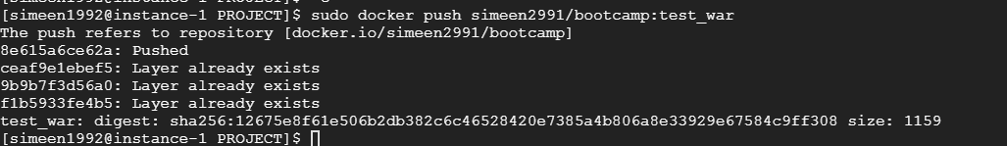

Docker Compose:

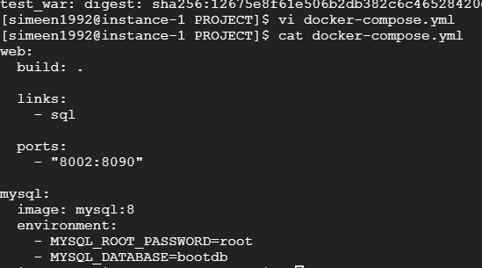

Error occurred due to link name incorrect:



Corrected the link name:

Running the yaml file:

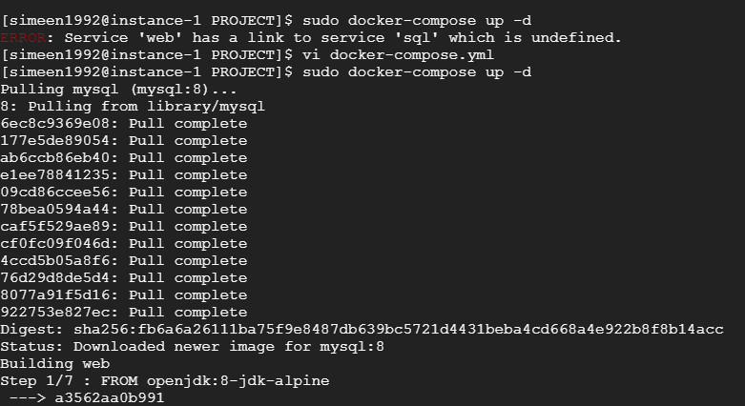

Modified Yaml file

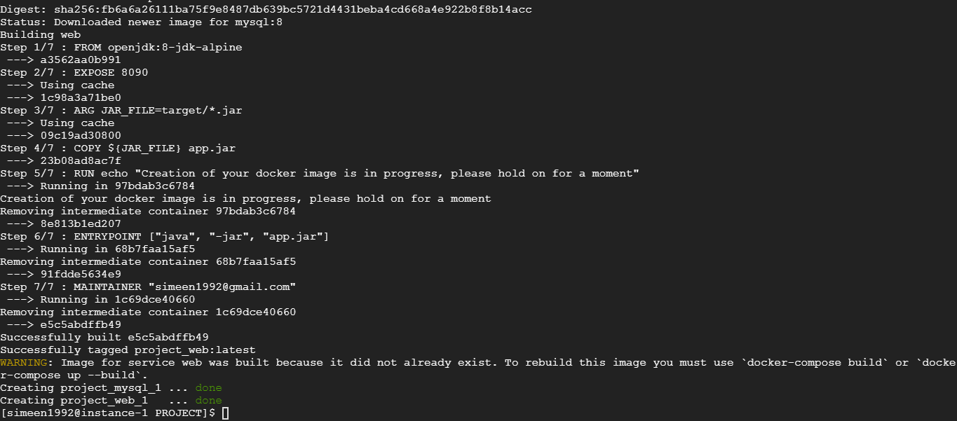

Verification of mysql server being up:

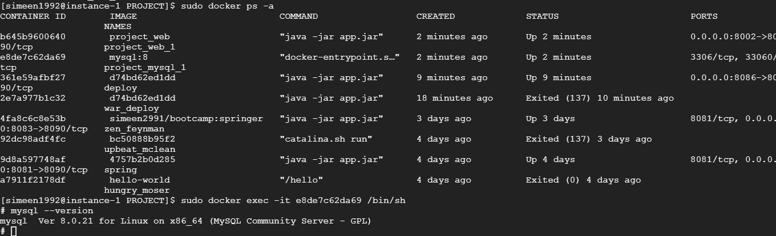

Docker compose stop:

