Ref Link: <https://devstack.in/2019/01/24/how-to-set-up-continuous-integration-pipelines-with-azure-pipelines-and-pcf/>

* Initial pipeline creation stages

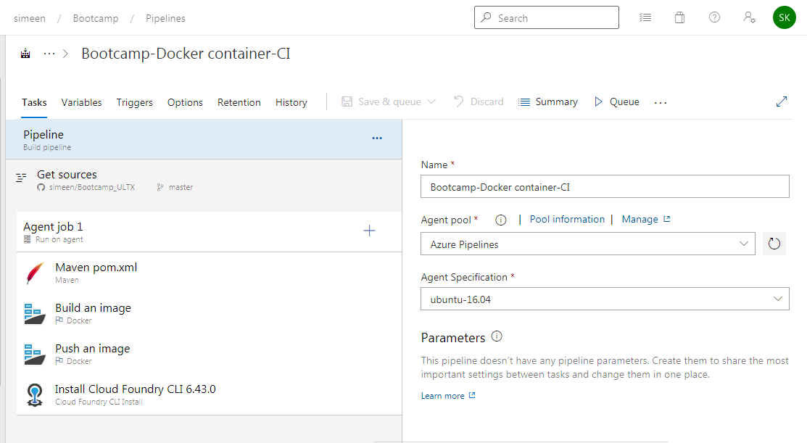

* Maven Initialization

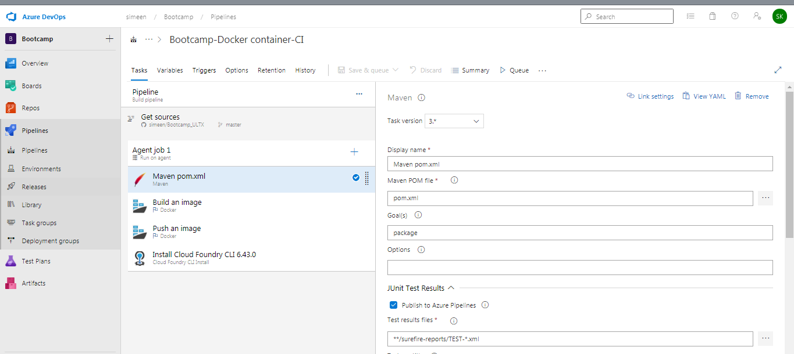

* Docker build stage initialization : Make sure name of image in dockerhub matches the one provided in build step

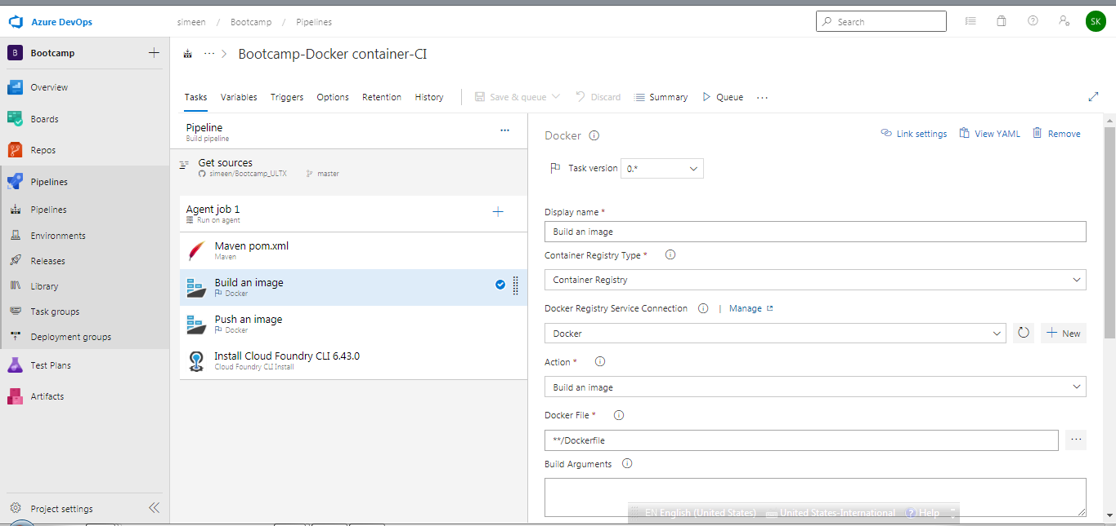

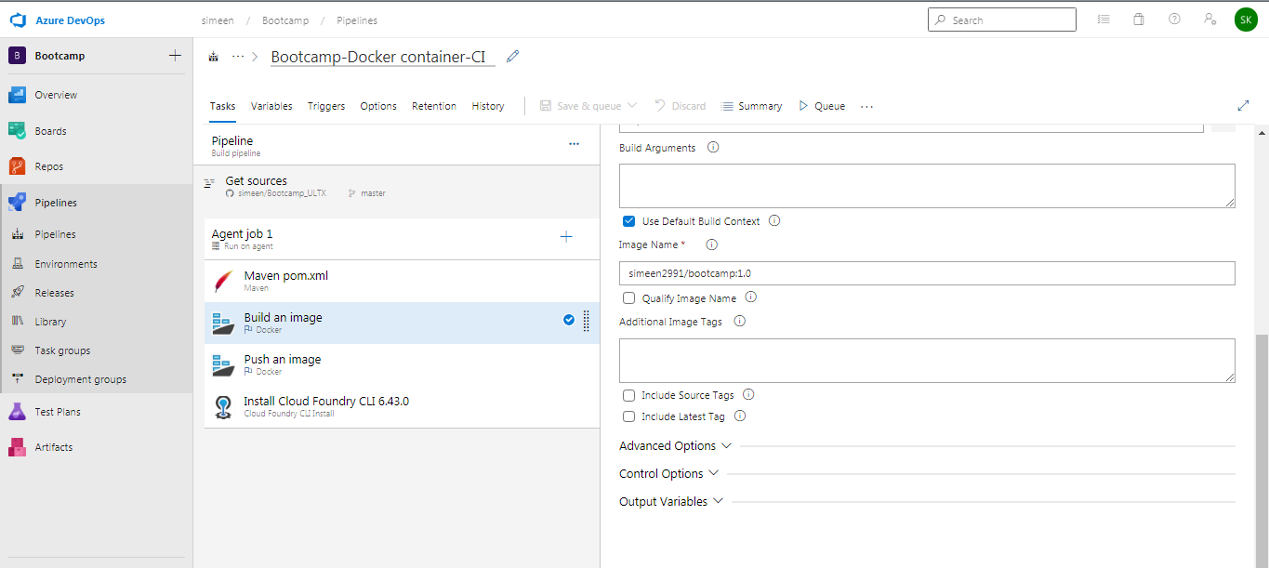

* Pushing an image into CF

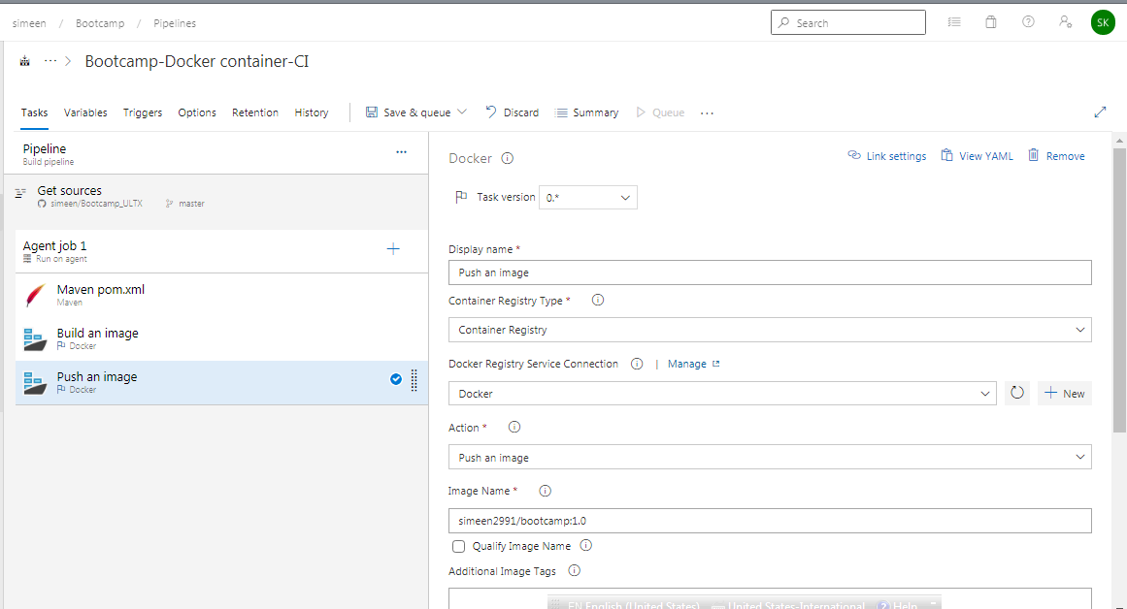

* Release pipeline creation

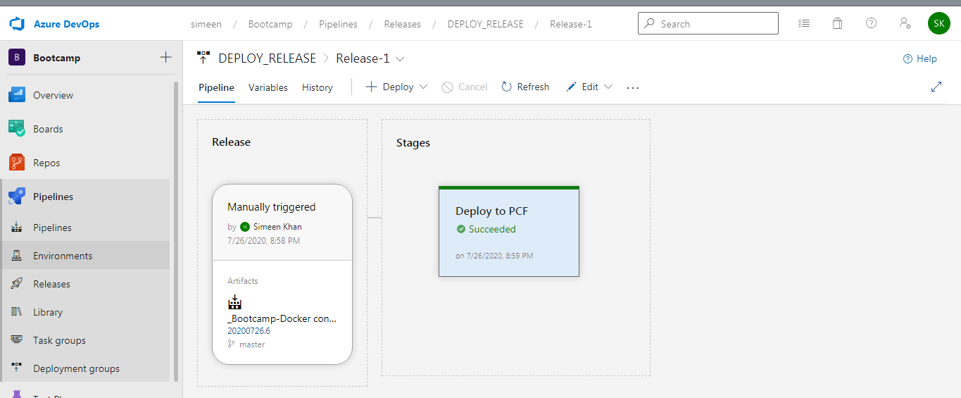

* Log of successful Push to cloud foundry

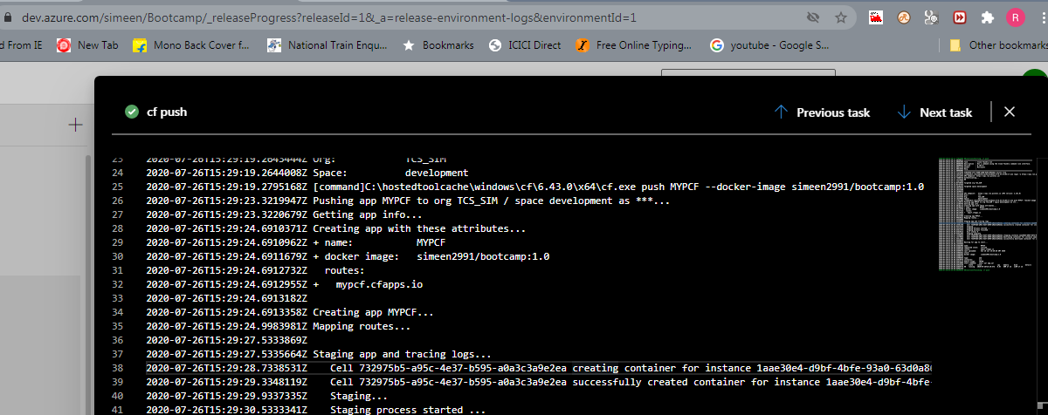

* Application deployed on Cloud foundry using Azure Release pipeline

