**https://github.com/simeen/GIT_TEST.git**

1. check git version > git –version



2) configure username > git config --global user.name "your name"

3) configure email > git config --global user.email "your email"

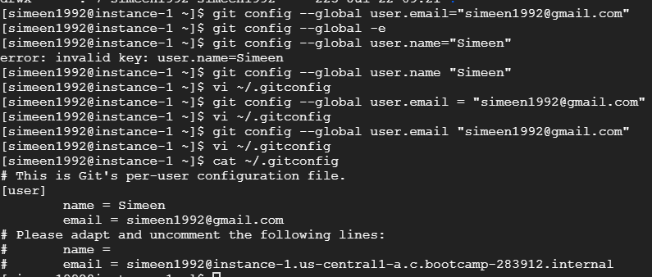

**Creating a git repository**

* **mkdir <directory name>**



**To Change the directory and Converts a directory into a local git repository.**

* **cd <directory name>**
* **git init**



**To add a single or muiltiple files to staging area and To commit the changes in the local repository and To list the status of the files in staging area.**

* **git commit -m "commit message"**
* **git status**

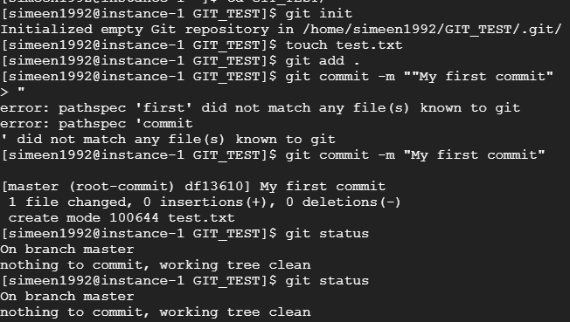

**To configure the global username and email id**

* **git config user.name "Shubham"**
* **git config user.email "shubham@gmail.com"**



**To connect a local repository to a specific remote repository. And To Clone a remote git repository into a local git repository.**

* **git remote add origin <ssh url>**
* **git clone <repo name>**



**To Pull the changes from master branch of the remote git repository. And To Push the changes to master branch of the remote git repository.**

* **git pull origin master**
* **git push origin master**

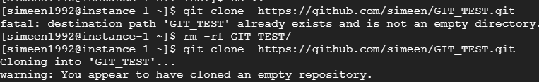

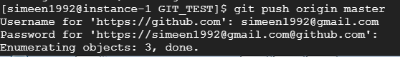

**To List all the branches and To create a new branch and To delete an existing branch**

* **git branch**
* **git branch $branchName**
* **git branch -d $branchName**

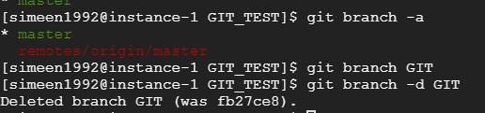

**To merge a child branch to master**

* **git merge $branchName**

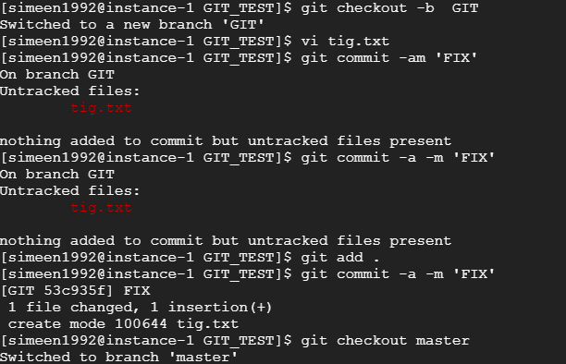

**Advance git commands**

**To save the changes, when they are not in state of commit.**

* **git stash**

**To stash changes and clearing up the directory**

* **git stash -u**

**To List the stashes created.**

* **git stash list**

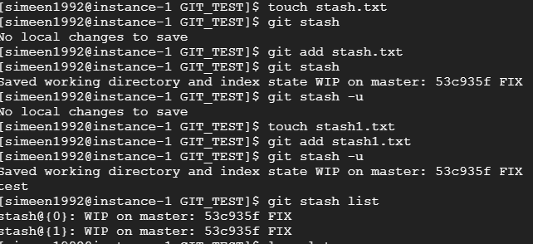

**To List the stashes created.**

* **git stash list**

**To get the stashed work back.**

* **git stash apply**

**To get the context and history of logs of a repository**

* **git log**

**To Copy and Store a set of commit outside of our repository.**

* **git rebase**

**To revert back to the previous version of the file.**

* **git revert**

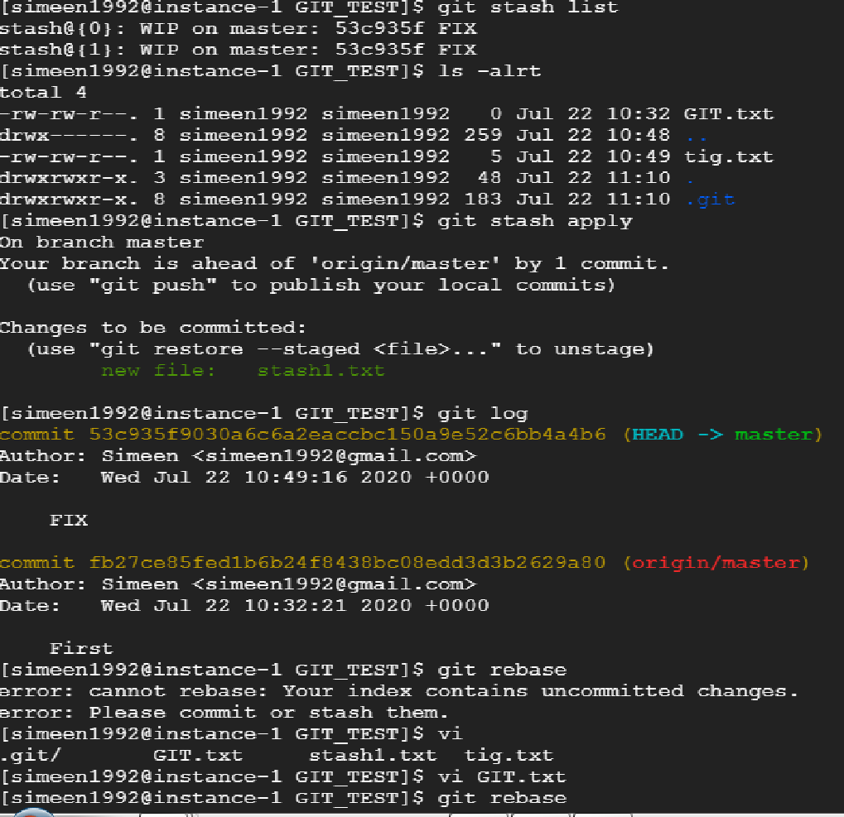

**To Copy and Store a set of commit outside of our repository.**

* **git rebase**

