A Quarto manuscript template for RevTeX
Abstract
This is a placeholder abstract. The document demonstrates the features of a Quarto manuscript project that renders a RevTeX PDF: author and affiliation metadata, numbered sections and equations, cross-references, citations, and figures generated from Python code.

Workflow
This section documents how the manuscript is built and should be removed before submission. The source is the Quarto file index.qmd, and _quarto.yml configures a Quarto manuscript project that renders HTML, Word, JATS and a RevTeX PDF from that single source.

Building
Render all formats, or only the PDF, with
quarto render
quarto render index.qmd --to pdf
Output is written to _manuscript/. Because freeze: true is set, a project-wide render reuses stored code output; rendering index.qmd explicitly re-executes the Python chunks. Use quarto preview for live reloading while writing.

RevTeX setup
The PDF uses documentclass: revtex4-2 with the options aps, pra, reprint, superscriptaddress; change pra to target another journal, or reprint to preprint for a single-column draft. The folder _revtex/ holds the glue between Quarto and RevTeX. The file before-body.tex emits \title, \author, \affiliation, \email and the abstract after \begin{document}, as RevTeX requires. The file preamble.tex resolves a longtable* clash with the caption package. The generated LaTeX is kept in _manuscript/_tex/ for journal submission.

Fonts
Text and mathematics are set in STIX Two in both the PDF and the HTML output. The font files are in _fonts/, and they are switched on by stix: true in _quarto.yml; set it to false to use the default fonts. The filter _fonts/stix.lua loads the fonts in the PDF preamble and, for HTML, tells MathJax 4 to use its STIX Two math font.

Plots
The first code chunk in this file loads the local package revtexplot, which styles matplotlib figures to match the PDF. It is switched on by plot-style: true in _quarto.yml; set it to false for matplotlib’s defaults. Figures are one column wide by default and use 8 pt text, the size of \footnotesize, in STIX Two (or Computer Modern with stix: false). They are saved at exactly their set size, so the text in them matches the captions. The package provides these sizes:
- rp.COLUMN: one column, 3.40 × 2.10 in (the default)
- rp.WIDE: both columns, 7.06 × 2.35 in
- rp.figsize(width, aspect): width is "column", "wide" or inches, and aspect is height / width
For example, plt.subplots(figsize=rp.figsize("column", 1)) gives a square one-column figure.

Writing
Authors, affiliations, e-mail addresses and the abstract are set in the YAML header. Sections, equations and figures get labels with the prefixes sec-, eq- and fig-, and are referenced as @sec-methods, @eq-gaussian or @fig-example. A displayed equation is labelled by appending {#eq-name} after its closing $$. Citations use keys from references.bib, e.g. [@knuth1984], and are formatted by BibTeX with the apsrev4-2 style. Figures are produced by Python chunks whose label and fig-cap options set the reference and caption; see Section 4 for an example.

Wide figures and equations
In the two-column reprint layout, a figure spans both columns when it uses RevTeX’s figure* environment. For a Python chunk, add the options
#| fig-env: "figure*"
#| fig-pos: "t"
and create the figure with plt.subplots(figsize=rp.WIDE) (see Section 1.4). For an image file, write
![Caption.](figures/wide.pdf){#fig-wide
fig-env="figure*" fig-pos="t"}
Wide figures float to the top of a following page. Always set fig-pos: "t": Quarto places chunk figures with [H] by default, which makes a figure* vanish from the PDF. Do not use column: page; it loads the sidenotes package, which stops every figure* from spanning both columns.
A long equation is set across both columns by wrapping it in RevTeX’s widetext environment with raw LaTeX blocks:
```{=latex}
\begin{widetext}
```
$$
E = \sum_n a_n x^n + \dots
$$ {#eq-wide}
```{=latex}
\end{widetext}
```
Labels and cross-references work as usual. The HTML output ignores fig-env, fig-pos and the raw LaTeX, so both render normally there.

Introduction
This is placeholder text for the introduction. Literate programming (Knuth 1984) advocates weaving code and prose into a single document, an idea that Quarto applies to scientific manuscripts. The typesetting itself is done by TeX (Knuth 1986) and LaTeX (Lamport 1994). Multiple references can be cited together (Knuth 1984; Lamport 1994).

Methods

Inline and displayed mathematics
Inline mathematics is written between single dollar signs, as in $e^{iπ}+1=0$. Displayed equations are written between double dollar signs and numbered when given a label, as for the Gaussian integral
$$\int_{−∞}^{∞}{e^{−ax^{2}}} dx=\sqrt{\frac{π}{a}}, a>0. (1)$$

Multi-line equations
Long expressions can be split with an aligned environment inside a single labelled equation,
$$\begin{aligned}f(x)&=\sum_{n=0}^{∞}{\frac{f^{(n)}(x_{0})}{n!}}(x−x_{0})^{n} \\ &=f(x_{0})+f^{′}(x_{0})(x−x_{0})+O\left((x−x_{0})^{2}\right).\end{aligned} (2)$$

Cross-references
Equations are referenced as Equation 1 and Equation 2, sections as Section 4, and figures as Figure 1. The numbers are assigned automatically in every output format.

Results
Figure 1 is generated by the Python code chunk embedded in the source file. It shows the damped oscillation
$$f(t)=e^{−γt}cos(ωt). (3)$$
for three values of the damping rate $γ$.
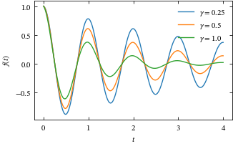
Figure 1: Damped oscillations for three values of the damping rate $γ$, with $ω=2π$.
Figure 2 spans both columns and shows each damping rate in its own panel.
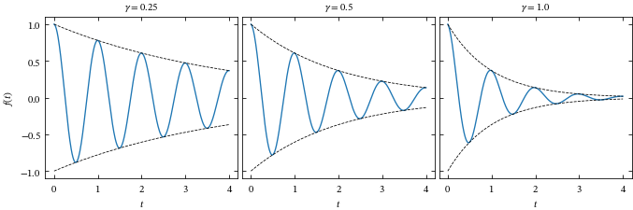
Figure 2: The oscillations of Figure 1 with their envelopes $±e^{−γt}$ (dashed).

Conclusion
This is placeholder text for the conclusion. Replace the contents of this file with your own manuscript, keeping Section 1 as a reference until submission.
Knuth, Donald E. 1984. “Literate Programming.” Comput. J. 27 (2): 97–111. https://doi.org/10.1093/comjnl/27.2.97.
Knuth, Donald E. 1986. The TeXbook. Addison-Wesley.
Lamport, Leslie. 1994. LaTeX: A Document Preparation System. 2nd ed. Addison-Wesley.

