Bureau of Statistics Data Analysis Competition 2023  
based on  
Multiple Indicator Cluster Survey

Simeon Chester

# Introdution

This paper is based on an analysis of men and women between 15 to 49 years of age with emphasis on the highest level of school attended for the two groups in the urban and rural areas. According, to the World Bank[1], approximately 70% of Guyana’s population live in the rural areas. Although a large proportion of the population live in rural areas, from experience and observations, education opportunities and social importance are higher in urban areas than they are in rural areas. One of the objectives of this analysis was to prove this dissonance empirically.

# Data and Descriptive Statistics

## Data Collection

For this study, the dataset [2] was based on a Multiple Indicator Cluster Survey (MICS6) conducted in 2018 by the Bureau of Statistics in collaboration with United Nations Children’s Fund (UNICEF) with a sample size of 8700 households in Guyana distributed country wide in both urban and rural areas.

The datasets used for this particular study were:

1. wm_Women 15 to 49_Stat_Day Data Set for Surveyed Women in Reproductive age range 15
2. mn_Males 15 to 49_Stat_Day Data Set for Surveyed Men in Reproductive age Range 15
3. hh_Household_Stat_Day Data Set for Surveyed Households

## Data Preprocessing

All data was processed using the Python programming language [3]. The modules used in Python were seaborn [4], matplotlib [5] and pandas [6]. This document has also been typset using LaTeX.

For the men and women data, to get the region and area values, the cluster number and household number had to be searched for in the household dataset, with the region and area values extracted from the matched rows.

The total respondents per region for each region area had to also be calculated to get the averages of each school level in each region by area. However, before doing this, all null and not-available values had to be filtered so the total and averages were not skewed/distorted.

All data and source files used in this analysis have been uploaded to a public Github repository. The Jupyter Notebook contained in the Github repository explicitly explains the steps taken to clean and shape the data and produce the figures [7].

## Final Processed Data

### Tables

Table showing highest level of school attended by male respondents per Region Area

|  |  |  |  |  |
| --- | --- | --- | --- | --- |
|  |  |  |  |  |
|  |  | Region Area |  |  |
| 1 | 1 | 0.29 | urban | Primary |
| 1 | 2 | 0.29 | urban | Lower Secondary |
| 1 | 3 | 0.41 | urban | Higher Secondary |
| 1 | 4 | 0.02 | urban | Higher |
| 2 | 1 | 0.10 | urban | Primary |
| 2 | 2 | 0.41 | urban | Lower Secondary |
| 2 | 3 | 0.47 | urban | Higher Secondary |
| 2 | 4 | 0.02 | urban | Higher |
| 4 | 1 | 0.05 | urban | Primary |
| 4 | 2 | 0.19 | urban | Lower Secondary |
| 4 | 3 | 0.43 | urban | Higher Secondary |
| 4 | 4 | 0.32 | urban | Higher |
| 4 | 9 | 0.01 | urban | Don’t Know |
| 6 | 1 | 0.11 | urban | Primary |
| 6 | 2 | 0.16 | urban | Lower Secondary |
| 6 | 3 | 0.59 | urban | Higher Secondary |
| 6 | 4 | 0.11 | urban | Higher |
| 6 | 9 | 0.03 | urban | Don’t Know |
| 7 | 1 | 0.05 | urban | Primary |
| 7 | 2 | 0.18 | urban | Lower Secondary |
| 7 | 3 | 0.73 | urban | Higher Secondary |
| 7 | 4 | 0.04 | urban | Higher |
| 9 | 1 | 0.16 | urban | Primary |
| 9 | 2 | 0.19 | urban | Lower Secondary |
| 9 | 3 | 0.45 | urban | Higher Secondary |
| 9 | 4 | 0.19 | urban | Higher |
| 10 | 1 | 0.01 | urban | Primary |
| 10 | 2 | 0.19 | urban | Lower Secondary |
| 10 | 3 | 0.47 | urban | Higher Secondary |
| 10 | 4 | 0.33 | urban | Higher |
| 1 | 1 | 0.19 | rural | Primary |
| 1 | 2 | 0.32 | rural | Lower Secondary |
| 1 | 3 | 0.44 | rural | Higher Secondary |
| 1 | 4 | 0.05 | rural | Higher |
| 2 | 0 | 0.01 | rural | Nursery |
| 2 | 1 | 0.16 | rural | Primary |
| 2 | 2 | 0.30 | rural | Lower Secondary |
| 2 | 3 | 0.47 | rural | Higher Secondary |
| 2 | 4 | 0.07 | rural | Higher |
| 3 | 0 | 0.01 | rural | Nursery |
| 3 | 1 | 0.10 | rural | Primary |
| 3 | 2 | 0.29 | rural | Lower Secondary |
| 3 | 3 | 0.41 | rural | Higher Secondary |
| 3 | 4 | 0.18 | rural | Higher |
| 4 | 0 | 0.01 | rural | Nursery |
| 4 | 1 | 0.13 | rural | Primary |
| 4 | 2 | 0.22 | rural | Lower Secondary |
| 4 | 3 | 0.49 | rural | Higher Secondary |
| 4 | 4 | 0.16 | rural | Higher |
| 5 | 1 | 0.13 | rural | Primary |
| 5 | 2 | 0.22 | rural | Lower Secondary |
| 5 | 3 | 0.47 | rural | Higher Secondary |
| 5 | 4 | 0.16 | rural | Higher |
| 5 | 9 | 0.01 | rural | Don’t Know |
| 6 | 0 | 0.00 | rural | Nursery |
| 6 | 1 | 0.20 | rural | Primary |
| 6 | 2 | 0.27 | rural | Lower Secondary |
| 6 | 3 | 0.41 | rural | Higher Secondary |
| 6 | 4 | 0.09 | rural | Higher |
| 6 | 9 | 0.02 | rural | Don’t Know |
| 7 | 1 | 0.17 | rural | Primary |
| 7 | 2 | 0.25 | rural | Lower Secondary |
| 7 | 3 | 0.51 | rural | Higher Secondary |
| 7 | 4 | 0.07 | rural | Higher |
| 8 | 0 | 0.01 | rural | Nursery |
| 8 | 1 | 0.26 | rural | Primary |
| 8 | 2 | 0.15 | rural | Lower Secondary |
| 8 | 3 | 0.50 | rural | Higher Secondary |
| 8 | 4 | 0.08 | rural | Higher |
| 9 | 1 | 0.22 | rural | Primary |
| 9 | 2 | 0.29 | rural | Lower Secondary |
| 9 | 3 | 0.45 | rural | Higher Secondary |
| 9 | 4 | 0.03 | rural | Higher |
| 9 | 9 | 0.01 | rural | Don’t Know |
| 10 | 1 | 0.03 | rural | Primary |
| 10 | 2 | 0.19 | rural | Lower Secondary |
| 10 | 3 | 0.61 | rural | Higher Secondary |
| 10 | 4 | 0.17 | rural | Higher |
|  |  |  |  |  |

Table showing highest level of school attended by female respondents per Region Area

|  |  |  |  |  |
| --- | --- | --- | --- | --- |
|  |  |  |  |  |
|  |  | Region Area |  |  |
| 1 | 1 | 0.22 | urban | Primary |
| 1 | 2 | 0.20 | urban | Lower Secondary |
| 1 | 3 | 0.55 | urban | Higher Secondary |
| 1 | 4 | 0.03 | urban | Higher |
| 2 | 1 | 0.11 | urban | Primary |
| 2 | 2 | 0.22 | urban | Lower Secondary |
| 2 | 3 | 0.57 | urban | Higher Secondary |
| 2 | 4 | 0.09 | urban | Higher |
| 4 | 1 | 0.02 | urban | Primary |
| 4 | 2 | 0.12 | urban | Lower Secondary |
| 4 | 3 | 0.51 | urban | Higher Secondary |
| 4 | 4 | 0.35 | urban | Higher |
| 4 | 9 | 0.01 | urban | Don’t Know |
| 6 | 1 | 0.11 | urban | Primary |
| 6 | 2 | 0.21 | urban | Lower Secondary |
| 6 | 3 | 0.52 | urban | Higher Secondary |
| 6 | 4 | 0.16 | urban | Higher |
| 6 | 9 | 0.00 | urban | Don’t Know |
| 7 | 1 | 0.06 | urban | Primary |
| 7 | 2 | 0.17 | urban | Lower Secondary |
| 7 | 3 | 0.68 | urban | Higher Secondary |
| 7 | 4 | 0.08 | urban | Higher |
| 9 | 1 | 0.03 | urban | Primary |
| 9 | 2 | 0.23 | urban | Lower Secondary |
| 9 | 3 | 0.62 | urban | Higher Secondary |
| 9 | 4 | 0.12 | urban | Higher |
| 10 | 1 | 0.02 | urban | Primary |
| 10 | 2 | 0.11 | urban | Lower Secondary |
| 10 | 3 | 0.57 | urban | Higher Secondary |
| 10 | 4 | 0.30 | urban | Higher |
| 10 | 9 | 0.00 | urban | Don’t Know |
| 1 | 1 | 0.21 | rural | Primary |
| 1 | 2 | 0.27 | rural | Lower Secondary |
| 1 | 3 | 0.47 | rural | Higher Secondary |
| 1 | 4 | 0.05 | rural | Higher |
| 2 | 0 | 0.00 | rural | Nursery |
| 2 | 1 | 0.15 | rural | Primary |
| 2 | 2 | 0.23 | rural | Lower Secondary |
| 2 | 3 | 0.52 | rural | Higher Secondary |
| 2 | 4 | 0.09 | rural | Higher |
| 2 | 9 | 0.01 | rural | Don’t Know |
| 3 | 1 | 0.08 | rural | Primary |
| 3 | 2 | 0.26 | rural | Lower Secondary |
| 3 | 3 | 0.50 | rural | Higher Secondary |
| 3 | 4 | 0.16 | rural | Higher |
| 3 | 9 | 0.00 | rural | Don’t Know |
| 4 | 1 | 0.09 | rural | Primary |
| 4 | 2 | 0.23 | rural | Lower Secondary |
| 4 | 3 | 0.48 | rural | Higher Secondary |
| 4 | 4 | 0.20 | rural | Higher |
| 4 | 9 | 0.00 | rural | Don’t Know |
| 5 | 0 | 0.00 | rural | Nursery |
| 5 | 1 | 0.10 | rural | Primary |
| 5 | 2 | 0.19 | rural | Lower Secondary |
| 5 | 3 | 0.59 | rural | Higher Secondary |
| 5 | 4 | 0.11 | rural | Higher |
| 5 | 9 | 0.01 | rural | Don’t Know |
| 6 | 0 | 0.00 | rural | Nursery |
| 6 | 1 | 0.17 | rural | Primary |
| 6 | 2 | 0.23 | rural | Lower Secondary |
| 6 | 3 | 0.51 | rural | Higher Secondary |
| 6 | 4 | 0.08 | rural | Higher |
| 6 | 9 | 0.00 | rural | Don’t Know |
| 7 | 1 | 0.23 | rural | Primary |
| 7 | 2 | 0.19 | rural | Lower Secondary |
| 7 | 3 | 0.53 | rural | Higher Secondary |
| 7 | 4 | 0.05 | rural | Higher |
| 8 | 0 | 0.00 | rural | Nursery |
| 8 | 1 | 0.15 | rural | Primary |
| 8 | 2 | 0.19 | rural | Lower Secondary |
| 8 | 3 | 0.61 | rural | Higher Secondary |
| 8 | 4 | 0.04 | rural | Higher |
| 9 | 1 | 0.13 | rural | Primary |
| 9 | 2 | 0.28 | rural | Lower Secondary |
| 9 | 3 | 0.54 | rural | Higher Secondary |
| 9 | 4 | 0.05 | rural | Higher |
| 10 | 1 | 0.05 | rural | Primary |
| 10 | 2 | 0.19 | rural | Lower Secondary |
| 10 | 3 | 0.49 | rural | Higher Secondary |
| 10 | 4 | 0.27 | rural | Higher |
|  |  |  |  |  |

Table showing highest level of school attended per each area by Gender

|  |  |  |  |  |
| --- | --- | --- | --- | --- |
|  |  |  |  |  |
|  |  |  |  |  |
| nursery | 0.00 | 0.00 | 0.00 | 0.00 |
| primary | 0.09 | 0.16 | 0.06 | 0.13 |
| lower secondary | 0.22 | 0.26 | 0.16 | 0.23 |
| higher secondary | 0.50 | 0.46 | 0.56 | 0.52 |
| higher | 0.18 | 0.11 | 0.21 | 0.12 |
| don’t know | 0.01 | 0.00 | 0.00 | 0.00 |

### Figures

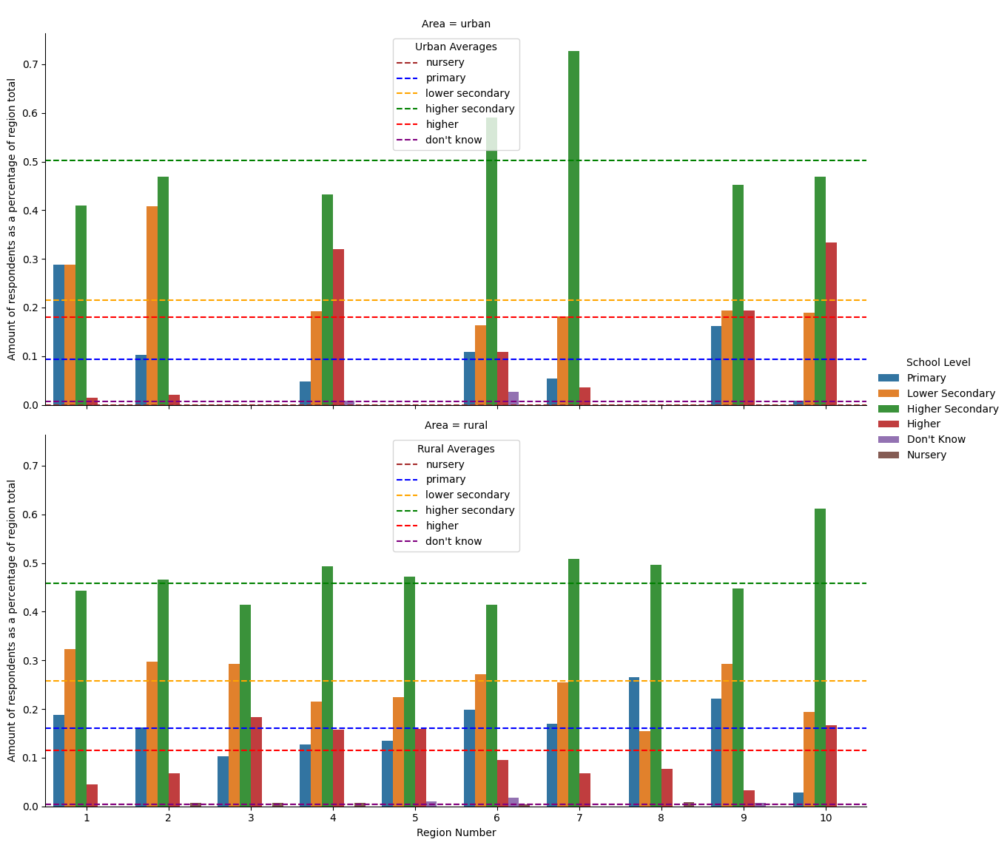

Graph showing highest level of school atttended for male respondents per region in each area

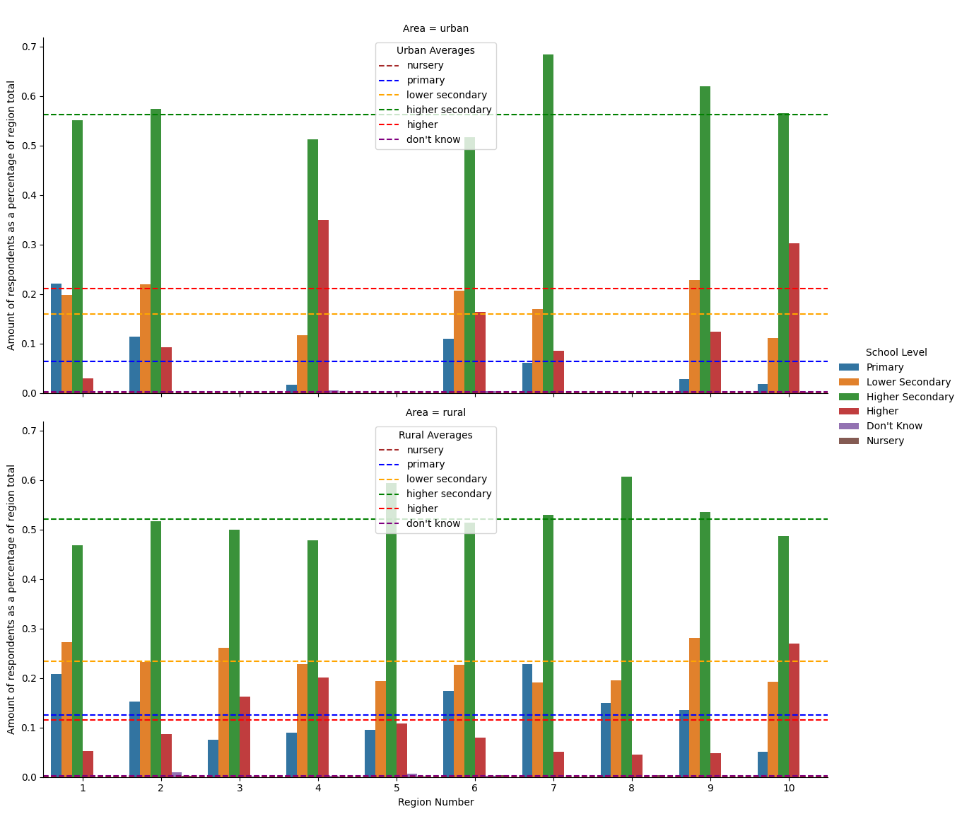

Graph showing highest level of school atttended for female respondents per region in each area

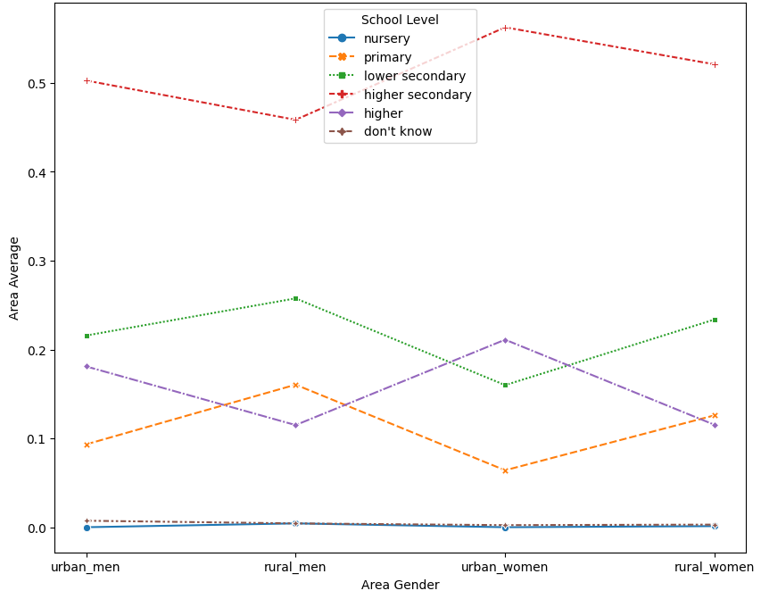

Graph showing highest level of school attended by area and gender per area total

# Discussion

## Female highest level of school attended per Area and Region

For both the urban and rural areas it was observed that the predominant school level was higher secondary with an average of nearly 50% of the respondents. In the rural area this was followed by lower secondary, primary and then higher with averages of 23%, 13% and 12% respectively. In the urban area, the higher secondary level was followed by higher, lower secondary then primary with averages of 21%, 16% and 6% respectively (see Table 2 and Figure 3). This shows that in the urban area women are far more likely to attend institutions of higher learning after finishing their highschool education. This reason might be attributed to proximity of institutions from living area. This assumption can be supported by looking at the averages per region, where regions 3, 4 and 10 is observed to have the greatest portions of women in both rural and urban areas having attended a higher institution level.

## Male highest level of school attended per Area and Region

For both the urban and rural areas it was observed that the predominant school level was higher secondary with an average of nearly 50% of the respondents. In the rural area this was followed by lower secondary, primary then higher with averages of 26%, 16% and 11% respectively while in the urban area this was followed by lower secondary, higher then primary with area averages of 22%, 18% and 9% respectively (see Table 2 and Figure 3). While the positions for the higher and lower secondary levels didn’t change positions by area, the average level of rural men with primary school levels vs. those in the urban area did change positions with third and fourth respectively with a difference of 7% more rural men having primary school as their highest level attended. This is also the reverse case with the higher school level as well with a difference of 7% more in the urban area vs. rural area having a higher school level attendance. A look at school level per region shows that regions 1, 2, 3, 6, 7 and 9 have averages of and above 26% of the respondents having lower secondary as their highest school attended (see Figure 1). These same regions with the exception of region 6 but addition of region 8 have averages of about or above the rural average for primary school level of 16%. In the urban area, the region that sticks out is region 1 in terms of having a higher percentage of its respondents having primary and lower secondary levels of highest schooling with both having 29% while the higher secondary average is 41%, a difference of 9% of the urban average of 50% (see Table 1).

Just like the regions that have the greatest portion of females with higher school levels, this is also the case with the males where regions 3, 4, 10 and to some extent 5 and 6 having the greatest portions of male respondents having a higher level schooling. The assumption of proximity to higher institutions from living area may also be applied here.

## Recommendations

While more analysis is needed to improve on and test hypotheses, it can be seen that males have a relatively higher and earlier school dropout rate than females. However, they both suffer from relatively high levels of early dropout especially in the rural areas.

Some recommendations would be

* to provide mentoring and apprenticeships in various sectors such as sewing, carpentry, maisonry etc. While the Government Technical Instutitues provide training in some of these areas, most students when finished with these programmes tend to sit on the certificate and be jobless or have jobs that are "lesser" than that which they are either qualified for or have the certification for (structural unemployment). With both males and females, from observations and experience, frustration steps in and can be crippling and where there’s frustration there is irrationality.
* to improve upon recreational facilities - these facilities are where communities reach and are built for better or worse. It often seems that the farther one goes from the city, the more neglected these facilities are. Establishing afterschool programmes in education and sports with dedicated facilitators at these facilities would help to boost the communities’ social welfare. Given the direct interaction with members in the community, further information on the specific areas that need attention can be identified and highlighted. Hence, improving programmes’ effectiveness through efficiency increase.
* to improve upon education monitoring, evaluation and programme implementation - this improvement is especially needed for rural areas that are farthest from the city (see Regions 1 and 8). In these areas it can often be seen children peddling items, working at crossings (see Sherima, Tiperu, Iteballi etc.) washing vehicles, being porters etc. I believe more needs to be done to monitor truancy in these areas.
* to improve on any programme implementation - this applies to the previous recommendations and any programmes. In Guyana, programmes are often rolled out without seeing it through or lackadaisically monitored. For example, government agencies would have a lot of planned programmes at the start of a fiscal year and only start to implement most of these programmes coming on to the end of the year although it would have already been budgeted for.

# Conclusion

Time has been a huge limitation in this analysis. While the code used to analyse the data was checked, extra time would have been used to further ensure data integrity. The code and by extension the data produced by the code has also not been peer-reviewed which further limits its integrity. This analysis also only focuses on a specific parameter i.e. highest level of school attended which makes the analysis relatively myopic. If further analysis is done it would be interesting and wise to look at other parameters in the dataset, stratify and compare to see their relations (correlation and/or causation).

1. .
2. .
3. .
4. .
5. .
6. .
7. .