Interpretable Risk Stratification for Elevated Blood Pressure
A Reproducible Methodological Demonstration on Public Clinical Data
Olatunde Simeon Awolola
September 2026
Independent supplementary technical project, prepared to demonstrate applied interpretable-AI methodology relevant to the author's proposed U.S. endeavor as a Health Data Scientist.

1. Purpose and Scope
This project applies interpretable machine-learning methods to a publicly available clinical dataset to model elevated blood pressure risk in a diabetes cohort, and explicitly evaluates whether model performance holds evenly across a patient subgroup. It was undertaken as a self-directed, reproducible technical demonstration -- not as a publication, a clinical tool, or a claim of deployment -- to complement the author's existing scholarship on responsible and interpretable artificial intelligence in health data (see the author's 2025 publications on genomic health equity and on mitigating bias in machine-learning models).
The project deliberately mirrors, on public data, the design of the author's ongoing retrospective research at the School of Health Information Management, University College Hospital, Ibadan, examining predictors of hypertension among patients with Type 2 diabetes. No University College Hospital data, patient records, or protected health information of any kind were used anywhere in this project; that distinction is maintained throughout.

2. Data Source and Ethical Note
The dataset is the diabetes study distributed with the scikit-learn machine-learning library (Efron, Hastie, Johnstone & Tibshirani, "Least Angle Regression," Annals of Statistics, 2004), comprising 442 patients with ten baseline clinical variables: age, sex, body mass index (BMI), average blood pressure, a six-part serum lipid/glucose panel (s1-s6), and a quantitative measure of disease progression one year after baseline. The dataset is public, de-identified, and distributed under a permissive open license for research and educational use; it contains no identifiable information.

3. Methods

3.1 Outcome Definition
Because the source study's response variable is continuous disease progression rather than a blood-pressure diagnosis, a binary outcome, elevated blood pressure, was defined as membership in the upper tertile of the dataset's blood-pressure variable (cutoff: 101.0 in the dataset's recorded units). This is a sample-relative research threshold for methodological demonstration only and should not be read as a clinical diagnostic criterion.

3.2 Models
Two models were trained on a 75/25 train-test split (stratified by outcome, random seed fixed for reproducibility): a logistic regression, which is directly interpretable through its coefficients on standardized features, and a gradient boosting classifier, which typically achieves higher predictive flexibility at the cost of direct interpretability.

3.3 Interpretability Approach
Rather than treat the gradient boosting model as a black box, three complementary interpretability techniques were applied: (1) logistic-regression coefficients, directly interpretable on the standardized feature scale; (2) permutation importance, which measures the drop in model performance (AUC) when each feature is randomly shuffled, isolating each variable's contribution; and (3) partial dependence plots, which show the modeled relationship between each top predictor and the predicted outcome, holding other variables at their observed distribution. These are standard, well-established interpretability methods (implemented via scikit-learn's inspection module) and are reported here in place of the SHAP library specifically, which was not available in the environment used for this project; the substitution is noted for full methodological transparency.

3.4 Subgroup (Responsible-AI) Evaluation
Consistent with the author's published scholarship on fairness and bias in machine-learning models, model performance was evaluated separately by sex to check whether predictive accuracy held evenly across subgroups rather than only in aggregate. This check, and its limitations given the dataset's small size, are reported openly in Section 6, in keeping with the responsible-AI principle that data quality and representativeness -- not model architecture alone -- determine whether a model's conclusions can be trusted.

4. Results
Both models achieved comparable, moderate discriminative performance on held-out test data:
Model | Test AUC | Test Accuracy
Logistic Regression (baseline) | 0.798 | 77.5%
Gradient Boosting | 0.787 | 73.9%

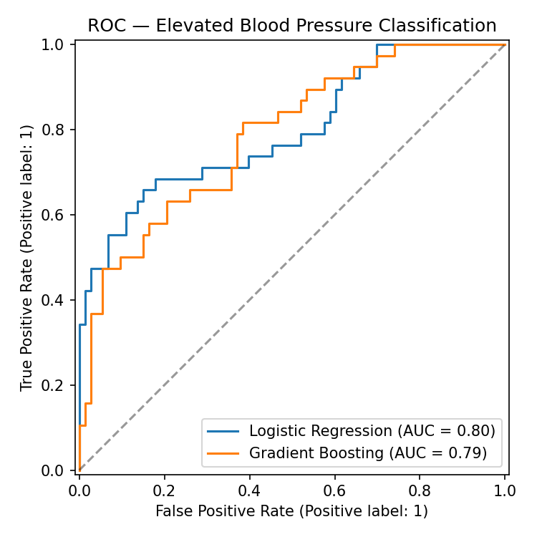
Figure 1. ROC curves for both models on the held-out test set (n = 111).
An AUC in the high 0.7s indicates the models capture a genuine, non-trivial signal relating age, adiposity, lipid/glucose profile, and overall disease progression to elevated blood pressure -- consistent with well-established clinical associations -- while leaving clear room for improvement, as expected from ten baseline variables in a modest sample.

5. Interpretability Analysis
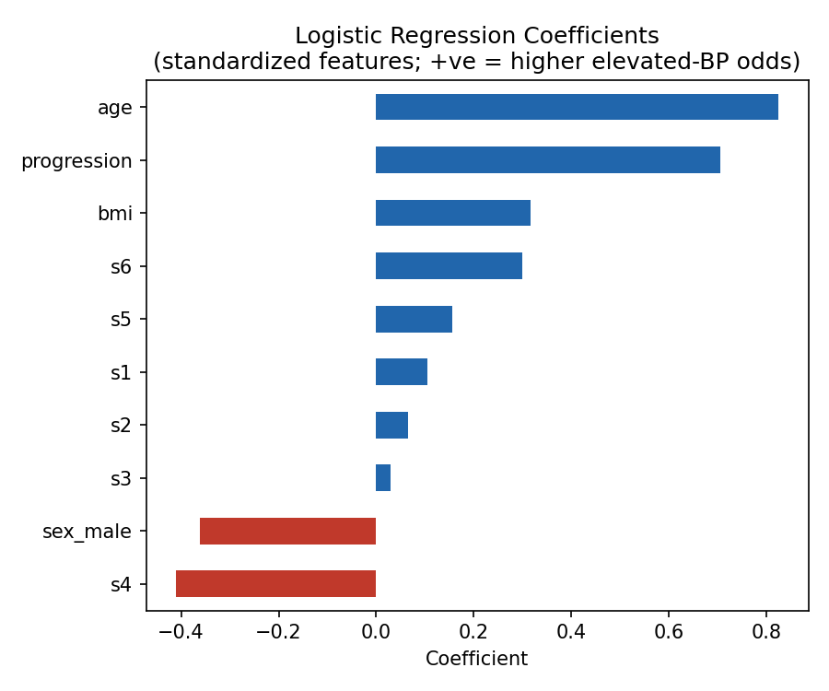
Figure 2. Logistic regression coefficients on standardized features. Positive values indicate higher odds of elevated blood pressure.
The logistic regression identifies age, overall disease progression, and BMI as the strongest positive predictors of elevated blood pressure, and s4 (a cholesterol-ratio measure) and sex (male) as protective in this sample -- directionally consistent with general clinical literature on age- and adiposity-related blood pressure risk.
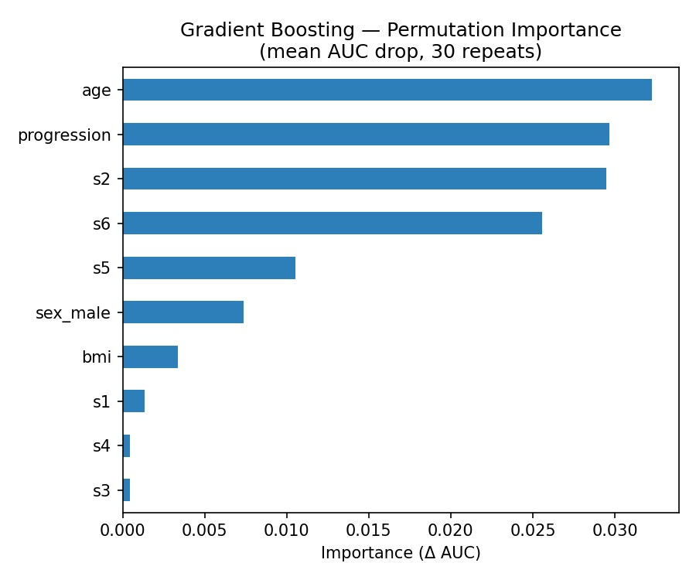
Figure 3. Permutation importance for the gradient boosting model (mean AUC drop over 30 repeats).
The permutation-importance ranking for the gradient boosting model -- age, overall disease progression, s2 (LDL cholesterol), and s6 (blood glucose) as the top four drivers -- corroborates the logistic-regression findings using an entirely different attribution method, which is itself a useful interpretability check: when two independent methods agree on which variables matter, the finding is more trustworthy than either method alone.
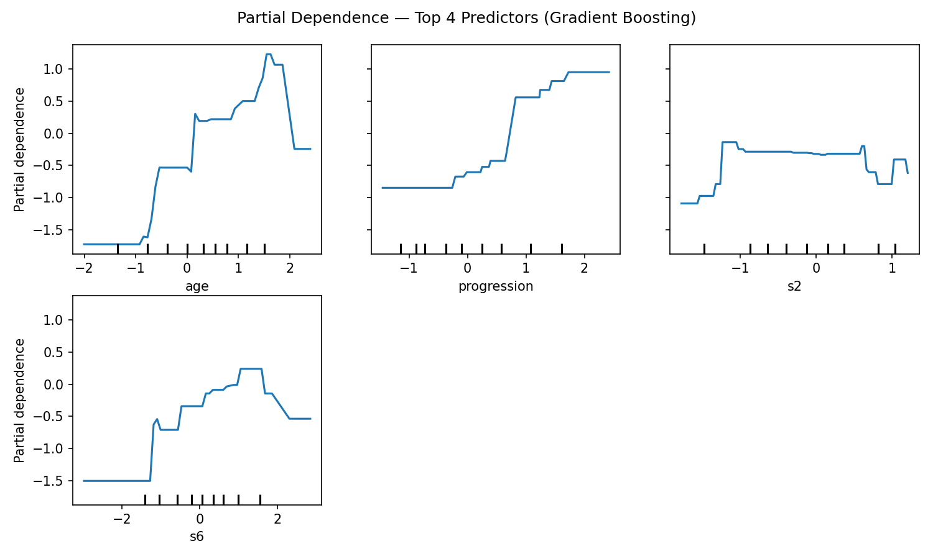
Figure 4. Partial dependence of predicted elevated-blood-pressure probability on the four top-ranked predictors.
The partial dependence plots show a clinically plausible pattern: predicted risk rises with age up to late middle age, rises with overall disease progression, and rises with LDL cholesterol (s2) and blood glucose (s6) -- again consistent with established associations between metabolic risk factors and blood pressure, lending face validity to the model beyond its aggregate accuracy score.

6. Subgroup Evaluation and Limitations
Subgroup | n (test set) | Elevated-BP rate | AUC
Male | 60 | 21.7% | 0.797
Female | 51 | 49.0% | 0.765

The model performed with similar discrimination in both subgroups (AUC 0.797 for male patients, 0.765 for female patients in the test set), a modest, not statistically decisive, difference given the small subgroup sizes (n = 60 and n = 51). Two limitations are reported openly rather than glossed over, in keeping with the responsible-AI framing this project is meant to demonstrate:
- Sample size and homogeneity: the underlying dataset (442 patients total, drawn from a single 1990s U.S. research cohort) is too small and insufficiently documented in its demographic composition to support strong subgroup fairness conclusions. The near-twofold difference in elevated-BP prevalence between the male and female test subgroups (21.7% vs. 49.0%) itself illustrates how an unrepresentative or imbalanced sample can distort what a subgroup comparison can responsibly conclude -- precisely the data-representativeness concern the author's own published scholarship on genomic health equity and algorithmic bias addresses in a different context.
- No clinical deployment claim: this project is a methodological demonstration, not a validated clinical decision-support tool. It has not been tested on an independent cohort, has not undergone clinical validation, and is not intended for, and must not be used for, any individual patient risk assessment.

7. Relationship to the Author's Ongoing Research
This project is a technical companion to, not a substitute for, the author's ongoing retrospective research at the School of Health Information Management, University College Hospital, Ibadan, on predictors of hypertension among patients with Type 2 diabetes. That institutional research uses real patient-derived clinical data under the appropriate institutional research and data-governance processes and is reported separately. The present project instead demonstrates, on fully public data with no institutional or patient-privacy considerations, the specific interpretable-modeling and subgroup-evaluation methodology the author intends to extend to more heterogeneous health data -- clinical, genomic, and population-health -- as described in the author's proposed U.S. endeavor.

8. Reproducibility
All code (data loading, modeling, interpretability analysis, and figure generation) is written in Python using scikit-learn, pandas, and matplotlib, and is organized as a single reproducible script with a fixed random seed. The code and this report are intended to be published to a public GitHub repository so that every figure and statistic in this document can be independently regenerated and verified.

References
Efron, B., Hastie, T., Johnstone, I., & Tibshirani, R. (2004). Least Angle Regression. Annals of Statistics, 32(2), 407-499.
Pedregosa, F., et al. (2011). Scikit-learn: Machine Learning in Python. Journal of Machine Learning Research, 12, 2825-2830.

