SIMEON BINIATIDIS
July 5, 2016
Financial Instrument Task.

To run the project from the command line, go to the ‘dist’ folder and
type the following:

java -jar "CopyFIFileToTable.jar"

To distribute this project, zip up the dist folder (including the lib folder)
and distribute the ZIP file.

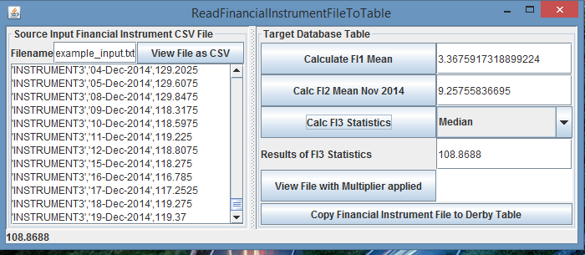
Figure 1

Typically you want first to Press Button “View File as CSV” which reads the ‘example_input.txt’ file and prints it in the TextArea below the button, as CSV. Strings are single-quoted, double values as is.
Then Press Button “Copy Financial Instrument File to Derby Table” which copies the file example_input.txt as a CSV to Table INSTRUMENT_TABLE of the Derby Database.
Pressing the Button “Calculate FI1 Mean” calculates the Mean of Financial Instrument1 and sets the TextField next to it.
Pressing the Button “Calc FI2 Mean Nov 2014 ” calculates the Mean of INSTRUMENT2 during November 2014 and sets it to the TextField next to it.
It can be easily made configurable and parametrizable according to MONTH, YEAR, DATE- RANGE. It’s a matter of time to implement and space arrangement in the App window.
Pressing the Button “Calculate FI3 Statistics” takes a choice from the drop-down list next to it, and calculates the corresponding statistic of INSTRUMENT3, then sets the TextField underneath the list.
The choices of statistics are shown in Figure 2.
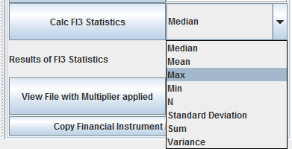
Figure 2

If you Press Button “View File with Multiplier applied”, reads the Table from Derby “INSTRUMENT_PRICE_MULTIPLIER” (my mistake, should have been MODIFIER) and fills up the TextArea next to it.
Then Reads the example_input.txt again and prints it in the TextArea to the left.
It does a linearSearch to INSTRUMENT_PRICE_MULTIPLIER for the name of INSTRUMENT. If it shows up there, multiplies the value with the multiplier, then prints it to the textarea.
If the name does not show on the multiplier Table, it leaves the double value of input unchanged.

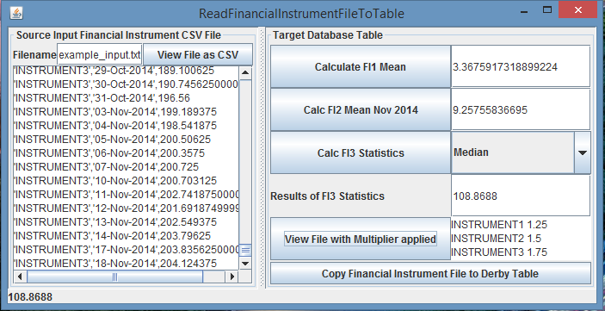
Figure 3

The result sets in this Task are read sequentially. A result set maintains a cursor pointing to its current row of data. Initially the cursor is positioned before the first row. The next() method moves the cursor forward to the next row. This is known as sequential forward reading.
A more powerful way of accessing database is to use a scrollable and updatable result, which scrolls the rows both forward and backward and moves the cursor to a desired location using the first, last, next, previous, absolute, or relative method. You can also insert, delete, or update a row in the result set and have the changes automatically reflected in the database.
To obtain a scrollable or updatable result set, you must first create a statement with an appropriate type and concurrency mode. E.g. for a static statement,
Statement statement = connection.createStatement
(int resultSetType, int resultSetConcurrency);

For a prepared statement, use
PreparedStatement statement = connection.prepareStatement
(String sql, int resultSetType, int resultSetConcurrency);

The result sets used in the preceding examples are read sequentially. A result set maintains a cursor pointing to its current row of data. Initially the cursor is positioned before the first row. The next() method moves the cursor forward to the next row. This is known as sequential forward reading.
The prepare statement is more popular because makes parametrizable inputs easier to configure in code with the use of ? and setValue afterwards.

Apache Derby has a DB by the name of FI, and two Tables: INTRUMENT_TABLE (ID, INSTRUMENT_NAME, DATE, VALUE) and INSTRUMENT_PRICE_MULTIPLIER (ID, NAME, MULTIPLIER).

