Problem 3 – My Movie Watchlist
Working with Remote Data
For the solution of some of the following tasks, you will need to use an up-to-date version of the local REST service provided in the lesson’s resources archive. You can read the documentation here.
Environment Specifics
Please be aware that every JS environment may behave differently when executing code. Certain things that work in the browser are not supported in Node.js, which is the environment used by Judge.
The following actions are NOT supported:
- .forEach() with NodeList (returned by querySelector() and querySelectorAll())
- .forEach() with HTMLCollection (returned by getElementsByClassName() and element.children)
- using the spread-operator (...) to convert a NodeList into an array
- append() (use only appendChild())
- prepend()
- replaceWith()
- replaceAll()
- closest()
- replaceChildren()
If you want to perform these operations, you may use Array.from() to first convert the collection into an array.

Requirements
Write a JS program that can load, create, remove and edit a list of movies. You will be given an HTML template to which you must bind the needed functionality.
First, you need to install all dependencies using the npm install command
Then, you can start the front-end application with the npm start command
You also must start the server.js file in the server folder using the node server.js command in another console (BOTH THE CLIENT AND THE SERVER MUST RUN AT THE SAME TIME).
At any point, you can open up another console and run npm test to test the current state of your application. It’s preferable for all of your tests to pass locally before you submit to the Judge platform, like this:
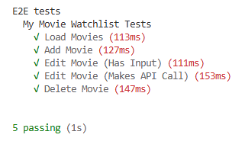

Endpoints
- http://localhost:3030/jsonstore/movies/
- http://localhost:3030/jsonstore/movies/:id

Load Movies
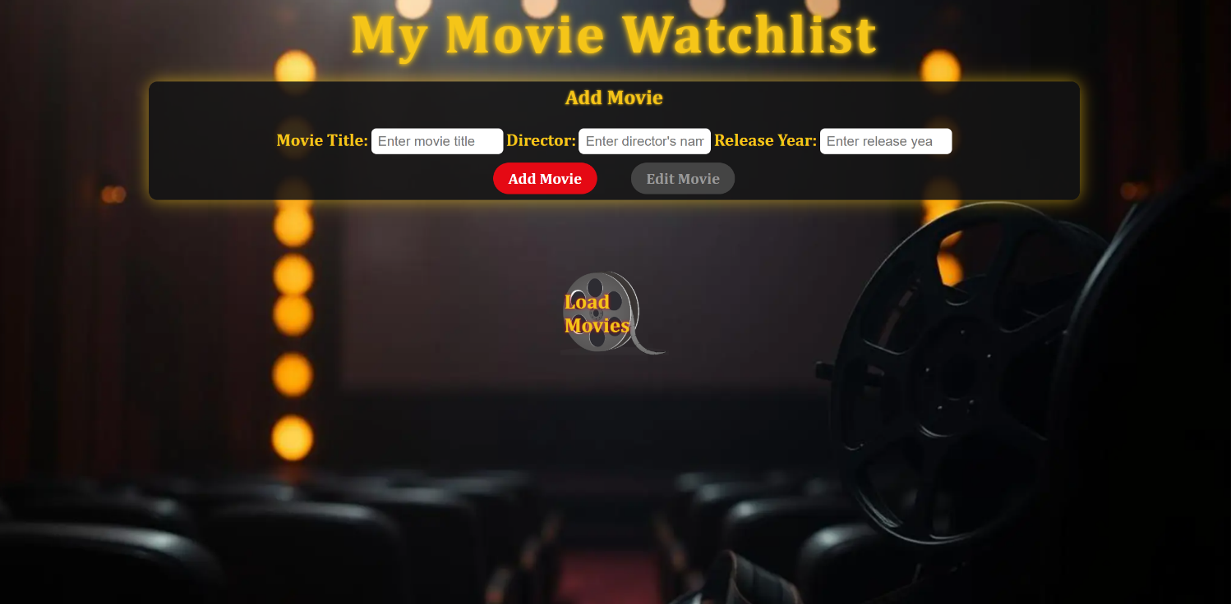
Clicking the [Load Movies] button should send a GET request to the server to fetch all records from your local database. You must add each task to the <div> with id="movie-list". [Edit Movie] button should be deactivated.
Each record has the following HTML structure:
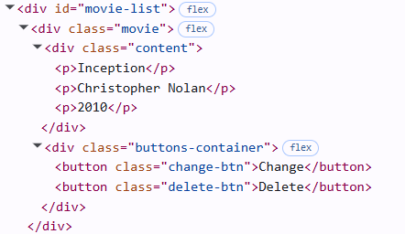
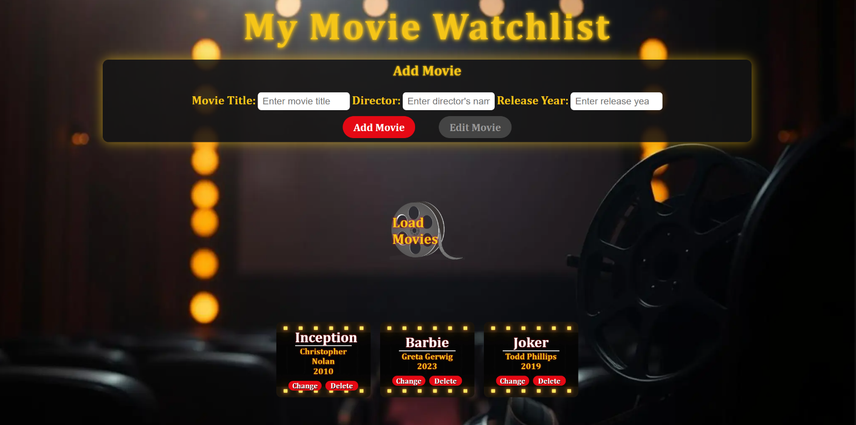

Add а Movie
Clicking the [Add Movie] button should send a POST request to the server, creating a new movie record with the title, director, and year from the input values. After a successful creation, you should send another GET request to fetch all the movie records,including the newly added one. You should also clear all the input fields after the creation!
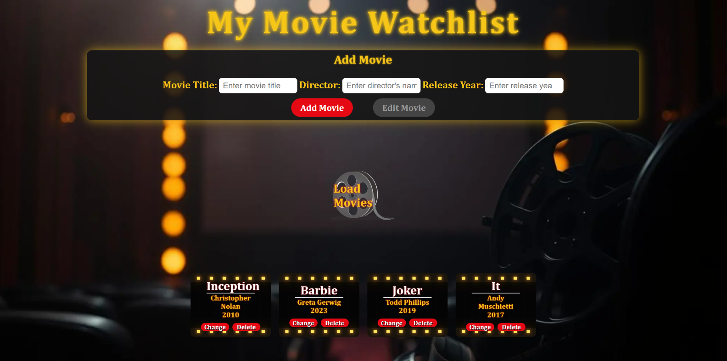

Edit a Movie
Clicking the [Change] button on a movie should remove the movie from the DOM structure and the information about the movie should be populated into the input fields above. The [Edit Movie] button in the form should be activated and the [Add Movie] one should be deactivated.
After clicking the [Edit Movie] button in the form, you should send a PUT request to the server to modify the title, director and the year of the changed item. After the successful request, you should fetch the items again and see that the changes have been made. After that, the [Edit Movie] button should be deactivated and the [Add Movie] one should be activated.
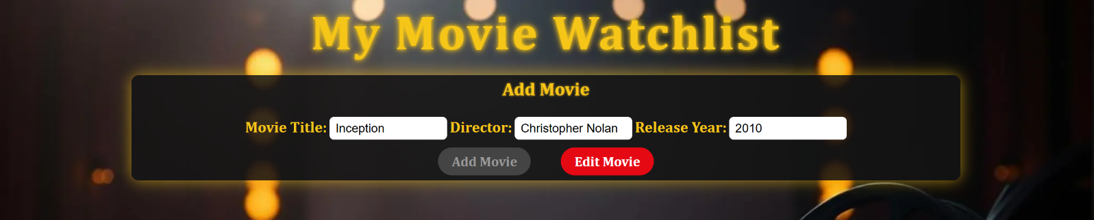

Delete
Clicking the [Delete] button should send a DELETE request to the server and remove the item from your local database. After you've removed it successfully, fetch the movies again.

Submitting Your Solution
Select the content of your working folder (the given resources). Exclude the node_modules & tests folders. Archive the rest into a ZIP file and upload the archive to Judge.
