Lab 2: Software Models and UML Foundations
Accompanies: Lecture 2 · Work: individually or in pairs · Tools: draw.io, PlantUML, StarUML or pen and paper (the thinking matters more than the tool).
By the end of this lab you can: read and correct a UML class diagram, build one from a scenario using abstraction, and model an object’s behaviour with a state machine.
Task 1 – Read a class diagram
Figure 1 shows part of a University Library System. Answer the questions.
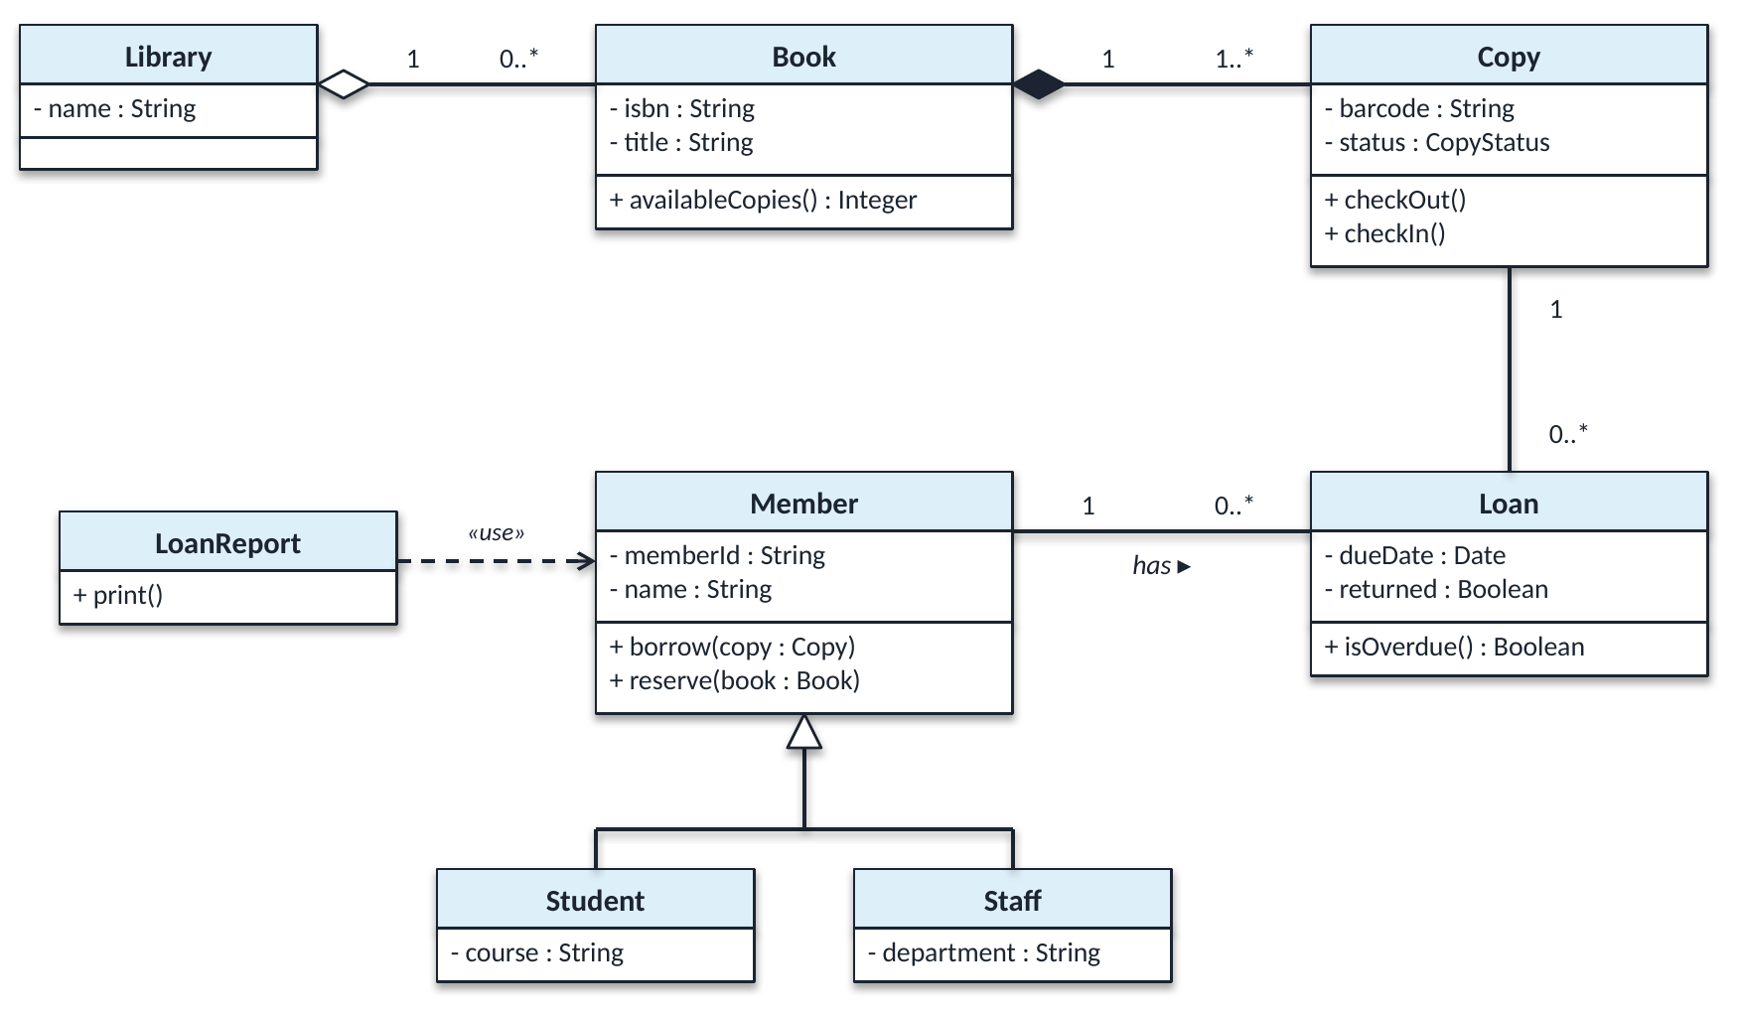
Figure 1 – University Library System
# | Question | Your answer
1 | How many Copies can a Book have? Can a Copy exist without its Book? Which symbol tells you? | 1..* – a Book has at least one Copy and possibly many; each Copy belongs to exactly 1 Book.  No. The filled (black) diamond at the Book end is composition: a Copy’s lifetime depends on its Book, so deleting the Book deletes its Copies.
2 | Can a Book exist without the Library? How does this symbol differ from the one in Q1? | Yes. The hollow (white) diamond at the Library end is aggregation – a weak whole–part link where the part keeps its own lifetime (a Book is not destroyed if the Library is removed and could move to another library).  Composition (Q1) is strong ownership: the part belongs to one whole only and is created and destroyed with it.
3 | Read the Member–Loan association in both directions. | Member → Loan: one Member has 0..* Loans (none, one or many).  Loan → Member: each Loan belongs to exactly 1 Member. (The ▸ shows the name reads “Member has Loan”.)
4 | What do Student and Staff inherit from Member? | Everything Member has: the attributes memberId : String and name : String, the operations borrow(copy : Copy) and reserve(book : Book), and the “has” association to Loan – so a Student or Staff member can also have 0..* Loans.  Each subclass then adds its own attribute (Student: course, Staff: department). The attributes are private (–), so subclasses inherit them but reach them through Member’s public operations.
5 | What does the dashed «use» arrow mean? Why is it not an association? | It is a dependency: LoanReport temporarily uses Member (e.g. a Member is passed into or looked up inside print()), so a change to Member may force a change to LoanReport.  It is not an association because LoanReport keeps no lasting structural link to a Member – no attribute holds a Member, there are no multiplicities and nothing to navigate; the link only exists while print() runs.

Task 2 – Spot the mistakes
A team modelled this specification: “A Restaurant has exactly one Menu, and the Menu cannot exist without its Restaurant. A Menu contains one or more MenuItems. A Customer can place many Orders; each Order is placed by exactly one Customer. A VIPCustomer is a special kind of Customer who receives a discount.” It is an analysis model for discussing requirements with the restaurant owner.
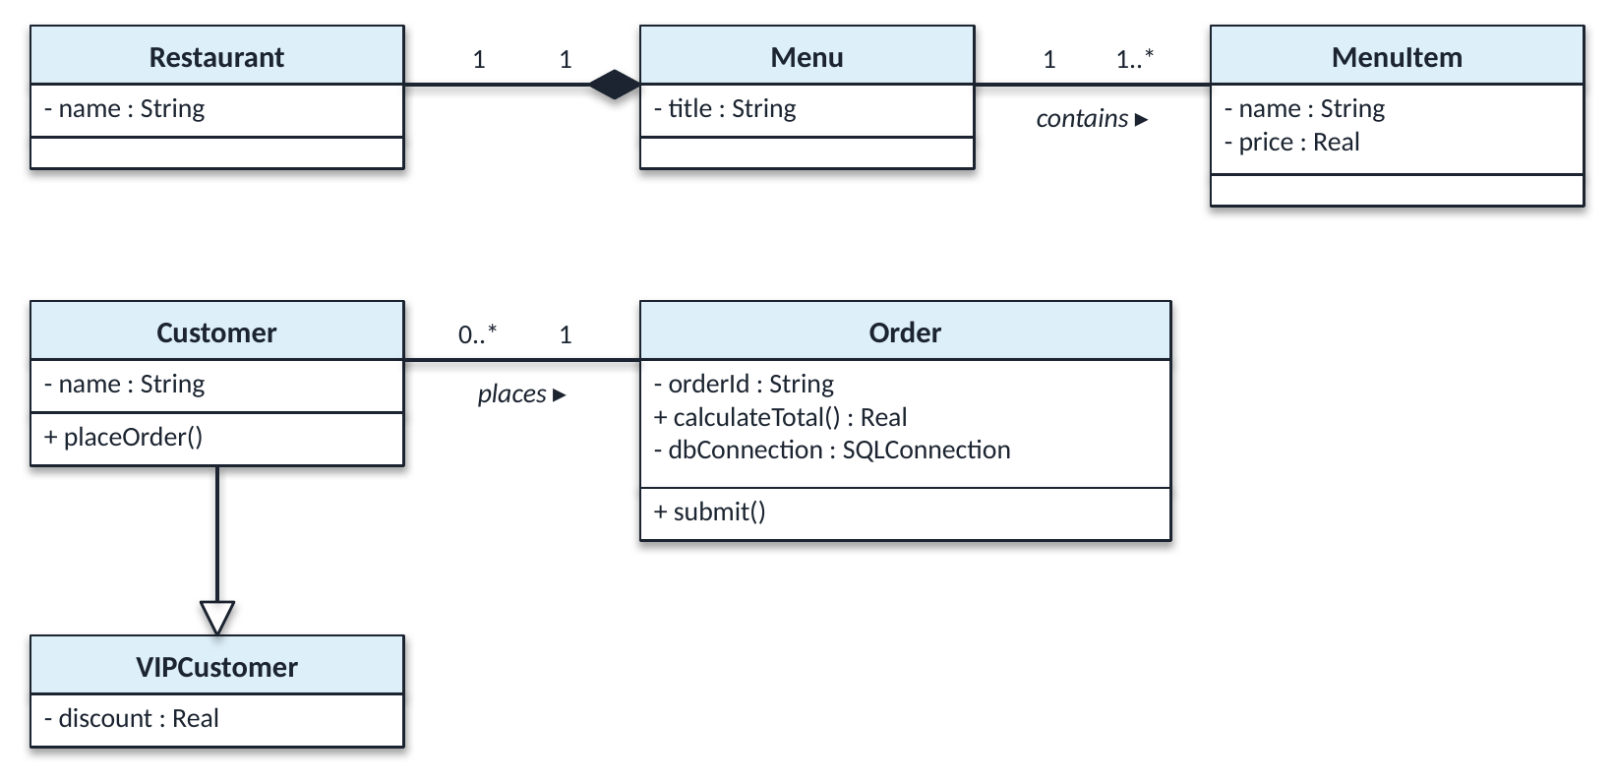
Figure 2 – The team’s diagram (five mistakes)
# | Mistake | Why it is wrong | Correction
1 | Composition diamond is drawn at the Menu end of Restaurant–Menu. | The diamond belongs on the whole. As drawn it says the Restaurant is part of the Menu – the opposite of “the Menu cannot exist without its Restaurant”. | Move the filled diamond to the Restaurant end (keep 1 … 1).
2 | Customer–Order multiplicities are swapped (0..* at Customer, 1 at Order). | It reads “a Customer places exactly one Order and an Order is placed by many Customers” – the reverse of the specification. | Put 1 at the Customer end and 0..* at the Order end.
3 | Generalisation arrow points the wrong way (triangle at VIPCustomer). | The hollow triangle must point to the more general class. As drawn, Customer is a kind of VIPCustomer. | Draw the arrow from VIPCustomer to Customer, with the triangle touching Customer.
4 | calculateTotal() : Real is in Order’s attribute compartment. | It is an operation (it has brackets and computes a value), not data the object stores. Operations go in the third compartment. | Move + calculateTotal() : Real into the operations compartment, next to submit().
5 | dbConnection : SQLConnection is an attribute of Order. | Wrong level of abstraction. This is an analysis model for talking to the restaurant owner; a database connection is an implementation detail, not a property of a real order. | Remove it. Persistence is decided later, in the design model.
Corrected diagram (all five fixes applied):
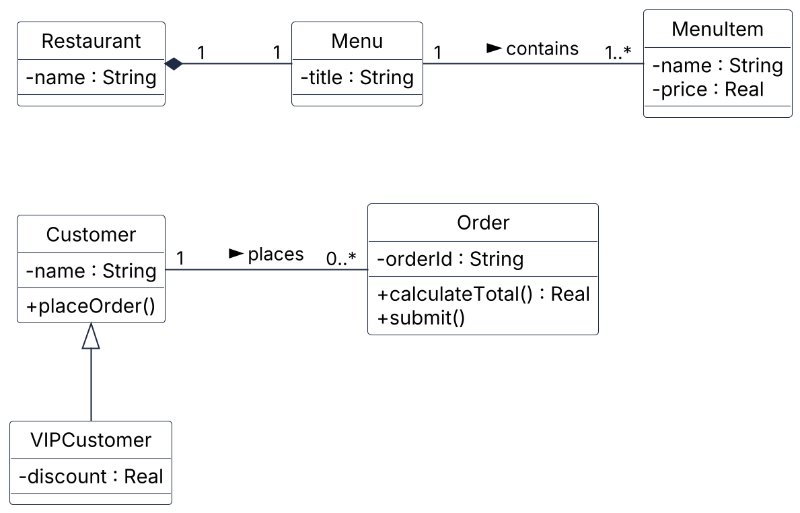
Figure 3 – Corrected restaurant analysis model

Task 3 – Build a class diagram
A car rental company has several branches, each with a name and an address. Every car has a registration number, make, model and daily rate, and is based at exactly one branch. Customers register with their name, driving licence number and email. A customer can make any number of bookings; each booking is for exactly one car and has a start date, an end date and a total cost. A booking may have at most one damage report, which cannot exist without its booking. Cars are either standard or electric; electric cars also record their battery range. The system must calculate the cost of a booking and check whether a car is available for given dates.
Draw the class diagram. Include attribute types, the two operations named above, a multiplicity on both ends of every association, and at least one composition and one generalisation.
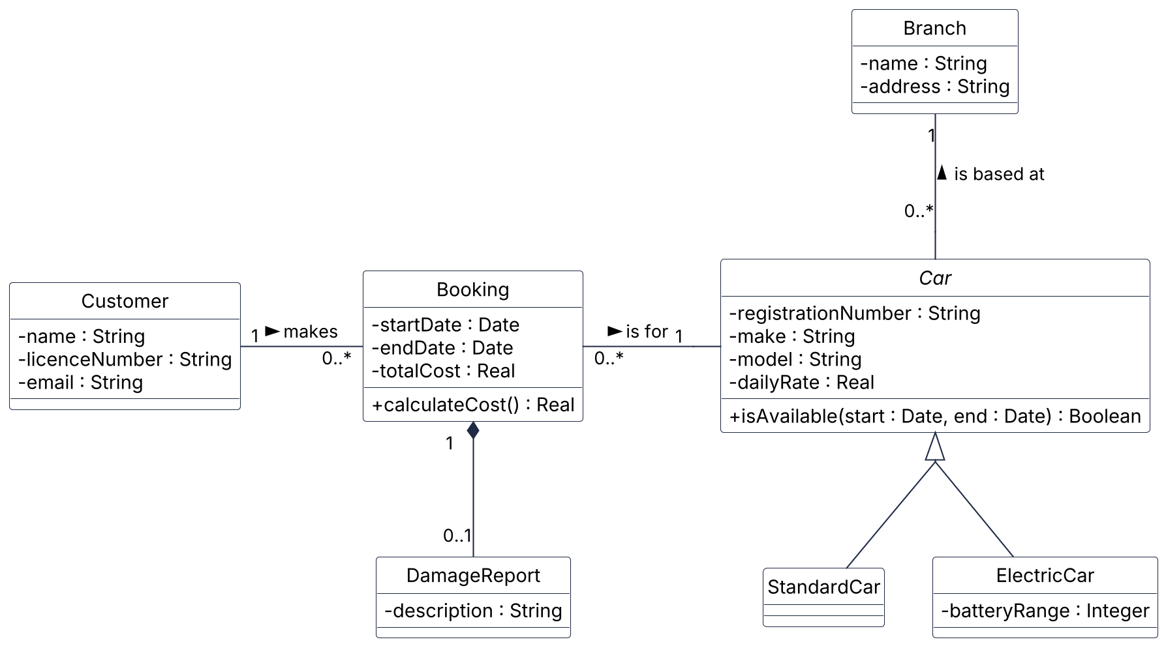
Figure 4 – Car rental class diagram
Generalisation: Car is abstract (name in italics) because every car is either a StandardCar or an ElectricCar – the generalisation is {complete, disjoint}. Only ElectricCar adds an attribute (batteryRange : Integer).
Composition: Booking ◆— DamageReport (1 to 0..1): a booking has at most one damage report, and the report cannot exist without its booking.
Operations: calculateCost() sits on Booking because a Booking knows its dates and its Car’s daily rate (cost = number of days × dailyRate). isAvailable(start, end) sits on Car because a Car can check its own Bookings for overlapping dates.
Assumption: the scenario names no attributes for DamageReport, so I gave it a single description : String.
Name two things you deliberately left out of your diagram, and say why.
1. The rental company itself. There is only one company and it is the system being built, so a RentalCompany class would have a single instance and no attributes or behaviour of its own – it would add a box without adding meaning.
2. Implementation details – getters/setters, constructors, database IDs and storage classes (e.g. a BookingRepository). This is an analysis model for understanding the problem domain; those details belong in a later design model and would only clutter this one.
Task 4 – Model behaviour with a state machine
A library Copy can be Available, OnLoan, Reserved or Lost. Draw a state machine using the events checkOut(), checkIn(), reserve(), cancelReservation(), reportLost() and found(). Include an initial state and at least one transition written as event [guard] / action.
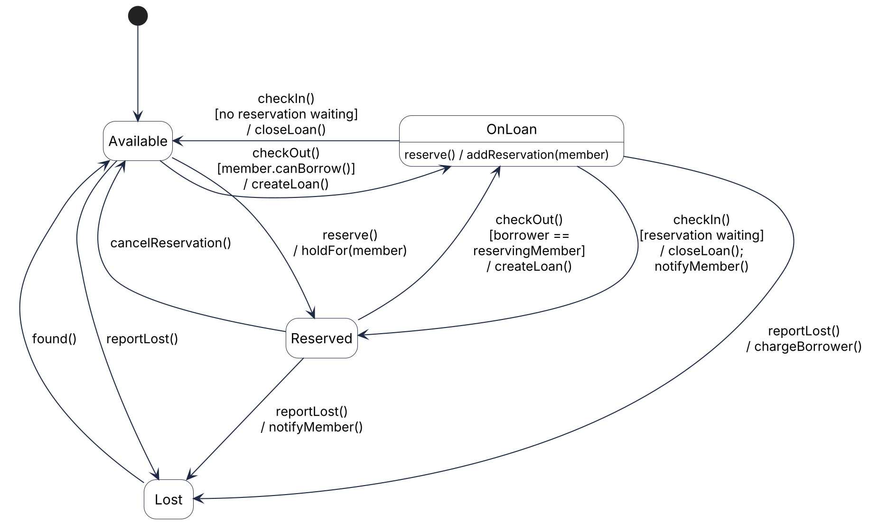
Figure 5 – State machine for a library Copy
The initial state is Available. Transitions are written event [guard] / action, e.g. checkOut() [member.canBorrow()] / createLoan(). A reserve() on a borrowed copy is an internal transition of OnLoan – the reservation is queued and the copy stays on loan; on checkIn() the guard decides whether the copy goes to Reserved (someone is waiting) or back to Available.
Name two transitions your model does not allow. Why is it useful for a tester to know this?
Not allowed 1 – checkOut() in Lost (there is no Lost → OnLoan transition). A lost copy is not on the shelf, so it cannot be lent; the only way out of Lost is found().
Not allowed 2 – checkIn() in Available (Available has no checkIn() transition). The copy is not on loan, so there is nothing to return and the event must be rejected.
Why this helps a tester: every forbidden event/state pair is a ready-made negative test case. The tester fires, for example, checkOut() on a Lost copy and checks that the system rejects it – an error is shown, the copy stays Lost and no Loan is created. The model gives both the valid paths to cover and the invalid “sneak paths” where bugs hide (e.g. a phantom loan on a lost copy), together with the expected result of each test.
Finished early?
Draw a sequence diagram for borrowing a copy, with the participants Librarian, :LoanController, m : Member, c : Copy and a new :Loan. Use an alt fragment: if m.canBorrow() is true the copy is checked out and a Loan is created; otherwise a refusal is returned.
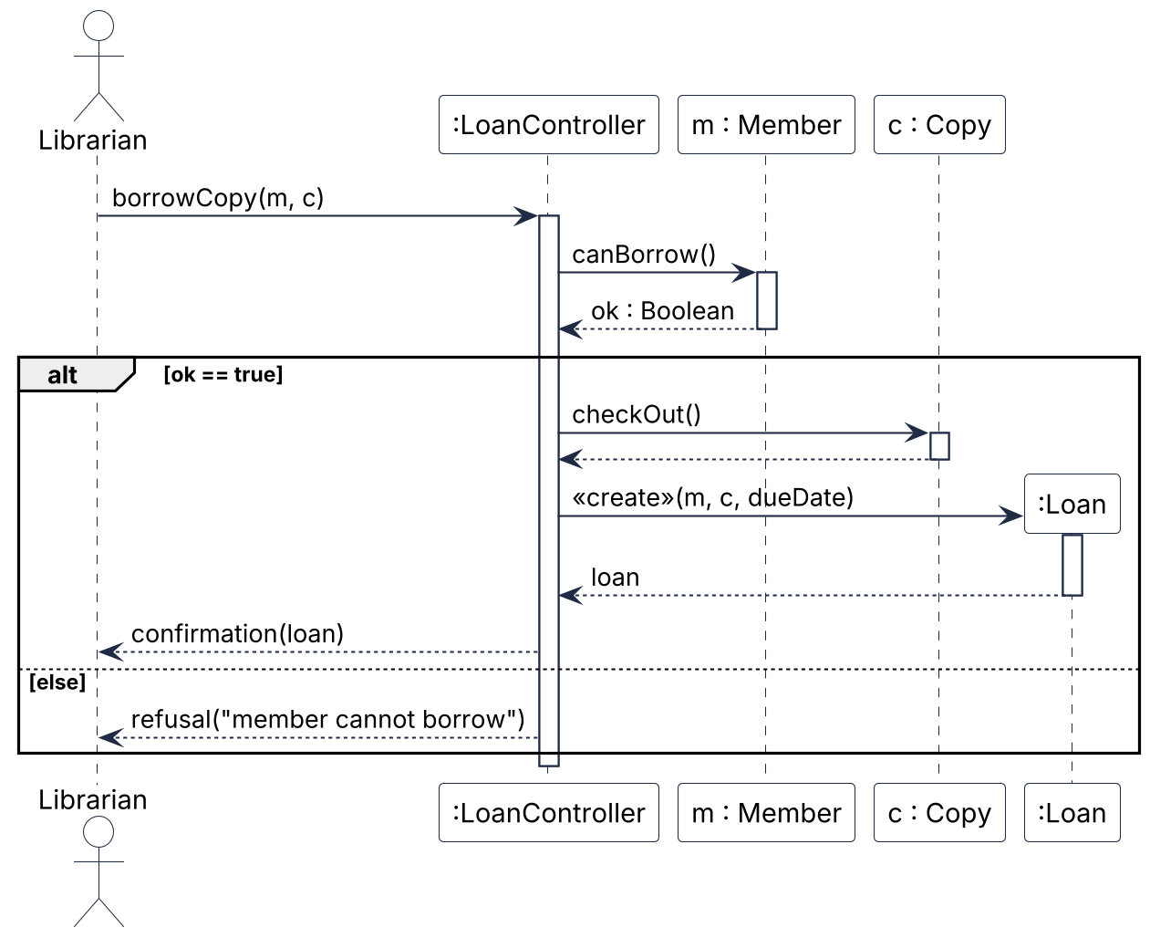
Figure 6 – Sequence diagram: borrowing a copy
The controller asks m.canBorrow() once and keeps the result. In the [ok == true] operand the copy is checked out and a new :Loan is created with a «create» message (its box starts at the point of creation); in [else] the controller returns a refusal and no Loan is created.
Self-check before you leave
☐ I can read multiplicity in both directions ☐ I can tell aggregation, composition and generalisation apart ☐ I can build a class diagram from a scenario ☐ I can draw a state machine with guards
Appendix – PlantUML source
Paste any block into plantuml.com (or a PlantUML plug-in for VS Code / IntelliJ) to regenerate the diagram.
Figure 3 – Corrected restaurant model (Task 2)
@startuml Task2_Restaurant_Corrected
' Task 2 - corrected analysis model of the restaurant specification
hide circle
skinparam classAttributeIconSize 0
skinparam shadowing false
skinparam nodesep 90
skinparam class {
BackgroundColor White
BorderColor #1F2A44
ArrowColor #1F2A44
}

class Restaurant {
- name : String
}

class Menu {
- title : String
}

class MenuItem {
- name : String
- price : Real
}

class Customer {
- name : String
+ placeOrder()
}

class VIPCustomer {
- discount : Real
}

' dbConnection removed: implementation detail, not part of an analysis model
class Order {
- orderId : String
+ calculateTotal() : Real
+ submit()
}

' Fix 1: filled diamond sits at the WHOLE (Restaurant), not the part
' (the spaces in " 1" only nudge the label clear of the diamond)
Restaurant " 1" *-right- "1" Menu
Menu "1" -right- "1..*" MenuItem : contains >

' Fix 2: one Customer places many Orders; each Order has exactly one Customer
Customer "1" -right- "0..*" Order : places >

' Fix 3: hollow triangle points at the general class (Customer)
Customer <|-down- VIPCustomer

Restaurant -[hidden]down- Customer
@enduml
Figure 4 – Car rental class diagram (Task 3)
@startuml Task3_CarRental
' Task 3 - car rental class diagram (analysis / domain model)
hide circle
skinparam classAttributeIconSize 0
skinparam shadowing false
skinparam groupInheritance 2
skinparam ranksep 70
skinparam class {
BackgroundColor White
BorderColor #1F2A44
ArrowColor #1F2A44
}

class Customer {
- name : String
- licenceNumber : String
- email : String
}

class Booking {
- startDate : Date
- endDate : Date
- totalCost : Real
+ calculateCost() : Real
}

class DamageReport {
- description : String
}

' Car is abstract (italic): every car is either a StandardCar or an ElectricCar
abstract class Car {
- registrationNumber : String
- make : String
- model : String
- dailyRate : Real
+ isAvailable(start : Date, end : Date) : Boolean
}

class StandardCar

class ElectricCar {
- batteryRange : Integer
}

class Branch {
- name : String
- address : String
}

Customer "1" -right- "0..*" Booking : makes >
Booking "0..*" -right- "1" Car : is for >
Car "0..*" -up- "1" Branch : is based at >

' Composition: a DamageReport cannot exist without its Booking
' (the spaces in "1 " only nudge the label clear of the diamond)
DamageReport "0..1" -up-* "1 " Booking

' Generalisation {complete, disjoint}
Car <|-down- StandardCar
Car <|-down- ElectricCar
@enduml
Figure 5 – Copy state machine (Task 4)
@startuml Task4_Copy_StateMachine
' Task 4 - state machine for a library Copy
' Transition syntax: event() [guard] / action()
hide empty description
skinparam shadowing false
skinparam ranksep 90
skinparam nodesep 70
skinparam state {
BackgroundColor White
BorderColor #1F2A44
ArrowColor #1F2A44
}

state Available
state Reserved
state Lost
' Internal transition: a reservation on a borrowed copy is queued,
' the copy stays OnLoan (no exit / re-entry)
state OnLoan : reserve() / addReservation(member)

[*] -down-> Available

OnLoan -left-> Available : checkIn()\n[no reservation waiting]\n/ closeLoan()
Available -right-> OnLoan : checkOut()\n[member.canBorrow()]\n/ createLoan()

Available -down-> Reserved : reserve()\n/ holdFor(member)
Reserved -up-> Available : cancelReservation()

OnLoan -down-> Reserved : checkIn()\n[reservation waiting]\n/ closeLoan();\nnotifyMember()
Reserved -up-> OnLoan : checkOut()\n[borrower ==\nreservingMember]\n/ createLoan()

Available -down-> Lost : reportLost()
OnLoan -down-> Lost : reportLost()\n/ chargeBorrower()
Reserved -down-> Lost : reportLost()\n/ notifyMember()
Lost -up-> Available : found()
@enduml
Figure 6 – Borrowing sequence diagram (Finished early)
@startuml Borrow_Copy_Sequence
' Finished early - sequence diagram for borrowing a copy
skinparam shadowing false
skinparam sequenceMessageAlign left
skinparam sequence {
ParticipantBackgroundColor White
ParticipantBorderColor #1F2A44
ActorBorderColor #1F2A44
ActorBackgroundColor White
LifeLineBorderColor #1F2A44
ArrowColor #1F2A44
}

actor Librarian
participant ":LoanController" as ctrl
participant "m : Member" as m
participant "c : Copy" as c

Librarian -> ctrl : borrowCopy(m, c)
activate ctrl

ctrl -> m : canBorrow()
activate m
m --> ctrl : ok : Boolean
deactivate m

alt ok == true
ctrl -> c : checkOut()
activate c
c --> ctrl
deactivate c

create ":Loan" as loan
ctrl -> loan : <<create>>(m, c, dueDate)
activate loan
loan --> ctrl : loan
deactivate loan

ctrl --> Librarian : confirmation(loan)
else else
ctrl --> Librarian : refusal("member cannot borrow")
end

deactivate ctrl
@enduml

