Lab 2: Software Models and UML Foundations
Accompanies: Lecture 2 · Work: individually or in pairs · Tools: draw.io, PlantUML, StarUML or pen and paper (the thinking matters more than the tool).
By the end of this lab you can: read and correct a UML class diagram, build one from a scenario using abstraction, and model an object’s behaviour with a state machine.
Task 1 – Read a class diagram
Figure 1 shows part of a University Library System. Answer the questions.
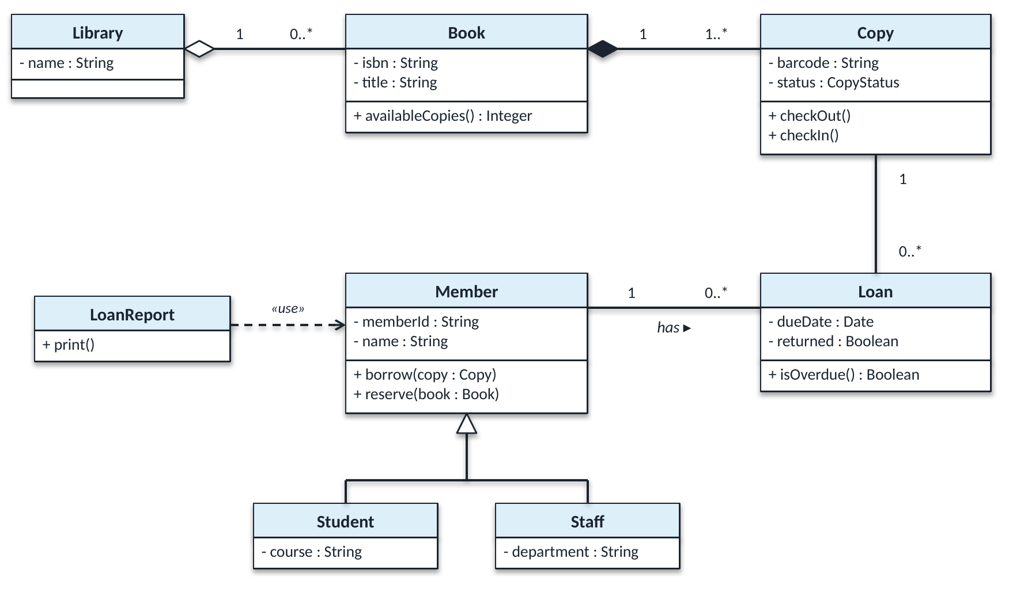
Figure 1 – University Library System
# | Question | Your answer
1 | How many Copies can a Book have? Can a Copy exist without its Book? Which symbol tells you?
2 | Can a Book exist without the Library? How does this symbol differ from the one in Q1?
3 | Read the Member–Loan association in both directions.
4 | What do Student and Staff inherit from Member?
5 | What does the dashed «use» arrow mean? Why is it not an association?

Task 2 – Spot the mistakes
A team modelled this specification: “A Restaurant has exactly one Menu, and the Menu cannot exist without its Restaurant. A Menu contains one or more MenuItems. A Customer can place many Orders; each Order is placed by exactly one Customer. A VIPCustomer is a special kind of Customer who receives a discount.” It is an analysis model for discussing requirements with the restaurant owner.
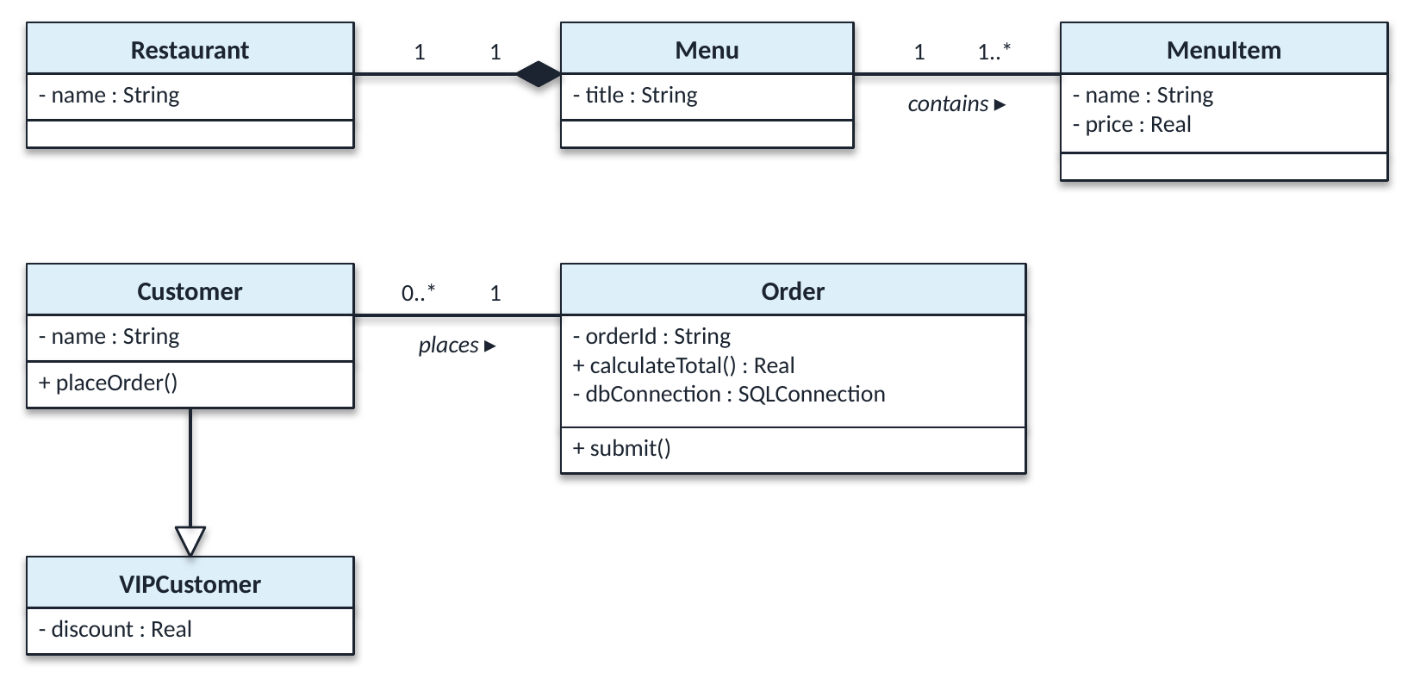
Figure 2 – The team’s diagram (five mistakes)
# | Mistake | Why it is wrong | Correction
1
2
3
4
5

Task 3 – Build a class diagram
A car rental company has several branches, each with a name and an address. Every car has a registration number, make, model and daily rate, and is based at exactly one branch. Customers register with their name, driving licence number and email. A customer can make any number of bookings; each booking is for exactly one car and has a start date, an end date and a total cost. A booking may have at most one damage report, which cannot exist without its booking. Cars are either standard or electric; electric cars also record their battery range. The system must calculate the cost of a booking and check whether a car is available for given dates.
Draw the class diagram. Include attribute types, the two operations named above, a multiplicity on both ends of every association, and at least one composition and one generalisation.
Name two things you deliberately left out of your diagram, and say why.
..................................................................................................................................................
..................................................................................................................................................
Task 4 – Model behaviour with a state machine
A library Copy can be Available, OnLoan, Reserved or Lost. Draw a state machine using the events checkOut(), checkIn(), reserve(), cancelReservation(), reportLost() and found(). Include an initial state and at least one transition written as event [guard] / action.
Name two transitions your model does not allow. Why is it useful for a tester to know this?
..................................................................................................................................................
..................................................................................................................................................
Finished early?
Draw a sequence diagram for borrowing a copy, with the participants Librarian, :LoanController, m : Member, c : Copy and a new :Loan. Use an alt fragment: if m.canBorrow() is true the copy is checked out and a Loan is created; otherwise a refusal is returned.
Self-check before you leave
☐ I can read multiplicity in both directions ☐ I can tell aggregation, composition and generalisation apart ☐ I can build a class diagram from a scenario ☐ I can draw a state machine with guards

